

**FPT UNIVERSITY**

**Capstone Project Document**

**IKFTS**

**Interactive Kiosk For Travel Service**

|  |  |
| --- | --- |
| Group SP22SE15 | |
| **Group members** | Phạm Càn Long – SE141128  Tô Ngọc Lam Linh – SE140303  Huỳnh Hữu Tín – SE140856  Trần Thế Đông Anh – SE140078  Vũ Sơn Tùng – SE140240 |
| **Supervisor** | **Nguyễn Thế Hoàng** |
| **Project code** | **IKFTS** |

- Ho Chi Minh City, 21 August 2022 -

# Table of Contents

Table of Contents 2

List of Tables 4

List of Figures 4

Acknowledgements 5

Definition and Acronyms 6

I. Project Introduction 6

1. Overview 6

1.1 Project Information 6

1.2 Project Team 6

2. Product Background 7

3. Existing Systems 7

3.1 App 1: 7

3.2 App 2: 8

4. Business Opportunity 8

5. Software Product Vision 8

6. Project Scope and Exclusions 8

6.1 Major Features 8

6.2 Limitations and Exclusions 9

II. Project Management Plan 9

1. Overview 9

1.1 WBS and Estimation 9

1.2 Project Objectives 12

1.3 Project Risks 12

2. Management Approach 13

2.1 Project Process 13

2.2 Quality Management 13

2.3 Training Plan 13

3. Project Organization 14

3.1 Team and Structure 14

3.2 Roles and Responsibilities 14

4. Project Communication 15

4.1 Communication 15

4.2 External Interface 15

5. Configuration Management 16

5.1 Tools and Infrastructures 16

5.2 Document Management 16

5.3 Source Code Management 16

III. Software Requirements Specification 16

1. Overall Description 16

1.1 User Requirements Overview 16

1.2 Business Rules 18

2. User Requirements 22

2.1 System Actors 23

2.2 Use Case Diagram 23

2.3 Use Cases List 26

2.4 Use Case Specification 31

3. Functional Requirements 155

3.1 System Functional Overview 155

4. Non-Functional Requirements 160

4.1 External Interfaces 160

4.2 Quality Attributes 160

IV. Software Design Description 161

1. Overall Description 161

1.1 Assumptions 161

2. System Architecture Design 161

2.1 Overall System Architecture 161

2.2 Component Diagram 163

2.3 Package Diagram 164

3. Activity Diagram 165

3.1 Renter Mobile Application 165

3.2 Owner Mobile Application 174

4. System Detailed Design 181

4.1 Class Diagram 181

4.2 Class Specification 182

4.3 State Machine Diagrams 200

4.4 Sequence Diagram 202

5. Data and Database Design 205

5.1 Database Design 205

5.2 Data File Design 205

V. Software Testing Documentation 222

1. Overall Description 222

1.1 Test Model 222

1.2 Testing Levels 222

2. Test Plan 222

2.1 Test Stages 222

2.2 Resources 222

2.3 Test Milestones 223

3. Test Cases and Test Reports 223

VI. Release Package and User Guides 223

1. Deliverable Package 223

1.1 Source Codes and Documents 223

2. Installation Guide 224

2.1 System Requirements 224

2.2 Setup Files 225

2.3 Installation Instruction 225

3. User Manual 230

3.1 Terms and Definitions 230

3.2 System Requirement 230

3.3 Application Usage 230

3.4 Troubleshooting 274

VII. Appendix 274

# Acknowledgements

Foremost, we would like to express our sincere gratitude to our mentor Mr. Lam Huu Khanh Phuong and Mr. Nguyen The Hoang for the continuous support of our capstone project, for his patience, motivation, enthusiasm, and immense knowledge. His guidance helped us in all the time of research, designing, building, and developing of this thesis. We could not have imagined having a better advisor and mentor for our capstone project.

Besides our advisor, we would like to thank the rest of our thesis committee: Mr. Lam Huu Khanh Phuong, Mr. Ngo Dang Ha An, Mr. Nguyen Trong Tai, Ms. Vo Thi Thanh Van for their quality recommend, insightful comments, and challenging questions.

We thank our friends in FPT University Ho Chi Minh City for the assets, advises and helping us in research and testing, and for all the fun we have had in many years.

We thank our company Long Van System Solution and Katalon for allowing time and task flexibility and providing knowledge and environment to deploy and test our product.

Last but not the least, we would like to thank our family for giving birth to us at the first place and supporting us spiritually throughout our life.

# Definition and Acronyms

|  |  |
| --- | --- |
| Acronym | Definition |
| BR | Business Rule |
| ERD | Entity Relationship Diagram |
| GUI | Graphical User Interface |
| UC | Use Case |
| API | Application Program Interface |
| IKFTS | Interactive Kiosk For Travel Service |
| POI | Point Of Interest |
| Location Owner | Users who manage kiosk and set up information to show on kiosk |
| Service Provider | Users who provide application to display on kiosk |
| Admin | Users who manage entities on system |
| Kiosk | The interactive Kiosk |
| Kiosk Portal/Portal | The website application to manage Kiosk |

Table 1: Definition and Acronyms

# Project Introduction

## Overview

### Project Information

* Project name: IKFTS – Interactive Kiosk For Travel Service
* Project code: KS
* Group name: SU22SE37
* Software type: Web application, Mobile Application

### Project Team

Supervisor

|  |  |  |  |
| --- | --- | --- | --- |
| Full Name | Email | Phone Number | Title |
| Nguyễn Thế Hoàng | hoangnt2@fpt.edu.vn | 098 662 85 25 | Lecturer |

Table 2. Supervisor

Team member

|  |  |  |  |
| --- | --- | --- | --- |
| Full Name | Email | Mobile | Role |
| Phạm Càn Long | longpcse141128@fpt.edu.vn | 0705 799 900 | Leader |
| Tô Ngọc Lam Linh | linhtnlse140303@fpt.edu.vn | 0775 051 234 | Member |
| Huỳnh Hữu Tín | tinhhse140856@fpt.edu.vn | 0912 700 360 | Member |
| Trần Thế Đông Anh | anhttdse140078@fpt.edu.vn | 0901 343 020 | Member |
| Vũ Sơn Tùng | tungvsse140240@fpt.edu.vn | 0777 997 001 | Member |

Table 3. Team members

## Product Background

After the covid 19 pandemic ended, due to being restrained for too long, tourism demand increased. In the first quarter of 2022, international tourists to our country were estimated at nearly 91,000 arrivals, up 89.1% over the same period last year. Many of them have problems that make their experience worse.

Tourists often have difficulty accessing local services such as entertainment venues, cafes, events, booking tickets, etc. Tourists are often ripped off when they go to unreliable places. Besides, they have no idea about the interesting places nearby. So they waste their time to find a good place to go. Moreover, they often miss nearby events because there is no information about it.

Realizing the problem, IKFTS aims to make the above process easier, we provide 3rd party services and information of nearby events to satisfy the needs of tourists and we also suggest reliable and suitable places for tourists. Moreover, IKFTS also helps service providers and kiosk implementers to have more income from service revenue.

## Existing Systems

### App 1: One Tap Check-In Software

OneTap is a digital attendance app used by event organizers, gyms, martial arts studios, yoga studios, schools, universities, and nonprofits. OneTap helps businesses create a check-in process using multiple devices with features like self-check-in link, customized kiosk, survey, photo, QR passes, and signature.

## Business Opportunity

## Software Product Vision

In order to make it easier for people to find out and choose places to play and visit when travelling as well as to use the services there, IKFTS is a solution to help users easily find and connect. with a variety of services from 3rd parties for a better travel and entertainment experience, it also supports information about places and happening events in the area so that people can easily create their own schedule and not miss the events there.

## Project Scope and Exclusions

### Major Feature

#### Admin uses Web Application

As a IKFTS admin who use Admin IKFTS web application system with the following features:

1. Create an account
2. Update an account
3. Change status an account
4. View kiosks are distributed on map.
5. Filter kiosks are distributed on map.
6. View kiosks by Location Owner.
7. View all kiosks
8. Create a kiosk
9. Edit profile
10. Change password
11. Add a POI
12. Delete a POI
13. Search a POI
14. View POI on map
15. Edit a POI
16. View events
17. Search an event
18. Add an event
19. Edit an event
20. Delete an event
21. Add a location
22. Edit a location
23. Delete a location
24. Search accounts by status, name, address, phone number, role, first name or last name
25. View application ratings and comments on the application market.
26. Deny or approve a service application to publish to the market.
27. Temporary stop a service application and send a report to the service provider.
28. View request from Service providers.
29. Edit content of email

Service Provider uses Web Application

As a service provider who uses Service Provider IKFTS web application, I want to use these following features:

1. Create a service app.
2. Update a service app.
3. Delete a service app.
4. View my service apps
5. View my applications ratings and comments.
6. Send an order report to the Location Owner to pay sales commissions
7. View the statistics of the number of people who use my application.
8. View the statistics of the number of Location owners who install my application.
9. Receive email when my application approves/rejects or is forced to stop.
10. Edit profile
11. Change password
12. Receive email when my account is deactivated or activated.

Location owner use Web Application

As a kiosk owner, I want to use the following features:

1. Manage the interface of the kiosk: set a schedule to change the interface base on template by the hour or day,..
2. Manage template of the kiosk: add, delete, edit template,add the component to template,...
3. Manage application in kiosk: install, uninstall apps on kiosk, view the statistic of the number of people who use application,..
4. Manage all kiosks you own: search a kiosk, view list of kiosk, update kiosk, view kiosk in map, view the statistic of the interaction of a kiosk
5. Manage event: add,search,update, remove event around the area
6. Rate or feedback to the service apps
7. View the profile of a service provider.
8. View ratings and feedback of a service app
9. View the commission of the application.

Guest use Kiosk Application

As a user who use interactive kiosk, I want to use these following features:

1. Filter POI on map.
2. View ongoing events and upcoming events in the area
3. Evaluate applications embedded in the kiosk.
4. Feedback kiosk experience.
5. Use services embedded in the kiosk.
6. View suggestions of interesting places around the area on map.
7. View suggestions of interesting places around the area.
8. See nearby kiosk locations.

### Limitations and Exclusions

1. Only develop for student, so that age of user must be greater than 17 and less than 25.
2. Only develop for accommodation in HCM city.
3. Renter mobile application has Search mode and Living mode, Renter web application only has Search mode.
4. Report problem just only user report the problem, not manage facility in room.

# Project Management Plan

## Overview

### WBS and Estimation

|  |  |  |  |
| --- | --- | --- | --- |
| # | WBS Item | Complexity | Est. Effort |
|  | ***Initiating*** |  |  |
|  | Collect requirement | Medium | 14 |
|  | ***Planning*** |  |  |
|  | Create plan document | Complex | 11 |
|  | ***Executing*** |  |  |
|  | **Analysis** |  |  |
|  | Analysis requirement | Complex | 12 |
|  | **Design** |  |  |
|  | Design Admin Web Application | Complex | 12 |
|  | Design Location Owner Web application | Complex | 10 |
|  | Design Service Provider Web application | Complex | 7 |
|  | Design Kiosk application | Complex | 12 |
|  | **Prototyping** |  |  |
|  | Mockup | Complex | 14 |
|  | **Implementation** |  |  |
|  | *Implement Base feature* |  |  |
|  | Login | Simple | 2 |
|  | Logout | Simple | 2 |
|  |  |  |  |
|  | *Implement Admin feature* |  |  |
|  | Home Main | Medium | 4 |
|  | Search | Complex | 5 |
|  | Profile | Medium | 4 |
|  | Manage Account | Complex | 6 |
|  | Create Kiosk | Complex | 6 |
|  | Manage Event | Complex | 6 |
|  | Manage POI | Medium | 5 |
|  | Manage Service Application | Medium | 3 |
|  | *Implement Location Owner feature* |  |  |
|  | Home Main | Medium | 4 |
|  | Profile | Medium | 4 |
|  | Manage Device/Kiosk | Medium | 4 |
|  | Manage Schedule | Medium | 4 |
|  | Manage Template | Complex | 4 |
|  | Manage Event | Complex | 4 |
|  | Manage POI | Complex | 4 |
|  | Manage Service Application | Medium | 3 |
|  | Manage Service Order/Transaction | Medium | 4 |
|  | Statistic | Medium | 4 |
|  | *Implement Service Provider feature* |  |  |
|  | Home Main | Medium | 5 |
|  | Profile | Medium | 5 |
|  | Manage Service Application | Medium | 5 |
|  | Monthly Survey | Medium | 4 |
|  | *Implement Kiosk feature* |  |  |
|  | Home Main | Medium | 5 |
|  | Service Application Category | Medium | 5 |
|  | Service Application List | Medium | 5 |
|  | Event Information | Medium | 5 |
|  | POI Information | Medium | 5 |
|  | Rating | Medium | 5 |
|  | **Testing** |  |  |
|  | Unit Test | Complex | 12 |
|  | Integration Test | Complex | 12 |
|  | System Test | Complex | 12 |
|  | **Monitoring and Controlling** |  |  |
|  | Control the process | Complex | 12 |
|  | Track performance a quality | Complex | 12 |
|  | **Closing** |  |  |
| **Total Estimated Effort (man-days): 303** | | | |

Table 4: WBS and Estimation

### Project Objectives

|  |  |  |  |  |
| --- | --- | --- | --- | --- |
| # | Quality Stage | No. of Defects | % of Defect | Notes |
|  | Reviewing | 20 | 27,6% |  |
|  | System Test | 40 | 72,4% |  |
|  | User Acceptance Test | X | X |  |
| Total | | 60 | 100% |  |

Table 5: Project Objectives

### Project Risks

|  |  |  |  |  |
| --- | --- | --- | --- | --- |
| # | Risk Description | Impact | Possibility | Response Plans |
|  | Technology risk: cannot find the suitable solution for technique problems, the software cannot fulfill the expectation. | High | Medium | Do more research on official resources, discuss with mentor |
|  | Requirement changes: requirements unexpected changes. | Critical | Medium | Chose another way of solution to respond to those changes. |

Table 6: Project Risks

## Management Approach

### Project Process

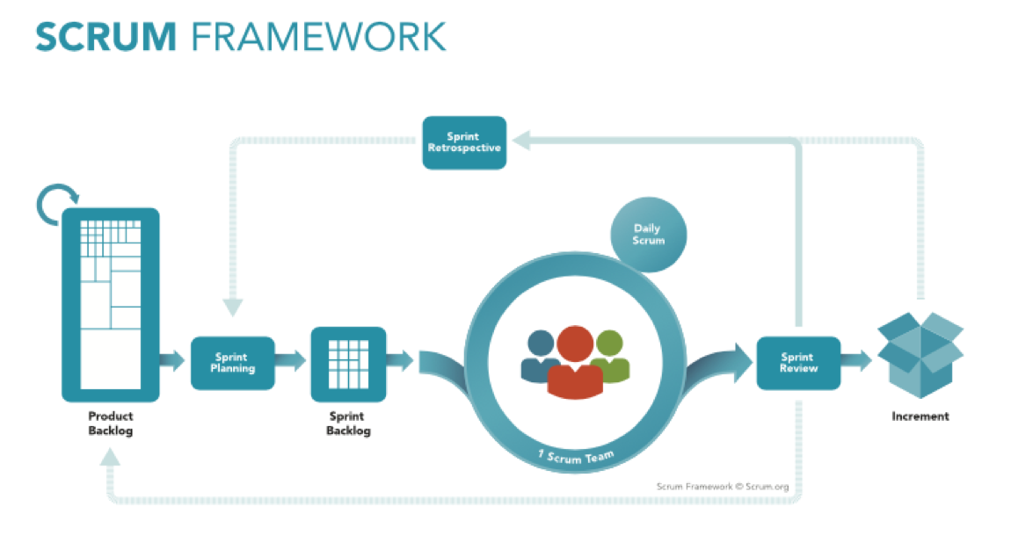

Figure 1 Scrum framework

This project is developed using Scrum model – part of an Agile framework for project development because of the following reasons:

* Suitable for small and medium team.
* Easy to learn and apply.
* Flexible to requirement changes.

### Quality Management

To increase the project quality and user experience, IKFTS team apply those:

* Do survey to understand what users wants and their need.
* Acceptance testing:
* Do survey to understand how users receive the application and collect feedback.
* Based on user’s feedback, IKFTS team fix bug and update.
* Hold daily meeting to track project progress and support each other.

### Training Plan

|  |  |  |  |
| --- | --- | --- | --- |
| Training Area | Participants | When, Duration | Waiver Criteria |
| ReactJS, Redux | TinHH, LinhTNL, LongPC | Week 1 – 3 days | Mandatory |
| C# Entity Framework | LongPC, AnhDTT, TungST | Week 1 – 6 days | Mandatory |
| Project flow, Git | All member | Week 1 – 2 days | Mandatory |
| Firebase | All member | Week 2 – 2 days | Mandatory |

Table 7: Training plan

## Project Organization

### Team and Structure

|  |  |
| --- | --- |
| Role | Full Name |
| Product Owner | Lâm Hữu Khánh Phương  Nguyễn Thế Hoàng |
| Scrum Master | Phạm Càn Long |
| Development Team | Phạm Càn Long  Tô Ngọc Lam Linh  Huỳnh Hữu Tín  Trần Thế Đông Anh  Vũ Sơn Tùng |

Table 8: Team and Structure

### Roles and Responsibilities

|  |  |
| --- | --- |
| Role | Responsibility |
| Product Owner | Specify user requirements  Control the development process  Control technical process  Support for answers on algorithms  Give out technique and business analysis support  Review the document and product |
| Scrum Master | Analyze requirements and business rules  Clarify requirement  Trach work progress  Database design  GUI design  Write document  Divide tasks for each member  Testing |
| Development Team | Analyze requirement and business rules  Database design  GUI design  Coding  Testing |

Table 9: Role and Responsibilities

## Project Communication

### Communication

|  |  |  |  |  |
| --- | --- | --- | --- | --- |
| Communication Item | Who/Target | Purpose | When, Frequency | Type, Tool, Method |
| Texting | Supervisor + Team member | Confirm Meeting time  Report Working progress  Internal conversations | Usually | Zalo, Messenger |
| Meeting online | Supervisor + Team member | Progress report  Report and handle problem  Review task | Always | Google Meet |
| Tracking progress | Team member | Check personal tasks  Tracking progress of project | Always | Jira, Github |

Table 10: Communication Plan

### External Interface

FPTU Contacts

|  |  |  |  |
| --- | --- | --- | --- |
| Function | Contact Person  (name, position) | Contact address  (email, telephone) | Responsibility |
| Supervisor | Nguyễn Thế Hoàng | hoangnt2@fpt.edu.vn | Guide project team with problem  Review project result  Supervise project status  Provide document template.  Guide project team with problem  Review project result  Supervise project status |

Table 11: FPTU Contacts

## Configuration Management

### Tools and Infrastructures

|  |  |
| --- | --- |
| Programming Languages | JavaScript, C#, TypeScript |
| Framework | Entity Framework, React, PWA |
| API | ASP.NET Core 5.0 |
| DBMS | SQL Server |
| IDEs/Editors | Jetbrain Rider, Visual Studio Code |
| UML tools | Draw.io |
| Version Control | GitHub, Fork |
| Deployment server | Long Van Datacenter Cloud Service, Firebase Storage |
| Project Management Tool | Jira |

Table 12: Tool and Infrastructures

### Document Management

* Use Google Drive to save document and for real-time editing on Google Docs.
* Use Google Drive to save meeting report, meeting record, diagram, image, design, document to each category folder and for real-time editing on Google Docs, Google Sheet or Google Slide.

### Source Code Management

* GitHub server to store source code.
* Follow the rule of team when using Git:
* Commit and note the changes details often.
* Review carefully before push into develop branch.
* Fetch, review and resolve conflicts when merging usually
* The name branch follow format <MemberName>/<TicketId>. (Example: linh/CPF100)

# Software Requirements Specification

## Overall Description

### User Requirements Overview

Guest

Those who do not need to log in to the kiosk can use the following functions:

* View POI (Point of interest) near by Kiosk
* View Events
* Use Applications
* View Banners
* View Map
* View Direction from Kiosk to Event
* View Direction from Kiosk to
* View Location Information

Member

Those who have the ability to log in to the management website and can use the following functions

* Login
* Logout
* Forget password
* Receive notifications
* View profile
* Update profile
* Change password

Location Owner

People who deploy kiosks in tourist destinations and can use the following features

* Manage Kiosks
* Manage Events
* Manage POI (Point of interest)
* Manage Schedule
* Manage Scenario
* Manage Templates
* Install Applications
* Manage Profile
* Setup Kiosk

Service Provider

Those who provide applications for the kiosk system and can use the following features

* Manage Application
* Manage Application Publish Request

Admin

Those who manage the kiosk system and can use the following features

* Manage users’ accounts
* Create kiosk for location owner
* Manage System POI (Point of interest)
* Manage POI Category (Point of interest Category)
* Manage System Event
* Manage Application
* Manage Application Category
* Verify Application

### Business Rules

|  |  |
| --- | --- |
| Code | Business Definition |
|  | One account can be login by many platforms |
|  | When logging in, the system will save the account’s device id to send a notification if needed. |
|  | When login by another device, the old device will not sign out automatically. |
|  | Link reset password is valid for 5 minutes. |
|  | Actor can only update profile of them, or admin can change information of them. |
|  | Password must have at least 7 characters. |
|  | Hash Password with BCrypt.Net before save it into database. |
|  | Get list application with current template of schedule. If no schedule, get list application by default. |
|  | Get list event with current temple of schedule. If no schedule, get list event near by. |
|  | Get list POI with current temple of schedule. If no schedule, get list POI near by. |
|  | The application name is unique in system. |
|  | Service Provider can only view provided application which belong to them. |
|  | If no one feedback an application. Rating point will be set to 0. |
|  | Valid rating point of feedback in system is between 1 to 5. |
|  | Service Provider can only create request to publish when provided application has status “Unavailable”. |
|  | Service Provider can only cancel request to publish when the request status is “Pending”. |
|  | Show all request to publish with any status from Service Provider. |
|  | Only show request to publish application service that belong to their Service Provider. |
|  | Location Owner can only view their statistical chart. |
|  | Only Category that actor has application on it will be shown. |
|  | Template’s status will be changed to “Available” when actor set at least 1 Category or 1 event in template. |
|  | Template must have at least 1 event in row 1 to add more event in row 2. |
|  | Location Owner can only update information template which belong to them. |
|  | Location Owner can only delete template which belong to them. |
|  | If Location Owner delete template which is set in scenario. The scenario will change template to default. |
|  | Location Owner can only view template which belong to them. |
|  | Location Owner can only install application when that application is not installed or it was uninstalled. |
|  | Location Owner can only install application which status is “Available”. |
|  | Location Owner can only uninstall application that installed. |
|  | Location Owner can only view their statistic commission of their embedded application. |
|  | Location Owner can only feedback when they has installed application once before. |
|  | Location Owner can only get list kiosk which belong to them. |
|  | Location Owner can only update kiosk information which belong to them. |
|  | Location Owner can only view commission profit statistics of kiosk which belong to them. |
|  | Scenario which schedule is time-conflict cannot be created. |
|  | Location Owner can only choose location which is created by them. |
|  | Location Owner cannot update schedule which not belong to them. |
|  | Location Owner cannot view detail schedule which not belong to them. |
|  | Every Kiosk Placement must has at least 1 image. |
|  | Location Owner can only update Kiosk Placement which belong to them. |
|  | Location Owner can only view Kiosk Placement which is belong to them. |
|  | The type of event which is created by Location Owner is “Local”. |
|  | Each event has a maximum of 5 images, minimum of 1 image. |
|  | Location Owner can only update event which belong to them. |
|  | Location Owner can only delete event which belong to them. |
|  | Location Owner can only view local event which belong to them. |
|  | Local POI between location owners can be duplicated. |
|  | Address of local POI of 1 location owner cannot be duplicated. |
|  | Location Owner can only update local POI which belong to them. |
|  | Location Owner can only deactivate local POI which belong to them. |
|  | Location Owner can only view local POI which belong to them. |
|  | POI category name cannot be duplicated. |
|  | Can not delete category has at least 1 poi set that category. |
|  | Each POI has a maximum of 5 images, minimum of 1 image. |
|  | Each location on the map has only 1 POI. |
|  | POI type which is created by Admin is “Server”. |
|  | Admin can only update POI which type is “Server”. |
|  | List POI will be paging with page size is 5. |
|  | Admin can only view POI which type is “Server”. |
|  | After account is created, system automatically send mail to user to give them password. |
|  | List account will be paging with page size is 5. |
|  | Password will be hidden. |
|  | After status of account is changed, system will automatically send mail to user to notify about this. |
|  | Each event has a maximum of 5 images, minimum of 1 image. |
|  | Event type which is created by Admin is “Server”. |
|  | Admin can only update event which type is “Server”. |
|  | Admin can only delete event which type is “Server”. |
|  | List event will be paging with page size is 5. |
|  | App category name cannot be duplicated. |
|  | Commission must be a float number. |
|  | Actor can not delete category which has at least 1 application set on that category. |
|  | System automatically send mail to user to notify that their application is denied to publish. |

Table 13: Business Rule

## User Requirements

### System Actors

|  |  |  |
| --- | --- | --- |
| # | Actor | Description |
|  | Guest | Users who use kiosk |
|  | Location Owner | Users who manage kiosk |
|  | Service Provider | Users who have Application want to publish it on Kiosk |
|  | System Handler | System. |
|  | Admin | Users who manage other roles and entities. |

Table 14: System Actors

### Use Case Diagram E:\FPT\Capstone\UseCaseDiagram.jpgUseCaseDiagram

Admin and System Handler

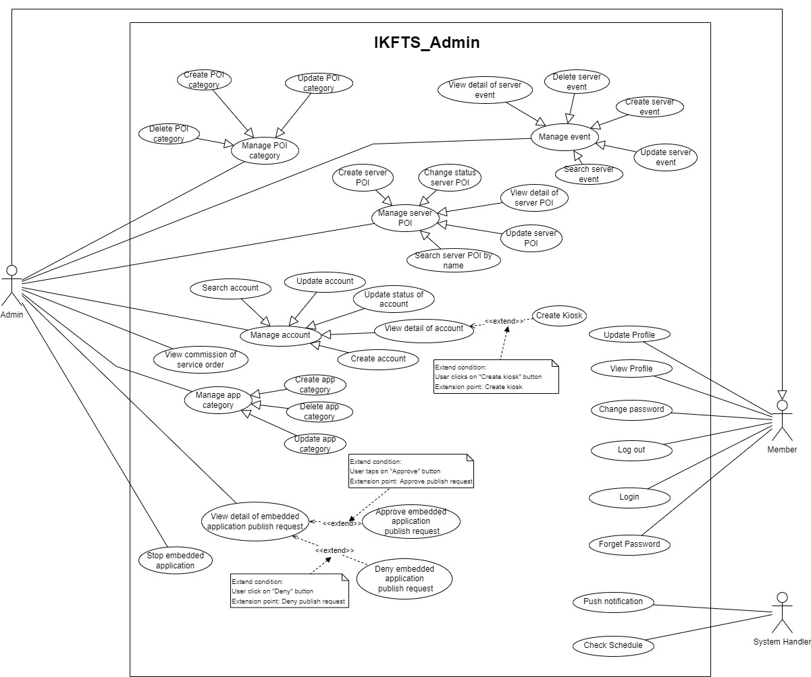

Location Owner

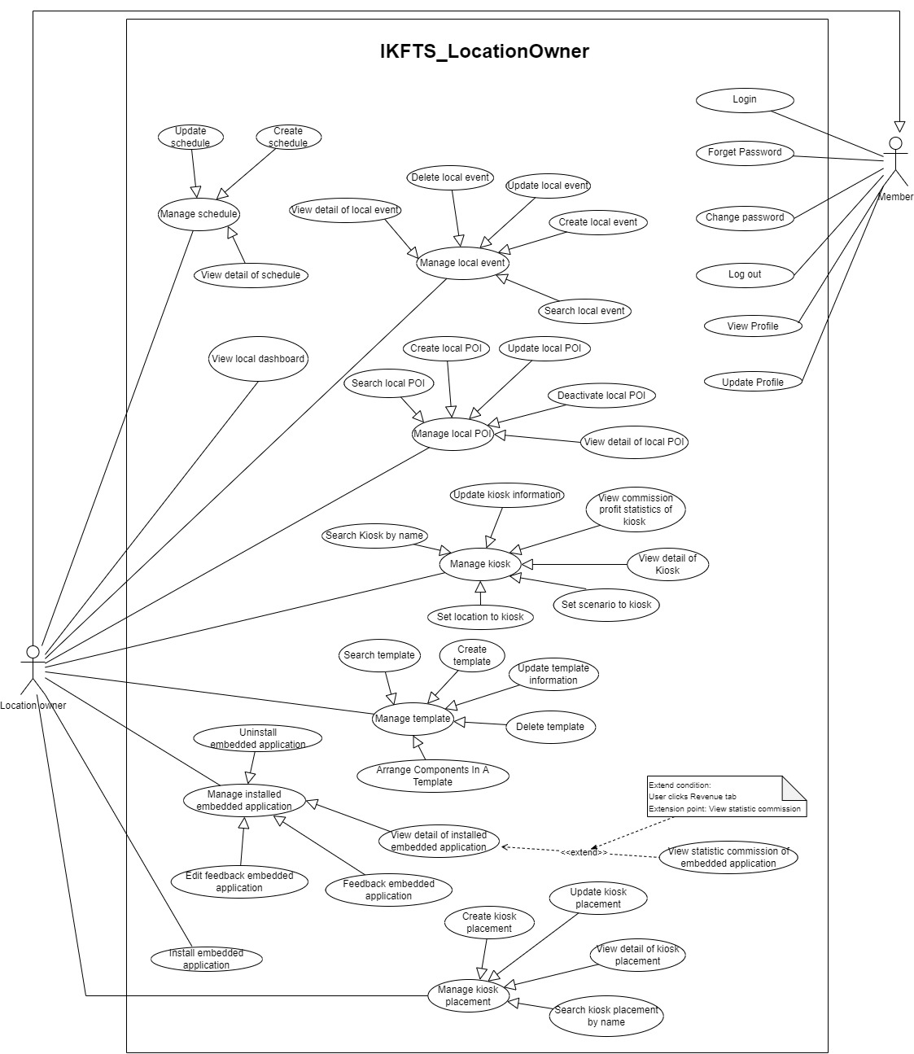

Service Provider

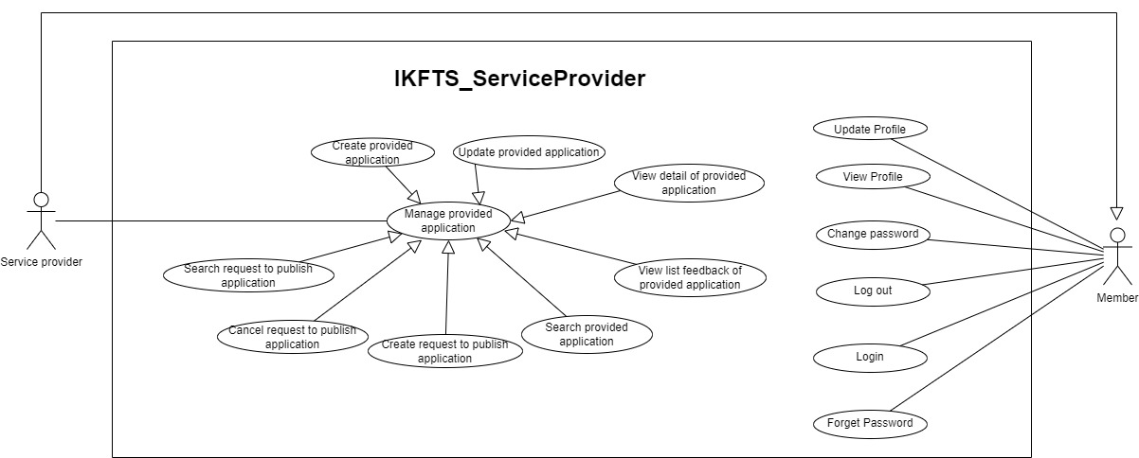

Guest  
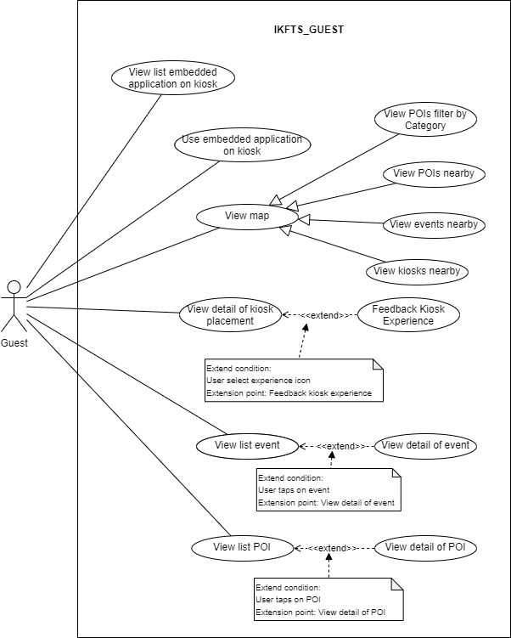

### Use Cases List

Member

|  |  |  |  |
| --- | --- | --- | --- |
| ID | Use Case | Primary Actors | Secondary Actors |
|  | Login | Member |  |
|  | Log out | Member |  |
|  | Forget password | Member |  |
|  | Update profile | Member |  |
|  | Change password | Member |  |
|  | View Profile | Member |  |

Guest

|  |  |  |  |
| --- | --- | --- | --- |
| ID | Use Case | Primary Actors | Secondary Actors |
|  | View list embedded application on kiosk | Guest |  |
|  | Use embedded application on kiosk | Guest |  |
|  | View list event on kiosk | Guest |  |
|  | View list POI on kiosk | Guest |  |
|  | View detail of event on kiosk | Guest |  |
|  | View detail of POI on kiosk | Guest |  |
|  | View map on kiosk | Guest |  |
|  | View POI on map filter by category | Guest |  |
|  | View kiosk placement detail | Guest |  |
|  | Feedback experience on kiosk | Guest |  |

Service Provider

|  |  |  |  |
| --- | --- | --- | --- |
| ID | Use Case | Primary Actors | Secondary Actors |
|  | Create Provided Application | Service Provider |  |
|  | Update Provided Application | Service Provider |  |
|  | Search Provided Application | Service Provider |  |
|  | View Detail Of Provided Application | Service Provider |  |
|  | View List Feedback Of Provided Application | Service Provider |  |
|  | Create Request To Publish Provided Application | Service Provider |  |
|  | Cancel Request To Publish Provided Application | Service Provider |  |
|  | Search Request To Publish Provided Application | Service Provider |  |

Location Owner

|  |  |  |  |
| --- | --- | --- | --- |
| ID | Use Case | Primary Actors | Secondary Actors |
|  | View Local Dashboard | Location Owner |  |
|  | Create Template | Location Owner |  |
|  | Arrange Component In A Template | Location Owner |  |
|  | Update Template Information | Location Owner |  |
|  | Delete Template | Location Owner |  |
|  | Search Template | Location Owner |  |
|  | Install Embedded Application | Location Owner |  |
|  | Uninstall Embedded Application | Location Owner |  |
|  | View Detail Of Installed Embedded Application | Location Owner |  |
|  | View Statistic Commission Of Embedded Application | Location Owner |  |
|  | Feedback Embedded Application | Location Owner |  |
|  | Edit Feedback Embedded Application | Location Owner |  |
|  | Search Kiosk By Name | Location Owner |  |
|  | Update Kiosk Information | Location Owner |  |
|  | View Commission Profit Statistics Of Kiosk | Location Owner |  |
|  | View Detail Of Kiosk | Location Owner |  |
|  | Set Scenario To Kiosk | Location Owner |  |
|  | Set Location To Kiosk | Location Owner |  |
|  | Create Schedule | Location Owner |  |
|  | Update Schedule | Location Owner |  |
|  | View Detail Of Schedule | Location Owner |  |
|  | Create Kiosk Placement | Location Owner |  |
|  | Update Kiosk Placement | Location Owner |  |
|  | Search Kiosk Placement By Name | Location Owner |  |
|  | View Detail Of Kiosk Placement | Location Owner |  |
|  | Create Local Event | Location Owner |  |
|  | Update Local Event | Location Owner |  |
|  | Delete Local Event | Location Owner |  |
|  | Search Local Event | Location Owner |  |
|  | View Detail Of Local Event | Location Owner |  |
|  | Create Local POI | Location Owner |  |
|  | Update Local POI | Location Owner |  |
|  | Deactivate Local POI | Location Owner |  |
|  | Search Local POI | Location Owner |  |
|  | View Detail Of Local POI | Location Owner |  |

Admin

|  |  |  |  |
| --- | --- | --- | --- |
| ID | Use Case | Primary Actors | Secondary Actors |
|  | Create POI Category | Admin |  |
|  | Update POI Category | Admin |  |
|  | Delete POI Category | Admin |  |
|  | Create Server POI | Admin |  |
|  | Update Server POI | Admin |  |
|  | Search Server POI | Admin |  |
|  | View Detail Of Server POI | Admin |  |
|  | Change Status Server POI | Admin |  |
|  | Create Account | Admin |  |
|  | Search Account | Admin |  |
|  | View Detail Of Account | Admin |  |
|  | Create Kiosk | Admin |  |
|  | Update Account | Admin |  |
|  | Update Status Of Account | Admin |  |
|  | Create Server Event | Admin |  |
|  | Update Server Event | Admin |  |
|  | Delete Server Event | Admin |  |
|  | View Detail Of Server Event | Admin |  |
|  | Search Server Event | Admin |  |
|  | Create App Category | Admin |  |
|  | Update App Category | Admin |  |
|  | Delete App Category | Admin |  |
|  | View Detail Of Embedded Application Publish Request | Admin |  |
|  | Deny Embedded Application Publish Request | Admin |  |
|  | Approve Embedded Application Publish Request | Admin |  |
|  | Stop Embedded Application | Admin |  |

### Use Case Specification

Member

##### Login

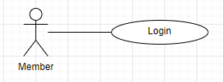

|  |  |  |  |  |  |
| --- | --- | --- | --- | --- | --- |
| **ID and Name** | **UC-01: Login** | | | | |
| Created By: | AnhTTD | | Date Created: | | 16/08/2022 |
| Primary Actor: | Member | | Secondary Actor: | | N/A |
| Trigger: | Actor wants to login IKFTS Kiosk portal website. | | | | |
| Description: | This feature allows users to login in IKFTS Kiosk portal website. | | | | |
| Preconditions: | Actor has authenticated into IKFTS Kiosk portal website. | | | | |
| Post-conditions: | **Success:** Actor will be redirected to Home screen of the Kiosk portal website.  **Failed:** System inform “Wrong username or password”. | | | | |
| Normal Flow: | **Step** | **Actor Action** | | **System Response** | |
|  | Actor goes to login view. It includes:   * Email: text input. * Password: hidden input. | |  | |
|  | Actor inputs Email and Password. | | [Exception 1] | |
|  | Actor click on “Sign In” button. | | System redirects to Home screen.  [Exception 2] | |
| Alternative Flows: | N/A | | | | |
| Exceptions: | **No** | **Cause** | | **System Response** | |
|  | Actor fills invalid information: Email, Password. | | System informs “Invalid email”, “Password must be at least 7 characters” | |
|  | Actor fills wrong identity information | | System informs ”Wrong username or password” | |
| Priority: | High | | | | |
| Frequency of Use: | Usually | | | | |
| Business Rule: | BR-01: One account can be login by many platforms  BR-02: When logging in, the system will save the account’s device id to send a notification if needed.  BR-03: When login by another device, the old device will not sign out automatically. | | | | |
| Other Information: | N/A | | | | |
| Assumptions: | Internet connection is available. | | | | |

##### Log Out

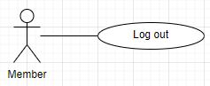

|  |  |  |  |  |  |
| --- | --- | --- | --- | --- | --- |
| **ID and Name** | **UC-03: Log Out** | | | | |
| Created By: | AnhTTD | | Date Created: | | 17/08/2022 |
| Primary Actor: | Member | | Secondary Actor: | | N/A |
| Trigger: | Actor wants to log out of the IKFTS. | | | | |
| Description: | This feature allows users to log out of the IKFTS. | | | | |
| Preconditions: | Actor logged in to IKFTS portal website. | | | | |
| Post-conditions: | **Success:** System redirects Login screen. The user’s token information is removed from local storage.  **Failed:** System inform error message. | | | | |
| Normal Flow: | **Step** | **Actor Action** | | **System Response** | |
| 1 | Actor chooses “Logout” tab. | | System shows popup Confirm Logout. | |
| 2 | Actor chooses “Yes” button. | | System redirects Login screen. The user’s token information is removed from local storage. | |
| Alternative Flows: | N/A | | | | |
| Exceptions: | N/A | | | | |
| Priority: | High | | | | |
| Frequency of Use: | Usually | | | | |
| Business Rule: | N/A | | | | |
| Other Information: | N/A | | | | |
| Assumptions: | Internet connection is available. | | | | |

##### Forget Password

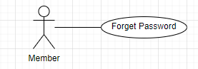

|  |  |  |  |  |  |
| --- | --- | --- | --- | --- | --- |
| **ID and Name** | **UC-03: Forget Password** | | | | |
| Created By: | ANHTTD | | Date Created: | | 16/08/2022 |
| Primary Actor: | Member | | Secondary Actor: | | N/A |
| Trigger: | Actor wants to get and change password of IKFTS account. | | | | |
| Description: | This feature allows users to change password of IKFTS account without login into system. | | | | |
| Preconditions: | Actor has an email of IKFTS account. | | | | |
| Post-conditions: | **Success:** Actor will receive new password to login to IKFTS system.  **Failed:** System informs “Cannot found”. | | | | |
| Normal Flow: | **Step** | **Actor Action** | | **System Response** | |
|  | Actor goes to login view and click “Forgot password?” . | | System redirects to Forgot password screen. | |
|  | Actor inputs email. | | [Exception 1] | |
|  | Actor clicks “Send email verify” | | System informs “Request to reset password successful. Please check your email”, redirect to Login screen.  System send mail to actor to reset password.  [Exception 2] | |
|  | Actor check mail from “Kiosk-Platform” | |  | |
|  | Actor click “Nhấn vào đây để reset mật khẩu” from mail content. | | System inform new password, redirect to Change Password screen.  System send mail to actor to remind new password. | |
| Alternative Flows: | N/A | | | | |
| Exceptions: | **No** | **Cause** | | **System Response** | |
|  | Actor fills invalid information: Email. | | System informs “Invalid email” | |
|  | Actor enters wrong email. | | System inform “Can not found” | |
| Priority: | High | | | | |
| Frequency of Use: | Usually | | | | |
| Business Rule: | BR-04: Link reset password is valid for 5 minutes. | | | | |
| Other Information: | N/A | | | | |
| Assumptions: | Internet connection is available. | | | | |

##### Update Profile

|  |  |  |  |  |  |
| --- | --- | --- | --- | --- | --- |
| **ID and Name** | **UC-04: Update Profile** | | | | |
| Created By: | AnhTTD | | Date Created: | | 17/08/2022 |
| Primary Actor: | Member | | Secondary Actor: | | N/A |
| Trigger: | Actor wants to update their information. | | | | |
| Description: | This feature allows users to update their information. | | | | |
| Preconditions: | Actor logged in to IKFTS portal website. | | | | |
| Post-conditions: | **Success:** Actor’s Profile is updated.  **Failed:** System inform error message. | | | | |
| Normal Flow: | **Step** | **Actor Action** | | **System Response** | |
| 1 | Actor chooses “Profile” tab. | | System redirects Profile screen. | |
| 2 | Actor change information they want to update. | | [Exception]{6} | |
| Alternative Flows: | N/A | | | | |
| Exceptions: | **Step** | **Actor Action** | | **System Response** | |
| 1 | First Name field is empty. | | System inform “Please input first name !” | |
| 2 | Last Name field is empty. | | System inform “Please input last name !” | |
| 3 | Phone Number field is empty. | | System inform “Please input phone number !” | |
| 4 | Invalid Phone Number. | | System inform “Please input phone number with right format !” | |
| 5 | Address field is empty. | | System inform “Please input address !” | |
| 6 | DOB field is not valid. User is under 18 years old. | | System inform “The age must be over 18” | |
| Priority: | High | | | | |
| Frequency of Use: | Usually | | | | |
| Business Rule: | BR-05: Actor can only update profile of them, or admin can change information of them. | | | | |
| Other Information: | N/A | | | | |
| Assumptions: | Internet connection is available. | | | | |

##### Change Password

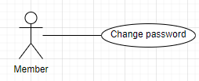

|  |  |  |  |  |  |
| --- | --- | --- | --- | --- | --- |
| **ID and Name** | **UC-05: Change Password** | | | | |
| Created By: | AnhTTD | | Date Created: | | 17/08/2022 |
| Primary Actor: | Member | | Secondary Actor: | | N/A |
| Trigger: | Actor wants to change their account’s password. | | | | |
| Description: | This feature allows users to change their account’s password. | | | | |
| Preconditions: | Actor logged in to IKFTS portal website. | | | | |
| Post-conditions: | **Success:** Password is changed.  **Failed:** System inform error message. | | | | |
| Normal Flow: | **Step** | **Actor Action** | | **System Response** | |
| 1 | Actor chooses “Profile” tab. | | System redirects Profile screen. | |
| 2 | Actor input field to change password. | | [Exception 1]  [Exception 2]  [Exception 3]  [Exception 4]  [Exception 5]  [Exception 6]  [Exception 7] | |
| Alternative Flows: | N/A | | | | |
| Exceptions: | **Step** | **Actor Action** | | **System Response** | |
| 1 | Old Password field is empty. | | System inform “Please input first name !” | |
| 2 | New Password field is empty. | | System inform “Please input last name !” | |
| 3 | Confirm Password field is empty. | | System inform “Please input phone number !” | |
| 4 | Old Password less than 7 characters. | | System inform “Old Password must be at least 7 characters” | |
| 5 | New Password less than 7 characters. | | System inform “New Password must be at least 7 characters” | |
| 6 | Confirm Password and New Password does not match. | | System inform “The two passwords that you entered do not match!” | |
| 7 | Old Password is not correct. | | System inform “Wrong old password” | |
| Priority: | High | | | | |
| Frequency of Use: | Usually | | | | |
| Business Rule: | BR-06: Password must have at least 7 characters.  BR-07: Hash Password with BCrypt.Net before save it into database. | | | | |
| Other Information: | N/A | | | | |
| Assumptions: | Internet connection is available. | | | | |

##### View Profile

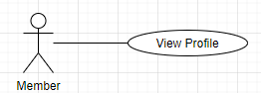

|  |  |  |  |  |  |
| --- | --- | --- | --- | --- | --- |
| **ID and Name** | **UC-06: View Profile** | | | | |
| Created By: | AnhTTD | | Date Created: | | 17/08/2022 |
| Primary Actor: | Member | | Secondary Actor: | | N/A |
| Trigger: | Actor wants to view their profile. | | | | |
| Description: | This feature allows users to view their profile. | | | | |
| Preconditions: | Actor logged in to IKFTS portal website. | | | | |
| Post-conditions: | **Success:** System redirects Profile screen.  **Failed:** System inform error message. | | | | |
| Normal Flow: | **Step** | **Actor Action** | | **System Response** | |
| 1 | Actor chooses “Profile” tab. | | System redirects Profile screen. | |
| Alternative Flows: | N/A | | | | |
| Exceptions: | N/A | | | | |
| Priority: | High | | | | |
| Frequency of Use: | Usually | | | | |
| Business Rule: | Actor can only view profile of them. | | | | |
| Other Information: | N/A | | | | |
| Assumptions: | Internet connection is available. | | | | |

Guest

##### View List Embedded Application On Kiosk

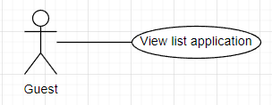

|  |  |  |  |  |  |
| --- | --- | --- | --- | --- | --- |
| **ID and Name** | **UC-07: View List Embedded Application On Kiosk** | | | | |
| Created By: | TungVS | | Date Created: | | 08/08/2022 |
| Primary Actor: | Guest | | Secondary Actor: | | N/A |
| Trigger: | Actor wants to view list application on kiosk. | | | | |
| Description: | This feature allows actor to view list application on kiosk . | | | | |
| Preconditions: | Kiosk has been log in by location owner. | | | | |
| Post-conditions: | **Success:** System show list application  **Failed:** System informs error message | | | | |
| Normal Flow: | **Step** | **Actor Action** | | **System Response** | |
| 1 | Actor clicks on “App” on menu bar | | System redirects application page and show list application  [Exception 1] | |
| Alternative Flows: | N/A | | | | |
| Exceptions: | **No** | **Cause** | | **System Response** | |
| 1 | No application exist | | System show “No Data” | |
| Priority: | High | | | | |
| Frequency of Use: | Usually | | | | |
| Business Rule: | BR-08: Get list application with current template of schedule. If no schedule, get list application by default. | | | | |
| Other Information: | N/A | | | | |
| Assumptions: | Internet connection is available. | | | | |

##### Use Embedded Application On Kiosk

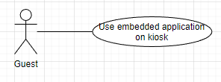

|  |  |  |  |  |  |
| --- | --- | --- | --- | --- | --- |
| **ID and Name** | **UC-08: Use Embedded Application On Kiosk** | | | | |
| Created By: | TungVS | | Date Created: | | 08/08/2022 |
| Primary Actor: | Guest | | Secondary Actor: | | N/A |
| Trigger: | Actor wants to use embedded application on kiosk. | | | | |
| Description: | This feature allows actor to use embedded application on kiosk. | | | | |
| Preconditions: | Kiosk has been log in by location owner.  Kiosk must have embedded application to use. | | | | |
| Post-conditions: | **Success:** System shows iframe of embedded application.  **Failed:** System informs error message | | | | |
| Normal Flow: | **Step** | **Actor Action** | | **System Response** | |
| 1 | Actor taps on “App” on menu bar.  [Alternative 1] | | System shows list embedded application filter by category. | |
| 2 | Actor taps on application card. | | System shows iframe of embedded application. | |
| Alternative Flows: | **Step** | **Actor Action** | | **System Response** | |
|  | 1 | Actor clicks on event banner at home page. | | System show iframe of embedded application. | |
| Exceptions: | N/A | | | | |
| Priority: | High | | | | |
| Frequency of Use: | Usually | | | | |
| Business Rule: | N/A | | | | |
| Other Information: | N/A | | | | |
| Assumptions: | Internet connection is available. | | | | |

##### View List Event On Kiosk

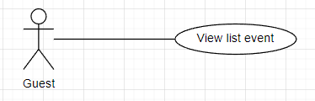

|  |  |  |  |  |  |
| --- | --- | --- | --- | --- | --- |
| **ID and Name** | **UC-09: View List Event On Kiosk** | | | | |
| Created By: | TungVS | | Date Created: | | 08/08/2022 |
| Primary Actor: | Guest | | Secondary Actor: | | N/A |
| Trigger: | Actor wants to view list event. | | | | |
| Description: | This feature allows actor to view list event. | | | | |
| Preconditions: | Kiosk has been log in by location owner. | | | | |
| Post-conditions: | **Success:** System show list event  **Failed:** System informs error message | | | | |
| Normal Flow: | **Step** | **Actor Action** | | **System Response** | |
|  | Actor clicks on “Event” on menu bar | | System redirects event page and show list event | |
| Alternative Flows: | N/A | | | | |
| Exceptions: | N/A | | | | |
| Priority: | High | | | | |
| Frequency of Use: | Usually | | | | |
| Business Rule: | BR-09: Get list event with current temple of schedule. If no schedule, get list event near by. | | | | |
| Other Information: | N/A | | | | |
| Assumptions: | Internet connection is available. | | | | |

##### View List POI On Kiosk

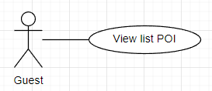

|  |  |  |  |  |  |
| --- | --- | --- | --- | --- | --- |
| **ID and Name** | **UC-10: View list POI in kiosk** | | | | |
| Created By: | TungVS | | Date Created: | | 08/08/2022 |
| Primary Actor: | Guest | | Secondary Actor: | | N/A |
| Trigger: | Actor wants to view list POI in kiosk. | | | | |
| Description: | This feature allows actor to view list POI in kiosk . | | | | |
| Preconditions: | Kiosk has been log in by location owner. | | | | |
| Post-conditions: | **Success:** System show list POI  **Failed:** System informs error message | | | | |
| Normal Flow: | **Step** | **Actor Action** | | **System Response** | |
| 1 | Actor clicks on “POI” on menu bar | | System redirects poi page and show list poi  [Exception 1] | |
| Alternative Flows: | N/A | | | | |
| Exceptions: | **No** | **Cause** | | **System Response** | |
| 1 | No POIs exist | | System show “No Data” | |
| Priority: | High | | | | |
| Frequency of Use: | Usually | | | | |
| Business Rule: | BR-10: Get list POI with current temple of schedule. If no schedule, get list POI near by. | | | | |
| Other Information: | N/A | | | | |
| Assumptions: | Internet connection is available. | | | | |

##### View Detail Of Event On Kiosk

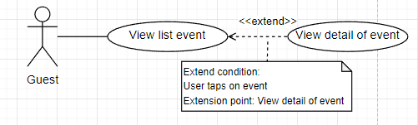

|  |  |  |  |  |  |
| --- | --- | --- | --- | --- | --- |
| **ID and Name** | **UC-11: View detail of event in kiosk** | | | | |
| Created By: | TungVS | | Date Created: | | 08/08/2022 |
| Primary Actor: | Guest | | Secondary Actor: | | N/A |
| Trigger: | Actor wants to view detail of event. | | | | |
| Description: | This feature allows actor to view detail of event. | | | | |
| Preconditions: | Kiosk has been log in by location owner. | | | | |
| Post-conditions: | **Success:** System redirects Event Detail page  **Failed:** System informs error message | | | | |
| Normal Flow: | **Step** | **Actor Action** | | **System Response** | |
| 1 | Actor clicks on “Event” on menu bar  [Alternative 1] | | System shows list event | |
| 2 | Actor clicks on event in list event | | System redirects Event Detail page | |
| Alternative Flows: | **Step** | **Actor Action** | | **System Response** | |
|  | 1 | Actor clicks on event banner at home page | | System redirects Event Detail page | |
| Exceptions: | N/A | | | | |
| Priority: | High | | | | |
| Frequency of Use: | Usually | | | | |
| Business Rule: | N/A | | | | |
| Other Information: | N/A | | | | |
| Assumptions: | Internet connection is available. | | | | |

##### View Detail Of POI On Kiosk

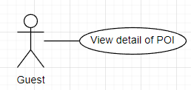

|  |  |  |  |  |  |
| --- | --- | --- | --- | --- | --- |
| **ID and Name** | **UC-12: View Detail Of POI On Kiosk** | | | | |
| Created By: | TungVS | | Date Created: | | 08/08/2022 |
| Primary Actor: | Admin | | Secondary Actor: | | Location owner |
| Trigger: | Actor wants to view detail of POI. | | | | |
| Description: | This feature allows actor to view detail of POI . | | | | |
| Preconditions: | Kiosk has been log in by location owner. | | | | |
| Post-conditions: | **Success:** System redirects POI detail page  **Failed:** System informs error message | | | | |
| Normal Flow: | **Step** | **Actor Action** | | **System Response** | |
| 1 | Actor clicks on “POI Category” on side bar. | | System shows list POI category. | |
| 2 | Actor clicks on “Detail” on list POI. | | System redirects POI detail page. | |
| Alternative Flows: | N/A | | | | |
| Exceptions: | N/A | | | | |
| Priority: | High | | | | |
| Frequency of Use: | Usually | | | | |
| Business Rule: | N/A | | | | |
| Other Information: | N/A | | | | |
| Assumptions: | Internet connection is available. | | | | |

##### View Map On Kiosk

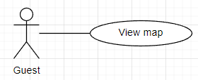

|  |  |  |  |  |  |
| --- | --- | --- | --- | --- | --- |
| **ID and Name** | **UC-13: View map on kiosk** | | | | |
| Created By: | TungVS | | Date Created: | | 08/08/2022 |
| Primary Actor: | Guest | | Secondary Actor: | | N/A |
| Trigger: | Actor wants to view map on kiosk. | | | | |
| Description: | This feature allows actor to view map on kiosk . | | | | |
| Preconditions: | Kiosk has been log in by location owner. | | | | |
| Post-conditions: | **Success:** System show map  **Failed:** System informs error message | | | | |
| Normal Flow: | **Step** | **Actor Action** | | **System Response** | |
| 1 | Actor clicks on “Map” on menu bar | | System redirects map page and show map with current location, events and pois near by. | |
| Alternative Flows: | N/A | | | | |
| Exceptions: | N/A | | | | |
| Priority: | High | | | | |
| Frequency of Use: | Usually | | | | |
| Business Rule: | N/A | | | | |
| Other Information: | N/A | | | | |
| Assumptions: | Internet connection is available. | | | | |

##### View POI On Map Filter By Category

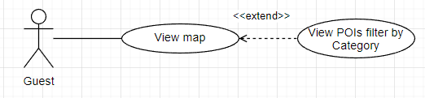

|  |  |  |  |  |  |
| --- | --- | --- | --- | --- | --- |
| **ID and Name** | **UC-14: View POI On Map Filter By Category** | | | | |
| Created By: | TungVS | | Date Created: | 08/08/2022 | |
| Primary Actor: | Guest | | Secondary Actor: | N/A | |
| Trigger: | Actor wants to view list POI filter by category on map. | | | | |
| Description: | This feature allows actor to view list POI filter by category on map . | | | | |
| Preconditions: | Kiosk has been log in by location owner. | | | | |
| Post-conditions: | **Success:** System show list poi filter by category  **Failed:** System informs error message | | | | |
| Normal Flow: | **Step** | **Actor Action** | | | **System Response** |
| 1 | Actor clicks on “Map” on menu bar | | | System redirects map page and show map with current location, events and POI near by. |
|  | 2 | Actor clicks on category at the top of the screen | | | System show list POI of category near by with category selected |
| Alternative Flows: | N/A | | | | |
| Exceptions: | N/A | | | | |
| Priority: | High | | | | |
| Frequency of Use: | Usually | | | | |
| Business Rule: | N/A | | | | |
| Other Information: | N/A | | | | |
| Assumptions: | Internet connection is available. | | | | |

##### View Kiosk Placement Detail

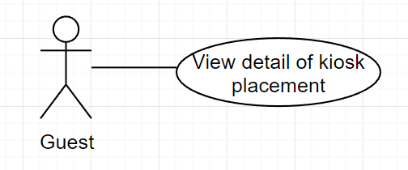

|  |  |  |  |  |  |
| --- | --- | --- | --- | --- | --- |
| **ID and Name** | **UC-15: View Kiosk Placement detail** | | | | |
| Created By: | TungVS | | Date Created: | | 08/08/2022 |
| Primary Actor: | Guest | | Secondary Actor: | | N/A |
| Trigger: | Actor wants to view Kiosk Placement detail. | | | | |
| Description: | This feature allows actor to view Kiosk Placement detail. | | | | |
| Preconditions: | Kiosk has been log in by location owner. | | | | |
| Post-conditions: | **Success:** System show Kiosk Placement detail.  **Failed:** System informs error message | | | | |
| Normal Flow: | **Step** | **Actor Action** | | **System Response** | |
| 1 | Actor clicks on “Info” on menu bar | | System redirects Kiosk Placement detail | |
| Alternative Flows: | N/A | | | | |
| Exceptions: | N/A | | | | |
| Priority: | High | | | | |
| Frequency of Use: | Usually | | | | |
| Business Rule: | N/A | | | | |
| Other Information: | N/A | | | | |
| Assumptions: | Internet connection is available. | | | | |

##### Feedback Experience On Kiosk

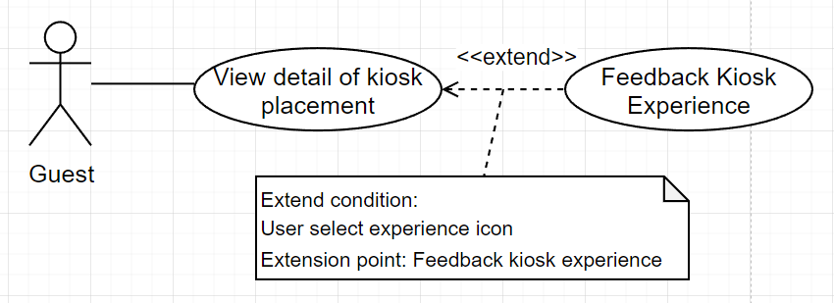

|  |  |  |  |  |  |
| --- | --- | --- | --- | --- | --- |
| **ID and Name** | **UC-16: Feedback experience on kiosk** | | | | |
| Created By: | TungVS | | Date Created: | 08/08/2022 | |
| Primary Actor: | Guest | | Secondary Actor: | N/A | |
| Trigger: | Actor wants to feedback experience on kiosk. | | | | |
| Description: | This feature allows actor to feedback experience on kiosk. | | | | |
| Preconditions: | Kiosk has been log in by location owner. | | | | |
| Post-conditions: | **Success:** System save feedback  **Failed:** System informs error message | | | | |
| Normal Flow: | **Step** | **Actor Action** | | | **System Response** |
| 1 | Actor clicks on “Info” on menu bar. | | | System shows detail of Kiosk Placement. |
| 2 | Actor select experience on Rating box. | | | System show confirm popup "Are you sure to rating this kiosk?" |
| 3 | Actor clicks on "Yes" button.  [Alternative 1] | | | System insert feedback, close popup and show toast "Thank you for rating" |
| Alternative Flows: | **Step** | **Actor Action** | | | **System Response** |
| 1 | Actor clicks on "No" button. | | | System closes confirm popup. |
| Exceptions: | N/A | | | | |
| Priority: | High | | | | |
| Frequency of Use: | Usually | | | | |
| Business Rule: | N/A | | | | |
| Other Information: | N/A | | | | |
| Assumptions: | Internet connection is available. | | | | |

Service Provider

##### Create Provided Application

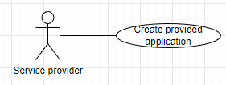

|  |  |  |  |  |  |
| --- | --- | --- | --- | --- | --- |
| **ID and Name** | **UC-17: Create Provided Application** | | | | |
| Created By: | AnhTTD | | Date Created: | | 16/08/2022 |
| Primary Actor: | Service Provider | | Secondary Actor: | | N/A |
| Trigger: | Actor wants to create provided application. | | | | |
| Description: | This feature allows users to create provided application. | | | | |
| Preconditions: | Actor has logged into IKFTS Kiosk portal website as a Service Provider. | | | | |
| Post-conditions: | **Success:** New Provided Application is created.  **Failed:** System inform an error message. | | | | |
| Normal Flow: | **Step** | **Actor Action** | | **System Response** | |
|  | Actor clicks “Application” tab | | System redirects to Application screen. | |
|  | Actor clicks “+ Application” button. | | System shows pop up a create application form. | |
|  | Actor fills information. | | [Exception 1]  [Exception 2]  [Exception 3]  [Exception 4] | |
|  | Actor clicks “Create Application” button. | | System inform “Create application success”, redirect to Application screen.  [Exception 5] | |
| Alternative Flows: | N/A | | | | |
| Exceptions: | **No** | **Cause** | | **System Response** | |
|  | Name Field is empty. | | System inform “Please input name !!!” | |
|  | Link Field is empty. | | System inform “Please input link !!!” | |
|  | Logo image is empty. | | System inform “Please input logo !!!” | |
|  | Category is not selected. | | System inform “Please select category !!!” | |
|  | Actor inputs an application name which is exist in system | | System inform “Service application is exist” | |
| Priority: | High | | | | |
| Frequency of Use: | Always | | | | |
| Business Rule: | BR-11: The application name is unique in system. | | | | |
| Other Information: | N/A | | | | |
| Assumptions: | Internet connection is available. | | | | |

##### Update Provided Application

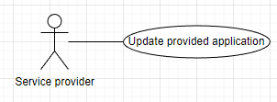

|  |  |  |  |  |  |
| --- | --- | --- | --- | --- | --- |
| **ID and Name** | **UC-18: Update Provided Application** | | | | |
| Created By: | AnhTTD | | Date Created: | | 16/08/2022 |
| Primary Actor: | Service Provider | | Secondary Actor: | | N/A |
| Trigger: | Actor wants update their provided application. | | | | |
| Description: | This feature allows users update their provided application. | | | | |
| Preconditions: | Actor has logged into IKFTS Kiosk portal website as a Service Provider.  Actor must have at least 1 provided application to update. | | | | |
| Post-conditions: | **Success:** Provided Application is updated.  **Failed:** System inform an error message. | | | | |
| Normal Flow: | **Step** | **Actor Action** | | **System Response** | |
|  | Actor clicks “Application” tab | | System redirects to Application screen. | |
|  | Actor clicks “Update” button of specific application. | | System shows pop up a update application form. | |
|  |  | Actor changes information they want to update. | | [Exception 1]  [Exception 2]  [Exception 3]  [Exception 4] | |
|  |  | Actor clicks “Create Application” button. | | System informs “Update application success”, redirects to Application screen.  [Exception 5] | |
| Alternative Flows: | N/A | | | | |
| Exceptions: | N/A | | | | |
| Exceptions: | **No** | **Cause** | | **System Response** | |
|  | Name Field is empty. | | System inform “Please input name !!!” | |
|  |  | Link Field is empty. | | System inform “Please input link !!!” | |
|  |  | Logo image is empty. | | System inform “Please input logo !!!” | |
|  |  | Category is not selected. | | System inform “Please select category !!!” | |
|  |  | Actor inputs an application name which is exist in system | | System inform “Service application is exist” | |
| Priority: | High | | | | |
| Frequency of Use: | Always | | | | |
| Business Rule: | BR-11: The application name is unique in system. | | | | |
| Other Information: | N/A | | | | |
| Assumptions: | Internet connection is available. | | | | |

##### Search Provided Application

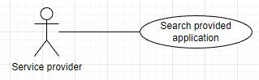

|  |  |  |  |  |  |
| --- | --- | --- | --- | --- | --- |
| **ID and Name** | **UC-19: Search Provided Application** | | | | |
| Created By: | AnhTTD | | Date Created: | | 16/08/2022 |
| Primary Actor: | Service Provider | | Secondary Actor: | | N/A |
| Trigger: | Actor wants to search their provided application with name and status. | | | | |
| Description: | This feature allows users to search their provided application with name and status. | | | | |
| Preconditions: | Actor has logged into IKFTS Kiosk portal website as a Service Provider. | | | | |
| Post-conditions: | **Success:** System returns list of their provided application.  **Failed:** System inform an error message. | | | | |
| Normal Flow: | **Step** | **Actor Action** | | **System Response** | |
|  | Actor clicks “Application” tab | | System redirects to Application screen. | |
|  | Actor inputs Name on Search field and choose status. | |  | |
|  | Actor clicks “Search” icon. | | System returns list of their service application.  [Exception 1] | |
| Alternative Flows: | N/A | | | | |
| Exceptions: | **No** | **Cause** | | **System Response** | |
|  | No data found. | | System shows toast “Cannot found” | |
| Priority: | High | | | | |
| Frequency of Use: | Usually | | | | |
| Business Rule: | BR-12: Service Provider can only view provided application which belong to them. | | | | |
| Other Information: | N/A | | | | |
| Assumptions: | Internet connection is available. | | | | |

##### View Detail Of Provided Application

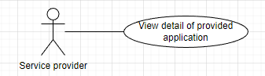

|  |  |  |  |  |  |
| --- | --- | --- | --- | --- | --- |
| **ID and Name** | **UC-20: View Detail Of Provided Application** | | | | |
| Created By: | AnhTTD | | Date Created: | | 16/08/2022 |
| Primary Actor: | Service Provider | | Secondary Actor: | | N/A |
| Trigger: | Actor wants to view detail of their provided application. | | | | |
| Description: | This feature allows users to view detail of their provided application. | | | | |
| Preconditions: | Actor has logged into IKFTS Kiosk portal website as a Service Provider.  Actor must have at least 1 provided application to view detail. | | | | |
| Post-conditions: | **Success:** System redirects to Application Detail screen.  **Failed:** System inform an error message. | | | | |
| Normal Flow: | **Step** | **Actor Action** | | **System Response** | |
|  | Actor clicks “Application” tab | | System redirects to Application screen. | |
|  | Actor clicks “Detail” button of specific application. | | System redirects to Application Detail screen. | |
| Alternative Flows: | N/A | | | | |
| Exceptions: | N/A | | | | |
| Priority: | High | | | | |
| Frequency of Use: | Usually | | | | |
| Business Rule: | N/A | | | | |
| Other Information: | N/A | | | | |
| Assumptions: | Internet connection is available. | | | | |

##### View List Feedback Of Provided Application

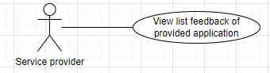

|  |  |  |  |  |  |
| --- | --- | --- | --- | --- | --- |
| **ID and Name** | **UC-21: View List Feedback Of Provided Application** | | | | |
| Created By: | AnhTTD | | Date Created: | | 16/08/2022 |
| Primary Actor: | Service Provider | | Secondary Actor: | | N/A |
| Trigger: | Actor wants to view list feedback of their provided application. | | | | |
| Description: | This feature allows users to view list feedback of their provided application. | | | | |
| Preconditions: | Actor has logged into IKFTS Kiosk portal website as a Service Provider.  Actor must have at least 1 provided application to view list feedback of provided application. | | | | |
| Post-conditions: | **Success:** System redirects to Application Detail screen with Feedback tap.  **Failed:** System inform an error message. | | | | |
| Normal Flow: | **Step** | **Actor Action** | | **System Response** | |
| 1 | Actor clicks “Application” tab | | System redirects to Application screen. | |
| 2 | Actor clicks “Detail” button on the chosen application. | | System redirects to Application Detail screen. | |
|  | 3 | Actor clicks “Feedback” tap. | | System redirects to Application Detail screen with Feedback tap. | |
| Alternative Flows: | N/A | | | | |
| Exceptions: | N/A | | | | |
| Priority: | High | | | | |
| Frequency of Use: | Usually | | | | |
| Business Rule: | BR-13: If no one feedback an application. Rating point will be set to 0.  BR-14: Valid rating point of feedback in system is between 1 to 5. | | | | |
| Other Information: | N/A | | | | |
| Assumptions: | Internet connection is available. | | | | |

##### Create Request To Publish Provided Application

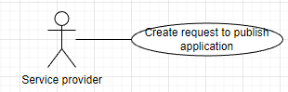

|  |  |  |  |  |  |
| --- | --- | --- | --- | --- | --- |
| **ID and Name** | **UC-22: Create Request To Publish Provided Application** | | | | |
| Created By: | AnhTTD | | Date Created: | | 16/08/2022 |
| Primary Actor: | Service Provider | | Secondary Actor: | | N/A |
| Trigger: | Actor wants to create request to publish their application. | | | | |
| Description: | This feature allows users to create request to publish their application. | | | | |
| Preconditions: | Actor has logged into IKFTS Kiosk portal website as a Service Provider.  Actor must have at least 1 provided application which status is “Unavailable” to create request to publish. | | | | |
| Post-conditions: | **Success:** New request to publish a service application is created.  **Failed:** System inform an error message. | | | | |
| Normal Flow: | **Step** | **Actor Action** | | **System Response** | |
|  | Actor clicks “Application” tab | | System redirects to Application screen. | |
|  | Actor clicks “Publish” button of specific application. | | System shows pop up to confirm to create publish request. | |
|  |  | Actor clicks “Yes” button.  [Alternative 1] | | System shows toast “Send request publish success” and redirect to Application screen. | |
| Alternative Flows: | **Step** | **Actor Action** | | **System Response** | |
| 1 | Actor clicks “No” button. | | System closes popup. | |
| Exceptions: | N/A | | | | |
| Priority: | Medium | | | | |
| Frequency of Use: | Sometimes | | | | |
| Business Rule: | BR-15: Actor can only create request to publish when provided application has status “Unavailable”. | | | | |
| Other Information: | N/A | | | | |
| Assumptions: | Internet connection is available. | | | | |

##### Cancel Request To Publish Provided Application

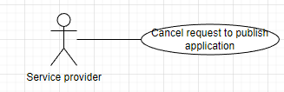

|  |  |  |  |  |  |
| --- | --- | --- | --- | --- | --- |
| **ID and Name** | **UC-23: Cancel Request To Publish Provided Application** | | | | |
| Created By: | AnhTTD | | Date Created: | | 16/08/2022 |
| Primary Actor: | Service Provider | | Secondary Actor: | | N/A |
| Trigger: | Actor wants to cancel request to publish their service application. | | | | |
| Description: | This feature allows users to cancel request to publish their service application. | | | | |
| Preconditions: | Actor has logged into IKFTS Kiosk portal website as a Service Provider. | | | | |
| Post-conditions: | **Success:** Their request is canceled,  **Failed:** System inform an error message. | | | | |
| Normal Flow: | **Step** | **Actor Action** | | **System Response** | |
|  | Actor clicks “App Publish” tab | | System redirects to App Publish screen. | |
|  | Actor clicks “Cancel” button of specific request. | | System shows popup to confirm cancel request to publish. | |
|  |  | Actor clicks “Yes” button.  [Alternative 1] | | System shows toast “Cancel Request Success” and redirect to App Publish screen. | |
| Alternative Flows: | **Step** | **Actor Action** | | **System Response** | |
|  | 1 | Actor clicks “No” button. | | System closes popup. | |
| Exceptions: | N/A | | | | |
| Priority: | Medium | | | | |
| Frequency of Use: | Sometimes | | | | |
| Business Rule: | BR-16: Actor can only cancel request to publish when the request status is “Pending”. | | | | |
| Other Information: | N/A | | | | |
| Assumptions: | Internet connection is available. | | | | |

##### Search Request To Publish Provided Application

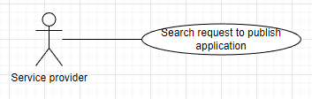

|  |  |  |  |  |  |
| --- | --- | --- | --- | --- | --- |
| **ID and Name** | **UC-24: Search Request To Publish Provided Application** | | | | |
| Created By: | AnhTTD | | Date Created: | | 17/08/2022 |
| Primary Actor: | Service Provider | | Secondary Actor: | | N/A |
| Trigger: | Actor wants to search request to publish provided application. | | | | |
| Description: | This feature allows users to search request to publish provided application. | | | | |
| Preconditions: | Actor has logged into IKFTS Kiosk portal website as a Service Provide. | | | | |
| Post-conditions: | **Success:** System returns list of their request to publish service application.  **Failed:** System inform an error message. | | | | |
| Normal Flow: | **Step** | **Actor Action** | | **System Response** | |
|  | Actor clicks “App Publish” tab. | | System redirects to App Publish screen. | |
|  | Actor inputs Name on Search field and choose status. | |  | |
|  | Actor clicks “Search” icon. | | System returns list of their request to publish service application. | |
| Alternative Flows: | N/A | | | | |
| Exceptions: | N/A | | | | |
| Priority: | High | | | | |
| Frequency of Use: | Usually | | | | |
| Business Rule: | BR-17: Show all request to publish with any status from Service Provider.  BR-18: Only show request to publish application service that belong to their Service Provider. | | | | |
| Other Information: | N/A | | | | |
| Assumptions: | Internet connection is available. | | | | |

Location Owner

##### View Local Dashboard

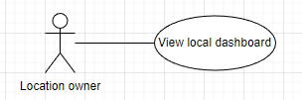

|  |  |  |  |  |  |
| --- | --- | --- | --- | --- | --- |
| **ID and Name** | **UC-25: View Local Dashboard** | | | | |
| Created By: | AnhTTD | | Date Created: | | 18/08/2022 |
| Primary Actor: | Location Owner | | Secondary Actor: | | N/A |
| Trigger: | Actor wants to view local dashboard. | | | | |
| Description: | This feature allows users to view local dashboard. | | | | |
| Preconditions: | Actor has logged into IKFTS Kiosk portal website as a Location Owner. | | | | |
| Post-conditions: | **Success:** System shows statistical chart at Home screen.  **Failed:** System inform an error message. | | | | |
| Normal Flow: | **Step** | **Actor Action** | | **System Response** | |
|  | Actor clicks on “Home” tab. | | System redirects to My Application screen and shows statistical chart. | |
| Alternative Flows: | N/A | | | | |
| Exceptions: | N/A | | | | |
| Priority: | High | | | | |
| Frequency of Use: | Usually | | | | |
| Business Rule: | BR-19: Location Owner can only view their statistical chart. | | | | |
| Other Information: | N/A | | | | |
| Assumptions: | Internet connection is available. | | | | |

##### Create Template

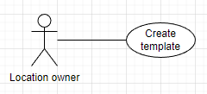

|  |  |  |  |  |  |
| --- | --- | --- | --- | --- | --- |
| **ID and Name** | **UC-26: Create Template** | | | | |
| Created By: | AnhTTD | | Date Created: | | 18/08/2022 |
| Primary Actor: | Location Owner | | Secondary Actor: | | N/A |
| Trigger: | Actor wants to create new template. | | | | |
| Description: | This feature allows users to create new template. | | | | |
| Preconditions: | Actor logged into IKFTS portal website as a Location Owner. | | | | |
| Post-conditions: | **Success:** New Template is created.  **Failed:** System inform error message. | | | | |
| Normal Flow: | **Step** | **Actor Action** | | **System Response** | |
|  | Actor clicks “Template” tap. | | System redirects to Template screen. | |
|  | Actor clicks “+ Template” button. | | System shows popup of create template form. | |
|  | Actor fills in information | | [Exception 1] | |
|  | Actor clicks “CONTINUE” button. | | System redirects to Template Creating screen. | |
| Alternative Flows: | N/A | | | | |
| Exceptions: | **No** | **Cause** | | **System Response** | |
|  | Name is empty. | | System inform “Please input name !” | |
| Priority: | Medium | | | | |
| Frequency of Use: | Sometimes | | | | |
| Business Rule: | N/A | | | | |
| Other Information: | N/A | | | | |
| Assumptions: | Internet connection is available. | | | | |

##### Arrange Components In A Template

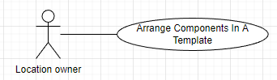

|  |  |  |  |  |  |
| --- | --- | --- | --- | --- | --- |
| **ID and Name** | **UC-27: Arrange Components In A Template** | | | | |
| Created By: | AnhTTD | | Date Created: | | 17/08/2022 |
| Primary Actor: | Location Owner | | Secondary Actor: | | N/A |
| Trigger: | Actor wants to arrange components in a template. | | | | |
| Description: | This feature allows users to arrange components in a template. | | | | |
| Preconditions: | Actor logged in to IKFTS portal website as a Location Owner.  Actor has at least 1 template. | | | | |
| Post-conditions: | **Success:** Components are set in a template.  **Failed:** System inform error message. | | | | |
| Normal Flow: | **Step** | **Actor Action** | | **System Response** | |
| 1 | Actor clicks “Template” tab. | | System informs Template screen and return list template. | |
| 2 | Actor clicks “Edit” button on the chosen template. | | System inform Customize Layout screen. | |
| 3 | Actor chooses “Category” field. | | System inform Customize Layout screen with Category field.  [Alternative 1] | |
| 4 | Actor drags component that they want to add to template from “Available” field and drop it into “Displaying” field or change position of components in “Displaying” field. | |  | |
| 5 | Actor clicks “Save” button. | | System will save positions of components and inform “Save category components successfully”  [Exception 1] | |
| Alternative Flows: | **Step** | **Actor Action** | | **System Response** | |
| 1 | Actor chooses “Event” field. | | System inform Customize Layout screen with Event field. | |
| 2 | Actor drags component that they want to add to template from “Available” field and drop it into “Row 1” or “Row 2” field or change position of components in “Row 1” and “Row 2” field. | |  | |
| 3 | Actor clicks “Save” button. | | System will save positions of components and inform “Save event components successfully”  [Exception 2] | |
| Exceptions: | **No** | **Cause** | | **System Response** | |
| 1 | Displaying field is empty. | | System inform “No component is added!” | |
| 2 | Row 1 and Row 2 are empty. | | System inform “No component is added!” | |
| Priority: | High | | | | |
| Frequency of Use: | Usually | | | | |
| Business Rule: | BR-20: Only Category that actor has application on it will be shown.  BR-21: Template’s status will be changed to “Available” when actor set at least 1 Category or 1 event in template.  BR-22: Template must have at least 1 event in row 1 to add more event in row 2. | | | | |
| Other Information: | N/A | | | | |
| Assumptions: | Internet connection is available. | | | | |

##### Update Template Information

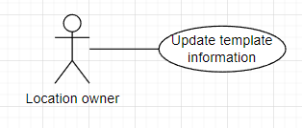

|  |  |  |  |  |  |
| --- | --- | --- | --- | --- | --- |
| **ID and Name** | **UC-28: Update Template Information** | | | | |
| Created By: | AnhTTD | | Date Created: | | 17/08/2022 |
| Primary Actor: | Location Owner | | Secondary Actor: | | N/A |
| Trigger: | Actor wants to update template information. | | | | |
| Description: | This feature allows users to update template information. | | | | |
| Preconditions: | Actor logged in to IKFTS portal website as a Location Owner.  Actor has a template. | | | | |
| Post-conditions: | **Success:** Template has changed information.  **Failed:** System inform error message. | | | | |
| Normal Flow: | **Step** | **Actor Action** | | **System Response** | |
| 1 | Actor chooses “Template” tab. | | System inform Template screen. | |
| 2 | Actor clicks “Edit” button on the chosen template. | | System shows popup Edit form. | |
| 3 | Actor change information they want to update. | | [Exception 1] | |
| 4 | Actor clicks “Save” button. | | System inform “Update success”, redirect to Template screen. | |
| Alternative Flows: | N/A | | | | |
| Exceptions: | **No** | **Cause** | | **System Response** | |
| 1 | Name is empty | | System inform “Please input name !” | |
| Priority: | Medium | | | | |
| Frequency of Use: | Sometimes | | | | |
| Business Rule: | BR-23: Location Owner can only update information template which belong to them. | | | | |
| Other Information: | N/A | | | | |
| Assumptions: | Internet connection is available. | | | | |

##### Delete Template

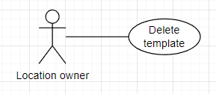

|  |  |  |  |  |  |
| --- | --- | --- | --- | --- | --- |
| **ID and Name** | **UC-29: Delete Template** | | | | |
| Created By: | AnhTTD | | Date Created: | | 17/08/2022 |
| Primary Actor: | Location Owner | | Secondary Actor: | | N/A |
| Trigger: | Actor wants to delete template. | | | | |
| Description: | This feature allows users to delete template. | | | | |
| Preconditions: | Actor logged in to IKFTS portal website as a Location Owner.  Actor has a template. | | | | |
| Post-conditions: | **Success:** Template has deleted.  **Failed:** System inform error message. | | | | |
| Normal Flow: | **Step** | **Actor Action** | | **System Response** | |
| 1 | Actor chooses “Template” tab. | | System inform Template screen. | |
| 2 | Actor clicks “Delete” button on the chosen template. | | System shows popup Confirm delete the template.  No: System redirects to Template screen. | |
| 3 | Actor clicks “Yes” button. | | Template is deleted. System inform “Delete success” ,redirect to Template screeen. | |
| Alternative Flows: | N/A | | | | |
| Exceptions: | N/A | | | | |
| Priority: | Medium | | | | |
| Frequency of Use: | Sometimes | | | | |
| Business Rule: | BR-24: Location Owner can only delete template which belong to them.  BR-25: If Location Owner delete template which is set in scenario. The scenario will change template to default. | | | | |
| Other Information: | N/A | | | | |
| Assumptions: | Internet connection is available. | | | | |

##### Search Template

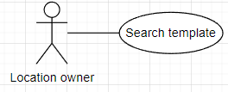

|  |  |  |  |  |  |
| --- | --- | --- | --- | --- | --- |
| **ID and Name** | **UC-30: Search Template** | | | | |
| Created By: | AnhTTD | | Date Created: | | 17/08/2022 |
| Primary Actor: | Location Owner | | Secondary Actor: | | N/A |
| Trigger: | Actor wants to search template. | | | | |
| Description: | This feature allows users to search template. | | | | |
| Preconditions: | Actor logged in to IKFTS portal website as a Location Owner. | | | | |
| Post-conditions: | **Success:** System return list of template.  **Failed:** System inform error message. | | | | |
| Normal Flow: | **Step** | **Actor Action** | | **System Response** | |
| 1 | Actor chooses “Template” tab. | | System inform Template screen. | |
| 2 | Actor inputs Name on Search field and choose status. | |  | |
| 3 | Actor clicks “Search” icon. | | System returns list of template. | |
| Alternative Flows: | N/A | | | | |
| Exceptions: | N/A | | | | |
| Priority: | High | | | | |
| Frequency of Use: | Usually | | | | |
| Business Rule: | * BR-26: Location Owner can only view template which belong to them. | | | | |
| Other Information: | N/A | | | | |
| Assumptions: | Internet connection is available. | | | | |

##### Install Embedded Application

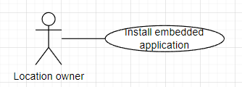

|  |  |  |  |  |  |
| --- | --- | --- | --- | --- | --- |
| **ID and Name** | **UC-31: Install Embedded Application** | | | | |
| Created By: | AnhTTD | | Date Created: | | 17/08/2022 |
| Primary Actor: | Location Owner | | Secondary Actor: | | N/A |
| Trigger: | Actor wants to install embedded application from application market. | | | | |
| Description: | This feature allows users to install embedded application from application market. | | | | |
| Preconditions: | Actor logged in to IKFTS portal website as a Location Owner.  Application market has application on it. | | | | |
| Post-conditions: | **Success:** Embedded Application has been installed.  **Failed:** System inform error message. | | | | |
| Normal Flow: | **Step** | **Actor Action** | | **System Response** | |
| 1 | Actor chooses “Application Market” tab. | | System inform Application Market screen. | |
| 2 | Actor clicks “Install” button on the chosen application. | | System shows popup Confirm install application  No: system redirects Application Market screen. | |
| 3 | Actor clicks “Yes” button. | | System inform “Install successful”, redirects Application Market screen. | |
| Alternative Flows: | N/A | | | | |
| Exceptions: | N/A | | | | |
| Priority: | High | | | | |
| Frequency of Use: | Usually | | | | |
| Business Rule: | BR-27: Location Owner can only install application when that application is not installed or it was uninstalled.  BR-28: Location Owner can only install application which status is “Available”. | | | | |
| Other Information: | N/A | | | | |
| Assumptions: | Internet connection is available. | | | | |

##### Uninstall Embedded Application

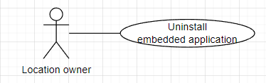

|  |  |  |  |  |  |
| --- | --- | --- | --- | --- | --- |
| **ID and Name** | **UC-32: Uninstall Embedded Application** | | | | |
| Created By: | AnhTTD | | Date Created: | | 17/08/2022 |
| Primary Actor: | Location Owner | | Secondary Actor: | | N/A |
| Trigger: | Actor wants to uninstall embedded application from my application. | | | | |
| Description: | This feature allows users to uninstall embedded application from my application. | | | | |
| Preconditions: | Actor logged in to IKFTS portal website as a Location Owner.  Actor has installed application. | | | | |
| Post-conditions: | **Success:** EmbeddedApplication has been uninstalled.  **Failed:** System inform error message. | | | | |
| Normal Flow: | **Step** | **Actor Action** | | **System Response** | |
| 1 | Actor chooses “My Application” tab. | | System inform My Application screen. | |
| 2 | Actor clicks “Uninstall” button on the chosen application. | | System shows popup Confirm uninstall application  No: System redirects My Application screen. | |
| 3 | Actor clicks “Yes” button. | | System inform “Uninstall successful”, redirects My Application screen. | |
| Alternative Flows: | N/A | | | | |
| Exceptions: | N/A | | | | |
| Priority: | High | | | | |
| Frequency of Use: | Usually | | | | |
| Business Rule: | BR-29: Location Owner can only uninstall application that installed. | | | | |
| Other Information: | N/A | | | | |
| Assumptions: | Internet connection is available. | | | | |

##### View Detail Of Installed Embedded Application

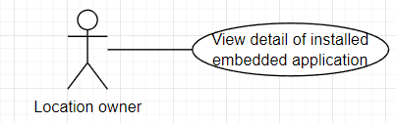

|  |  |  |  |  |  |
| --- | --- | --- | --- | --- | --- |
| **ID and Name** | **UC-33: View Detail Of Installed Embedded Application** | | | | |
| Created By: | AnhTTD | | Date Created: | | 17/08/2022 |
| Primary Actor: | Location Owner | | Secondary Actor: | | N/A |
| Trigger: | Actor wants to view detail of installed embedded application. | | | | |
| Description: | This feature allows users to view detail of installed embedded application. | | | | |
| Preconditions: | Actor logged in to IKFTS portal website as a Location Owner. | | | | |
| Post-conditions: | **Success:** System redirects to Application Detail screen.  **Failed:** System inform error message. | | | | |
| Normal Flow: | **Step** | **Actor Action** | | **System Response** | |
| 1 | Actor chooses “My Application” tab. | | System inform My Application screen. | |
| 2 | Actor clicks “Detail” button. | | System redirects to Application Detail screen. | |
| Alternative Flows: | N/A | | | | |
| Exceptions: | N/A | | | | |
| Priority: | High | | | | |
| Frequency of Use: | Usually | | | | |
| Business Rule: | N/A | | | | |
| Other Information: | N/A | | | | |
| Assumptions: | Internet connection is available. | | | | |

##### View Statistic Commission Of Embedded Application

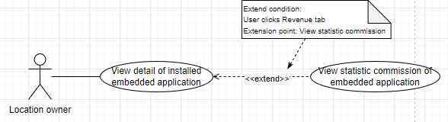

|  |  |  |  |  |  |
| --- | --- | --- | --- | --- | --- |
| **ID and Name** | **UC-34: View Statistic Commission Of Embedded Application** | | | | |
| Created By: | AnhTTD | | Date Created: | | 17/08/2022 |
| Primary Actor: | Location Owner | | Secondary Actor: | | N/A |
| Trigger: | Actor wants to View statistic commission of embedded application. | | | | |
| Description: | This feature allows users to View statistic commission of embedded application. | | | | |
| Preconditions: | Actor logged in to IKFTS portal website as a Location Owner.  Actor must have at least 1 embedded application to view statistic commission. | | | | |
| Post-conditions: | **Success:** System redirects to Application Detail screen with Revenue tab and shows statistical chart.  **Failed:** System inform error message. | | | | |
| Normal Flow: | **Step** | **Actor Action** | | **System Response** | |
| 1 | Actor chooses “My Application” tab. | | System inform My Application screen. | |
| 2 | Actor clicks “Detail” button. | | System redirects to Application Detail screen. | |
|  | 3 | Actor clicks “Revenue” tab. | | System redirects to Application Detail screen with Revenue tab and shows statistical chart. | |
| Alternative Flows: | N/A | | | | |
| Exceptions: | N/A | | | | |
| Priority: | High | | | | |
| Frequency of Use: | Usually | | | | |
| Business Rule: | BR-30: Location Owner can only view their statistic commission of their embedded application. | | | | |
| Other Information: | N/A | | | | |
| Assumptions: | Internet connection is available. | | | | |

##### Feedback Embedded Application

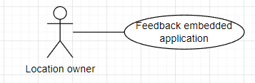

|  |  |  |  |  |  |
| --- | --- | --- | --- | --- | --- |
| **ID and Name** | **UC-35: Feedback Embedded Application** | | | | |
| Created By: | AnhTTD | | Date Created: | | 17/08/2022 |
| Primary Actor: | Location Owner | | Secondary Actor: | | N/A |
| Trigger: | Actor wants to feedback embedded application. | | | | |
| Description: | This feature allows users to feedback embedded application. | | | | |
| Preconditions: | Actor logged in to IKFTS portal website as a Location Owner.  Actor are required to install or have installed before to be able to give feedback to application. | | | | |
| Post-conditions: | **Success:** System feedback application successfully.  **Failed:** System inform error message. | | | | |
| Normal Flow: | **Step** | **Actor Action** | | **System Response** | |
| 1 | Actor clicks “My Application” tab. | | System informs My Application screen. | |
| 2 | Actor clicks “Detail” button. | | System redirects to Application Detail screen. | |
| 3 | Actor clicks “Feedback” tap. | | System returns list feedback. | |
| 4 | Actor clicks “Feedback Now” button. | | System shows popup Feedback form. | |
| 5 | Actor rates point and give a feedback and clicks “Submit” button. | | System inform “Feedback success” | |
| Alternative Flows: | N/A | | | | |
| Exceptions: | N/A | | | | |
| Priority: | Medium | | | | |
| Frequency of Use: | Sometimes | | | | |
| Business Rule: | BR-31: Location Owner can only feedback when they has installed application once before. | | | | |
| Other Information: | N/A | | | | |
| Assumptions: | Internet connection is available. | | | | |

##### Edit Feedback Embedded Application

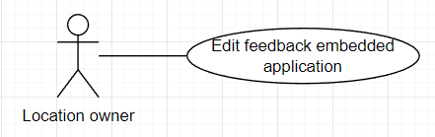

|  |  |  |  |  |  |
| --- | --- | --- | --- | --- | --- |
| **ID and Name** | **UC-36: Edit Feedback Embedded Application** | | | | |
| Created By: | AnhTTD | | Date Created: | | 17/08/2022 |
| Primary Actor: | Location Owner | | Secondary Actor: | | N/A |
| Trigger: | Actor wants to edit feedback embedded application. | | | | |
| Description: | This feature allows users to edit feedback embedded application. | | | | |
| Preconditions: | Actor logged in to IKFTS portal website as a Location Owner.  Actor has feedback embedded application. | | | | |
| Post-conditions: | **Success:** Feedback embedded application is edited.  **Failed:** System inform error message. | | | | |
| Normal Flow: | **Step** | **Actor Action** | | **System Response** | |
| 1 | Actor chooses “My Application” tab. | | System informs My Application screen. | |
| 2 | Actor clicks “Detail” button. | | System redirects to Application Detail screen. | |
| 3 | Actor clicks “Feedback” tap. | | System returns list feedback. | |
| 4 | Actor clicks “Update Feedback” button. | | System shows popup Feedback form. | |
| 5 | Actor rates point and give a feedback and clicks “Submit” button. | | System shows toast “Update success” | |
| Alternative Flows: | N/A | | | | |
| Exceptions: | N/A | | | | |
| Priority: | Medium | | | | |
| Frequency of Use: | Sometimes | | | | |
| Business Rule: | N/A | | | | |
| Other Information: | N/A | | | | |
| Assumptions: | Internet connection is available. | | | | |

##### Search Kiosk By Name

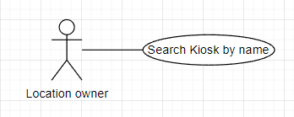

|  |  |  |  |  |  |
| --- | --- | --- | --- | --- | --- |
| **ID and Name** | **UC-37: Search Kiosk By Name** | | | | |
| Created By: | AnhTTD | | Date Created: | | 17/08/2022 |
| Primary Actor: | Location Owner | | Secondary Actor: | | N/A |
| Trigger: | Actor wants to search kiosk by name. | | | | |
| Description: | This feature allows users to search kiosk by name. | | | | |
| Preconditions: | Actor logged in to IKFTS portal website as a Location Owner. | | | | |
| Post-conditions: | **Success:** System return list kiosk.  **Failed:** System inform error message. | | | | |
| Normal Flow: | **Step** | **Actor Action** | | **System Response** | |
| 1 | Actor chooses “Kiosk” tab. | | System inform Kiosk screen. | |
| 2 | Actor inputs name in search field. | |  | |
| 3 | Actor clicks “Search” icon. | | System return list kiosk. | |
| Alternative Flows: | N/A | | | | |
| Exceptions: | N/A | | | | |
| Priority: | High | | | | |
| Frequency of Use: | Usually | | | | |
| Business Rule: | BR-32: Location Owner only get list kiosk which belong to them. | | | | |
| Other Information: | N/A | | | | |
| Assumptions: | Internet connection is available. | | | | |

##### Update Kiosk Information

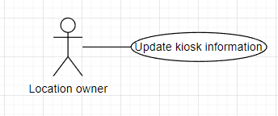

|  |  |  |  |  |  |
| --- | --- | --- | --- | --- | --- |
| **ID and Name** | **UC-38: Update Kiosk Information** | | | | |
| Created By: | AnhTTD | | Date Created: | | 17/08/2022 |
| Primary Actor: | Location Owner | | Secondary Actor: | | N/A |
| Trigger: | Actor wants to change name of kiosk. | | | | |
| Description: | This feature allows users to change name of kiosk. | | | | |
| Preconditions: | Actor logged in to IKFTS portal website as a Location Owner.  Actor has kiosk at least 1 kiosk. | | | | |
| Post-conditions: | **Success:** Kiosk’s Name has changed.  **Failed:** System inform error message. | | | | |
| Normal Flow: | **Step** | **Actor Action** | | **System Response** | |
| 1 | Actor chooses “Kiosk” tab. | | System informs Kiosk screen, return list kiosk. | |
| 2 | Actor clicks “Change Name” button of the chosen Kiosk. | | System shows popup change kiosk’s name form. | |
| 3 | Actor inputs name to change. | | [Exception 1] | |
| 4 | Actor clicks “Ok” button. | | System informs “Change name success”, redirect to Kiosk screen. | |
| Alternative Flows: | N/A | | | | |
| Exceptions: | No | Cause | | System Response | |
| 1 | Name is empty. | | System informs “Please input name !” | |
| Priority: | High | | | | |
| Frequency of Use: | Usually | | | | |
| Business Rule: | BR-33: Location Owner can only update kiosk information which belong to them. | | | | |
| Other Information: | N/A | | | | |
| Assumptions: | Internet connection is available. | | | | |

##### View Commission Profit Statistics Of Kiosk

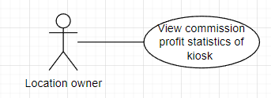

|  |  |  |  |  |  |
| --- | --- | --- | --- | --- | --- |
| **ID and Name** | **UC-39: View Commission Profit Statistics Of Kiosk** | | | | |
| Created By: | AnhTTD | | Date Created: | | 17/08/2022 |
| Primary Actor: | Location Owner | | Secondary Actor: | | N/A |
| Trigger: | Actor wants to view commission profit statistics of kiosk. | | | | |
| Description: | This feature allows users to view commission profit statistics of kiosk. | | | | |
| Preconditions: | Actor logged in to IKFTS portal website as a Location Owner.  Actor has at least 1 kiosk. | | | | |
| Post-conditions: | **Success:** System inform commission as table or chart.  **Failed:** System inform error message. | | | | |
| Normal Flow: | **Step** | **Actor Action** | | **System Response** | |
| 1 | Actor chooses “Kiosk” tab. | | System redirects Kiosk screen, return list kiosk. | |
| 2 | Actor clicks “Detail” button of the chosen Kiosk. | | System redirect to Kiosk Detail screen. | |
| 3 | Actor clicks “Revenue” tab and choose “Table”. | | System returns list commission as “Table”.  [Alternative 1] | |
| Alternative Flows: | **Step** | **Actor Action** | | **System Response** | |
| 1 | Actor clicks “Revenue” tab and choose “Chart”. | | System returns list commission as “Chart”. | |
| Exceptions: | N/A | | | | |
| Priority: | High | | | | |
| Frequency of Use: | Usually | | | | |
| Business Rule: | BR-34: Location Owner can only view commission profit statistics of kiosk which belong to them. | | | | |
| Other Information: | N/A | | | | |
| Assumptions: | Internet connection is available. | | | | |

##### View Detail Of Kiosk

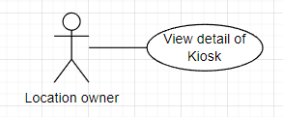

|  |  |  |  |  |  |
| --- | --- | --- | --- | --- | --- |
| **ID and Name** | **UC-40: View Detail Of Kiosk** | | | | |
| Created By: | AnhTTD | | Date Created: | | 17/08/2022 |
| Primary Actor: | Location Owner | | Secondary Actor: | | N/A |
| Trigger: | Actor wants to view detail of kiosk. | | | | |
| Description: | This feature allows users to view detail of kiosk. | | | | |
| Preconditions: | Actor logged in to IKFTS portal website as a Location Owner. | | | | |
| Post-conditions: | **Success:** System redirect to Kiosk Detail screen.  **Failed:** System inform error message. | | | | |
| Normal Flow: | **Step** | **Actor Action** | | **System Response** | |
| 1 | Actor chooses “Kiosk” tab. | | System inform Kiosk screen, return list kiosk. | |
| 2 | Actor clicks “Detail” button of the chosen Kiosk. | | System redirect to Kiosk Detail screen. | |
| Alternative Flows: | N/A | | | | |
| Exceptions: | N/A | | | | |
| Priority: | High | | | | |
| Frequency of Use: | Usually | | | | |
| Business Rule: | BR-32: Location Owner only get list kiosk which belong to them. | | | | |
| Other Information: | N/A | | | | |
| Assumptions: | Internet connection is available. | | | | |

##### Set Scenario To Kiosk

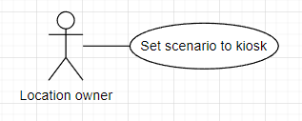

|  |  |  |  |  |  |
| --- | --- | --- | --- | --- | --- |
| **ID and Name** | **UC-41: Set** **Scenario To Kiosk** | | | | |
| Created By: | AnhTTD | | Date Created: | | 17/08/2022 |
| Primary Actor: | Location Owner | | Secondary Actor: | | N/A |
| Trigger: | Actor wants to set schedule and template to a kiosk. | | | | |
| Description: | This feature allows users to set schedule and template to a kiosk. | | | | |
| Preconditions: | Actor logged in to IKFTS portal website as a Location Owner.  Actor has at least 1 kiosk.  Actor has at least 1 schedule.  Actor has at least 1 complete template. | | | | |
| Post-conditions: | **Success:** Scenario is set.  **Failed:** System inform error message. | | | | |
| Normal Flow: | **Step** | **Actor Action** | | **System Response** | |
| 1 | Actor chooses “Kiosk” tab. | | System redirects Kiosk screen, return list kiosk. | |
| 2 | Actor clicks “Detail” button of the chosen Kiosk. | | System redirect to Kiosk Detail screen. | |
| 3 | Actor clicks “Scenario” tab. | | System returns list scenario. | |
| 4 | Actor clicks “+ Scenario” button. | | System shows popup Create scenario form. | |
| 5 | Actor chooses Schedule and Template and clicks “Create” button. | | [Exception 1]  System informs “Create success” | |
| Alternative Flows: | N/A | | | | |
| Exceptions: | No | Cause | | System Response | |
| 1 | Duplicated Scenario. | | System informs “This template and schedule are already set for kiosk." | |
| Priority: | High | | | | |
| Frequency of Use: | Usually | | | | |
| Business Rule: | BR-35: Scenario which schedule is time-conflict cannot be created. | | | | |
| Other Information: | N/A | | | | |
| Assumptions: | Internet connection is available. | | | | |

##### Set Location To Kiosk

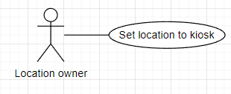

|  |  |  |  |  |  |
| --- | --- | --- | --- | --- | --- |
| **ID and Name** | **UC-42: Set Location To Kiosk** | | | | |
| Created By: | AnhTTD | | Date Created: | | 17/08/2022 |
| Primary Actor: | Location Owner | | Secondary Actor: | | N/A |
| Trigger: | Actor wants to set location to kiosk. | | | | |
| Description: | This feature allows users to set location to kiosk. | | | | |
| Preconditions: | Actor logged in to IKFTS portal website as a Location Owner.  Actor has at least 1 kiosk.  Actor has at least 1 Kiosk Placement. | | | | |
| Post-conditions: | **Success:** Location is set.  **Failed:** System inform error message. | | | | |
| Normal Flow: | **Step** | **Actor Action** | | **System Response** | |
| 1 | Actor chooses “Kiosk” tab. | | System redirects Kiosk screen, return list kiosk. | |
| 2 | Actor clicks “Update Location” button of the chosen Kiosk. | | System shows popup Update kiosk’s location form. | |
| 3 | Actor chooses Location and clicks “OK” button. | | System informs “Update success”, redirects to Kiosk screen.  [Exception 1] | |
| Alternative Flows: | N/A | | | | |
| Exceptions: | No | Cause | | System Response | |
| 1 | Location is empty. | | System informs “Please select location !" | |
| Priority: | High | | | | |
| Frequency of Use: | Usually | | | | |
| Business Rule: | BR-36: Location Owner can only choose location which is created by them. | | | | |
| Other Information: | N/A | | | | |
| Assumptions: | Internet connection is available. | | | | |

##### Create Schedule

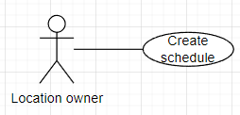

|  |  |  |  |  |  |
| --- | --- | --- | --- | --- | --- |
| **ID and Name** | **UC-43: Create Schedule** | | | | |
| Created By: | AnhTTD | | Date Created: | | 17/08/2022 |
| Primary Actor: | Location Owner | | Secondary Actor: | | N/A |
| Trigger: | Actor wants to create a schedule. | | | | |
| Description: | This feature allows users to create a schedule. | | | | |
| Preconditions: | Actor logged in to IKFTS portal website as a Location Owner. | | | | |
| Post-conditions: | **Success:** Schedule is set.  **Failed:** System inform error message. | | | | |
| Normal Flow: | **Step** | **Actor Action** | | **System Response** | |
| 1 | Actor chooses “Schedule” tab. | | System redirects Schedule screen, returns list schedule. | |
| 2 | Actor clicks “+ Schedule” button. | | System shows popup Create schedule form. | |
| 3 | Actor fills information. | | [Exception 1]  [Exception 2]  [Exception 3]  [Exception 4] | |
| 4 | Actor clicks “Create Schedule” button. | | System shows toast “Create Schedule success” | |
| Alternative Flows: | N/A | | | | |
| Exceptions: | No | Cause | | System Response | |
|  | 1 | Name is empty. | | System informs “Please input name !" | |
| 2 | Time start is empty | | System informs “Please select time start !” | |
| 3 | Time end is empty | | System informs “Please choose time end or check to end day checkbox!" | |
| 4 | Actor did not choose any day of week. | | System informs “Please choose day of week !” | |
| Priority: | High | | | | |
| Frequency of Use: | Usually | | | | |
| Business Rule: | N/A | | | | |
| Other Information: | N/A | | | | |
| Assumptions: | Internet connection is available. | | | | |

##### Update Schedule

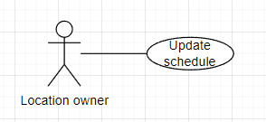

|  |  |  |  |  |  |
| --- | --- | --- | --- | --- | --- |
| **ID and Name** | **UC-44: Update Schedule** | | | | |
| Created By: | AnhTTD | | Date Created: | | 17/08/2022 |
| Primary Actor: | Location Owner | | Secondary Actor: | | N/A |
| Trigger: | Actor wants to update a schedule. | | | | |
| Description: | This feature allows users to update a schedule. | | | | |
| Preconditions: | Actor logged in to IKFTS portal website as a Location Owner.  Actor must have at least 1 schedule to update. | | | | |
| Post-conditions: | **Success:** Schedule is set.  **Failed:** System inform error message. | | | | |
| Normal Flow: | **Step** | **Actor Action** | | **System Response** | |
| 1 | Actor chooses “Schedule” tab. | | System redirects Schedule screen, return list schedule. | |
| 2 | Actor clicks Edit” button. | | System shows popup Edit schedule form. | |
| 3 | Actor fills information. | | [Exception 1]  [Exception 2]  [Exception 3]  [Exception 4] | |
| 4 | Actor clicks “Edit Schedule” button. | | System shows toast “Update success” | |
| Alternative Flows: | N/A | | | | |
| Exceptions: | No | Cause | | System Response | |
| 1 | Name is empty. | | System informs “Please input name !" | |
| 2 | Time start is empty | | System informs “Please select time start !” | |
| 3 | Time end is empty | | System informs “Please choose time end or check to end day checkbox!" | |
| 4 | Actor did not choose any day of week. | | System informs “Please choose day of week !” | |
| Priority: | High | | | | |
| Frequency of Use: | Usually | | | | |
| Business Rule: | BR-37: Location Owner cannot update schedule which not belong to them. | | | | |
| Other Information: | N/A | | | | |
| Assumptions: | Internet connection is available. | | | | |

##### View Detail Of Schedule

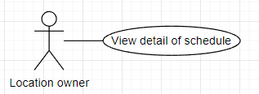

|  |  |  |  |  |  |
| --- | --- | --- | --- | --- | --- |
| **ID and Name** | **UC-45: View Detail Of Schedule** | | | | |
| Created By: | AnhTTD | | Date Created: | | 17/08/2022 |
| Primary Actor: | Location Owner | | Secondary Actor: | | N/A |
| Trigger: | Actor wants to view Detail of schedule. | | | | |
| Description: | This feature allows users to view detail of schedule. | | | | |
| Preconditions: | Actor logged in to IKFTS portal website as a Location Owner.  Actor must have at least 1 schedule to view detail. | | | | |
| Post-conditions: | **Success:** System shows popup Schedule Detail.  **Failed:** System informs error message. | | | | |
| Normal Flow: | **Step** | **Actor Action** | | **System Response** | |
| 1 | Actor chooses “Schedule” tab. | | System redirects Schedule screen, return list schedule. | |
|  | 2 | Actor chooses “Detail” button. | | System shows popup Schedule Detail. | |
| Alternative Flows: | N/A | | | | |
| Exceptions: | N/A | | | | |
| Priority: | High | | | | |
| Frequency of Use: | Usually | | | | |
| Business Rule: | BR-38: Location Owner cannot view detail schedule which not belong to them. | | | | |
| Other Information: | N/A | | | | |
| Assumptions: | Internet connection is available. | | | | |

##### Create Kiosk Placement

|  |  |  |  |  |  |
| --- | --- | --- | --- | --- | --- |
| **ID and Name** | **UC-46: Create Kiosk Placement** | | | | |
| Created By: | AnhTTD | | Date Created: | | 17/08/2022 |
| Primary Actor: | Location Owner | | Secondary Actor: | | N/A |
| Trigger: | Actor wants to create a Kiosk Placement. | | | | |
| Description: | This feature allows users to create a Kiosk Placement. | | | | |
| Preconditions: | Actor logged in to IKFTS portal website as a Location Owner. | | | | |
| Post-conditions: | **Success:** New Kiosk Placement is created.  **Failed:** System inform error message. | | | | |
| Normal Flow: | **Step** | **Actor Action** | | **System Response** | |
| 1 | Actor chooses “Kiosk Placement” tab. | | System redirects Kiosk Placement screen, return list Kiosk Placement. | |
| 2 | Actor clicks “+ Kiosk Placement” button. | | System shows popup Create Kiosk Placement form. | |
| 3 | Actor fills information. | | [Exception 1]  [Exception 2]  [Exception 3]  [Exception 4] | |
| 4 | Actor clicks “Create” button. | | System informs “Create success” | |
| Alternative Flows: | N/A | | | | |
| Exceptions: | No | Cause | | System Response | |
|  | 1 | Name is empty. | | System informs “Please input name !" | |
| 2 | Hotline is empty | | System informs “Please input hotline !” | |
| 3 | List image is empty | | System informs “Please choose picture to list image !” | |
| 4 | Description is empty. | | System informs “Please input description !” | |
| Priority: | High | | | | |
| Frequency of Use: | Usually | | | | |
| Business Rule: | BR-39: Every Kiosk Placement must has at least 1 image. | | | | |
| Other Information: | N/A | | | | |
| Assumptions: | Internet connection is available. | | | | |

##### Update Kiosk Placement

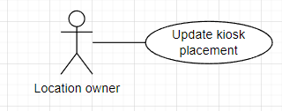

|  |  |  |  |  |  |
| --- | --- | --- | --- | --- | --- |
| **ID and Name** | **UC-47: Update Kiosk Placement** | | | | |
| Created By: | AnhTTD | | Date Created: | | 17/08/2022 |
| Primary Actor: | Location Owner | | Secondary Actor: | | N/A |
| Trigger: | Actor wants to update a Kiosk Placement. | | | | |
| Description: | This feature allows users to update a Kiosk Placement. | | | | |
| Preconditions: | Actor logged in to IKFTS portal website as a Location Owner.  Actor has at least 1 Kiosk Placement to update. | | | | |
| Post-conditions: | **Success:** Kiosk Placement is updated.  **Failed:** System inform error message. | | | | |
| Normal Flow: | **Step** | **Actor Action** | | **System Response** | |
| 1 | Actor chooses “Kiosk Placement” tab. | | System redirects Kiosk Placement screen, return list Kiosk Placement. | |
| 2 | Actor clicks “Detail” button. | | System redirect Kiosk Placement Detail screen. | |
| 3 | Actor change information they want to update. | | [Exception 1]  [Exception 2]  [Exception 3]  [Exception 4] | |
| 4 | Actor clicks “Update” button. | | System informs “Update success” | |
| Alternative Flows: | N/A | | | | |
| Exceptions: | No | Cause | | System Response | |
|  | 1 | Name is empty. | | System informs “Please input name !" | |
| 2 | Hotline is empty | | System informs “Please input hotline !” | |
| 3 | List image is empty | | System informs “Please choose at least 1 image to the "List Image" field “ | |
| 4 | Description is empty. | | System informs “Please input description !” | |
| Priority: | High | | | | |
| Frequency of Use: | Usually | | | | |
| Business Rule: | BR-39: Every Kiosk Placement must has at least 1 image.  BR-40: Location Owner can only update Kiosk Placement which belong to them. | | | | |
| Other Information: | N/A | | | | |
| Assumptions: | Internet connection is available. | | | | |

##### Search Kiosk Placement By Name

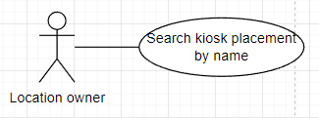

|  |  |  |  |  |  |
| --- | --- | --- | --- | --- | --- |
| **ID and Name** | **UC-48: Search Kiosk Placement By Name** | | | | |
| Created By: | AnhTTD | | Date Created: | | 17/08/2022 |
| Primary Actor: | Location Owner | | Secondary Actor: | | N/A |
| Trigger: | Actor wants to search a Kiosk Placement by name. | | | | |
| Description: | This feature allows users to search a Kiosk Placement by name. | | | | |
| Preconditions: | Actor logged in to IKFTS portal website as a Location Owner. | | | | |
| Post-conditions: | **Success:** System return list Kiosk Placement.  **Failed:** System inform error message. | | | | |
| Normal Flow: | **Step** | **Actor Action** | | **System Response** | |
| 1 | Actor chooses “Kiosk Placement” tab. | | System redirects Kiosk Placement screen, return list Kiosk Placement. | |
| 2 | Actor inputs name in search field. | |  | |
| 3 | Actor clicks “Search” icon. | | System return list Kiosk Placement. | |
| Alternative Flows: | N/A | | | | |
| Exceptions: | N/A | | | | |
| Priority: | High | | | | |
| Frequency of Use: | Usually | | | | |
| Business Rule: | BR-41: Location Owner can only view Kiosk Placement which is belong to them. | | | | |
| Other Information: | N/A | | | | |
| Assumptions: | Internet connection is available. | | | | |

##### View Detail Of Kiosk Placement

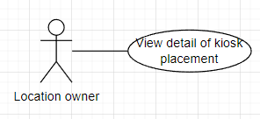

|  |  |  |  |  |  |
| --- | --- | --- | --- | --- | --- |
| **ID and Name** | **UC-49: View Detail Of A** **Kiosk Placement By Name** | | | | |
| Created By: | AnhTTD | | Date Created: | | 17/08/2022 |
| Primary Actor: | Location Owner | | Secondary Actor: | | N/A |
| Trigger: | Actor wants to view list of Kiosk Placement. | | | | |
| Description: | This feature allows users to view list of Kiosk Placement. | | | | |
| Preconditions: | Actor logged in to IKFTS portal website as a Location Owner. | | | | |
| Post-conditions: | **Success:** System return list Kiosk Placement.  **Failed:** System inform error message. | | | | |
| Normal Flow: | **Step** | **Actor Action** | | **System Response** | |
| 1 | Actor chooses “Kiosk Placement” tab. | | System redirects Kiosk Placement screen, return list Kiosk Placement. | |
|  | 2 | Actor clicks “Detail” button. | | System redirect Kiosk Placement Detail screen. | |
| Alternative Flows: | N/A | | | | |
| Exceptions: | N/A | | | | |
| Priority: | High | | | | |
| Frequency of Use: | Usually | | | | |
| Business Rule: | BR-41: Location Owner can only view Kiosk Placement which is belong to them. | | | | |
| Other Information: | N/A | | | | |
| Assumptions: | Internet connection is available. | | | | |

##### Create Local Event

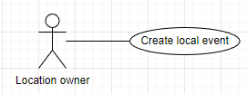

|  |  |  |  |  |  |
| --- | --- | --- | --- | --- | --- |
| **ID and Name** | **UC-50: Create Local Event** | | | | |
| Created By: | AnhTTD | | Date Created: | | 17/08/2022 |
| Primary Actor: | Location Owner | | Secondary Actor: | | N/A |
| Trigger: | Actor wants to create local event. | | | | |
| Description: | This feature allows users to create local event. | | | | |
| Preconditions: | Actor logged in to IKFTS portal website as a Location Owner. | | | | |
| Post-conditions: | **Success:** New local event is created.  **Failed:** System inform error message. | | | | |
| Normal Flow: | **Step** | **Actor Action** | | **System Response** | |
| 1 | Actor chooses “Event” tab. | | System redirects Event screen, return list event. | |
|  | 2 | Actor clicks “+Event” button. | | System redirect Event Creating screen. | |
|  | 3 | Actor fills information. | |  | |
|  | 4 |  | | System shows toast “Create Success”  [Exception]{12} | |
| Alternative Flows: | N/A | | | | |
| Exceptions: | **Step** | **Actor Action** | | **System Response** | |
| 1 | Name field is empty. | | System shows error text “Please input name !” | |
| 2 | Description field is empty. | | System shows error text “Please input description” | |
| 3 | Time start field is empty. | | System shows error text “Please select date start !”  “Please select time start !” | |
| 4 | Time end field is empty. | | System shows error text “Please select date end !”  “Please select time end !” | |
| 5 | Address field is empty. | | System shows error text “Please input address !” | |
| 6 | City field is empty. | | System shows error text “Please choose city !” | |
| 7 | District field is empty. | | System shows error text “Please choose district !” | |
| 8 | Ward field is empty. | | System shows error text “Please choose ward !” | |
| 9 | Thumbnail is not selected yet. | | System shows error text “Please input Thumbnail !” | |
| 10 | List image is not selected yet. | | System shows error text “Please choose picture to list image !” | |
| 11 | Time start is after time end. | | System shows toast “Please recheck date and time ending” | |
| 12 | Time start is before current time. | | System shows toast “Date star is over” | |
| Priority: | High | | | | |
| Frequency of Use: | Usually | | | | |
| Business Rule: | BR-42: The type of event which is created by Location Owner is “Local”. | | | | |
| Other Information: | N/A | | | | |
| Assumptions: | Internet connection is available. | | | | |

##### Update Local Event

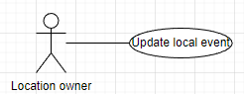

|  |  |  |  |  |  |
| --- | --- | --- | --- | --- | --- |
| **ID and Name** | **UC-51: Update event** | | | | |
| Created By: | AnhTTD | | Date Created: | 08/08/2022 | |
| Primary Actor: | Location Owner | | Secondary Actor: | N/A | |
| Trigger: | Actor wants to update local event. | | | | |
| Description: | This feature allows actor to update local event. | | | | |
| Preconditions: | Actor has logged into IKFTS application.  Actor must have at least 1 event to update. | | | | |
| Post-conditions: | **Success:** Local event is updated.  **Failed:** System informs error message. | | | | |
| Normal Flow: | **Step** | **Actor Action** | | | **System Response** |
| 1 | Actor clicks “Event” on side bar | | | System shows list event |
| 2 | Actor clicks “Detail” button in list event | | | System redirects Event Detail Screen. |
| 3 | Actor fills information they want to update. | | |  |
| 4 | Actor clicks “Update” button. | | | System shows toast “Update Success”  [Exception]{12} |
| Alternative Flows: | N/A | | | | |
| Exceptions: | **No** | **Cause** | | | **System Response** |
| 1 | Name field is empty | | | System show error text “Please input name !” |
| 2 | Description field is empty | | | System show error text “Please input description” |
| 3 | Time start field is empty | | | System show error text “Please select date start !”,  “Please select time start !” |
| 4 | Time end field is empty | | | System show error text “Please select date end !”,  “Please select time end !” |
| 5 | Address field is empty | | | System show error text “Please input address !” |
| 6 | City field is empty | | | System show error text “Please choose city !” |
| 7 | District field is empty | | | System show error text “Please choose district !” |
| 8 | Ward field is empty | | | System shows error text “Please choose ward !” |
| 9 | Thumbnail is not selected yet | | | System shows toast “Please add thumbnail image !” |
| 10 | List image is not selected yet | | | System shows toast “Please input at least 1 picture to list !” |
| 11 | Time start is after time end | | | System shows toast “Please recheck date and time ending” |
| 12 | Time start is before current time | | | System shows toast “Date star is over” |
| Priority: | High | | | | |
| Frequency of Use: | Usually | | | | |
| Business Rule: | BR-43: Each event has a maximum of 5 images, minimum of 1 image.  BR-44: Location Owner can only update event which belong to them. | | | | |
| Other Information: | N/A | | | | |
| Assumptions: | Internet connection is available. | | | | |

##### Delete Local Event

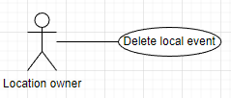

|  |  |  |  |  |  |
| --- | --- | --- | --- | --- | --- |
| **ID and Name** | **UC-52: Delete Local Event** | | | | |
| Created By: | AnhTTD | | Date Created: | 17/08/2022 | |
| Primary Actor: | Location Owner | | Secondary Actor: | N/A | |
| Trigger: | Actor wants to delete local event. | | | | |
| Description: | This feature allows users to delete local event. | | | | |
| Preconditions: | Actor logged in to IKFTS portal website as a Location Owner.  Actor must have at least 1 event to delete. | | | | |
| Post-conditions: | **Success:** New local event is created.  **Failed:** System inform error message. | | | | |
| Normal Flow: | **Step** | **Actor Action** | | | **System Response** |
| 1 | Actor chooses “Event” tab. | | | System redirects Event screen, return list event. |
| 2 | Actor clicks “Delete” button on the chosen event. | | | System shows popup Confirm Delete form.  [Alternative 1] |
| 3 | Actor clicks “Yes” button. | | | Systems shows toast “Delete Success” |
| Alternative Flows: | **Step** | **Actor Action** | | | **System Response** |
| 1 | Actor clicks “No” button. | | | System redirects Event screen. |
| Exception: | N/A | | | | |
| Priority: | High | | | | |
| Frequency of Use: | Usually | | | | |
| Business Rule: | BR-45: Location Owner can only delete event which belong to them. | | | | |
| Other Information: | N/A | | | | |
| Assumptions: | Internet connection is available. | | | | |

##### Search Local Event

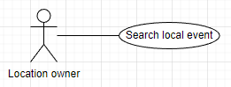

|  |  |  |  |  |  |
| --- | --- | --- | --- | --- | --- |
| **ID and Name** | **UC-53: Search Local Event** | | | | |
| Created By: | AnhTTD | | Date Created: | 17/08/2022 | |
| Primary Actor: | Location Owner | | Secondary Actor: | N/A | |
| Trigger: | Actor wants to search local event. | | | | |
| Description: | This feature allows users to search local event. | | | | |
| Preconditions: | Actor logged in to IKFTS portal website as a Location Owner. | | | | |
| Post-conditions: | **Success:** System return list of local event.  **Failed:** System inform error message. | | | | |
| Normal Flow: | **Step** | **Actor Action** | | | **System Response** |
| 1 | Actor chooses “Event” tab. | | | System redirects Event screen, return list local event. |
| 2 | Actor inputs name in search field and choose Status. | | |  |
| 3 | Actor clicks “Search” icon. | | | System return list of local event. |
| Alternative Flows: | N/A | | | | |
| Exception: | N/A | | | | |
| Priority: | High | | | | |
| Frequency of Use: | Usually | | | | |
| Business Rule: | BR-46: Location Owner can only view local event which belong to them. | | | | |
| Other Information: | N/A | | | | |
| Assumptions: | Internet connection is available. | | | | |

##### View Detail of Local Event

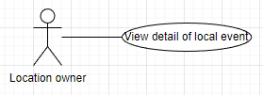

|  |  |  |  |  |  |
| --- | --- | --- | --- | --- | --- |
| **ID and Name** | **UC-54: View Detail of Local Event** | | | | |
| Created By: | AnhTTD | | Date Created: | 17/08/2022 | |
| Primary Actor: | Location Owner | | Secondary Actor: | N/A | |
| Trigger: | Actor wants to view detail local event. | | | | |
| Description: | This feature allows users to view detail local event. | | | | |
| Preconditions: | Actor logged in to IKFTS portal website as a Location Owner.  Actor has at least 1 local event. | | | | |
| Post-conditions: | **Success:** System redirects Event Detail screen.  **Failed:** System inform error message. | | | | |
| Normal Flow: | **Step** | **Actor Action** | | | **System Response** |
| 1 | Actor chooses “Event” tab. | | | System redirects Event screen, return list local event. |
| 2 | Actor clicks “Detail” button on the chosen event. | | | System redirects Event Detail Screen. |
| Alternative Flows: | N/A | | | | |
| Exception: | N/A | | | | |
| Priority: | High | | | | |
| Frequency of Use: | Usually | | | | |
| Business Rule: | BR-46: Actor can only view local event which belong to them. | | | | |
| Other Information: | N/A | | | | |
| Assumptions: | Internet connection is available. | | | | |

##### Create Local POI

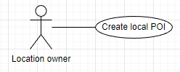

|  |  |  |  |  |  |
| --- | --- | --- | --- | --- | --- |
| **ID and Name** | **UC-55: Create Local POI** | | | | |
| Created By: | AnhTTD | | Date Created: | | 17/08/2022 |
| Primary Actor: | Location Owner | | Secondary Actor: | | N/A |
| Trigger: | Actor wants to create local POI. | | | | |
| Description: | This feature allows users to create local POI. | | | | |
| Preconditions: | Actor logged in to IKFTS portal website as a Location Owner. | | | | |
| Post-conditions: | **Success:** New local POI is created.  **Failed:** System inform error message. | | | | |
| Normal Flow: | **Step** | **Actor Action** | | **System Response** | |
| 1 | Actor chooses “POI” tab. | | System redirects POI screen, return list local POI. | |
|  | 2 | Actor clicks “+POI” button. | | System redirect POI Creating screen. | |
|  | 3 | Actor fills information. | |  | |
|  | 4 | Actor clicks “Create POI” button. | | System shows toast “Create Success”  [Exception]{14} | |
| Alternative Flows: | N/A | | | | |
| Exceptions: | **No** | **Cause** | | **System Response** | |
| 1 | Name field is empty | | System shows error text “Please input name” | |
| 2 | Description field is empty | | System shows error text “Please input description” | |
| 3 | Time start field is empty | | System shows error text “Please input time start” | |
| 4 | Time end field is empty | | System shows error text “Please input time end” | |
| 5 | Day of week are not selected yet | | System shows error text “Please select day of week” | |
| 6 | Address field is empty | | System shows error text “Please input your address!” | |
| 7 | City field is empty | | System shows error text “Please choose your city!” | |
| 8 | District field is empty | | System shows error text “Please choose your district!” | |
| 9 | Ward field is empty | | System shows error text “Please choose your ward!” | |
| 10 | Category field is empty | | System shows error text “Please choose your category” | |
| 11 | Logo is not selected yet | | System shows error text “Please choose application logo!” | |
| 12 | List image is not selected yet | | System shows error text “Please choose image for application” | |
| 13 | Time start is after time end | | System shows toast “Time start need to before or match with time end” | |
| 14 | Location of POI already exist | | System shows toast “The POI already exists at this location” | |
| Priority: | High | | | | |
| Frequency of Use: | Usually | | | | |
| Business Rule: | BR-47: Local POI between location owners can be duplicated.  BR-48: Address of local POI of 1 location owner cannot be duplicated. | | | | |
| Other Information: | N/A | | | | |
| Assumptions: | Internet connection is available. | | | | |

##### Update Local POI

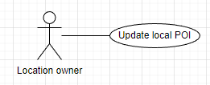

|  |  |  |  |  |  |
| --- | --- | --- | --- | --- | --- |
| **ID and Name** | **UC-56: Update Local POI** | | | | |
| Created By: | AnhTTD | | Date Created: | | 17/08/2022 |
| Primary Actor: | Location Owner | | Secondary Actor: | | N/A |
| Trigger: | Actor wants to update local POI. | | | | |
| Description: | This feature allows users to update local POI. | | | | |
| Preconditions: | Actor logged in to IKFTS portal website as a Location Owner.  Actor must have at least 1 local POI to update. | | | | |
| Post-conditions: | **Success:** Local POI is updated.  **Failed:** System inform error message. | | | | |
| Normal Flow: | **Step** | **Actor Action** | | **System Response** | |
| 1 | Actor chooses “POI” tab. | | System redirects POI screen, return list local POI. | |
|  | 2 | Actor clicks “Detail” button on the chosen POI. | | System redirect POI Detail screen. | |
|  | 3 | Actor fills information they want to update. | |  | |
|  | 4 | Actor clicks “Update” button. | | System shows toast “Create Success”  [Exception]{14} | |
| Alternative Flows: | N/A | | | | |
| Exceptions: | **No** | **Cause** | | **System Response** | |
| 1 | Name field is empty | | System shows error text “Please input name” | |
| 2 | Description field is empty | | System shows error text “Please input description” | |
| 3 | Time start field is empty | | System shows error text “Please input time start” | |
| 4 | Time end field is empty | | System shows error text “Please input time end” | |
| 5 | Day of week are not selected yet | | System shows error text “Please select day of week” | |
| 6 | Address field is empty | | System shows error text “Please input your address!” | |
| 7 | City field is empty | | System shows error text “Please choose your city!” | |
| 8 | District field is empty | | System shows error text “Please choose your district!” | |
| 9 | Ward field is empty | | System shows error text “Please choose your ward!” | |
| 10 | Category field is empty | | System shows error text “Please choose your category” | |
| 11 | Logo is not selected yet | | System shows error text “Please choose application logo!” | |
| 12 | List image is not selected yet | | System shows error text “Please choose image for application” | |
| 13 | Time start is after time end | | System shows toast “Time start need to before or match with time end” | |
| 14 | Location of POI already exist | | System shows toast “The POI already exists at this location” | |
| Priority: | High | | | | |
| Frequency of Use: | Usually | | | | |
| Business Rule: | BR-47: Local POI between location owners can be duplicated.  BR-48: Address of local POI of 1 location owner cannot be duplicated.  BR-49: Location Owner can only update local POI which belong to them. | | | | |
| Other Information: | N/A | | | | |
| Assumptions: | Internet connection is available. | | | | |

##### Deactivate Local POI

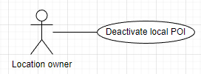

|  |  |  |  |  |  |
| --- | --- | --- | --- | --- | --- |
| **ID and Name** | **UC-57: Deactivate Local POI** | | | | |
| Created By: | AnhTTD | | Date Created: | | 17/08/2022 |
| Primary Actor: | Location Owner | | Secondary Actor: | | N/A |
| Trigger: | Actor wants to deactivate local POI. | | | | |
| Description: | This feature allows users to deactivate local POI. | | | | |
| Preconditions: | Actor logged in to IKFTS portal website as a Location Owner.  Actor must have at least 1 local POI to deactivate. | | | | |
| Post-conditions: | **Success:** Local POI is deactivated.  **Failed:** System inform error message. | | | | |
| Normal Flow: | **Step** | **Actor Action** | | **System Response** | |
| 1 | Actor chooses “POI” tab. | | System redirects POI screen, return list local POI. | |
|  | 2 | Actor clicks “Change Status” button on the chosen POI. | | System shows popup confirm to change status.  [Alternative 1] | |
|  | 3 | Actor clicks “Yes” button. | | System shows toast “Change status success” | |
| Alternative Flows: | **Step** | **Actor Action** | | **System Response** | |
| 1 | Actor clicks “No” button. | | System redirects POI screen, return list local POI. | |
| Exceptions: | N/A | | | | |
| Priority: | High | | | | |
| Frequency of Use: | Usually | | | | |
| Business Rule: | BR-50: Location Owner can only deactivate local POI which belong to them. | | | | |
| Other Information: | N/A | | | | |
| Assumptions: | Internet connection is available. | | | | |

##### Search Local POI

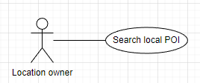

|  |  |  |  |  |  |
| --- | --- | --- | --- | --- | --- |
| **ID and Name** | **UC-58: Search Local POI** | | | | |
| Created By: | AnhTTD | | Date Created: | | 17/08/2022 |
| Primary Actor: | Location Owner | | Secondary Actor: | | N/A |
| Trigger: | Actor wants to search local POI. | | | | |
| Description: | This feature allows users to search local POI. | | | | |
| Preconditions: | Actor logged in to IKFTS portal website as a Location Owner. | | | | |
| Post-conditions: | **Success:** System returns list of local POI.  **Failed:** System inform error message. | | | | |
| Normal Flow: | **Step** | **Actor Action** | | **System Response** | |
| 1 | Actor chooses “POI” tab. | | System redirects POI screen, return list local POI. | |
|  | 2 | Actor inputs name in search field. | | System returns list local POI. | |
| Alternative Flows: | N/A | | | | |
| Exceptions: | N/A | | | | |
| Priority: | High | | | | |
| Frequency of Use: | Usually | | | | |
| Business Rule: | BR-51: Location Owner can only view local POI which belong to them. | | | | |
| Other Information: | N/A | | | | |
| Assumptions: | Internet connection is available. | | | | |

##### View Detail Of Local POI

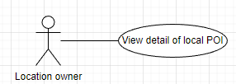

|  |  |  |  |  |  |
| --- | --- | --- | --- | --- | --- |
| **ID and Name** | **UC-59: View Detail Of Local POI** | | | | |
| Created By: | AnhTTD | | Date Created: | | 17/08/2022 |
| Primary Actor: | Location Owner | | Secondary Actor: | | N/A |
| Trigger: | Actor wants to view detail of local POI. | | | | |
| Description: | This feature allows users to view detail of local POI. | | | | |
| Preconditions: | Actor logged in to IKFTS portal website as a Location Owner.  Actor must have at least 1 local POI to view detail. | | | | |
| Post-conditions: | **Success:** System redirect POI Detail screen.  **Failed:** System inform error message. | | | | |
| Normal Flow: | **Step** | **Actor Action** | | **System Response** | |
| 1 | Actor chooses “POI” tab. | | System redirects POI screen, return list local POI. | |
|  | 2 | Actor clicks “Detail” on the chosen POI. | | System redirects POI Detail screen. | |
| Alternative Flows: | N/A | | | | |
| Exceptions: | N/A | | | | |
| Priority: | High | | | | |
| Frequency of Use: | Usually | | | | |
| Business Rule: | BR-51: Location Owner can only view local POI which belong to them. | | | | |
| Other Information: | N/A | | | | |
| Assumptions: | Internet connection is available. | | | | |

Admin

##### Create POI Category

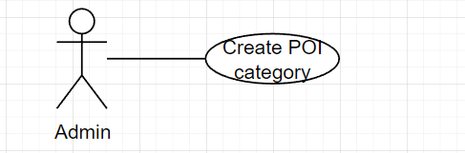

|  |  |  |  |  |  |
| --- | --- | --- | --- | --- | --- |
| **ID and Name** | **UC-60: Create POI category** | | | | |
| Created By: | TungVS | | Date Created: | | 08/08/2022 |
| Primary Actor: | Admin | | Secondary Actor: | | N/A |
| Trigger: | Actor wants to create POI category. | | | | |
| Description: | This feature allows actor to create POI category. | | | | |
| Preconditions: | Actor has logged into IKFTS application. | | | | |
| Post-conditions: | **Success:** System insert new POI category entity  **Failed:** System informs error message | | | | |
| Normal Flow: | **Step** | **Actor Action** | | **System Response** | |
|  | Actor clicks on “POI Category” on side bar | | System shows list poi category | |
|  | Actor clicks on “CREATE” button | | System popup a form detail of poi category | |
|  | Actor fills information | |  | |
|  | Actor clicks on “Create Poi Category” button  [Alternative1] | | System show toast “Create Success” and close popup  [Exception 1]  [Exception 2]  [Exception 3] | |
| Alternative Flows: | **Step** | **Actor Action** | | **System Response** | |
| 1 | Actor clicks “x” button or clicks out side the popup | | System close popup | |
| Exceptions: | **No** | **Cause** | | **System Response** | |
| 1 | Name of poi category is exist | | System send toast “Category name existed” | |
| 2 | Name field is empty | | System show error text “Please Input Name!” | |
| 3 | Haven't chosen an image for the logo yet | | System show error text “Please choose application logo!” | |
| Priority: | High | | | | |
| Frequency of Use: | Usually | | | | |
| Business Rule: | BR-52: POI category name cannot be duplicated. | | | | |
| Other Information: | N/A | | | | |
| Assumptions: | Internet connection is available. | | | | |

##### Update POI Category

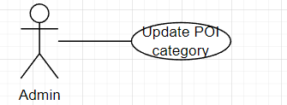

|  |  |  |  |  |  |
| --- | --- | --- | --- | --- | --- |
| **ID and Name** | **UC-61: Update POI category** | | | | |
| Created By: | TungVS | | Date Created: | | 08/08/2022 |
| Primary Actor: | Admin | | Secondary Actor: | | N/A |
| Trigger: | Actor wants to update POI category. | | | | |
| Description: | This feature allows actor to update POI category. | | | | |
| Preconditions: | Actor has logged into IKFTS application. | | | | |
| Post-conditions: | **Success:** System update POI category entity  **Failed:** System informs error message | | | | |
| Normal Flow: | **Step** | **Actor Action** | | **System Response** | |
| 1 | Actor clicks on “POI Category” on side bar | | System shows list poi category | |
| 2 | Actor clicks on “UPDATE” button in poi category | | System popup a form detail of poi category and auto fills old data | |
| 3 | Actor change data on form | |  | |
| 4 | Actor clicks on “Update Poi Category” button  [Alternative1] | | System show toast “Update Success” and close popup  [Exception 1]  [Exception 2]  [Exception 3] | |
| Alternative Flows: | **Step** | **Actor Action** | | **System Response** | |
| 1 | Actor clicks “x” button or clicks out side the popup | | System close popup | |
| Exceptions: | **No** | **Cause** | | **System Response** | |
| 1 | Name of poi category is exist | | System send toast “Category name existed” | |
| 2 | Name field is empty | | System show error text “Please Input Name!” | |
| 3 | Haven't chosen an image for the logo yet | | System send toast “Please choose logo” | |
| Priority: | High | | | | |
| Frequency of Use: | Usually | | | | |
| Business Rule: | BR-52: POI category name cannot be duplicated. | | | | |
| Other Information: | N/A | | | | |
| Assumptions: | Internet connection is available. | | | | |

##### Delete POI Category

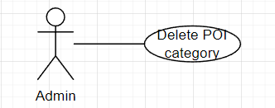

|  |  |  |  |  |  |
| --- | --- | --- | --- | --- | --- |
| **ID and Name** | **UC-62: Delete POI category** | | | | |
| Created By: | TungVS | | Date Created: | | 08/08/2022 |
| Primary Actor: | Admin | | Secondary Actor: | | N/A |
| Trigger: | Actor wants to delete POI category. | | | | |
| Description: | This feature allows actor to delete POI category. | | | | |
| Preconditions: | Actor has logged into IKFTS application. | | | | |
| Post-conditions: | **Success:** System delete POI category entity  **Failed:** System informs error message | | | | |
| Normal Flow: | **Step** | **Actor Action** | | **System Response** | |
| 1 | Actor clicks on “POI Category” on side bar | | System shows list poi category | |
| 2 | Actor clicks on “Delete” button in list poi category | | System confirm popup “Are you sure to delete this POI category” | |
| 3 | Actor clicks on “Yes” button  [Alternative 1] | | System show toast “Delete Success”, close popup and refresh list poi category  [Exception 1] | |
| Alternative Flows: | **Step** | **Actor Action** | | **System Response** | |
| 1 | Actor clicks “No” button or clicks out side the popup | | System close popup | |
| Exceptions: | **No** | **Cause** | | **System Response** | |
| 1 | Has POI on poi category | | System show toast “Already POI on this category, can not delete” | |
| Priority: | High | | | | |
| Frequency of Use: | Usually | | | | |
| Business Rule: | BR-53: Can not delete category has at least 1 poi set that category. | | | | |
| Other Information: | N/A | | | | |
| Assumptions: | Internet connection is available. | | | | |

##### Create Server POI

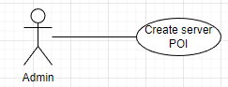

|  |  |  |  |  |  |
| --- | --- | --- | --- | --- | --- |
| **ID and Name** | **UC-63: Create Server POI** | | | | |
| Created By: | TungVS | | Date Created: | | 08/08/2022 |
| Primary Actor: | Admin | | Secondary Actor: | | N/A |
| Trigger: | Actor wants to create new POI with type is “Server”. | | | | |
| Description: | This feature allows actor to create new POI with type is “Server”. | | | | |
| Preconditions: | Actor has logged into IKFTS application. | | | | |
| Post-conditions: | **Success:** System inserts new POI entity.  **Failed:** System informs error message | | | | |
| Normal Flow: | **Step** | **Actor Action** | | **System Response** | |
| 1 | Actor clicks on “POI” on side bar | | System shows list poi | |
| 2 | Actor clicks on “CREATE” button | | System popup a form detail of poi | |
| 3 | Actor fills information | |  | |
| 4 | Actor clicks on “Create POI” button  [Alternative1] | | System show toast “Create Success” and close popup  [Exception]{14} | |
| Alternative Flows: | **Step** | **Actor Action** | | **System Response** | |
| 1 | Actor clicks “x” button or clicks out side the popup | | System close popup | |
| Exceptions: | **No** | **Cause** | | **System Response** | |
| 1 | Name field is empty | | System shows error text “Please input name” | |
| 2 | Description field is empty | | System shows error text “Please input description” | |
| 3 | Time start field is empty | | System shows error text “Please input time start” | |
| 4 | Time end field is empty | | System shows error text “Please input time end” | |
| 5 | Day of week are not selected yet | | System shows error text “Please select day of week” | |
| 6 | Address field is empty | | System shows error text “Please input your address!” | |
| 7 | City field is empty | | System show error text “Please choose your city!” | |
| 8 | District field is empty | | System show error text “Please choose your district!” | |
| 9 | Ward field is empty | | System show error text “Please choose your ward!” | |
| 10 | Category field is empty | | System show error text “Please choose your category” | |
| 11 | Logo is not selected yet | | System show error text “Please choose application logo!” | |
| 12 | List image is not selected yet | | System show error text “Please choose image for application” | |
| 13 | Time start is after time end | | System show toast “Time start need to before or match with time end” | |
| 14 | Location of POI already exist | | System show toast “The POI already exists at this location” | |
| Priority: | High | | | | |
| Frequency of Use: | Usually | | | | |
| Business Rule: | BR-54: Each POI has a maximum of 5 images, minimum of 1 image.  BR-55: Each location on the map has only 1 POI.  BR-56: POI type which is created by Admin is “Server”. | | | | |
| Other Information: | N/A | | | | |
| Assumptions: | Internet connection is available. | | | | |

##### Update Server POI

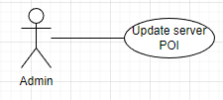

|  |  |  |  |  |  |
| --- | --- | --- | --- | --- | --- |
| **ID and Name** | **UC-64: Update Server POI** | | | | |
| Created By: | TungVS | | Date Created: | | 08/08/2022 |
| Primary Actor: | Admin | | Secondary Actor: | | N/A |
| Trigger: | Actor wants to update server POI. | | | | |
| Description: | This feature allows actor to update server POI. | | | | |
| Preconditions: | Actor has logged into IKFTS application. | | | | |
| Post-conditions: | **Success:** System update POI entity.  **Failed:** System informs error message | | | | |
| Normal Flow: | **Step** | **Actor Action** | | **System Response** | |
| 1 | Actor clicks on “POI Category” on side bar | | System shows list poi category | |
| 2 | Actor clicks on “Detail” button | | System redirects update poi category page | |
| 3 | Actor fills information in fields want to update | |  | |
| 4 | Actor clicks on “Update” button | | System show toast “Update Success”  [Exception 1]  [Alternative1] | |
| Alternative Flows: | N/A | | | | |
| Exceptions: | **No** | **Cause** | | **System Response** | |
| 1 | Name field is empty | | System show error text “Please input name” | |
| 2 | Description field is empty | | System show error text “Please input description” | |
| 3 | Time start field is empty | | System show error text “Please input time start” | |
| 4 | Time end field is empty | | System show error text “Please input time end” | |
| 5 | Day of week are not selected yet | | System show error text “Please select day of week” | |
| 6 | Address field is empty | | System show error text “Please input your address!” | |
| 7 | City field is empty | | System show error text “Please choose your city!” | |
| 8 | District field is empty | | System show error text “Please choose your district!” | |
| 9 | Ward field is empty | | System show error text “Please choose your ward!” | |
| 10 | Category field is empty | | System show error text “Please choose your category” | |
| 11 | Logo is not selected yet | | System show toast “Please choose logo” | |
| 12 | List image is not selected yet | | System show toast “Please input at least 1 picture” | |
| 13 | Time start is after time end | | System show toast “Time start need to before or match with time end” | |
| 14 | Location of POI already exist | | System show toast “The POI already exists at this location” | |
| Priority: | High | | | | |
| Frequency of Use: | Usually | | | | |
| Business Rule: | BR-54: Each POI has a maximum of 5 images, minimum of 1 image.  BR-55: Each location on the map has only 1 POI.  BR-57: Admin can only update POI which type is “Server”. | | | | |
| Other Information: | N/A | | | | |
| Assumptions: | Internet connection is available. | | | | |

##### Search Server POI

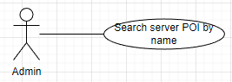

|  |  |  |  |  |  |
| --- | --- | --- | --- | --- | --- |
| **ID and Name** | **UC-65: Search Server POI** | | | | |
| Created By: | TungVS | | Date Created: | | 08/08/2022 |
| Primary Actor: | Admin | | Secondary Actor: | | N/A |
| Trigger: | Actor wants to search POI. | | | | |
| Description: | This feature allows actor to search POI . | | | | |
| Preconditions: | Actor has logged into IKFTS application. | | | | |
| Post-conditions: | **Success:** System show list POI match the search key.  **Failed:** System informs error message | | | | |
| Normal Flow: | **Step** | **Actor Action** | | **System Response** | |
| 1 | Actor clicks on “POI Category” on side bar | | System shows list poi category | |
| 2 | Actor input name to search filed | |  | |
| 3 | Actor clicks on search icon button | | System show list of POI match the search key  [Exception 1] | |
| Alternative Flows: | N/A | | | | |
| Exceptions: | **No** | **Cause** | | **System Response** | |
| 1 | No POI match search key | | System show “No Data” | |
| Priority: | High | | | | |
| Frequency of Use: | Usually | | | | |
| Business Rule: | BR-58: List POI will be paging with page size is 5.  BR-59: Admin can only view POI which type is “Server”. | | | | |
| Other Information: | N/A | | | | |
| Assumptions: | Internet connection is available. | | | | |

##### View Detail Of Server POI

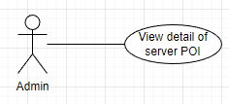

|  |  |  |  |  |  |
| --- | --- | --- | --- | --- | --- |
| **ID and Name** | **UC-66: View Detail Of Server POI** | | | | |
| Created By: | TungVS | | Date Created: | | 08/08/2022 |
| Primary Actor: | Admin | | Secondary Actor: | | N/A |
| Trigger: | Actor wants to view detail of server POI. | | | | |
| Description: | This feature allows actor to view detail of server POI . | | | | |
| Preconditions: | Actor has logged into IKFTS application. | | | | |
| Post-conditions: | **Success:** System redirects POI detail page  **Failed:** System informs error message | | | | |
| Normal Flow: | **Step** | **Actor Action** | | **System Response** | |
| 1 | Actor clicks on “POI” on side bar | | System shows list POI | |
| 2 | Actor clicks on “Detail” on list POI | | System redirects POI detail page | |
| Alternative Flows: | N/A | | | | |
| Exceptions: | N/A | | | | |
| Priority: | High | | | | |
| Frequency of Use: | Usually | | | | |
| Business Rule: | BR-59: Admin can only view POI which type is “Server”. | | | | |
| Other Information: | N/A | | | | |
| Assumptions: | Internet connection is available. | | | | |

##### Change Status Server POI

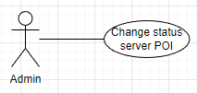

|  |  |  |  |  |  |
| --- | --- | --- | --- | --- | --- |
| **ID and Name** | **UC-67: Change Status Server POI** | | | | |
| Created By: | TungVS | | Date Created: | | 08/08/2022 |
| Primary Actor: | Admin | | Secondary Actor: | | N/A |
| Trigger: | Actor wants to change status server POI. | | | | |
| Description: | This feature allows actor to change status server POI. | | | | |
| Preconditions: | Actor has logged into IKFTS application. | | | | |
| Post-conditions: | **Success:** System change status server POI.  **Failed:** System informs error message | | | | |
| Normal Flow: | **Step** | **Actor Action** | | **System Response** | |
| 1 | Actor clicks on “POI” on side bar | | System shows list POI | |
| 2 | Actor clicks on “Change Status” on list POI | | System show confirm popup “Are you sure to change status this POI” | |
| 3 | Actor clicks on “Yes” button  [Alternative 1] | | System change status and show toast “Change status successful” | |
| Alternative Flows: | **Step** | **Actor Action** | | **System Response** | |
| 1 | Actor clicks on “No” button | | System close popup | |
| Exceptions: | N/A | | | | |
| Priority: | High | | | | |
| Frequency of Use: | Usually | | | | |
| Business Rule: | N/A | | | | |
| Other Information: | N/A | | | | |
| Assumptions: | Internet connection is available. | | | | |

##### Create Account

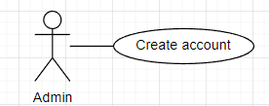

|  |  |  |  |  |  |
| --- | --- | --- | --- | --- | --- |
| **ID and Name** | **UC-68: Create account** | | | | |
| Created By: | TungVS | | Date Created: | | 08/08/2022 |
| Primary Actor: | Admin | | Secondary Actor: | | N/A |
| Trigger: | Actor wants to create account. | | | | |
| Description: | This feature allows actor to create account. | | | | |
| Preconditions: | Actor has logged into IKFTS application. | | | | |
| Post-conditions: | **Success:** System insert new account entity  **Failed:** System informs error message | | | | |
| Normal Flow: | **Step** | **Actor Action** | | **System Response** | |
| 1 | Actor clicks on “Account” on side bar | | System shows list account | |
| 2 | Actor clicks on “+ Account” button | | System popup a form detail of account | |
| 3 | Actor fills information | |  | |
| 4 | Actor clicks on “Sign-up” button | | System show toast “Create Success” and close popup  [Exception 1]  [Alternative1] | |
| Alternative Flows: | **Step** | **Actor Action** | | **System Response** | |
| 1 | Actor clicks “x” button or clicks out side the popup | | System close popup. | |
| Exceptions: | N/A | | | | |
| Priority: | High | | | | |
| Frequency of Use: | Usually | | | | |
| Business Rule: | BR-60: After account is created, system automatically send mail to user to give them password. | | | | |
| Other Information: | N/A | | | | |
| Assumptions: | Internet connection is available. | | | | |

##### Search Account

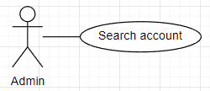

|  |  |  |  |  |  |
| --- | --- | --- | --- | --- | --- |
| **ID and Name** | **UC-69: Search account** | | | | |
| Created By: | TungVS | | Date Created: | | 08/08/2022 |
| Primary Actor: | Admin | | Secondary Actor: | | N/A |
| Trigger: | Actor wants to search account. | | | | |
| Description: | This feature allows actor to search account. | | | | |
| Preconditions: | Actor has logged into IKFTS application. | | | | |
| Post-conditions: | **Success:** System show list account match the search key with filter  **Failed:** System informs error message | | | | |
| Normal Flow: | **Step** | **Actor Action** | | **System Response** | |
| 1 | Actor clicks on “Account” on side bar | | System shows list account | |
| 2 | Actor select filter and input value | |  | |
| 3 | Actor clicks on search icon button | | System show list account match with search filter and key  [Exception 1] | |
| Alternative Flows: | N/A | | | | |
| Exceptions: | **No** | **Cause** | | **System Response** | |
| 1 | No accounts match | | System show “No Data” | |
| Priority: | High | | | | |
| Frequency of Use: | Usually | | | | |
| Business Rule: | BR-61: List account will be paging with page size is 5. | | | | |
| Other Information: | N/A | | | | |
| Assumptions: | Internet connection is available. | | | | |

##### View Detail Of Account

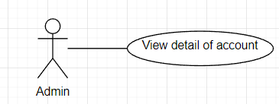

|  |  |  |  |  |  |
| --- | --- | --- | --- | --- | --- |
| **ID and Name** | **UC-70: View detail of account** | | | | |
| Created By: | TungVS | | Date Created: | | 08/08/2022 |
| Primary Actor: | Admin | | Secondary Actor: | | N/A |
| Trigger: | Actor wants to view detail of account. | | | | |
| Description: | This feature allows actor to view detail of account. | | | | |
| Preconditions: | Actor has logged into IKFTS application. | | | | |
| Post-conditions: | **Success:** System redirects Account Detail page  **Failed:** System informs error message | | | | |
| Normal Flow: | **Step** | **Actor Action** | | **System Response** | |
| 1 | Actor clicks on “Account” on side bar | | System shows list account | |
| 2 | Actor clicks on “Detail” button in list account | | System redirects Account Detail page with list of kiosk | |
| Alternative Flows: | N/A | | | | |
| Exceptions: | N/A | | | | |
| Priority: | High | | | | |
| Frequency of Use: | Usually | | | | |
| Business Rule: | BR-62: Password will be hidden. | | | | |
| Other Information: | N/A | | | | |
| Assumptions: | Internet connection is available. | | | | |

##### Create Kiosk

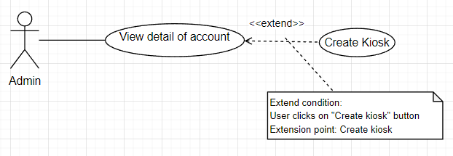

|  |  |  |  |  |  |
| --- | --- | --- | --- | --- | --- |
| **ID and Name** | **UC-71: Create kiosk** | | | | |
| Created By: | TungVS | | Date Created: | | 08/08/2022 |
| Primary Actor: | Admin | | Secondary Actor: | | N/A |
| Trigger: | Actor wants to create kiosk. | | | | |
| Description: | This feature allows actor to create kiosk. | | | | |
| Preconditions: | Actor has logged into IKFTS application. | | | | |
| Post-conditions: | **Success:** System insert new kiosk entity  **Failed:** System informs error message | | | | |
| Normal Flow: | **Step** | **Actor Action** | | **System Response** | |
| 1 | Actor clicks on “Account” on side bar | | System shows list account | |
| 2 | Actor clicks on “Detail” button | | System redirects Account Detail page with list of kiosk | |
| 3 | Actor clicks on “Create kiosk” button | | System show confirm popup “Are you sure to create Kiosk?” | |
| 4 | Actor clicks on “Confirm” button  [Alternative 1] | | System insert new kiosk, close popup, show toast “Create Success” and refresh list kiosk | |
| Alternative Flows: | **Step** | **Actor Action** | | **System Response** | |
| 1 | Actor clicks on “Cancel” button | | System close popup | |
| Exceptions: | N/A | | | | |
| Priority: | High | | | | |
| Frequency of Use: | Usually | | | | |
| Business Rule: | N/A | | | | |
| Other Information: | N/A | | | | |
| Assumptions: | Internet connection is available. | | | | |

##### Update Account

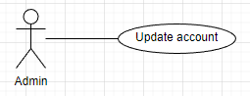

|  |  |  |  |  |  |
| --- | --- | --- | --- | --- | --- |
| **ID and Name** | **UC-72: Create kiosk** | | | | |
| Created By: | TungVS | | Date Created: | | 08/08/2022 |
| Primary Actor: | Admin | | Secondary Actor: | | N/A |
| Trigger: | Actor wants to update information of user’s account. | | | | |
| Description: | This feature allows actor to update information of user’s account. | | | | |
| Preconditions: | Actor has logged into IKFTS application.  Actor has at least 1 account in system except admin to update. | | | | |
| Post-conditions: | **Success:** Account information is updated.  **Failed:** System informs error message | | | | |
| Normal Flow: | **Step** | **Actor Action** | | **System Response** | |
| 1 | Actor clicks on “Account” on side bar. | | System shows list account. | |
| 2 | Actor clicks on “Edit” button on the chosen account. | | System shows popup Edit form. | |
| 3 | Actor fills information they want to edit. | |  | |
| 4 | Actor clicks on “Save” button.  [Alternative 1] | | System show toast “Edit account success” and refresh list account. | |
| Alternative Flows: | **Step** | **Actor Action** | | **System Response** | |
| 1 | Actor clicks on “Close” icon. | | System closes popup. | |
| Exceptions: | N/A | | | | |
| Priority: | High | | | | |
| Frequency of Use: | Usually | | | | |
| Business Rule: | N/A | | | | |
| Other Information: | N/A | | | | |
| Assumptions: | Internet connection is available. | | | | |

##### Update Status Of Account

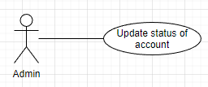

|  |  |  |  |  |  |
| --- | --- | --- | --- | --- | --- |
| **ID and Name** | **UC-73: Update Status Of Account** | | | | |
| Created By: | TungVS | | Date Created: | | 08/08/2022 |
| Primary Actor: | Admin | | Secondary Actor: | | N/A |
| Trigger: | Actor wants to update status of user’s account. | | | | |
| Description: | This feature allows actor to update status of user’s account. | | | | |
| Preconditions: | Actor has logged into IKFTS application.  Actor has at least 1 account in system except admin to update. | | | | |
| Post-conditions: | **Success:** Account’s status is updated.  **Failed:** System informs error message | | | | |
| Normal Flow: | **Step** | **Actor Action** | | **System Response** | |
| 1 | Actor clicks on “Account” on side bar. | | System shows list account. | |
| 2 | Actor clicks on “Change Status” button on the chosen account. | | System shows popup Confirm form. | |
| 3 | Actor clicks “Yes” button.  [Alternative 1] | | System shows toast “Change status account success” and refresh list account. | |
| Alternative Flows: | **Step** | **Actor Action** | | **System Response** | |
| 1 | Actor clicks on “No” icon. | | System closes popup. | |
| Exceptions: | N/A | | | | |
| Priority: | BR-63: After status of account is changed, system will automatically send mail to user to notify about this. | | | | |
| Frequency of Use: | Usually | | | | |
| Business Rule: | N/A | | | | |
| Other Information: | N/A | | | | |
| Assumptions: | Internet connection is available. | | | | |

##### Create Server Event

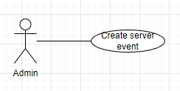

|  |  |  |  |  |  |
| --- | --- | --- | --- | --- | --- |
| **ID and Name** | **UC-74: Create Server Event** | | | | |
| Created By: | TungVS | | Date Created: | | 08/08/2022 |
| Primary Actor: | Admin | | Secondary Actor: | | Location owner |
| Trigger: | Actor wants to create server event. | | | | |
| Description: | This feature allows actor to create server event. | | | | |
| Preconditions: | Actor has logged into IKFTS application. | | | | |
| Post-conditions: | **Success:** System insert new event entity  **Failed:** System informs error message | | | | |
| Normal Flow: | **Step** | **Actor Action** | | **System Response** | |
| 1 | Actor clicks on “Event” on side bar | | System shows list event | |
| 2 | Actor clicks on “+Event” button | | System redirects Event Creating page | |
| 3 | Actor fills information | |  | |
| 4 | Actor clicks on “Create Event” button | | System shows toast “Create Success”  [Exception]{12} | |
| Alternative Flows: | N/A | | | | |
| Exceptions: | **No** | **Cause** | | **System Response** | |
|  | 1 | Name field is empty. | | System show error text “Please input name !” | |
|  | 2 | Description field is empty. | | System show error text “Please input description” | |
|  | 3 | Time start field is empty. | | System show error text “Please select date start !”  “Please select time start !” | |
|  | 4 | Time end field is empty. | | System show error text “Please select date end !”  “Please select time end !” | |
|  | 5 | Address field is empty. | | System show error text “Please input address !” | |
|  | 6 | City field is empty. | | System show error text “Please choose city !” | |
|  | 7 | District field is empty. | | System show error text “Please choose district !” | |
|  | 8 | Ward field is empty. | | System show error text “Please choose ward !” | |
|  | 9 | Thumbnail is not selected yet. | | System show error text “Please input Thumbnail !” | |
|  | 10 | List image is not selected yet. | | System show error text “Please choose picture to list image !” | |
|  | 11 | Time start is after time end. | | System show toast “Please recheck date and time ending” | |
|  | 12 | Time start is before current time . | | System show toast “Date star is over” | |
| Priority: | High | | | | |
| Frequency of Use: | Usually | | | | |
| Business Rule: | BR-64: Each event has a maximum of 5 images, minimum of 1 image.  BR-65: Event type which is created by Admin is “Server”. | | | | |
| Other Information: | N/A | | | | |
| Assumptions: | Internet connection is available. | | | | |

##### Update Server Event

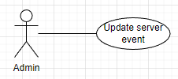

|  |  |  |  |  |  |
| --- | --- | --- | --- | --- | --- |
| **ID and Name** | **UC-75: Update Server Event** | | | | |
| Created By: | TungVS | | Date Created: | | 08/08/2022 |
| Primary Actor: | Admin | | Secondary Actor: | | Location owner |
| Trigger: | Actor wants to update event which type is “Server”. | | | | |
| Description: | This feature allows actor to update event which type is “Server”. | | | | |
| Preconditions: | Actor has logged into IKFTS application.  Actor must have at least 1 event to update. | | | | |
| Post-conditions: | **Success:** System update event entity  **Failed:** System informs error message | | | | |
| Normal Flow: | **Step** | **Actor Action** | | **System Response** | |
| 1 | Actor clicks on “Event” on side bar | | System shows list event | |
| 2 | Actor clicks on “Detail” button in list event | | System redirects Event Detail page | |
| 3 | Actor fills information | |  | |
| 4 | Actor clicks on “Update” button in form want to update | | System shows toast “Update Success”  [Exception]{12}  [Alternative1] | |
| Alternative Flows: | N/A | | | | |
| Exceptions: | **No** | **Cause** | | **System Response** | |
| 1 | Name field is empty | | System shows error text “Please input name !” | |
| 2 | Description field is empty | | System shows error text “Please input description” | |
| 3 | Time start field is empty | | System shows error text “Please select date start !”  “Please select time start !” | |
| 4 | Time end field is empty | | System shows error text “Please select date end !”  “Please select time end !” | |
| 5 | Address field is empty | | System shows error text “Please input address !” | |
| 6 | City field is empty | | System shows error text “Please choose city !” | |
| 7 | District field is empty | | System shows error text “Please choose district !” | |
| 8 | Ward field is empty | | System shows error text “Please choose ward !” | |
| 9 | Thumbnail is not selected yet | | System shows toast “Please add thumbnail iamge !” | |
| 10 | List image is not selected yet | | System shows toast “Please input at least 1 picture to list !” | |
| 11 | Time start is after time end | | System shows toast “Please recheck date and time ending” | |
| 12 | Time start is before current time | | System shows toast “Date star is over” | |
| Priority: | High | | | | |
| Frequency of Use: | Usually | | | | |
| Business Rule: | BR-64: Each event has a maximum of 5 images, minimum of 1 image.  BR-66: Admin can only update event which type is “Server”. | | | | |
| Other Information: | N/A | | | | |
| Assumptions: | Internet connection is available. | | | | |

##### Delete Server Event

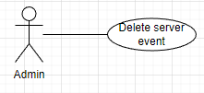

|  |  |  |  |  |  |
| --- | --- | --- | --- | --- | --- |
| **ID and Name** | **UC-76: Delete Server Event** | | | | |
| Created By: | TungVS | | Date Created: | | 08/08/2022 |
| Primary Actor: | Admin | | Secondary Actor: | | Location owner |
| Trigger: | Actor wants to delete event which type is “Server”. | | | | |
| Description: | This feature allows actor to delete event which type is “Server”. | | | | |
| Preconditions: | Actor has logged into IKFTS application. | | | | |
| Post-conditions: | **Success:** System change status of event entity to deleted.  **Failed:** System informs error message | | | | |
| Normal Flow: | **Step** | **Actor Action** | | **System Response** | |
| 1 | Actor clicks on “Event” on side bar. | | System shows list event | |
| 2 | Actor clicks on “Delete” button in list event. | | System shows confirm popup “Confirm delete event” | |
| 3 | Actor clicks on “Yes” button.  [Alternative 1] | | System changes status of event to deleted, close popup and show toast “Delete Success” | |
| Alternative Flows: | **Step** | **Actor Action** | | **System Response** | |
| 1 | Actor clicks on “No” button. | | System close confirm popup. | |
| Exceptions: | N/A | | | | |
| Priority: | High | | | | |
| Frequency of Use: | Usually | | | | |
| Business Rule: | BR-67: Admin can only delete event which type is “Server”. | | | | |
| Other Information: | N/A | | | | |
| Assumptions: | Internet connection is available. | | | | |

##### View Detail Of Server Event

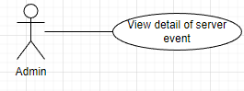

|  |  |  |  |  |  |
| --- | --- | --- | --- | --- | --- |
| **ID and Name** | **UC-77: View Detail of Server Event** | | | | |
| Created By: | TungVS | | Date Created: | | 08/08/2022 |
| Primary Actor: | Admin | | Secondary Actor: | | Location owner |
| Trigger: | Actor wants to view detail of server event. | | | | |
| Description: | This feature allows actor to view detail of server event. | | | | |
| Preconditions: | Actor has logged into IKFTS application.  Actor must have at least 1 server event to view detail. | | | | |
| Post-conditions: | **Success:** System redirects Event Detail page  **Failed:** System informs error message | | | | |
| Normal Flow: | **Step** | **Actor Action** | | **System Response** | |
| 1 | Actor clicks on “Event” on side bar | | System shows list event | |
| 2 | Actor clicks on “Detail” button in list event | | System redirects Event Detail page | |
| Alternative Flows: | N/A | | | | |
| Exceptions: | N/A | | | | |
| Priority: | High | | | | |
| Frequency of Use: | Usually | | | | |
| Business Rule: | N/A | | | | |
| Other Information: | N/A | | | | |
| Assumptions: | Internet connection is available. | | | | |

##### Search Server Event

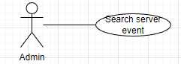

|  |  |  |  |  |  |  |
| --- | --- | --- | --- | --- | --- | --- |
| **ID and Name** | **UC-78: Search Server Event** | | | | | |
| Created By: | TungVS | | | Date Created: | | 08/08/2022 |
| Primary Actor: | Admin | | | Secondary Actor: | | Location owner |
| Trigger: | Actor wants to search server event. | | | | | |
| Description: | This feature allows actor to search server event. | | | | | |
| Preconditions: | Actor has logged into IKFTS application. | | | | | |
| Post-conditions: | **Success:** System show list event match filter and search key  **Failed:** System informs error message | | | | | |
| Normal Flow: | **Step** | | **Actor Action** | | **System Response** | |
| 1 | | Actor clicks on “Event” on side bar | | System shows list event | |
| 2 | | Actor select filter and input value | |  | |
| 3 | | Actor clicks on search icon button | | System show list event match with search filter and key  [Exception 1] | |
| Alternative Flows: | N/A | | | | | |
| Exceptions: | **No** | **Cause** | | | **System Response** | |
| 1 | No event match search key | | | System show “No Data” | |
| Priority: | High | | | | | |
| Frequency of Use: | Usually | | | | | |
| Business Rule: | BR-68: List event will be paging with page size is 5. | | | | | |
| Other Information: | N/A | | | | | |
| Assumptions: | Internet connection is available. | | | | | |

##### Create App Category

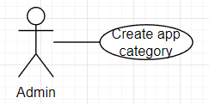

|  |  |  |  |  |  |
| --- | --- | --- | --- | --- | --- |
| **ID and Name** | **UC-79: Create app category** | | | | |
| Created By: | TungVS | | Date Created: | | 08/08/2022 |
| Primary Actor: | Admin | | Secondary Actor: | | N/A |
| Trigger: | Actor wants to create app category. | | | | |
| Description: | This feature allows actor to create app category. | | | | |
| Preconditions: | Actor has logged into IKFTS application. | | | | |
| Post-conditions: | **Success:** System insert new app category entity  **Failed:** System informs error message | | | | |
| Normal Flow: | **Step** | **Actor Action** | | **System Response** | |
| 1 | Actor clicks on “App Category” on side bar | | System shows list app category | |
| 2 | Actor clicks on “+App Category” button | | System shows popup a form detail of app category | |
| 3 | Actor fills information | |  | |
| 4 | Actor clicks on “Create App Category” button  [Alternative1] | | System shows toast “Create Success” and close popup  [Exception 1]  [Exception 2]  [Exception 3] | |
| Alternative Flows: | **Step** | **Actor Action** | | **System Response** | |
| 1 | Actor clicks “x” button or clicks out side the popup | | System close popup | |
| Exceptions: | **No** | **Cause** | | **System Response** | |
| 1 | Name of app category is exist | | System send toast “Category name existed” | |
| 2 | Name field is empty | | System show error text “Please input name !” | |
| 3 | Haven't chosen an image for the logo yet | | System show error text “Please input logo !” | |
| 4 | Commission field is empty | | System show error text “Please input commission percentage !” | |
| Priority: | High | | | | |
| Frequency of Use: | Usually | | | | |
| Business Rule: | BR-69: App category name cannot be duplicated.  BR-70: Commission must be a float number. | | | | |
| Other Information: | N/A | | | | |
| Assumptions: | Internet connection is available. | | | | |

##### Update App Category

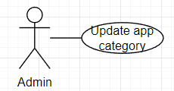

|  |  |  |  |  |  |
| --- | --- | --- | --- | --- | --- |
| **ID and Name** | **UC-80: Update app category** | | | | |
| Created By: | TungVS | | Date Created: | | 08/08/2022 |
| Primary Actor: | Admin | | Secondary Actor: | | N/A |
| Trigger: | Actor wants to update app category. | | | | |
| Description: | This feature allows actor to update app category. | | | | |
| Preconditions: | Actor has logged into IKFTS application.  Actor must have at least 1 app category to update. | | | | |
| Post-conditions: | **Success:** System update app category entity  **Failed:** System informs error message | | | | |
| Normal Flow: | **Step** | **Actor Action** | | **System Response** | |
| 1 | Actor clicks on “App Category” on side bar | | System shows list app category | |
| 2 | Actor clicks on “UPDATE” button in poi category | | System popup a form detail of app category and auto fills old data | |
| 3 | Actor change data on form | |  | |
| 4 | Actor clicks on “Update Application Category” button  [Alternative1] | | System update category, show toast “Update Success”, close popup and refresh list category  [Exception 1]  [Exception 2]  [Exception 3] | |
| Alternative Flows: | **Step** | **Actor Action** | | **System Response** | |
| 1 | Actor clicks “x” button or clicks out side the popup | | System close popup | |
| Exceptions: | **No** | **Cause** | | **System Response** | |
| 1 | Name of app category is exist | | System send toast “Category name existed” | |
| 2 | Name field is empty | | System show error text “Please input name !” | |
| 3 | Haven't chosen an image for the logo yet | | System show error text “Please input logo !” | |
| 4 | Commission field is empty | | System show error text “Please input commission percentage !” | |
| Priority: | High | | | | |
| Frequency of Use: | Usually | | | | |
| Business Rule: | BR-69: App category name cannot be duplicated. | | | | |
| Other Information: | N/A | | | | |
| Assumptions: | Internet connection is available. | | | | |

##### Delete App Category

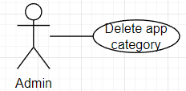

|  |  |  |  |  |  |
| --- | --- | --- | --- | --- | --- |
| **ID and Name** | **UC-81: Delete app category** | | | | |
| Created By: | TungVS | | Date Created: | | 08/08/2022 |
| Primary Actor: | Admin | | Secondary Actor: | | N/A |
| Trigger: | Actor wants to delete app category. | | | | |
| Description: | This feature allows actor to delete app category. | | | | |
| Preconditions: | Actor has logged into IKFTS application.  Actor must have at least 1 app category to delete. | | | | |
| Post-conditions: | **Success:** System delete app category entity  **Failed:** System informs error message | | | | |
| Normal Flow: | **Step** | **Actor Action** | | **System Response** | |
| 1 | Actor clicks on “App Category” on side bar | | System shows list app category | |
| 2 | Actor clicks on “Delete” button in list app category | | System show confirm popup “Are you sure to delete this application category” | |
| 3 | Actor clicks on “Yes” button  [Alternative 1] | | System show toast “Delete Success” , close popup and refresh list app category  [Exception 1] | |
| Alternative Flows: | **Step** | **Actor Action** | | **System Response** | |
| 1 | Actor clicks “No” button or clicks out side the popup | | System close popup | |
| Exceptions: | **No** | **Cause** | | **System Response** | |
| 1 | Has app on poi category | | System show toast “Already app on this category, can not delete” | |
| Priority: | High | | | | |
| Frequency of Use: | Usually | | | | |
| Business Rule: | BR-71: Actor can not delete category which has at least 1 application set on that category. | | | | |
| Other Information: | N/A | | | | |
| Assumptions: | Internet connection is available. | | | | |

##### View Detail Of Embedded Application Publish Request

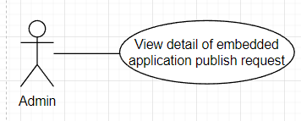

|  |  |  |  |  |  |
| --- | --- | --- | --- | --- | --- |
| **ID and Name** | **UC-82: View detail of embedded application publish request** | | | | |
| Created By: | TungVS | | Date Created: | | 08/08/2022 |
| Primary Actor: | Admin | | Secondary Actor: | | N/A |
| Trigger: | Actor wants to view detail of embedded application publish request. | | | | |
| Description: | This feature allows actor to view detail of embedded application publish request. | | | | |
| Preconditions: | Actor has logged into IKFTS application. | | | | |
| Post-conditions: | **Success:** System redirects publish request detail page.  **Failed:** System informs error message | | | | |
| Normal Flow: | **Step** | **Actor Action** | | **System Response** | |
| 1 | Actor clicks on “App Publish” on side bar. | | System shows list app publish request. | |
| 2 | Actor clicks on “Detail” button in list request. | | System redirects Publish Application Detail page. | |
| Alternative Flows: | N/A | | | | |
| Exceptions: | N/A | | | | |
| Priority: | High | | | | |
| Frequency of Use: | Usually | | | | |
| Business Rule: | N/A | | | | |
| Other Information: | N/A | | | | |
| Assumptions: | Internet connection is available. | | | | |

##### Deny Embedded Application Publish Request

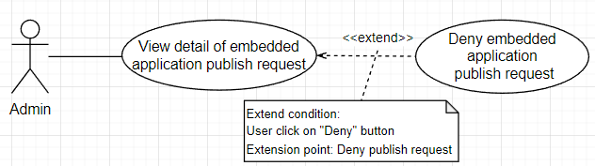

|  |  |  |  |  |  |
| --- | --- | --- | --- | --- | --- |
| **ID and Name** | **UC-83: Deny embedded application publish request** | | | | |
| Created By: | TungVS | | Date Created: | | 08/08/2022 |
| Primary Actor: | Admin | | Secondary Actor: | | N/A |
| Trigger: | Actor wants to deny embedded application publish request. | | | | |
| Description: | This feature allows actor to deny embedded application publish request. | | | | |
| Preconditions: | Actor has logged into IKFTS application.  Actor must have at least 1 request to publish which status is “Pending” to deny. | | | | |
| Post-conditions: | **Success:** System change status of publish request and application.  **Failed:** System informs error message | | | | |
| Normal Flow: | **Step** | **Actor Action** | | **System Response** | |
| 1 | Actor clicks on “App Publish” on side bar. | | System shows list app publish request. | |
| 2 | Actor clicks on “Detail” button in list request. | | System redirects Publish Application Detail page. | |
| 3 | Actor clicks on “Deny” button. | | System show confirm popup “Are you sure to deny this app?” | |
| 4 | Actor clicks on “Yes” button.  [Alternative 1] | | System show form popup with Comment text area. | |
| 5 | Actor clicks on “Deny publish request” button.  [Alternative 2] | | System change status, refresh page and show toast “Deny publish app success” | |
| Alternative Flows: | **Step** | **Actor Action** | | **System Response** | |
| 1 | Actor clicks on “No” button. | | System close confirm popup. | |
| 1 | Actor clicks on “X” icon. | | System close popup. | |
| Exceptions: | N/A | | | | |
| Priority: | High | | | | |
| Frequency of Use: | Usually | | | | |
| Business Rule: | BR-72: System automatically send mail to user to notify that their application is denied to publish. | | | | |
| Other Information: | N/A | | | | |
| Assumptions: | Internet connection is available. | | | | |

##### Approve Embedded Application Publish Request

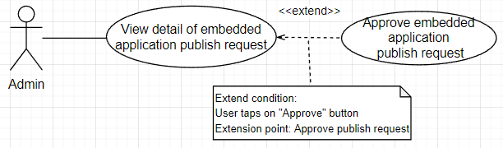

|  |  |  |  |  |  |
| --- | --- | --- | --- | --- | --- |
| **ID and Name** | **UC-84: Approve embedded application publish request** | | | | |
| Created By: | TungVS | | Date Created: | | 08/08/2022 |
| Primary Actor: | Admin | | Secondary Actor: | | N/A |
| Trigger: | Actor wants to approve embedded application publish request. | | | | |
| Description: | This feature allows actor to approve embedded application publish request. | | | | |
| Preconditions: | Actor has logged into IKFTS application.  Actor must have at least 1 request to publish which status is “Pending” to approve. | | | | |
| Post-conditions: | **Success:** System change status of publish request and application.  **Failed:** System informs error message | | | | |
| Normal Flow: | **Step** | **Actor Action** | | **System Response** | |
| 1 | Actor clicks on “App Publish” on side bar. | | System shows list app publish request. | |
| 2 | Actor clicks on “Detail” button in list request. | | System redirects Publish Application Detail page. | |
| 3 | Actor clicks on “Approve” button. | | System shows confirm popup “Are you sure to approve this app?” | |
| 4 | Actor clicks on “Yes” button.  [Alternative 1] | | System changes status, send mail, notification, refresh page and show toast “Approve publish app success” | |
| Alternative Flows: | **Step** | **Actor Action** | | **System Response** | |
| 1 | Actor clicks on “No” button. | | System closes confirm popup. | |
| Exceptions: | N/A | | | | |
| Priority: | High | | | | |
| Frequency of Use: | Usually | | | | |
| Business Rule: | BR-73: System automatically send mail to user to notify that their application is approved to publish. | | | | |
| Other Information: | N/A | | | | |
| Assumptions: | Internet connection is available. | | | | |

##### Stop Embedded Application

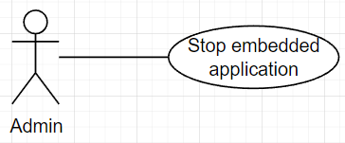

|  |  |  |  |  |  |
| --- | --- | --- | --- | --- | --- |
| **ID and Name** | **UC-85: Stop embedded application** | | | | |
| Created By: | TungVS | | Date Created: | | 08/08/2022 |
| Primary Actor: | Admin | | Secondary Actor: | | N/A |
| Trigger: | Actor wants to stop embedded application. | | | | |
| Description: | This feature allows actor to stop embedded application. | | | | |
| Preconditions: | Actor has logged into IKFTS application. | | | | |
| Post-conditions: | **Success:** System change status of service application, send mail and notification to service provider.  **Failed:** System informs error message | | | | |
| Normal Flow: | **Step** | **Actor Action** | | **System Response** | |
| 1 | Actor clicks on “Application” on side bar. | | System shows list application. | |
| 2 | Actor clicks on “Stop Application” button in list app. | | System show confirm popup “Are you sure to remove this application ?” | |
| 3 | Actor tap on “Yes” button.  [Alternative 1] | | System change status, send mail, notification, refresh page and show toast “Stop application success” | |
| Alternative Flows: | **Step** | **Actor Action** | | **System Response** | |
| 1 | Actor tap on “No” button.  [Alternative 1] | | System close confirm popup. | |
| Exceptions: | N/A | | | | |
| Priority: | High | | | | |
| Frequency of Use: | Usually | | | | |
| Business Rule: | BR-74: System automatically send mail to user to notify that their application is stopped. | | | | |
| Other Information: | N/A | | | | |
| Assumptions: | Internet connection is available. | | | | |

## Functional Requirements

### System Functional Overview

Screen Flow

##### Kiosk

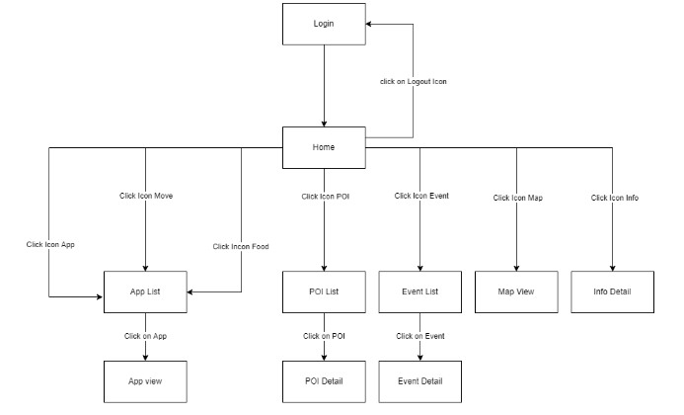

##### Location Owner on Portal Web Application

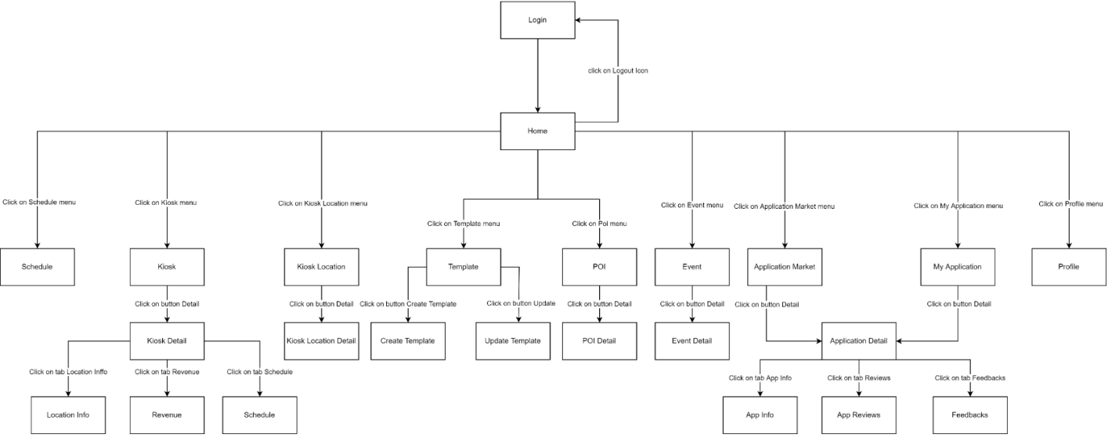

##### Service Provider on Portal Web Application

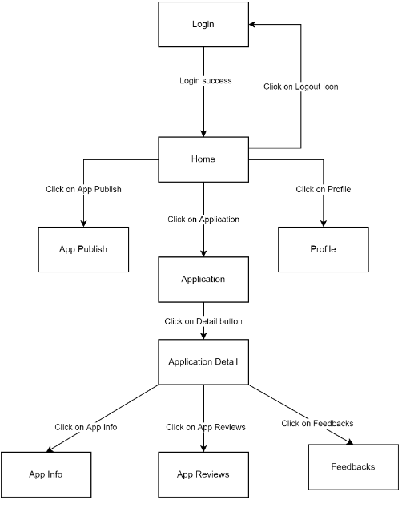

##### Admin on Portal Web Application

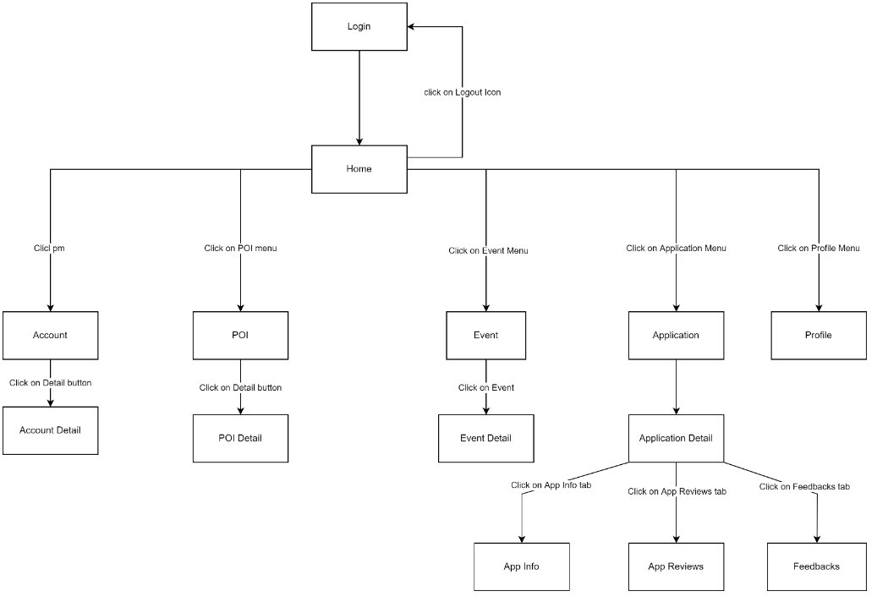

Screen Description

##### Kiosk

|  |  |  |  |
| --- | --- | --- | --- |
| ID | Feature | Screen | Description |
| KS-01 |  | Home |  |
| KS-02 |  | App List |  |
| KS-03 |  | App View |  |
| KS-04 |  | POI List |  |
| KS-05 |  | POI Detail |  |
| KS-06 |  | Event List |  |
| KS-07 |  | Event Detail |  |
| KS-08 |  | Map View |  |
| KS-09 |  | Info Detail |  |
| KS-10 |  | Login |  |

##### Renter Web Application

|  |  |  |  |
| --- | --- | --- | --- |
| ID | Feature | Screen | Description |
| KS-01 |  | Home |  |
| KS-02 |  | Schedule |  |
| KS-03 |  | Kiosk |  |
| KS-04 |  | Kiosk Detail |  |
| KS-05 |  | Location Info |  |
| KS-06 |  | Revenue |  |
| KS-07 |  | Schedule |  |
| KS-08 |  | Kiosk Location |  |
| KS-09 |  | Kiosk Location Detail |  |
| KS-10 |  | Template |  |
| KS-11 |  | Create Template |  |
| KS-12 |  | Update Template |  |
| KS-13 |  | POI |  |
| KS-14 |  | POI Detail |  |
| KS-15 |  | Event |  |
| KS-16 |  | Event Detail |  |
| KS-17 |  | Application Market |  |
| KS-18 |  | Application Detail |  |
| KS-19 |  | App Info |  |
| KS-20 |  | App Reviews |  |
| KS-21 |  | App Feedback |  |
| KS-22 |  | My Application |  |
| KS-23 |  | Profile |  |
| KS-24 |  | Login |  |

##### Service Provider Web Application

|  |  |  |  |
| --- | --- | --- | --- |
| ID | Feature | Screen | Description |
| KS-01 |  | Home |  |
| KS-02 |  | App Publish |  |
| KS-03 |  | Application |  |
| KS-04 |  | Application Detail |  |
| KS-05 |  | Profile |  |
| KS-06 |  | App Info |  |
| KS-07 |  | App Reviews |  |
| KS-08 |  | App Feedback |  |
| KS-09 |  | Login |  |

##### Admin Web Application

|  |  |  |  |
| --- | --- | --- | --- |
| ID | Feature | Screen | Description |
| KS-01 |  | Home |  |
| KS-02 |  | Account |  |
| KS-03 |  | Account Detail |  |
| KS-04 |  | POI |  |
| KS-05 |  | Event |  |
| KS-06 |  | Event Detail |  |
| KS-07 |  | Application |  |
| KS-08 |  | Application Detail |  |
| KS-09 |  | App Info |  |
| KS-10 |  | App Reviews |  |
| KS-11 |  | App Feedback |  |
| KS-12 |  | Profile |  |
| KS-13 |  | Login |  |

Non-Screen Functions

|  |  |  |
| --- | --- | --- |
| # | System Function | Description |
| 1 | Update Event Status to “End” | Update “Coming soon” and “On Going” Event to “End” status when event is end. This function runs every hour. |

Entity Relationship Diagram

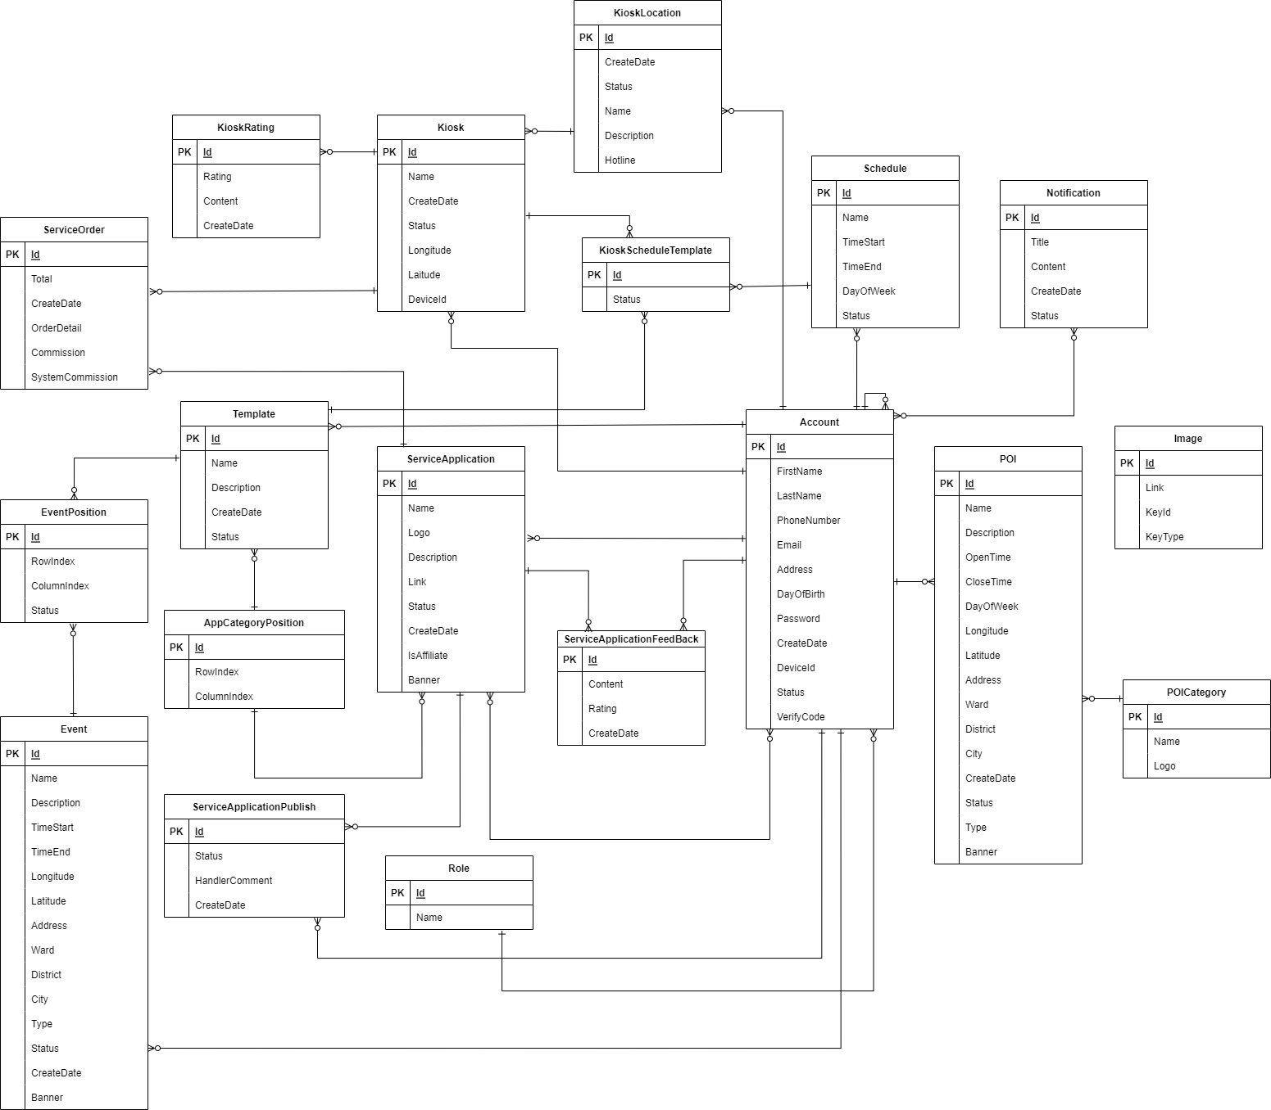

##### ServiceOrder Entity

|  |  |  |
| --- | --- | --- |
| **No** | **Attribute** | **Description** |
|  | Id | Unique definition of service order |
|  | Total | Total of service order |
|  | CreateDate | Create date of service order |
|  | OrderDetail | Order detail of service order |
|  | Commission | Commission of service order |
|  | SystemCommission | System commission of service order |

##### Template Entity

|  |  |  |
| --- | --- | --- |
| **No** | **Attribute** | **Description** |
|  | Id | Unique definition of template |
|  | Name | Name of template |
|  | Description | Description of template |
|  | CreateDate | Create date of template |
|  | Status | Status of template |

##### EventPosition Entity

|  |  |  |
| --- | --- | --- |
| **No** | **Attribute** | **Description** |
|  | Id | Unique definition of event position |
|  | RowIndex | Row index of event position |
|  | ColumnIndex | Column index of event position |
|  | Status | Status of event position |

##### Event Entity

|  |  |  |
| --- | --- | --- |
| **No** | **Attribute** | **Description** |
|  | Id | Unique definition of event |
|  | Name | Name of event |
|  | Description | Description of event |
|  | TimeStart | Time start of event |
|  | TimeEnd | Time end of event |
|  | Longitude | Longitude of event |
|  | Latitude | Latitude of event |
|  | Address | Address of event |
|  | Ward | Ward of event |
|  | District | District of event |
|  | City | City of event |
|  | Type | Type of event |
|  | Status | Status of event |
|  | CreateDate | Create date of event |
|  | Banner | Banner of event |

##### AppCategoryPosition Entity

|  |  |  |
| --- | --- | --- |
| **No** | **Attribute** | **Description** |
|  | Id | Unique definition of app category position |
|  | RowIndex | Row index of app category position |
|  | ColumnIndex | Column index of app category position |

##### ServiceApplicationPublish Entity

|  |  |  |
| --- | --- | --- |
| **No** | **Attribute** | **Description** |
|  | Id | Unique definition of service application publish |
|  | Status | Status of service application publish |
|  | HandlerComment | Handler comment of service application publish |
|  | CreateDate | Create date of service application publish |

##### ServiceApplication Entity

|  |  |  |
| --- | --- | --- |
| **No** | **Attribute** | **Description** |
|  | Id | Unique definition of service application |
|  | Name | Name of service application |
|  | Logo | Logo of service application |
|  | Description | Description of service application |
|  | Link | Link of service application |
|  | Status | Status of service application |
|  | CreateDate | Create Date of service application |
|  | IsAffiliate | App's Affiliate Marketing Confirmation |
|  | Banner | Banner of service application |

##### Role Entity

|  |  |  |
| --- | --- | --- |
| **No** | **Attribute** | **Description** |
|  | Id | Unique definition of role |
|  | Name | Name of role |

##### ServiceApplicationFeedback Entity

|  |  |  |
| --- | --- | --- |
| **No** | **Attribute** | **Description** |
|  | Id | Unique definition of service application feedback |
|  | Content | Content of service application feedback |
|  | Rating | Rating of service application feedback |
|  | CreateDate | Create date of service application feedback |

##### KioskRating Entity

|  |  |  |
| --- | --- | --- |
| No | Attribute | Description |
|  | Id | Unique definition of Kiosk Rating |
|  | Rating | Rating of kiosk |
|  | CreateDate | Create date of KioskRating |

##### Kiosk Entity

|  |  |  |
| --- | --- | --- |
| No | Attribute | Description |
|  | Id | Unique definition of kiosk |
|  | Name | Name of kiosk |
|  | CreateDate | Create date of kiosk |
|  | Status | Status of kiosk |
|  | Longitude | Longitude of kiosk |
|  | Latitude | Latitude of kiosk |
|  | DeviceId | DeviceId of kiosk |

##### KioskLocation Entity

|  |  |  |
| --- | --- | --- |
| No | Attribute | Description |
|  | Id | Unique definition of kiosk |
|  | CreateDate | Create date of kiosk location |
|  | Status | Status of kiosk location |
|  | Name | Name of kiosk location |
|  | Description | Description of kiosk location |
|  | Hotline | Hotline of kiosk location |

##### KioskScheduleTemplate Entity

|  |  |  |
| --- | --- | --- |
| No | Attribute | Description |
|  | Id | Unique definition of kiosk schedule template |
|  | Status | Status of kiosk schedule template |

##### Schedule Entity

|  |  |  |
| --- | --- | --- |
| No | Attribute | Description |
|  | Id | Unique definition of schedule |
|  | Name | Name of schedule |
|  | TimeStart | TimeStart of schedule |
|  | TimeEnd | TimeEnd of schedule |
|  | DayOfWeek | DayOfWeek of schedule |
|  | Status | Status of schedule |

##### Account Entity

|  |  |  |
| --- | --- | --- |
| No | Attribute | Description |
|  | Id | Unique definition of account |
|  | FirstName | First name of account |
|  | LastName | Last name of account |
|  | PhoneNumber | Phone Number of account |
|  | Email | Email of account |
|  | Address | Address of account |
|  | DayOfBirth | Day of birth of account |
|  | Password | Password of account |
|  | CreateDate | Create date of account |
|  | DeviceId | Device Id of account |
|  | Status | Status of account |
|  | Verify Code | Verify code of account |

##### POI Entity

|  |  |  |
| --- | --- | --- |
| No | Attribute | Description |
|  | Id | Unique definition of POI |
|  | Name | Name of POI |
|  | Description | Description of POI |
|  | OpenTime | Open time of POI |
|  | CloseTime | Close time of POI |
|  | DayOfWeek | Day of week that POI work |
|  | Longitude | Longitude of POI |
|  | Latitude | Latitude of POI |
|  | Address | Address of POI |
|  | Ward | Ward of POI |
|  | District | District of POI |
|  | City | City of POI |
|  | CreateDate | Create date of POI |
|  | Status | Status of POI |
|  | Type | Type of POI |
|  | Banner | Banner of POI |

##### POICategory Entity

|  |  |  |
| --- | --- | --- |
| No | Attribute | Description |
|  | Id | Unique definition of POI category |
|  | Name | Name of POI category |
|  | Logo | Logo of POI category |

##### Notification Entity

|  |  |  |
| --- | --- | --- |
| No | Attribute | Description |
|  | Id | Unique definition of Notification |
|  | Name | Title of Notification |
|  | Content | Content of Notification |
|  | CreateDate | Create date of Notification |
|  | Status | Status of Notification |

## Non-Functional Requirements

### External Interfaces

User Interfaces

* The authenticated users UI must be fully shown in web app.

Communications Interfaces

* The system can call API through data transferred by HTTPS.

### Quality Attributes

Usability

* All text, label and message should be uniformly written in Vietnamese.
* The application should be friendly and easy for users to use without training.
* The web application for admin should require no more than 2 days of training of use.

Reliability

* N/A

Security

* System users is divided into 3 roles: Location Owner, Service Provider and Admin.
* All input data are validated before saving to the database.
* Each role only access to a group of functions.
* The system always checks authentication and authorization before doing any features.

# Software Design Description

## Overall Description

### Assumptions

This system is designed basing on these following assumptions:

* Window 10
* Chrome 96
* Microsoft Edge 96
* SQL Server 2019
* Ubuntu 20.4
* End-User: Tourists, Citizens, Location Owner, Kiosk Developer Team
* Security requirement: prevent users from cheating as much as possible.
* Network communication: This system depends on network connections.

## System Architecture Design

### Overall System Architecture

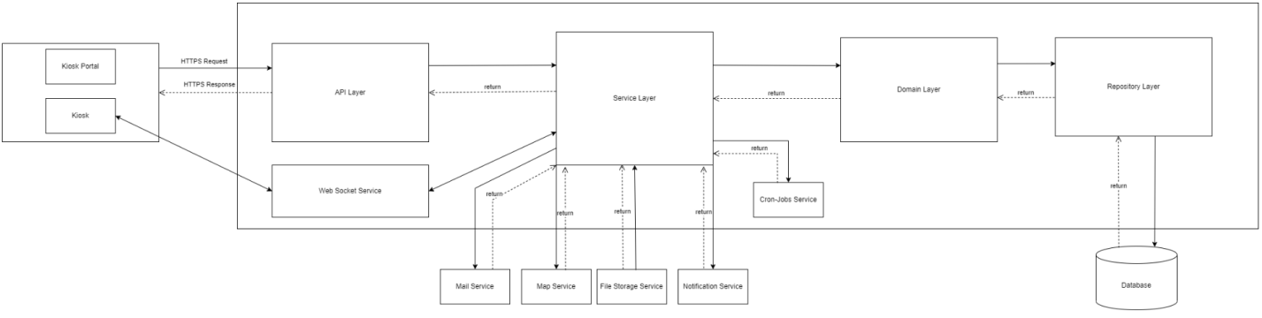

|  |  |  |
| --- | --- | --- |
| No. | Name | Description |
|  | File Storage Service | It oversees authenticating 3rd party account of the user and send the result to our system. |
|  | Email Service | It handles sending emails. |
|  | Notification service | It handles sending notification to users. |
|  | Map Service | It connects to 3rd Map API and gets data from it |
|  | Cron-Jobs Service | It provides the method to schedule a time to do job |
|  | Web Socket Service | It help Kiosk and API can connect and interactive communication sessions with real-time |
|  | Kiosk Portal | Client components to render and display data from the server.  Provide UI for Location Owner, Service Provider, Admin to manage Kiosk, POIs ,Events, Applications,… |
|  | Kiosk | Client components to render and display data from the server.  Provide UI for guest to interactive on map, application, view detail of events,… |
|  | API Layer | It handles requests from Kiosk portal and Kiosk and responses from the system. |
|  | Service Layer | It provides business logic to resolve all request |
|  | Domain Layer | It provides entities, models, data transfer object,… |
|  | Database | It stores the data of the system. |

### Component Diagram

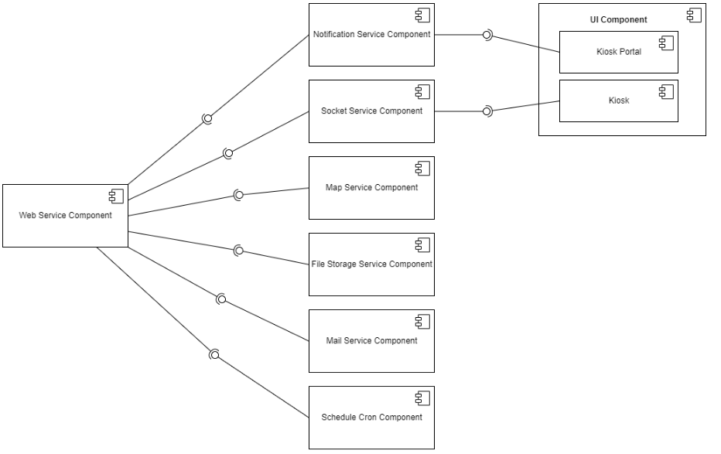

|  |  |  |
| --- | --- | --- |
| No. | Name | Description |
|  | Notification service components | This component handle issues related to notification |
|  | Socket Component | It provides methods to connect and communicate in real time between Server and UI |
|  | Map Service Component | It provides methods to get Map information, Map Directions, Geography,… |
|  | File Storage Service Component | It provides methods to storage files |
|  | Mail Service Component | It provides methods to send email |
|  | Schedule Cron Component | It provides the method to schedule a time to do job |
|  | Web Service Component | It handle all request from Kiosk Portal and Kiosk, resolve all system business logic and data then response to UI |
|  | Kiosk Portal | It provides UI for Location Owner, Service Provider, Admin to manage Kiosk, POIs ,Events, Applications,… |
|  | Kiosk | It provides UI for guest to interactive on map, application, view detail of events,… |

### Package Diagram

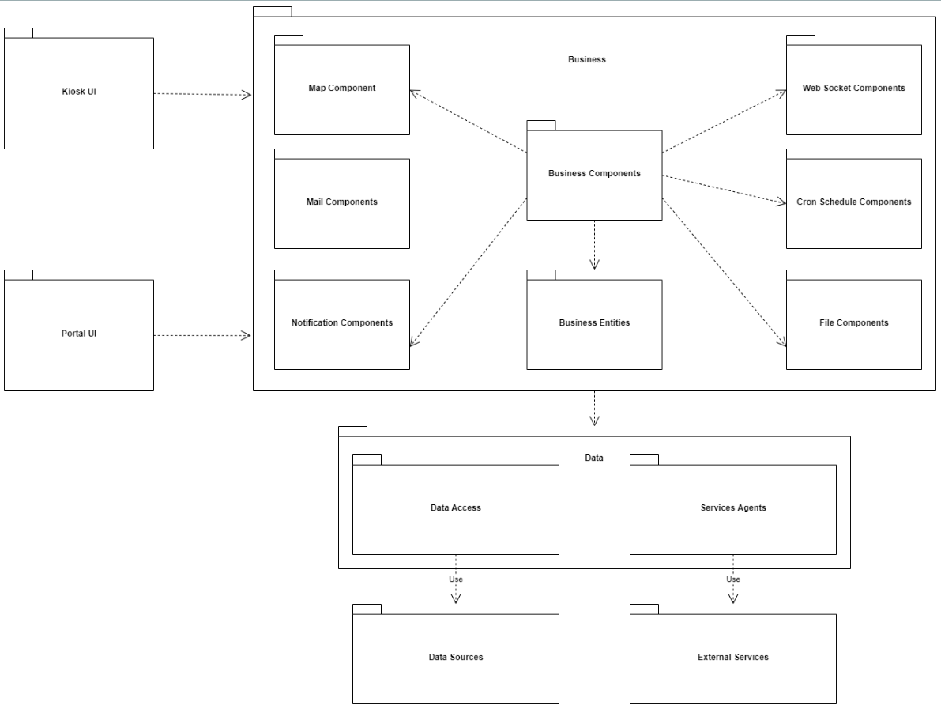

|  |  |  |
| --- | --- | --- |
| No. | Package | Description |
|  | Lib | This package contains folders of different layers in app. |
|  | Images | This package contains images using in app. |
|  | Config | This package contains configurations of environment variables which are used to run the application. |
|  | App | This package contains classes for app UI and business layers and main class. |
|  | Common | This package contains folders of common values and functions. |
|  | Constants | This package contains classes for common constants. |
|  | Providers | This package contains classes to send and receive HTTP requests from API. |
|  | Models | This package contains classes to map objects to/from json from API. |
|  | Utils | This package contains classes for common functions. |
|  | Enumerations | This package contains classes for enum data. |
|  | Widgets | This package contains classes for widget using in screen. |
|  | Bindings | This package contains classes to bind ui, controllers, providers. |
|  | Controllers | This package contains classes for controllers in app. |
|  | Views | This package contains classes for screen UI. |

## System Detailed Design

### Class Diagram

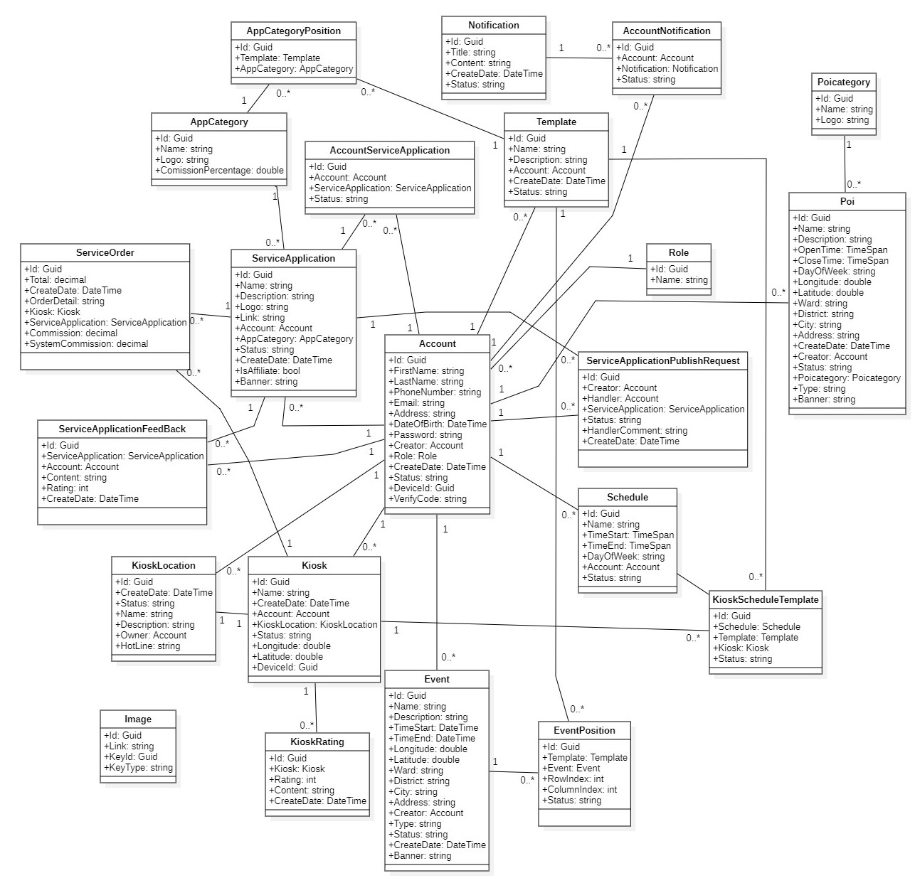

### Class Specification

Account Class

|  |  |  |  |  |
| --- | --- | --- | --- | --- |
| **No** | **Attribute** | **Data Type** | **Visibility** | **Description** |
|  | Id | Guid | Public | Unique id of account |
|  | FirstName | String | Public | First name of account |
|  | LastName | String | Public | Last name of account |
|  | PhoneNumber | String | Public | Phone number of account |
|  | Email | String | Public | Email of account |
|  | Address | String | Public | Address of account |
|  | DateOfBirth | DateTime | Public | Date of birth of account |
|  | Password | String | Public | Password of this account |
|  | Creator | Account | Public | Creator of account |
|  | Role | Role | Public | Role of account |
|  | CreateDate | DateTime | Public | Date create this account |
|  | Status | String | Public | Status of this account |
|  | DeviceId | Guid | Public | Device Id of this account |
|  | VerifyCode | String | Public | Verify code of this account |

|  |  |  |  |  |
| --- | --- | --- | --- | --- |
| **No** | **Method** | **Return Type** | **Accessibility** | **Description** |
| 1 | Get | DataType | Public | To get attribute value |
| 2 | Set | Void | Public | To set attribute value |

KioskLocation Class

|  |  |  |  |  |
| --- | --- | --- | --- | --- |
| **No** | **Attribute** | **Data Type** | **Visibility** | **Description** |
|  | Id | Guid | Public | Unique id of kiosk location |
|  | Name | String | Public | Name of kiosk location |
|  | Description | String | Public | Description of kiosk location |
|  | CreateDate | DateTime | Public | Date create this kiosk location |
|  | Status | String | Public | Status of kiosk location |
|  | Owner | Account | Public | Owner of kiosk location |
|  | HotLine | String | Public | Hotline of kiosk location |

|  |  |  |  |  |
| --- | --- | --- | --- | --- |
| **No** | **Method** | **Return Type** | **Accessibility** | **Description** |
| 1 | Get | DataType | Public | To get attribute value |
| 2 | Set | Void | Public | To set attribute value |

Kiosk Class

|  |  |  |  |  |
| --- | --- | --- | --- | --- |
| **No** | **Attribute** | **Data Type** | **Visibility** | **Description** |
|  | Id | Guid | Public | Id of kiosk |
|  | Name | String | Public | Name of kiosk |
|  | CreateDate | DateTime | Public | Date create of kiosk |
|  | Account | Account | Public | An account that is the owner of the kiosk |
|  | KioskLocation | KioskLocation | Public | Kiosk location of kiosk |
|  | Status | String | Public | Status of kiosk |
|  | Longitude | Double | Public | Longitude of kiosk |
|  | Latitude | Double | Public | Latitude of kiosk |
|  | DeviceId | Guid | Public | DeviceId of kiosk |

|  |  |  |  |  |
| --- | --- | --- | --- | --- |
| **No** | **Method** | **Return Type** | **Accessibility** | **Description** |
| 1 | Get | DataType | Public | To get attribute value |
| 2 | Set | Void | Public | To set attribute value |

AppCategory Class

|  |  |  |  |  |
| --- | --- | --- | --- | --- |
| **No** | **Attribute** | **Data Type** | **Visibility** | **Description** |
|  | Id | Guid | Public | Unique id of app category |
|  | Name | String | Public | Name of app category |
|  | Logo | String | Public | Logo of app category |
|  | CommissionPercentage | Double | Public | Commission percentage of app category |

|  |  |  |  |  |
| --- | --- | --- | --- | --- |
| **No** | **Method** | **Return Type** | **Accessibility** | **Description** |
| 1 | Get | DataType | Public | To get attribute value |
| 2 | Set | Void | Public | To set attribute value |

ServiceApplication Class

|  |  |  |  |  |
| --- | --- | --- | --- | --- |
| **No** | **Attribute** | **Data Type** | **Visibility** | **Description** |
|  | Id | Guid | Public | Unique id of service application |
|  | Name | String | Public | Name of service application |
|  | Description | String | Public | Description of service application |
|  | Logo | String | Public | Logo of service application |
|  | Link | String | Public | Link of service application' logo |
|  | Account | Account | Public | An account that is the owner of service application |
|  | AppCategory | AppCategory | Public | App category of service application |
|  | Status | String | Public | Status of service application |
|  | CreateDate | DateTime | Public | Application creation date |
|  | IsAffiliate | Bool | Public | Confirm the app has affiliate marketing or not |
|  | Banner | String | Public | Banner of service application |

|  |  |  |  |  |
| --- | --- | --- | --- | --- |
| **No** | **Method** | **Return Type** | **Accessibility** | **Description** |
| 1 | Get | DataType | Public | To get attribute value |
| 2 | Set | Void | Public | To set attribute value |

Schedule Class

|  |  |  |  |  |
| --- | --- | --- | --- | --- |
| **No** | **Attribute** | **Data Type** | **Visibility** | **Description** |
|  | Id | Guid | Public | Unique id of schedule |
|  | Name | String | Public | Name of schedule |
|  | TimeStart | TimeSpan | Public | Time start of schedule |
|  | TimeEnd | TimeSpan | Public | Time end of schedule |
|  | DayOfWeek | String | Public | Day of week that apply this schedule |
|  | Account | Account | Public | An account that is the owner of the schedule |
|  | Status | String | Public | Status of schedule |

|  |  |  |  |  |
| --- | --- | --- | --- | --- |
| **No** | **Method** | **Return Type** | **Accessibility** | **Description** |
| 1 | Get | DataType | Public | To get attribute value |
| 2 | Set | Void | Public | To set attribute value |

KioskScheduleTemplate Class

|  |  |  |  |  |
| --- | --- | --- | --- | --- |
| **No** | **Attribute** | **Data Type** | **Visibility** | **Description** |
|  | Id | Guid | Public | Unique id of kiosk schedule template |
|  | Kiosk | Kiosk | Public | The kiosk is set to template |
|  | Schedule | Schedule | Public | Schedule is set for kiosk |
|  | Template | Template | Public | Template is set for kiosk |
|  | Status | String | Public | Status of kiosk schedule template |

|  |  |  |  |  |
| --- | --- | --- | --- | --- |
| **No** | **Method** | **Return Type** | **Accessibility** | **Description** |
| 1 | Get | DataType | Public | To get attribute value |
| 2 | Set | Void | Public | To set attribute value |

Template Class

|  |  |  |  |  |
| --- | --- | --- | --- | --- |
| **No** | **Attribute** | **Data Type** | **Visibility** | **Description** |
|  | Id | Guid | Public | Unique id of template |
|  | Name | String | Public | Name of template |
|  | Description | String | Public | Description of template |
|  | Account | Account | Public | An account that is the owner of the template |
|  | CreateDate | DateTime | Public | Date create template |
|  | Status | String | Public | Status of template |

|  |  |  |  |  |
| --- | --- | --- | --- | --- |
| **No** | **Method** | **Return Type** | **Accessibility** | **Description** |
| 1 | Get | DataType | Public | To get attribute value |
| 2 | Set | Void | Public | To set attribute value |

Event Class

|  |  |  |  |  |
| --- | --- | --- | --- | --- |
| **No** | **Attribute** | **Data Type** | **Visibility** | **Description** |
|  | Id | Guid | Public | Unique id of event |
|  | Name | String | Public | Name of event |
|  | Description | String | Public | Description of event |
|  | TimeStart | DateTime | Public | Time start of event |
|  | TimeEnd | DateTime | Public | Time end of event |
|  | Longitude | Double | Public | Longitude of event |
|  | Latitude | Double | Public | Latitude of event |
|  | Ward | String | Public | Ward of the location of event |
|  | District | String | Public | District of the location of event |
|  | City | String | Public | City of the location of event |
|  | Address | String | Public | Address of the location of event |
|  | Creator | Account | Public | An account that is the creator of the template |
|  | Type | String | Public | Type of template to know what role create template |
|  | Status | String | Public | Status of template |
|  | CreateDate | DateTime | Public | Date create event |
|  | Banner | String | Public | Banner of Event |

|  |  |  |  |  |
| --- | --- | --- | --- | --- |
| **No** | **Method** | **Return Type** | **Accessibility** | **Description** |
| 1 | Get | DataType | Public | To get attribute value |
| 2 | Set | Void | Public | To set attribute value |

AppCategoryPosition Class

|  |  |  |  |  |
| --- | --- | --- | --- | --- |
| **No** | **Attribute** | **Data Type** | **Visibility** | **Description** |
|  | Id | Guid | Public | Unique id of app category position |
|  | Template | Template | Public | Id of template |
|  | AppCategory | AppCategory | Public | Id of app category |

|  |  |  |  |  |
| --- | --- | --- | --- | --- |
| **No** | **Method** | **Return Type** | **Accessibility** | **Description** |
| 1 | Get | DataType | Public | To get attribute value |
| 2 | Set | Void | Public | To set attribute value |

AccountNotification Class

|  |  |  |  |  |
| --- | --- | --- | --- | --- |
| **No** | **Attribute** | **Data Type** | **Visibility** | **Description** |
|  | Id | Guid | Public | Unique id for account notification |
|  | Account | Account | Public | Account receive notification |
|  | Notification | Notification | Public | Notification send to member |
|  | Status | String | Public | Status of account notification (Seen/Not) |

|  |  |  |  |  |
| --- | --- | --- | --- | --- |
| **No** | **Method** | **Return Type** | **Accessibility** | **Description** |
| 1 | Get | DataType | Public | To get attribute value |
| 2 | Set | Void | Public | To set attribute value |

Notification Class

|  |  |  |  |  |
| --- | --- | --- | --- | --- |
| **No** | **Attribute** | **Data Type** | **Visibility** | **Description** |
|  | Id | Guid | Public | Unique id for notification |
|  | Title | String | Public | Title of notification |
|  | Content | String | Public | Content of notification |
|  | CreateDate | DateTime | Public | Create date of notification |
|  | Status | String | Public | Status of notification |

|  |  |  |  |  |
| --- | --- | --- | --- | --- |
| **No** | **Method** | **Return Type** | **Accessibility** | **Description** |
| 1 | Get | DataType | Public | To get attribute value |
| 2 | Set | Void | Public | To set attribute value |

ServiceApplicationPublishRequest Class

|  |  |  |  |  |
| --- | --- | --- | --- | --- |
| **No** | **Attribute** | **Data Type** | **Visibility** | **Description** |
|  | Id | Guid | Public | Unique ID for service application publish request |
|  | Creator | Account | Public | Creator of service application publish request |
|  | Handler | Account | Public | Handler of service application publish request |
|  | ServiceApplication | ServiceApplication | Public | Service application of publish request |
|  | HandlerComment | String | Public | Comment of Handler |
|  | Status | String | Public | Status of service application publish request |
|  | CreateDate | DateTime | Public | Date create request to publish. |

|  |  |  |  |  |
| --- | --- | --- | --- | --- |
| **No** | **Method** | **Return Type** | **Accessibility** | **Description** |
| 1 | Get | DataType | Public | To get attribute value |
| 2 | Set | Void | Public | To set attribute value |

ServiceOrder Class

|  |  |  |  |  |
| --- | --- | --- | --- | --- |
| **No** | **Attribute** | **Data Type** | **Visibility** | **Description** |
|  | Id | Guid | Public | Unique ID for service order |
|  | Kiosk | Kiosk | Public | Kiosk where the transaction occurs |
|  | ServiceApplication | ServiceApplication | Public | Service Application of order |
|  | CreateDate | DateTime | Public | Create date of service order |
|  | OrderDetail | String | Public | Details of service order |
|  | Commission | Decimal | Public | Commission of service order |
|  | SystemCommission | Decimal | Public | System commission of service order |

|  |  |  |  |  |
| --- | --- | --- | --- | --- |
| **No** | **Method** | **Return Type** | **Accessibility** | **Description** |
| 1 | Get | DataType | Public | To get attribute value |
| 2 | Set | Void | Public | To set attribute value |

Image Class

|  |  |  |  |  |
| --- | --- | --- | --- | --- |
| **No** | **Attribute** | **Data Type** | **Visibility** | **Description** |
|  | Id | Guid | Public | Unique ID for Image |
|  | Link | String | Public | Link of Image |
|  | KeyId | Guid | Public | ID of Key |
|  | KeyData Type | String | Public | Data Type of Key |

|  |  |  |  |  |
| --- | --- | --- | --- | --- |
| **No** | **Method** | **Return Type** | **Accessibility** | **Description** |
| 1 | Get | DataType | Public | To get attribute value |
| 2 | Set | Void | Public | To set attribute value |

AccountServiceApplication Class

|  |  |  |  |  |
| --- | --- | --- | --- | --- |
| **No** | **Attribute** | **Data Type** | **Visibility** | **Description** |
|  | Id | Guid | Public | Unique ID for account service application |
|  | Account | Account | Public | Account has install service application |
|  | ServiceApplication | ServiceApplication | Public | Service application is installed by user |
|  | Status | String | Public | Status of account service application |

|  |  |  |  |  |
| --- | --- | --- | --- | --- |
| **No** | **Method** | **Return Type** | **Accessibility** | **Description** |
| 1 | Get | DataType | Public | To get attribute value |
| 2 | Set | Void | Public | To set attribute value |

POI Class

|  |  |  |  |  |
| --- | --- | --- | --- | --- |
| **No** | **Attribute** | **Data Type** | **Visibility** | **Description** |
|  | Id | Guid | Public | Unique ID for POI |
|  | Creator | Account | Public | Creator of POI |
|  | POICategory | Poicategory | Public | POI category of this POI |
|  | Name | String | Public | Name of POI |
|  | Description | String | Public | Description of POI |
|  | OpenTime | TimeSpan | Public | Open time of POI |
|  | CloseTime | TimeSpan | Public | Close time of POI |
|  | DayOfWeek | String | Public | Day Of Week of POI |
|  | Longitude | Double | Public | Longitude of POI |
|  | Latitude | Double | Public | Latitude of POI |
|  | Ward | String | Public | Ward of POI |
|  | District | String | Public | District of POI |
|  | City | String | Public | City of POI |
|  | Address | String | Public | Address of POI |
|  | CreateDate | DateTime | Public | Create date of POI |
|  | Data Type | String | Public | Data Type of POI |
|  | Status | String | Public | Status of POI |

|  |  |  |  |  |
| --- | --- | --- | --- | --- |
| **No** | **Method** | **Return Type** | **Accessibility** | **Description** |
| 1 | Get | DataType | Public | To get attribute value |
| 2 | Set | Void | Public | To set attribute value |

POICategory Class

|  |  |  |  |  |
| --- | --- | --- | --- | --- |
| **No** | **Attribute** | **Data Type** | **Visibility** | **Description** |
|  | Id | Guid | Public | Unique ID for POI category |
|  | Name | String | Public | Name of POI category |
|  | Logo | String | Public | Logo of POI category |

|  |  |  |  |  |
| --- | --- | --- | --- | --- |
| **No** | **Method** | **Return Type** | **Accessibility** | **Description** |
| 1 | Get | DataType | Public | To get attribute value |
| 2 | Set | Void | Public | To set attribute value |

EventPosition Class

|  |  |  |  |  |
| --- | --- | --- | --- | --- |
| **No** | **Attribute** | **Data Type** | **Visibility** | **Description** |
|  | Id | Guid | Public | Unique ID for event position |
|  | Template | Template | Public | The template that contains position |
|  | Event | Event | Public | The event is located at the stored location |
|  | RowIndex | Int | Public | Row index of event position |
|  | ColumnIndex | Int | Public | Column index of event position |
|  | Status | String | Public | Status of event position |

|  |  |  |  |  |
| --- | --- | --- | --- | --- |
| **No** | **Method** | **Return Type** | **Accessibility** | **Description** |
| 1 | Get | DataType | Public | To get attribute value |
| 2 | Set | Void | Public | To set attribute value |

Kiosk_Rating Class

|  |  |  |  |  |
| --- | --- | --- | --- | --- |
| **No** | **Attribute** | **Data Type** | **Visibility** | **Description** |
|  | Id | Guid | Public | Unique ID for kiosk rating |
|  | Kiosk | Kiosk | Public | Kiosk is rated |
|  | Rating | Int | Public | Rating of kiosk |
|  | Content | String | Public | Content of feedback |
|  | CreateDate | DateTime | Public | Date create of kiosk rating |

|  |  |  |  |  |
| --- | --- | --- | --- | --- |
| **No** | **Method** | **Return Type** | **Accessibility** | **Description** |
| 1 | Get | DataType | Public | To get attribute value |
| 2 | Set | Void | Public | To set attribute value |

### State Machine Diagrams

Publish Request State

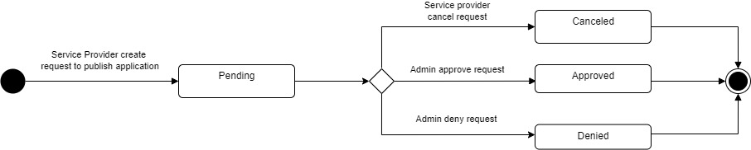

Event State

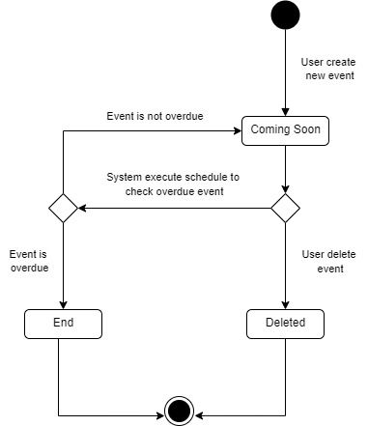

### Sequence Diagram

Send request publish application

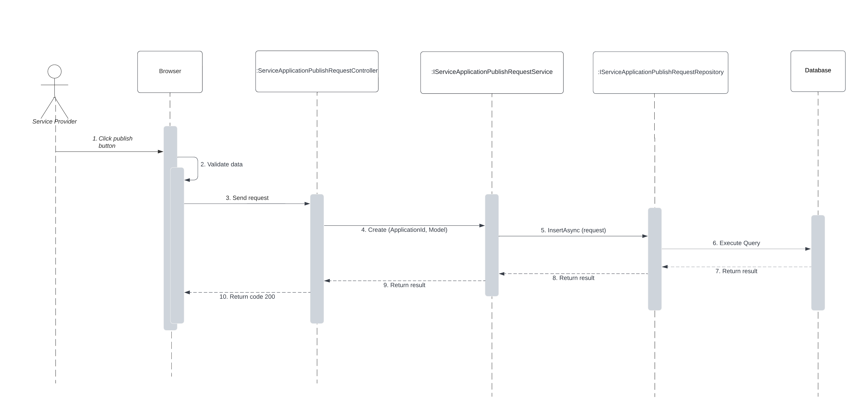

Approve application

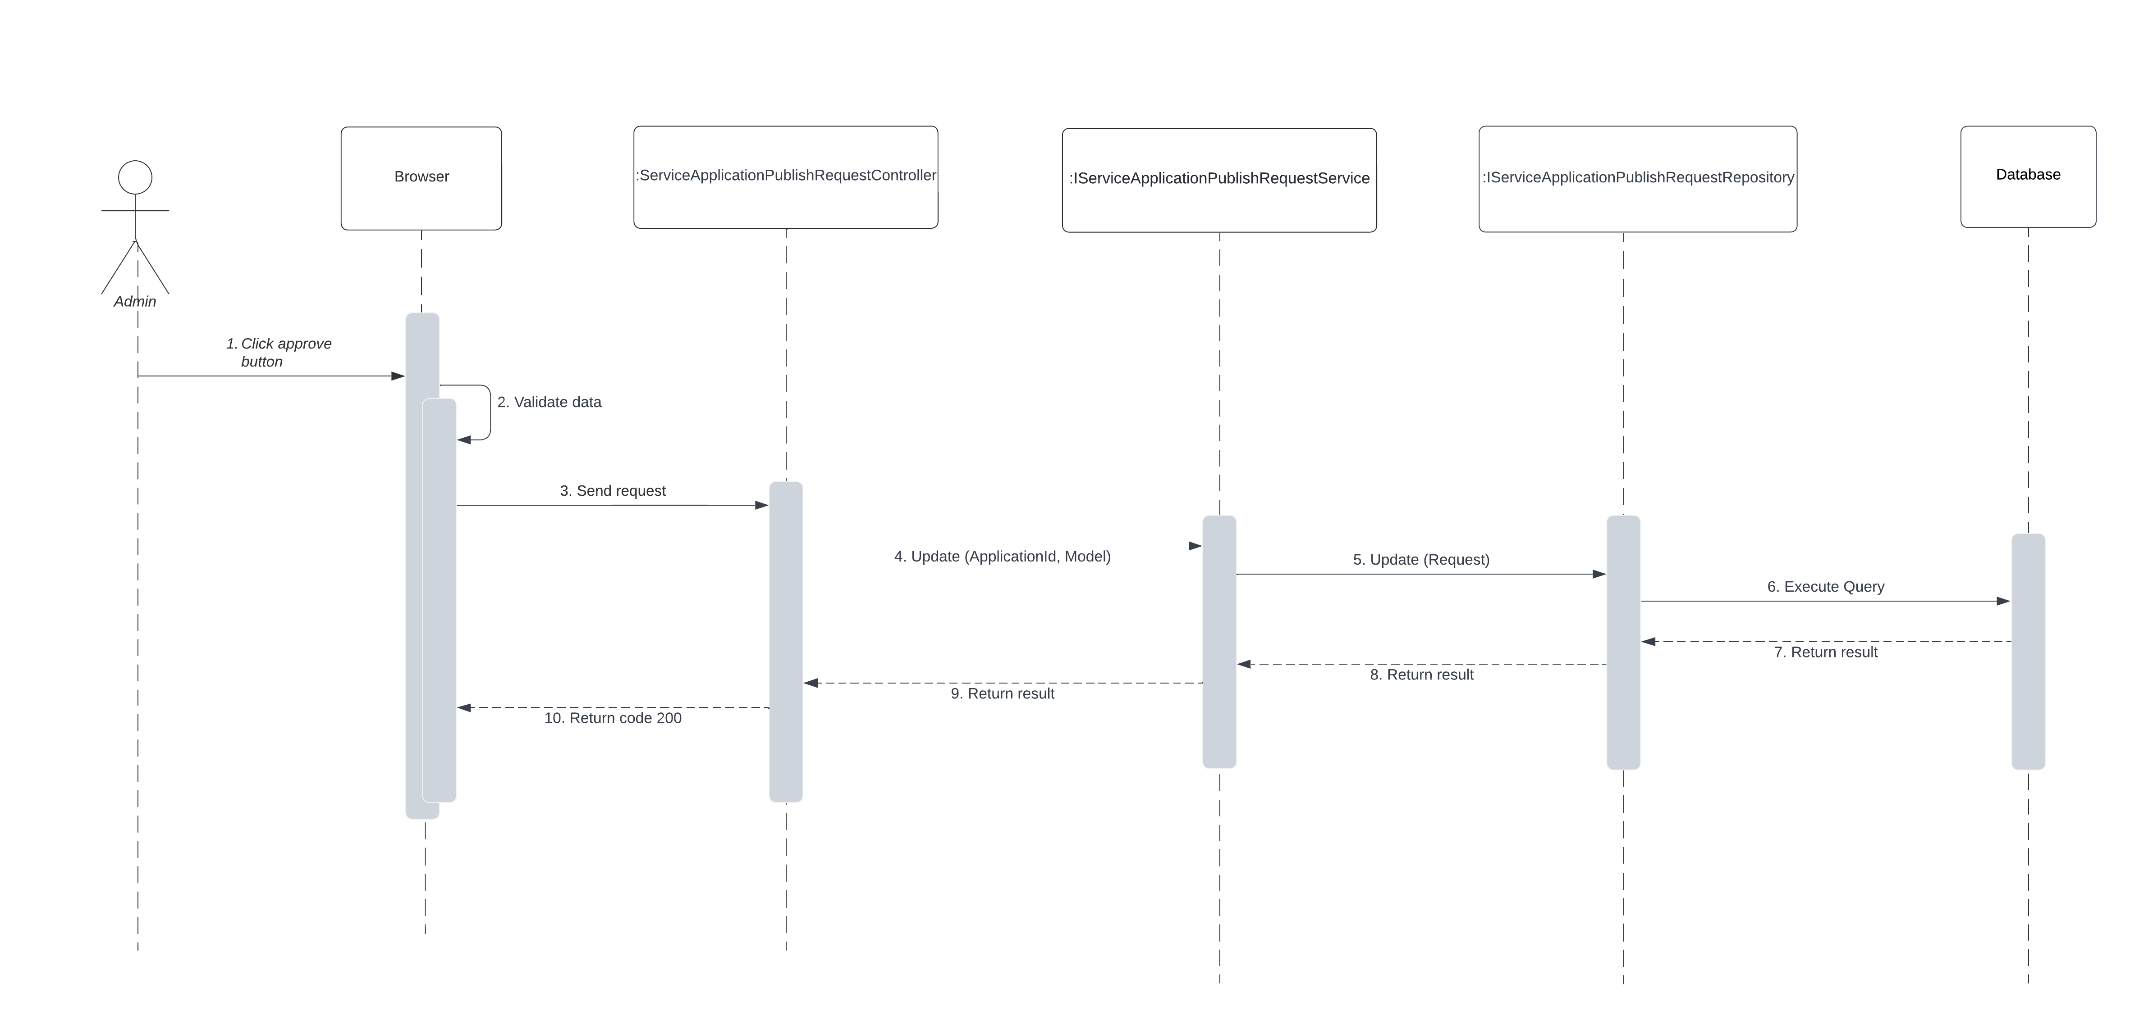

Create application

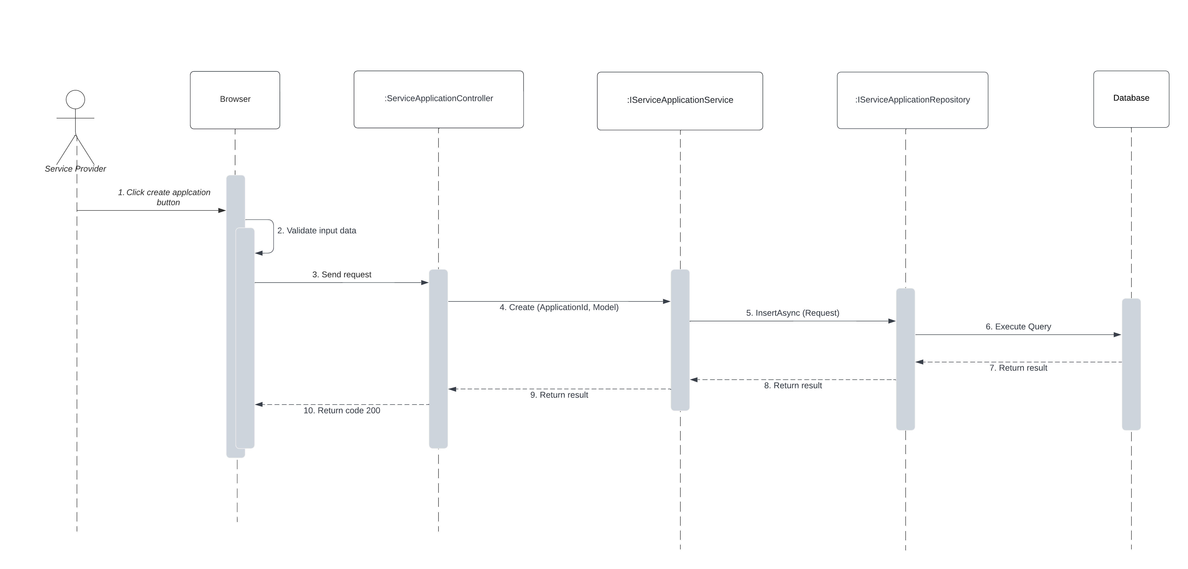

Login

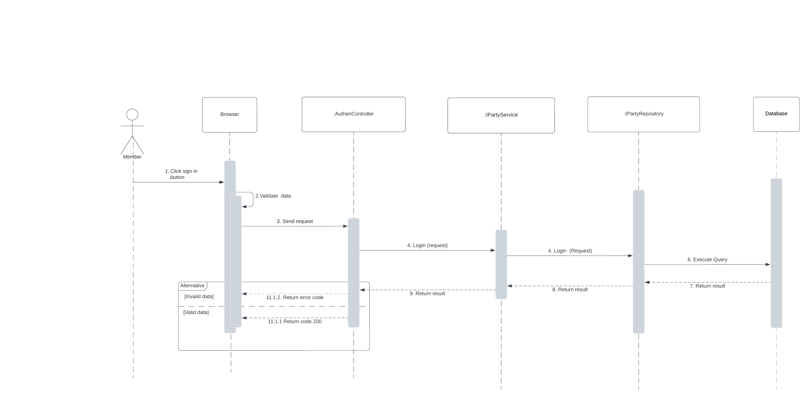

## Data and Database Design

### Database Design

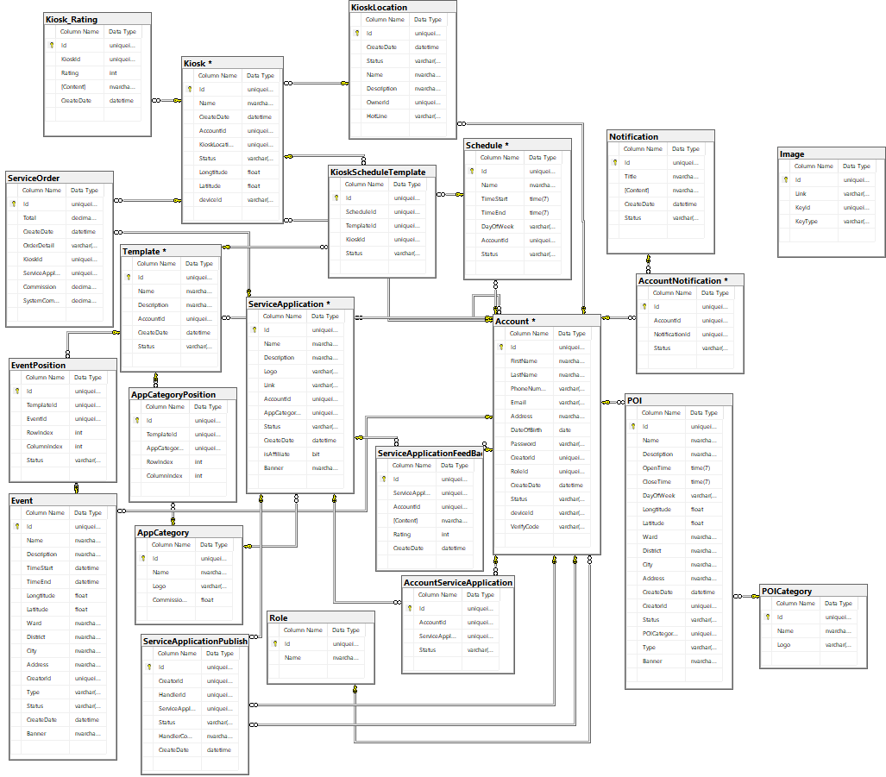

### Data File Design

Account Table

|  |  |  |  |  |  |
| --- | --- | --- | --- | --- | --- |
| **Field name** | **Type** | **Unique** | **Not Null** | **Description** | **PK/FK** |
| Id | UNIQUEIDENTIFIER | Yes | Yes | Unique id of Account | PK |
| FirstName | nvarchar(255) | No | Yes | First name of Account | No |
| LastName | nvarchar(255) | No | Yes | Last name of Account | No |
| PhoneNumber | varchar(10) | Yes | Yes | phone number of Account | No |
| Email | varchar(255) | Yes | Yes | Email of Account | No |
| Address | nvarchar(MAX) | No | Yes | Address of Account | No |
| DateOfBirth | date | No | Yes | Date of birth of Account | No |
| Password | varchar(300) | No | Yes | Password of this account | No |
| CreatorId | UNIQUEIDENTIFIER | Yes | Yes | Id of creator | FK |
| RoleId | UNIQUEIDENTIFIER | Yes | Yes | Id of role | FK |
| CreateDate | datetime | No | Yes | Date create this account | No |
| Status | varchar(20) | No | Yes | Status of this account | No |
| DeviceId | varchar(MAX) | No | No | Device Id of this account | No |
| VerifyCode | varchar(50) | No | No | VerifyCode of this account | No |

KioskLocation Table

|  |  |  |  |  |  |
| --- | --- | --- | --- | --- | --- |
| **Field name** | **Type** | **Unique** | **Not Null** | **Description** | **PK/FK** |
| Id | UNIQUEIDENTIFIER | Yes | Yes | Unique id of KioskLocation | PK |
| Name | nvarchar(255) | No | Yes | Name of KioskLocation | No |
| Description | nvarchar(MAX) | No | Yes | Description of KioskLocation | No |
| CreateDate | datetime | No | Yes | Date create this KioskLocation | No |
| Status | varchar(20) | No | Yes | Status of KioskLocation | No |
| OwnerId | UNIQUEIDENTIFIER | Yes | Yes | Unique id of Owner | FK |
| HotLine | varchar(10) | No | Yes | Hotline of KioskLocation | No |

Kiosk Table

|  |  |  |  |  |  |
| --- | --- | --- | --- | --- | --- |
| **Field name** | **Type** | **Unique** | **Not Null** | **Description** | **PK/FK** |
| Id | UNIQUEIDENTIFIER | Yes | Yes | Id of kiosk | PK |
| Name | nvarchar(255) | No | Yes | Name of kiosk | No |
| CreateDate | datetime | No | Yes | Date create of kiosk | No |
| AccountId | UNIQUEIDENTIFIER | Yes | Yes | Id of Account that is the owner of kiosk | FK |
| KioskLocationId | UNIQUEIDENTIFIER | Yes | Yes | Id of KioskLocaiton | FK |
| Status | varchar(20) | No | Yes | Status of kiosk | No |
| Longitude | float | No | Yes | Longitude of kisk | No |
| Latitude | float | No | Yes | Latitude of kiosk | No |
| DeviceId | varchar(MAX) | No | No | DeviceId of kiosk | No |

AppCategory Table

|  |  |  |  |  |  |
| --- | --- | --- | --- | --- | --- |
| **Field name** | **Type** | **Unique** | **Not Null** | **Description** | **PK/FK** |
| Id | UNIQUEIDENTIFIER | Yes | Yes | Unique id of app category | PK |
| Name | nvarchar(255) | Yes | Yes | Name of app category | No |
| Logo | varchar(MAX) | Yes | Yes | Logo of app category | No |
| CommissionPercentage | float | No | Yes | Commission percentage of app category | No |

ServiceApplication Table

|  |  |  |  |  |  |
| --- | --- | --- | --- | --- | --- |
| **Field name** | **Type** | **Unique** | **Not Null** | **Description** | **PK/FK** |
| Id | UNIQUEIDENTIFIER | Yes | Yes | Unique id of service application | PK |
| Name | nvarchar(255) | No | Yes | Name of service application | No |
| Description | nvarchar(MAX) | No | Yes | Description of service application | No |
| Logo | varchar(MAX) | Yes | Yes | Logo of service application | No |
| Link | varchar(MAX) | No | Yes | Link of service application' logo | No |
| AccountId | UNIQUEIDENTIFIER | Yes | Yes | Id of Account that is the owner of service application | FK |
| AppCategoryId | UNIQUEIDENTIFIER | Yes | Yes | Id of app category | FK |
| ApplicationMarketId | UNIQUEIDENTIFIER | Yes | Yes | Id of application market | FK |
| Status | varchar(20) | No | Yes | Status of service application | No |

Schedule Table

|  |  |  |  |  |  |
| --- | --- | --- | --- | --- | --- |
| **Field name** | **Type** | **Unique** | **Not Null** | **Description** | **PK/FK** |
| Id | UNIQUEIDENTIFIER | Yes | Yes | Unique id of schedule | PK |
| Name | nvarchar(255) | No | Yes | Name of schedule | No |
| DateStart | datetime | No | Yes | Date start of schedule | No |
| DateEnd | datetime | No | Yes | Date end of schedule | No |
| TimeStart | time(7) | No | Yes | Time start of schedule | No |
| TimeEnd | time(7) | No | Yes | Time end of schedule | No |
| DayOfWeek | varchar(255) | No | Yes | Day of week that apply this schedule | No |
| AccountId | UNIQUEIDENTIFIER | Yes | Yes | Id of Account that is the owner of schedule | FK |
| Status | varchar | No | Yes | Status of schedule | No |

KioskScheduleTemplate Table

|  |  |  |  |  |  |
| --- | --- | --- | --- | --- | --- |
| **Field name** | **Type** | **Unique** | **Not Null** | **Description** | **PK/FK** |
| Id | UNIQUEIDENTIFIER | Yes | Yes | Unique id of KioskScheduleTemplate | PK |
| KioskId | UNIQUEIDENTIFIER | Yes | Yes | Unique Id of Kiosk | FK |
| ScheduleId | UNIQUEIDENTIFIER | Yes | Yes | Unique Id of Schedule | FK |
| TemplateId | UNIQUEIDENTIFIER | Yes | Yes | Unique Id of Template | FK |
| Status | varchar(20) | No | Yes | Status of KioskScheduleTemplate | FK |

Template Table

|  |  |  |  |  |  |
| --- | --- | --- | --- | --- | --- |
| **Field name** | **Type** | **Unique** | **Not Null** | **Description** | **PK/FK** |
| Id | UNIQUEIDENTIFIER | Yes | Yes | Unique id of template | PK |
| Name | nvarchar(255) | No | Yes | Name of template | No |
| Description | nvarchar(MAX) | No | No | Description of template | No |
| AccountId | UNIQUEIDENTIFIER | Yes | Yes | Id of Account that is the owner of template | FK |
| CreateDate | datetime | No | Yes | Date create template | No |
| Status | varchar(20) | No | Yes | Status of template | No |

Event Table

|  |  |  |  |  |  |
| --- | --- | --- | --- | --- | --- |
| **Field name** | **Type** | **Unique** | **Not Null** | **Description** | **PK/FK** |
| Id | UNIQUEIDENTIFIER | Yes | Yes | Unique id of event | PK |
| Name | nvarchar(255) | No | Yes | Name of event | No |
| Description | nvarchar(MAX) | No | No | Description of event | No |
| TimeStart | datetime | No | Yes | Time start of event | No |
| TimeEnd | datetime | No | Yes | Time end of event | No |
| Longitude | float | No | Yes | Longitude of event | No |
| Latitude | float | No | Yes | Latitude of event | No |
| Ward | nvarchar(50) | No | Yes | Ward of the location of event | No |
| District | nvarchar(50) | No | Yes | District of the location of event | No |
| City | nvarchar(50) | No | Yes | City of the location of event | No |
| Address | nvarchar(MAX) | No | Yes | Address of the location of event | No |
| CreatorId | UNIQUEIDENTIFIER | Yes | Yes | Id of Account that is the creator of template | FK |
| Type | varchar(20) | No | Yes | Type of template to know what role create template | No |
| Status | varchar(20) | No | Yes | Status of template | No |
| CreateDate | datetime | No | Yes | Date create event | No |
| Banner | nvarchar(MAX) | No | No | Banner of Event | No |

AppCategoryPosition Table

|  |  |  |  |  |  |
| --- | --- | --- | --- | --- | --- |
| **Field name** | **Type** | **Unique** | **Not Null** | **Description** | **PK/FK** |
| Id | UNIQUEIDENTIFIER | Yes | Yes | Unique id of AppCategoryPosition | PK |
| TemplateId | UNIQUEIDENTIFIER | Yes | Yes | Id of template | FK |
| AppCategoryId | UNIQUEIDENTIFIER | Yes | Yes | Id of app category | FK |
| RowIndex | int | No | Yes | Row index of app category position | No |
| ColumnIndex | int | No | Yes | Column index of app category position | No |

AccountNotification Table

|  |  |  |  |  |  |
| --- | --- | --- | --- | --- | --- |
| **Field name** | **Type** | **Unique** | **Not Null** | **Description** | **PK/FK** |
| Id | UNIQUEIDENTIFIER | Yes | Yes | Unique ID for AccountNotification | PK |
| AccountId | UNIQUEIDENTIFIER | Yes | Yes | ID of Account | FK |
| NotificationId | UNIQUEIDENTIFIER | Yes | Yes | ID of Notification | FK |
| Status | varchar | No | Yes | Status of AccountNotification (Seen/Not) | No |

Notification Table

|  |  |  |  |  |  |
| --- | --- | --- | --- | --- | --- |
| **Field name** | **Type** | **Unique** | **Not Null** | **Description** | **PK/FK** |
| Id | UNIQUEIDENTIFIER | Yes | Yes | Unique ID for Notification | PK |
| Title | nvarchar(MAX) | No | Yes | Title of Notification | No |
| Content | nvarchar(MAX) | No | Yes | Content of Notification | No |
| CreateDate | datetime | No | Yes | Create date of Notification | No |
| Status | varchar(20) | No | Yes | Status of Notification* | No |

ServiceApplicationPublishRequest Table

|  |  |  |  |  |  |
| --- | --- | --- | --- | --- | --- |
| **Field name** | **Type** | **Unique** | **Not Null** | **Description** | **PK/FK** |
| Id | UNIQUEIDENTIFIER | Yes | Yes | Unique ID for ServiceApplicationPublishRequest | PK |
| CreatorId | UNIQUEIDENTIFIER | Yes | Yes | ID of CreatorId | FK |
| HandlerId | UNIQUEIDENTIFIER | Yes | Yes | ID of HandlerId | FK |
| ServiceApplicationId | UNIQUEIDENTIFIER | Yes | Yes | ID of ServiceApplicationId | FK |
| HandlerComment | nvarchar(MAX) | No | Yes | Comment of Handler | No |
| Status | varchar(20) | No | Yes | Status of ServiceApplicationPublishRequest | No |
| CreateDate | datetime | No | Yes | Date create request to publish. | No |

ServiceOrder Table

|  |  |  |  |  |  |
| --- | --- | --- | --- | --- | --- |
| Field name | Type | Unique | Not Null | Description | PK/FK |
| Id | UNIQUEIDENTIFIER | Yes | Yes | Unique ID for ServiceOrder | PK |
| KioskId | UNIQUEIDENTIFIER | Yes | Yes | ID of Kiosk | FK |
| ServiceApplicationId | UNIQUEIDENTIFIER | Yes | Yes | ID of ServiceApplication | FK |
| CreateDate | datetime | No | Yes | Create date of ServiceOrder | No |
| OrderDetail | varchar(MAX) | No | Yes | Details of ServiceOrder | No |
| Commission | decimal(18,2) | No | Yes | Commission of ServiceOrder | No |
| SystemCommission | decimal(18,2) | No | Yes | System commission of ServiceOrder | No |

Image Table

|  |  |  |  |  |  |
| --- | --- | --- | --- | --- | --- |
| **Field name** | **Type** | **Unique** | **Not Null** | **Description** | **PK/FK** |
| Id | UNIQUEIDENTIFIER | Yes | Yes | Unique ID for Image | PK |
| Link | varchar(MAX) | No | Yes | Link of Image | No |
| KeyId | UNIQUEIDENTIFIER | No | Yes | ID of Key | No |
| KeyType | varchar(100) | No | Yes | Type of Key | No |

AccountServiceApplication Table

|  |  |  |  |  |  |
| --- | --- | --- | --- | --- | --- |
| **Field name** | **Type** | **Unique** | **Not Null** | **Description** | **PK/FK** |
| Id | UNIQUEIDENTIFIER | Yes | Yes | Unique ID for AccountServiceApplication | PK |
| AccountId | UNIQUEIDENTIFIER | Yes | Yes | ID for Account | FK |
| ServiceApplicationId | UNIQUEIDENTIFIER | Yes | Yes | ID for ServiceApplication | FK |
| Status | varchar | No | Yes | Status of AccountServiceApplication | No |

POI Table

|  |  |  |  |  |  |
| --- | --- | --- | --- | --- | --- |
| **Field name** | **Type** | **Unique** | **Not Null** | **Description** | **PK/FK** |
| Id | UNIQUEIDENTIFIER | Yes | Yes | Unique ID for POI | PK |
| CreatorId | UNIQUEIDENTIFIER | Yes | Yes | ID for Creator | FK |
| POICategoryId | UNIQUEIDENTIFIER | Yes | Yes | ID for POICategory | FK |
| Name | nvarchar(255) | No | Yes | Name of POI | No |
| Description | nvarchar(MAX) | No | Yes | Description of POI | No |
| OpenTime | time(7) | No | Yes | OpenTime of POI | No |
| CloseTime | time(7) | No | Yes | CloseTime of POI | No |
| DayOfWeek | varchar(255) | No | Yes | Day Of Week of POI | No |
| Longtitude | float | No | Yes | Longtitude of POI | No |
| Latitude | float | No | Yes | Latitude of POI | No |
| Ward | Nvarchar(50) | No | Yes | Ward of POI | No |
| District | Nvarchar(50) | No | Yes | District of POI | No |
| City | Nvarchar(50) | No | Yes | City of POI | No |
| Address | Nvarchar(MAX) | No | Yes | Address of POI | No |
| CreateDate | Datetime | No | Yes | Create date of POI | No |
| Type | varchar(20) | No | Yes | Type of POI | No |
| Status | varchar(20) | No | Yes | Status of POI | No |

POICategory Table

|  |  |  |  |  |  |
| --- | --- | --- | --- | --- | --- |
| **Field name** | **Type** | **Unique** | **Not Null** | **Description** | **PK/FK** |
| Id | UNIQUEIDENTIFIER | Yes | Yes | Unique ID for POICategory | PK |
| Name | nvarchar(255) | Yes | Yes | Name of POICategory | No |
| Logo | varchar(MAX) | Yes | Yes | Logo of POICategory | No |

EventPosition Table

|  |  |  |  |  |  |
| --- | --- | --- | --- | --- | --- |
| **Field name** | **Type** | **Unique** | **Not Null** | **Description** | **PK/FK** |
| Id | UNIQUEIDENTIFIER | Yes | Yes | Unique ID for EventPosition | PK |
| TemplateId | UNIQUEIDENTIFIER | Yes | Yes | ID for Template | FK |
| EventId | UNIQUEIDENTIFIER | Yes | Yes | ID for Event | FK |
| RowIndex | int | No | Yes | Row index of EventPosition | No |
| ColumnIndex | int | No | Yes | Comlumn index of EventPosition | No |
| Status | varchar | No | No | Status of EventPosition | No |

Kiosk_Rating Table

|  |  |  |  |  |  |
| --- | --- | --- | --- | --- | --- |
| **Field name** | **Type** | **Unique** | **Not Null** | **Description** | **PK/FK** |
| Id | UNIQUEIDENTIFIER | Yes | Yes | Unique ID for Kiosk_Rating | PK |
| KioskId | UNIQUEIDENTIFIER | Yes | Yes | ID for Kiosk | FK |
| Rating | int | No | Yes | Rating of kiosk | No |
| Content | nvarchar | No | No | Content of feedback | No |
| CreateDate | datetime | No | Yes | Date create of kiosk rating | No |

## Software Testing Documentation

## Overall Description

### Test Model

In IKFTS project, we apply Incremental testing for many purposes:

* Each Module provides a definitive role to play in the project structure.
* Some function testing can start at early step of the develop process.

### Testing Levels

* Testing Level: System Test, User Acceptance Test
* Testing Types: Functional Testing, user Interface Testing

## Test Plan

### Test Stages

|  |  |  |  |
| --- | --- | --- | --- |
| Type of Test | State of Test | | |
| **Unit** | **System** | **Acceptance** |
| Function Testing |  | x |  |
| User Interface Testing |  | x |  |

### Resources

|  |  |  |
| --- | --- | --- |
| Worker | Role | Specific Responsibilities |
| Tô Ngọc Lam Linh | Member | Planning, verify test result assign test function to members. |
| Phạm Càn Long | Leader | Execute test and report as planned |
| Vũ Sơn Tùng | Member | Execute test and report as planned |
| Trần Thế Đông Anh | Member | Execute test and report as planned |
| Huỳ Hữu Tín | Member | Execute test and report as planned |

### Test Milestones

|  |  |  |
| --- | --- | --- |
| No. | Deliverables | Due Date |
| 1 | Test Document | 22/08/2022 |

## Test Cases and Test Reports

|  |  |
| --- | --- |
| Testing Level | File Name |
| System Test | 2022.Summer _ VCCS _ Capstone Project _ Test Report |

# Release Package and User Guides

## Deliverable Package

### Source Codes and Documents

|  |  |  |  |  |
| --- | --- | --- | --- | --- |
| No. | Items | Sub-Items | Type | Version |
| **Code Package** | | | | |
|  |  |  |  |  |
|  |  |  |  |  |
| **Database** | | | | |
|  |  |  |  |  |
|  |  |  |  |  |
| **Documents** | | | | |
|  |  |  |  |  |
|  |  |  |  |  |

## Installation Guide

### System Requirements

Hardware Requirement

* Web Application

|  |  |  |
| --- | --- | --- |
| PC | Minimum | Recommended |
| Internet connection | Cable, Wi-fi (4 Mbps) | Cable, Wi-fi (8 Mbps) |
| Processor | Intel Core i3 1.4Ghz | Intel Core i7 2.5Ghz |
| Memory | 2GB RAM | 4GB RAM up |
| Storage | 2GB | 4GB up |
| Web Browser | Chromes (v69 or higher) | Chrome latest stable version |

* Kiosk Application

|  |  |
| --- | --- |
| Operating System | Android 10 or higher |
| **Processor** | Intel(R) Atom(TM) CPU Z3580 @ 1.33GHz, or faster processor |
| **Storage** | Minimum 256 MB |
| **RAM** | Minimum of 1GB, 2GB is recommend |

Software Requirement

|  |  |  |
| --- | --- | --- |
| Component | Name and Version | Description |
| Operating System | Windows 7 SP1/8.1/10/Window Server 2016 or above (Web application)  Android 10 AndroidQ or above (Mobile application) |  |
| DBMS | SQL Server 2019 | Used to manage database |
| .Net Core Runtime | 3.1 | Used to hosting API server |

### Setup Files

Web Application API setup

* docker-compose.yml

version: '3'

services:

mssql:

container_name: mssql

restart: always

user: root

image: 'mcr.microsoft.com/mssql/server:2019-latest'

ports:

- 1433:1433

volumes:

- ./data:/var/opt/mssql/data

environment:

- ACCEPT_EULA=Y

- SA_PASSWORD=Goboi123

networks:

- capstone-docker-network

kiosk-solution:

container_name: kiosk-solution

restart: always

image: longpc/kiosk-solution

depends_on:

- mssql

ports:

- 5000:80

volumes:

- /etc/timezone:/etc/timezone:ro

- /etc/localtime:/etc/localtime:ro

networks:

- capstone-docker-network

booking-sample:

container_name: booking-sample

restart: always

image: longpc/booking-sample

depends_on:

- mssql

- kiosk-solution

ports:

- 5099:80

networks:

- capstone-docker-network

networks:

capstone-docker-network:

driver: bridge

Kiosk Application setup

* nginx.conf

server {

listen 80;

listen [::]:80;

server_name tikap.cf;

return 301 https://$server_name$request_uri;

}

# kiosk api

server {

listen 443 ssl;

server_name tikap.cf;

ssl_certificate ./ssl/certificate.crt;

ssl_certificate_key ./ssl/private.key;

sendfile on;

charset utf-8;

# max upload size

client_max_body_size 50G; # adjust to taste

location / {

proxy_pass http://172.168.4.99:5000/;

proxy_http_version 1.1;

proxy_set_header Upgrade $http_upgrade;

proxy_set_header Connection "upgrade";

proxy_set_header Host $host;

}

location /portal-swagger/ {

proxy_pass http://172.168.4.99:5000;

proxy_http_version 1.1;

proxy_set_header Upgrade $http_upgrade;

proxy_set_header Connection "upgrade";

proxy_set_header Host $host;

proxy_set_header X-Real-IP $remote_addr;

proxy_set_header X-Forwarded-For $proxy_add_x_forwarded_for;

proxy_set_header X-Scheme $scheme;

}

}

# kiosk portal

server {

listen 3000 ssl;

listen [::]:3000 ssl;

server_name tikap.cf;

ssl_certificate ./ssl/certificate.crt;

ssl_certificate_key ./ssl/private.key;

sendfile on;

root /var/www/html/kiosk-portal/build;

index index.html index.htm;

location / {

try_files $uri /index.html;

}

}

# booking sample

server {

listen 3001 ssl;

server_name tikap.cf;

ssl_certificate ./ssl/certificate.crt;

ssl_certificate_key ./ssl/private.key;

sendfile on;

charset utf-8;

# max upload size

client_max_body_size 50G; # adjust to taste

location / {

proxy_pass http://172.168.4.99:5099/;

proxy_http_version 1.1;

proxy_set_header Upgrade $http_upgrade;

proxy_set_header Connection "upgrade";

proxy_set_header Host $host;

}

}

# kiosk screen

server {

listen 3002 ssl;

listen [::]:3002 ssl;

server_name tikap.cf;

ssl_certificate ./ssl/certificate.crt;

ssl_certificate_key ./ssl/private.key;

sendfile on;

root /var/www/html/kiosk-screen/build;

index index.html index.htm;

location / {

try_files $uri /index.html;

}

}

* docker-compose.yml

version: '3'

services:

nginx:

image: nginx:latest

container_name: webserver

restart: unless-stopped

ports:

- 9958:80

- 9953:443

- 3000:3000

- 3001:3001

- 3002:3002

volumes:

- ./nginx.config:/etc/nginx/conf.d/default.conf

- ./ssl:/etc/nginx/ssl

- ./templates:/etc/nginx/templates

- ./src:/var/www/html

### Installation Instruction

Setup Application

Setup Kiosk Application and Kiosk Portal Application

**Use WinSCP to create run file on VPS**

Use WinSCP to SSH to VPS and copy file docker-compose.yml and nginx.conf file from your window to VPS

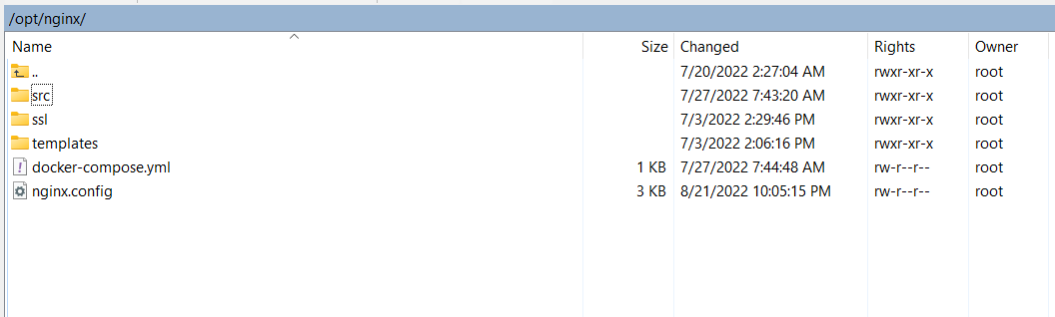

**Use command line to run docker-compose.yml with MRemoteNG**

Fill on SSH setting require with your VPS information

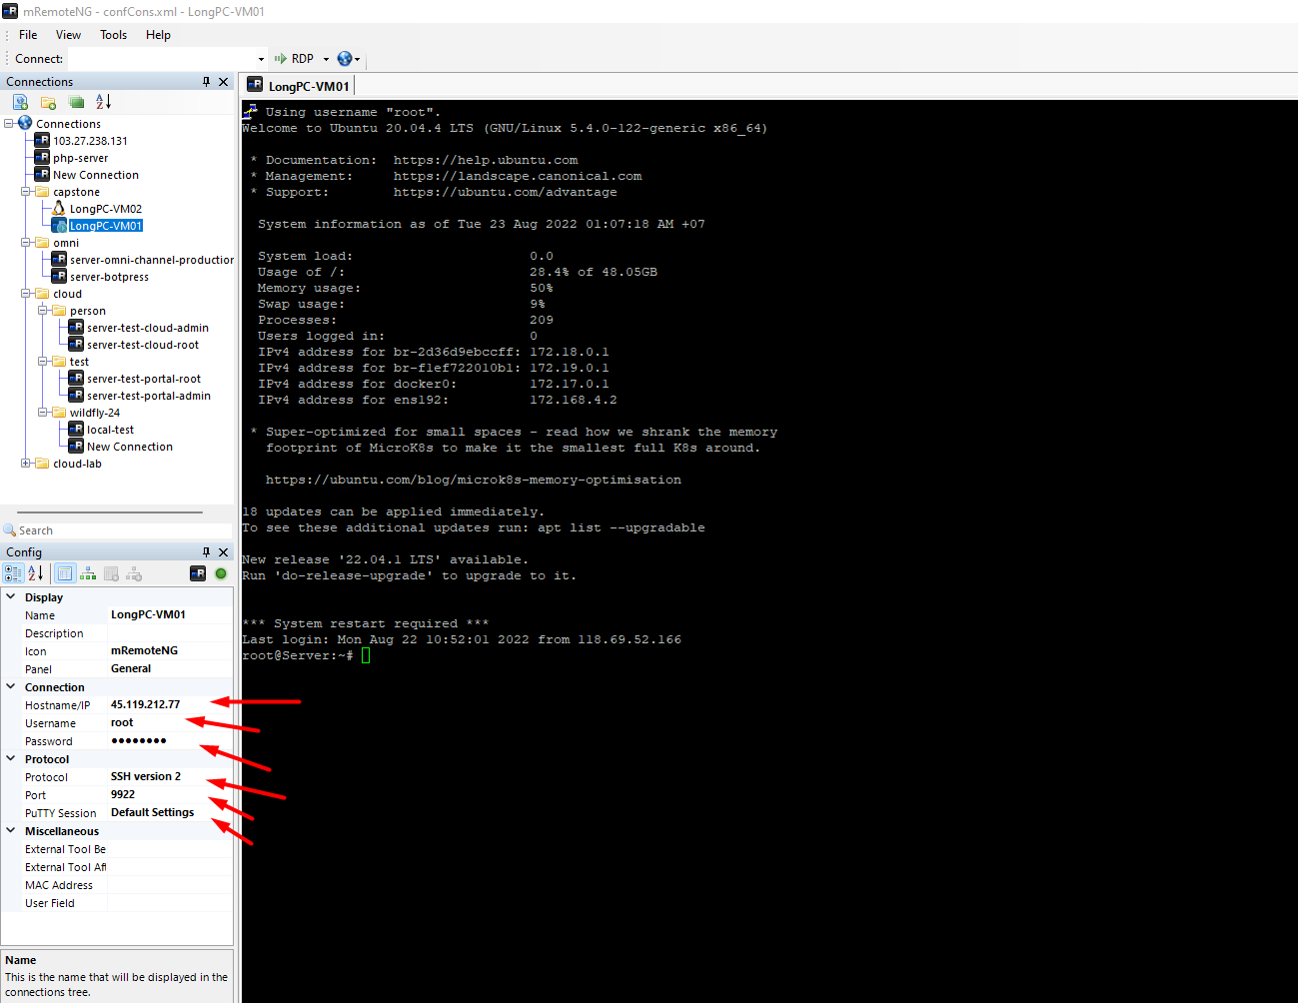

Run command line: cd/opt/nginx

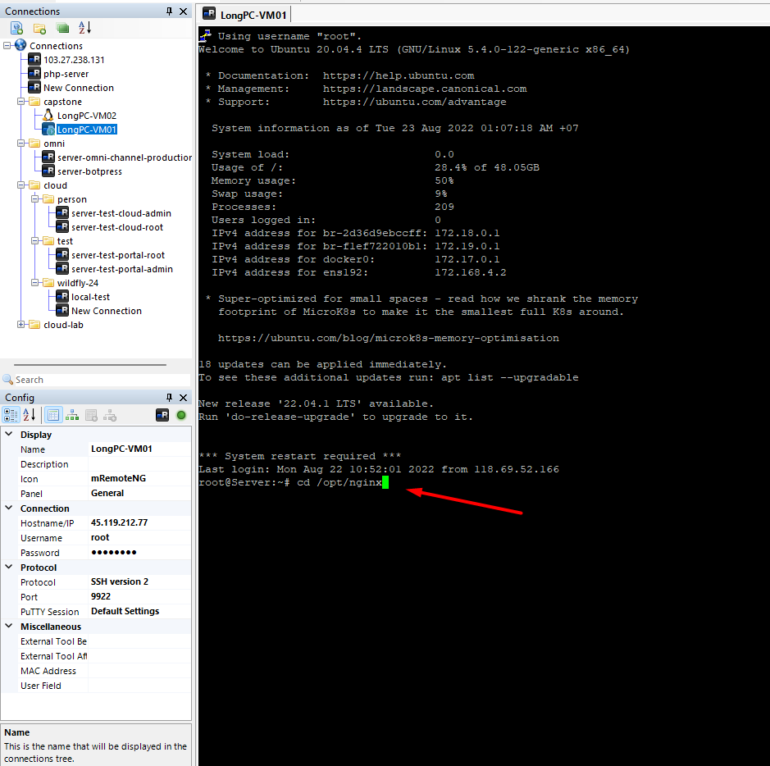

Run command line : docker-compose up

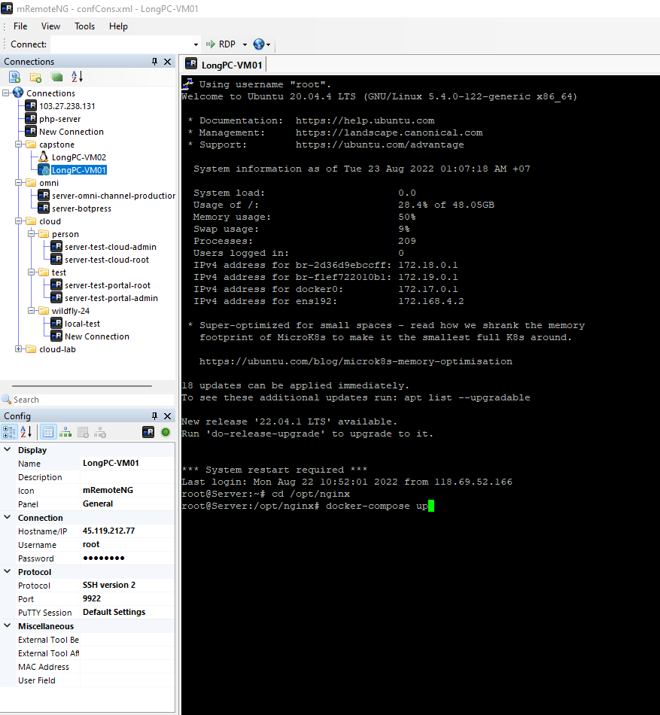

Run success

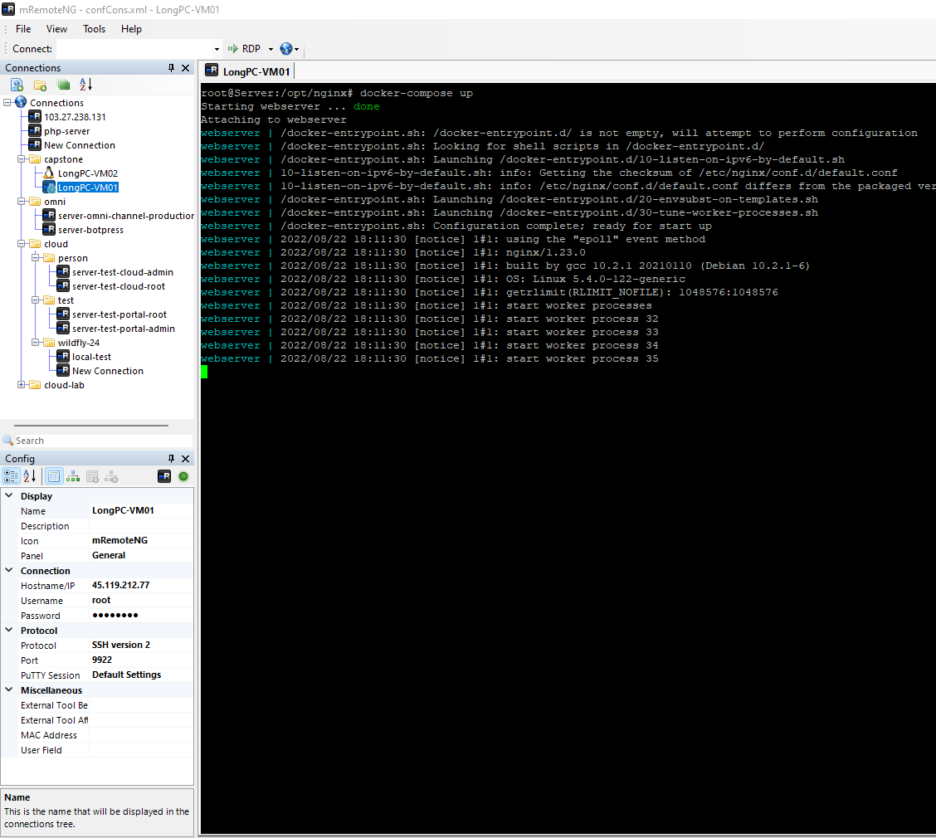

##### Setup Kiosk API

**Use WinSCP to create run file on VPS**

Use WinSCP to SSH to VPS and copy file docker-compose.yml and nginx.conf file from your window to VPS

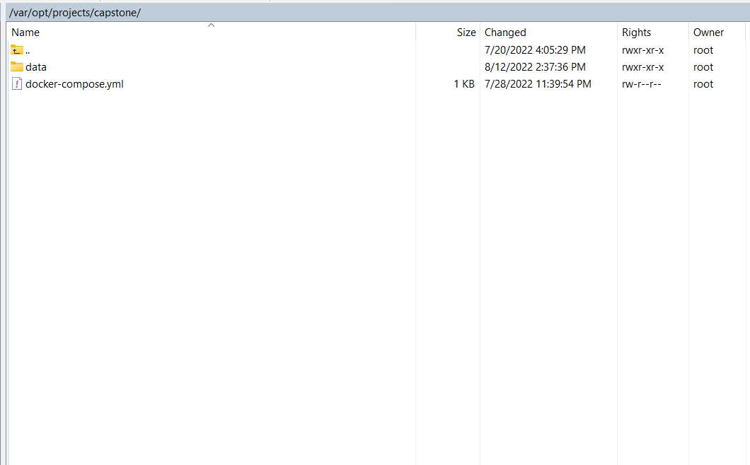

**Use command line to run docker-compose.yml with MRemoteNG**

Fill on SSH setting require with your VPS information

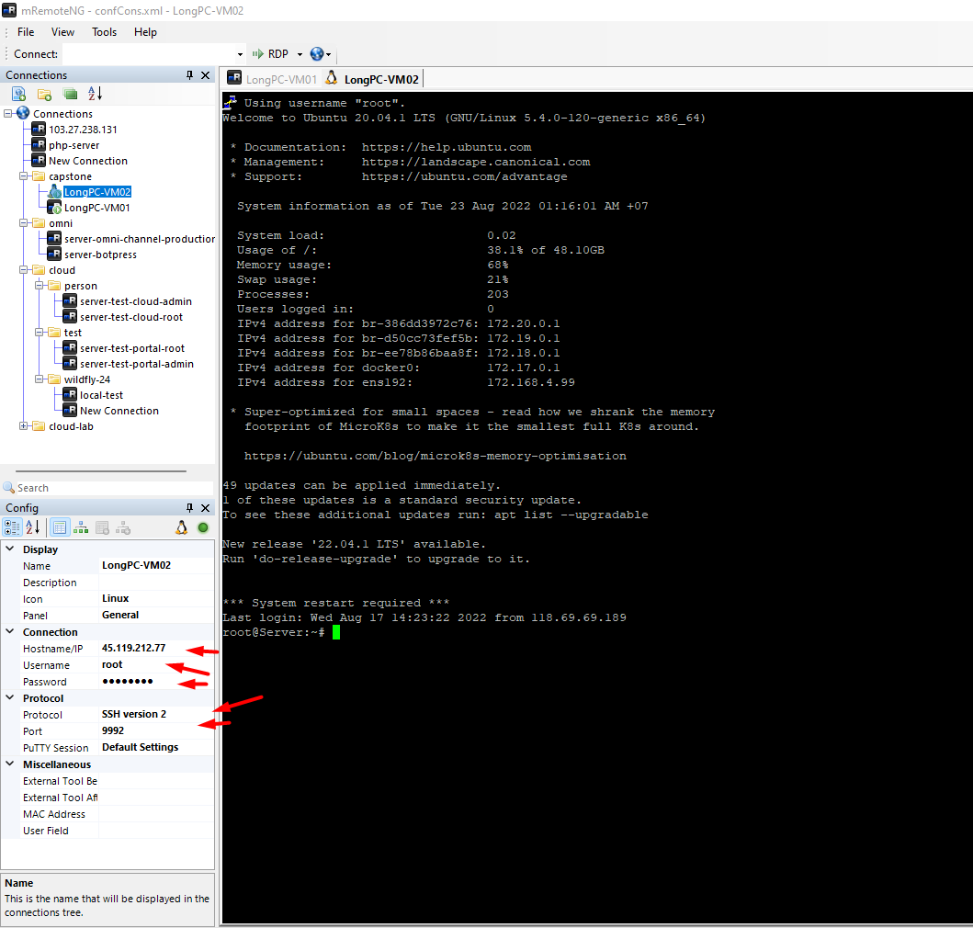

Run command line: docker pull longpc/kiosk-solution

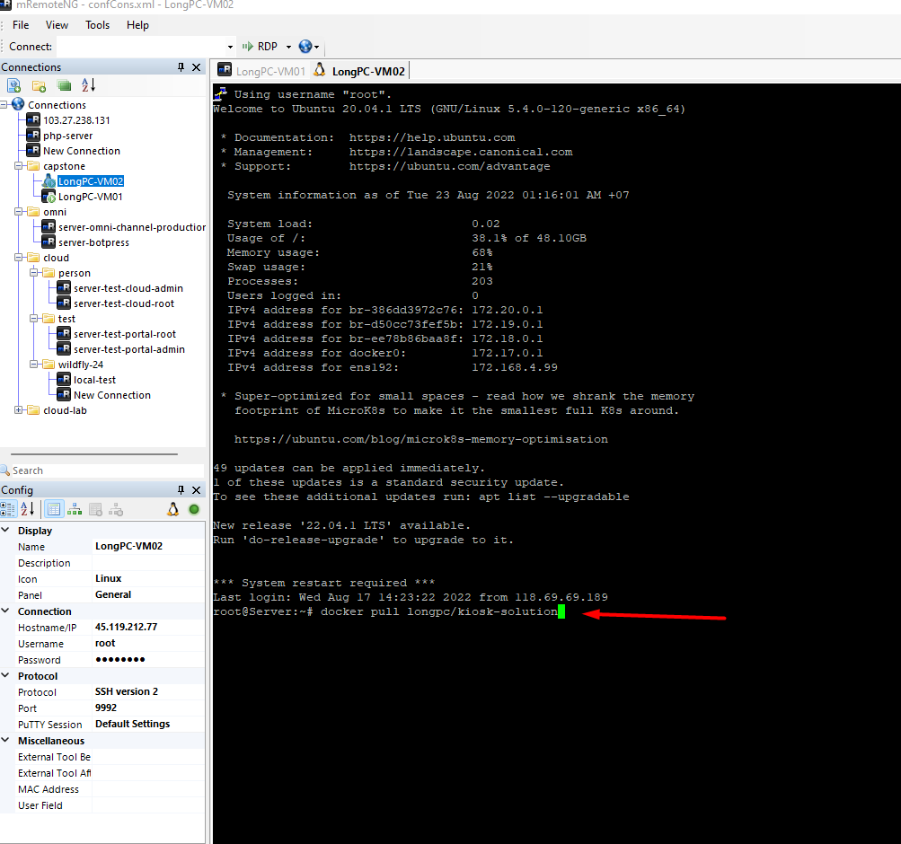

Run command line: cd /var/opt/projects/capstone && docker-compose up -d

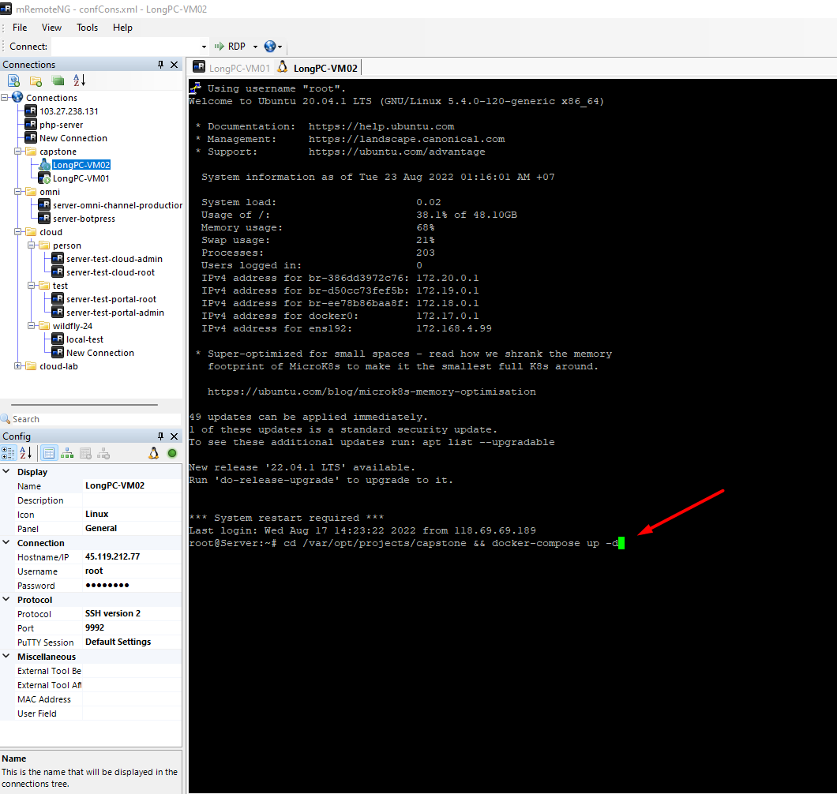

## User Manual

### Terms and Definitions

N/A

### System Requirement

Hardware Requirement

|  |  |  |  |
| --- | --- | --- | --- |
| Type | Part/Component | Minimum | Recommended |
| Computer | OS supported | Windows7 SP1 or later (64-bit), Linux | – |
| Computer | Network | LAN | LAN and Internet |
| Computer | RAM | 4GB | >= 8GB |
| Computer | HDD | 100 GB | >= 200 GB |
| Computer | Ports | USB, Network | – |
| Mobile | Camera | 5MP | – |
| Mobile | Network | Wi-Fi / Mobile Network | – |

Software Requirement

* Git
* .NET Core Runtime 5.0 Hosting bundles
* React JS v17.0.2
* PWA v12.5.0

### Application Usage

Member function

##### Login to system

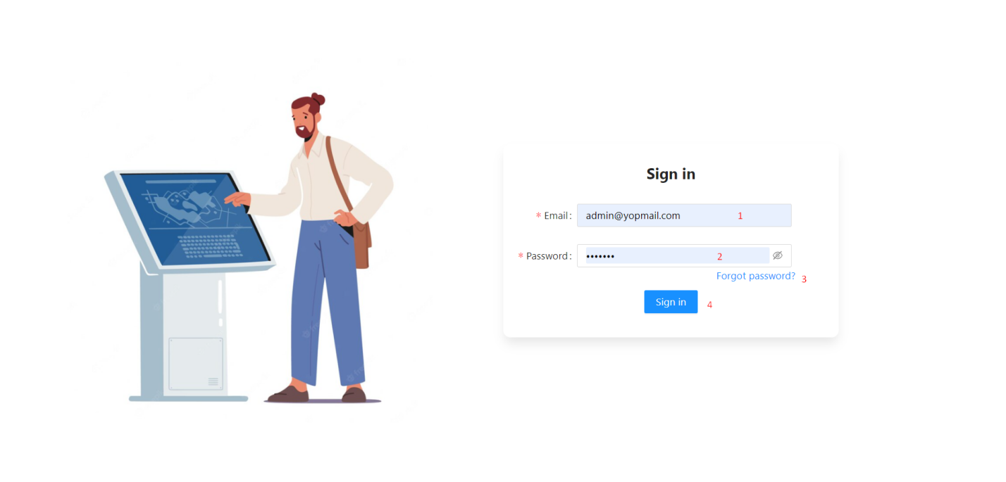

|  |  |  |  |  |  |  |  |  |
| --- | --- | --- | --- | --- | --- | --- | --- | --- |
| No. | Field Name | Description | | Read only | | Mandatory | Control Type | Data Type |
|  | Input email | Email to login | | No | | Yes | Text Box | String |
|  | Input password | Password to login | | No | | Yes | Text Box | Password |
| **No.** | **Function** | | **Description** | | **Validation** | | **Outcome** | |
| 3 | Forgot password | | Find password when forgot | | No | | Change to page forgot password | |
| 4 | Login | | Click to perform to login | | Yes | | User is authenticated and go to home page | |

##### Forgot password

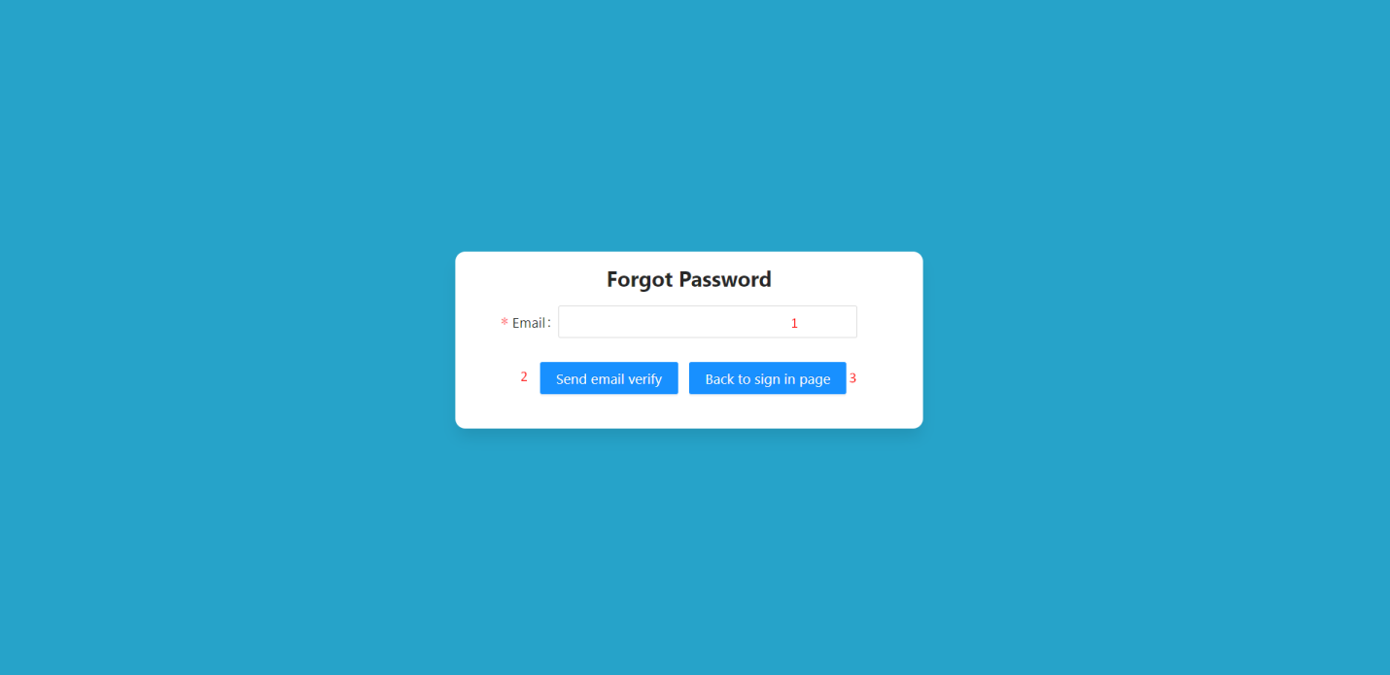

|  |  |  |  |  |  |  |  |  |
| --- | --- | --- | --- | --- | --- | --- | --- | --- |
| No. | Field Name | Description | | Read only | | Mandatory | Control Type | Data Type |
| 1 | Input email | Email to finding password | | No | | Yes | Text Box | String |
| **No.** | **Function** | | **Description** | | **Validation** | | **Outcome** | |
| 2 | Send email verify | | Confirm the email exists, then send the confirmation code to the email | | Yes | | Receive email confirmation email and change to login page | |
| 3 | Back to sign in page | | Back to login page | | No | | Change to login page | |

##### Verify email

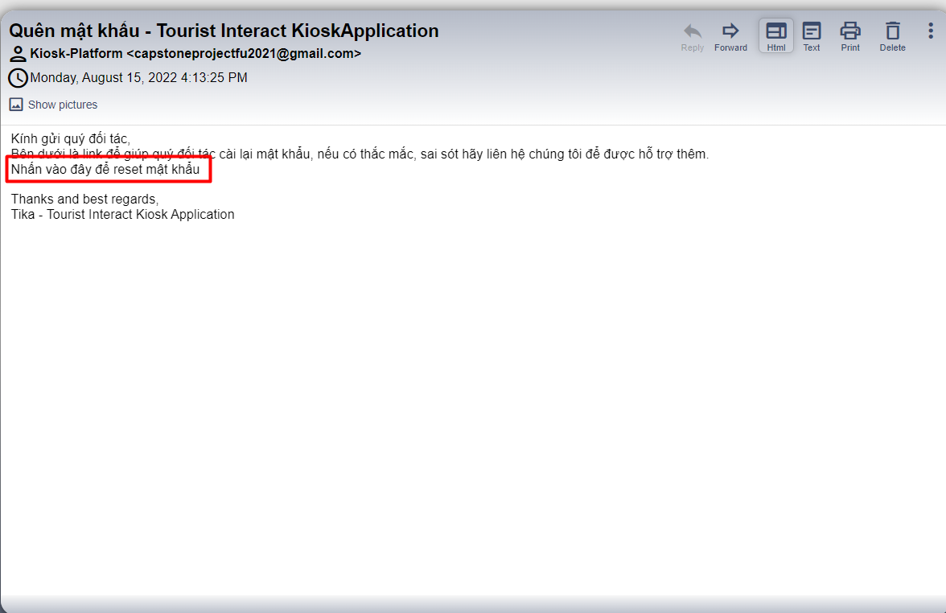

|  |  |  |  |  |
| --- | --- | --- | --- | --- |
| No. | Function | Description | Validation | Outcome |
| 1 | Verify email | Select the link in the picture above the mail you just registered | No | Change to received new password page |

##### Received new password

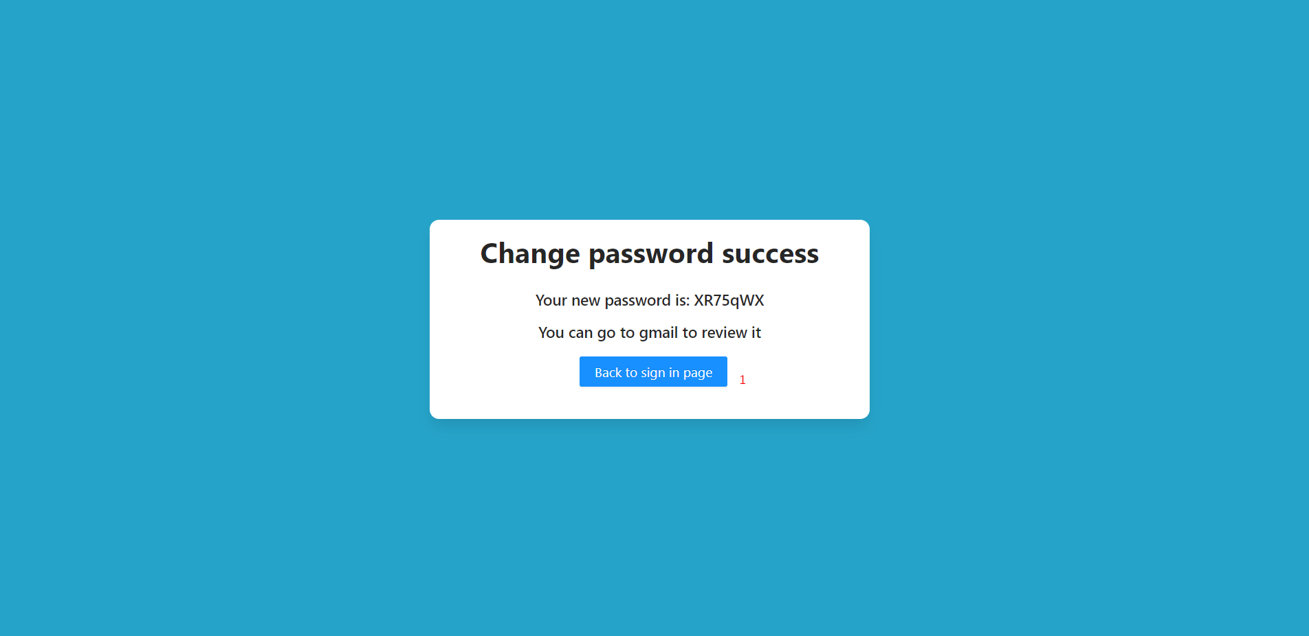

|  |  |  |  |  |
| --- | --- | --- | --- | --- |
| No. | Function | Description | Validation | Outcome |
| 1 | Back to sign in page | Back to login page | No | Change to login page |

Admin Module

##### Function overview

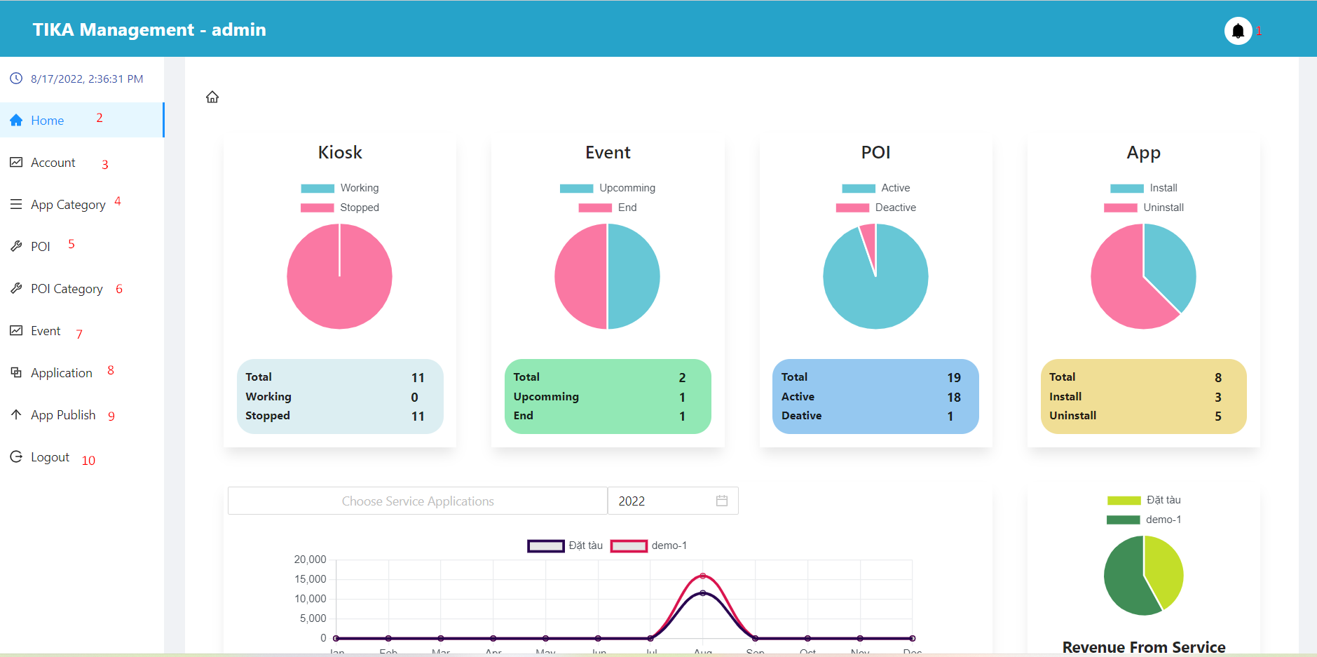

|  |  |  |  |  |
| --- | --- | --- | --- | --- |
| No. | Function | Description | Validation | Outcome |
| 1 | Notification button | Notification button | No | Display pop-ups showing user notifications |
| 2 | Home button | Home button | No | Go to home page |
| 3 | Account button | Account button | No | Go to account page |
| 4 | App category button | App category button | No | Go to application category page |
| 5 | Poi button | Poi button | No | Go to poi page |
| 6 | Poi category button | Poi category button | No | Go to poi category page |
| 7 | Event button | Event button | No | Go to event page |
| 8 | Application button | Application button | No | Go to application page |
| 9 | App publish button | App publish button | No | Go to application publish page |
| 10 | Logout button | Logout button | No | User is unauthenticated and go to login page |

##### Home Page (View system overview statistics)

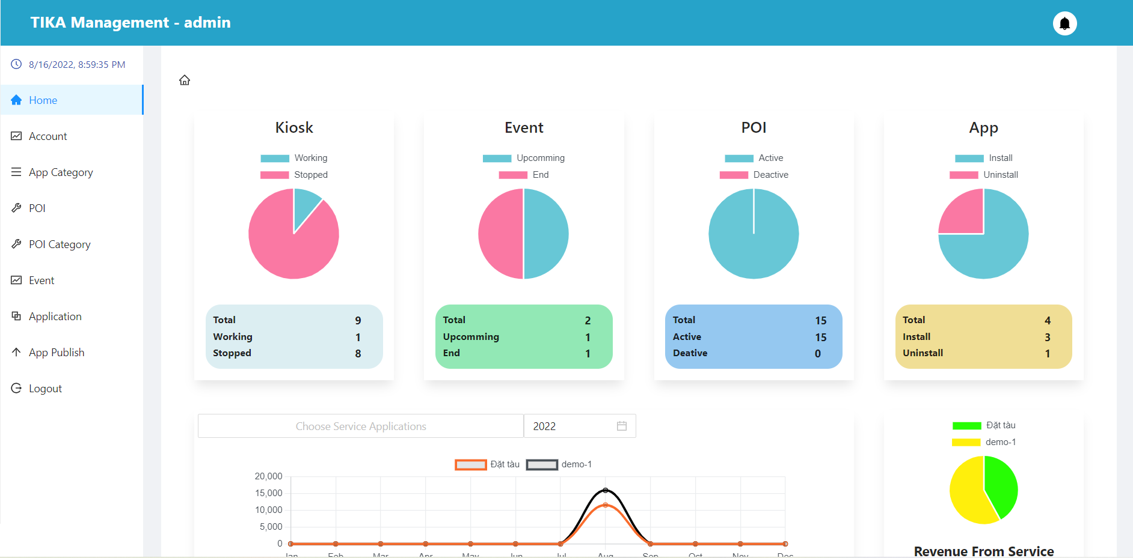

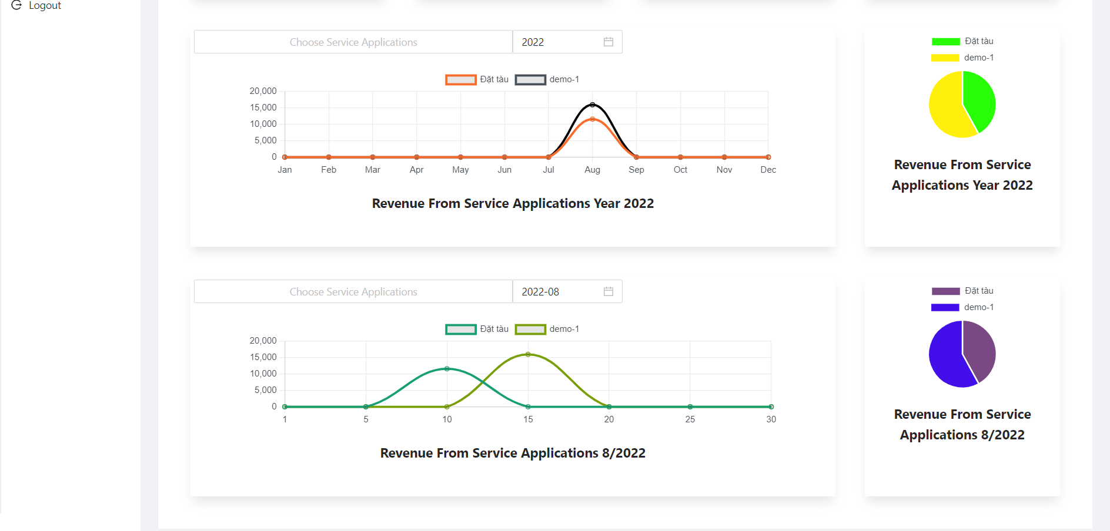

##### Account manager page

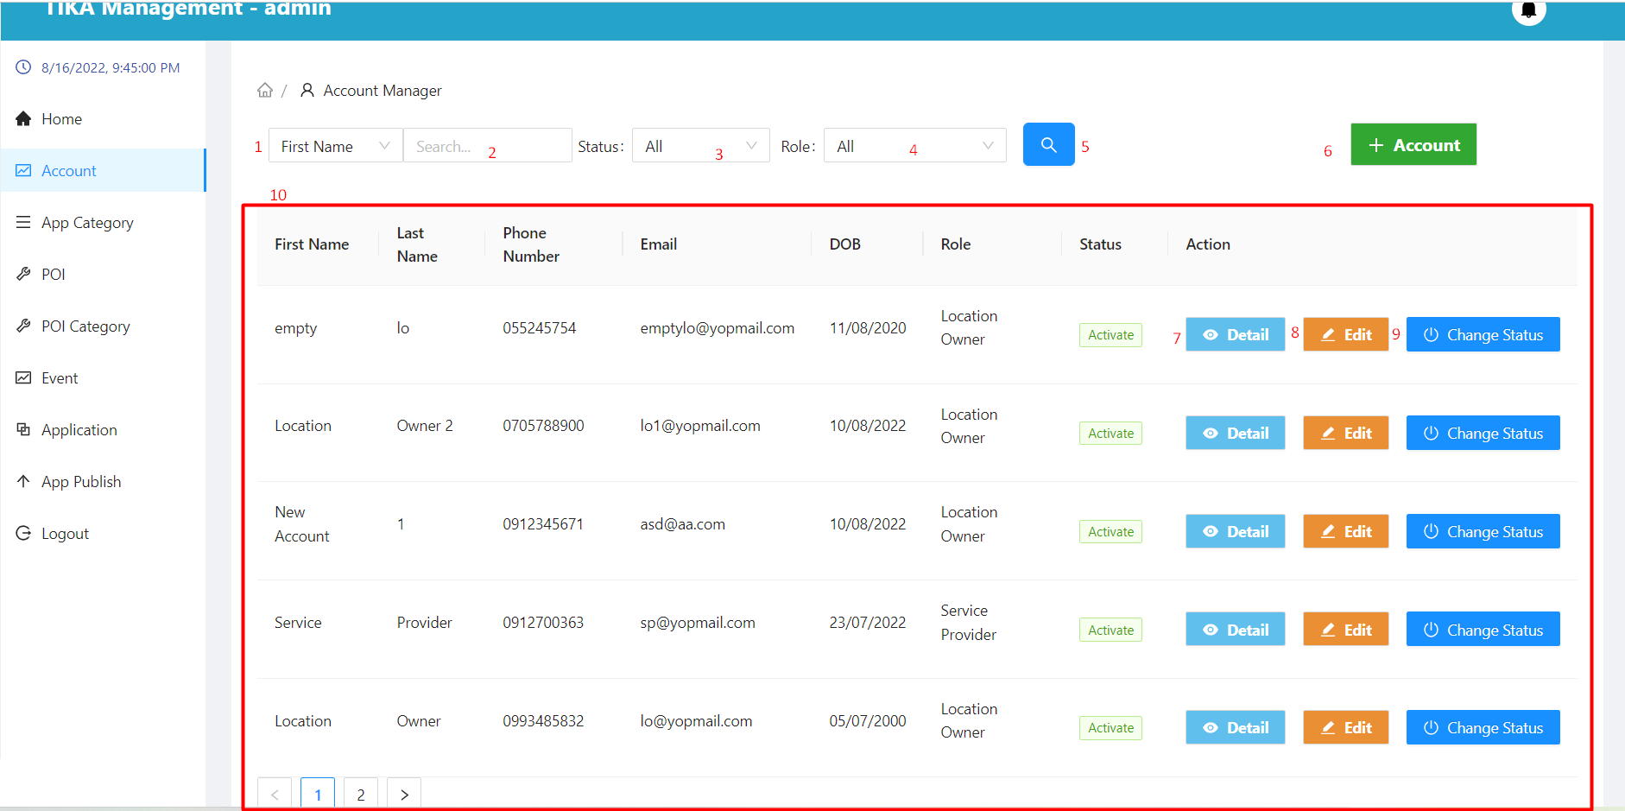

|  |  |  |  |  |  |  |  |  |
| --- | --- | --- | --- | --- | --- | --- | --- | --- |
| No. | Field Name | Description | | Read only | | Mandatory | Control Type | Data Type |
| 1 | Search field | Select field you want to search | | No | | No | Select | String |
| 2 | Input value to search | Enter a search value that corresponds to the search field selected in (1) | | No | | No | Input | String |
| 3 | Select status | Select value of status you want to search | | No | | No | Select | String |
| 4 | Select role | Select value of role you want to search | | No | | No | Select | String |
| 10 | Information of the account | Basic information of the account | | Yes | | Yes | Table | String |
| **No.** | **Function** | | **Description** | | **Validation** | | **Outcome** | |
| 5 | Search information | | Search with selected information and enter items 1, 2, 3, 4 | | Yes | | Information shown in the table below | |
| 6 | Create account button | | Create account with basic information | | No | | Show modal create account | |
| 7 | View detail account | | View account details in row | | No | | Move to detail account page | |
| 8 | Edit account button | | Edit account in row | | No | | Show modal edit account | |
| 9 | Change status account button | | Change status account in row | | No | | Show modal confirm to change status account | |

##### View create account modal

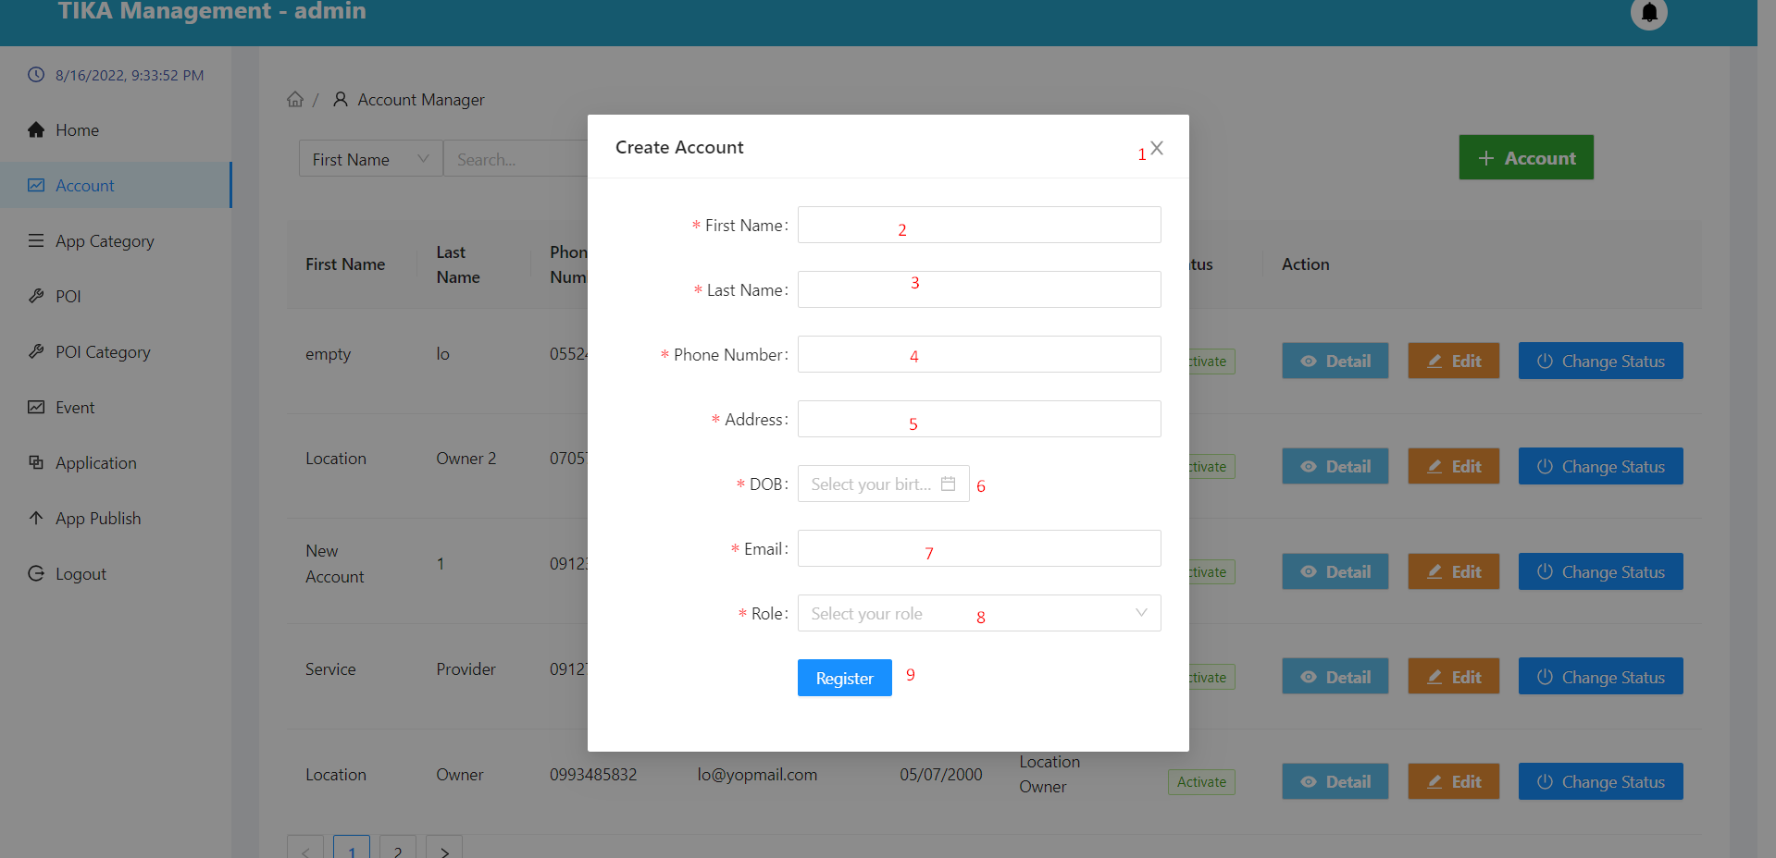

|  |  |  |  |  |  |  |  |  |
| --- | --- | --- | --- | --- | --- | --- | --- | --- |
| No. | Field Name | Description | | Read only | | Mandatory | Control Type | Data Type |
| 2 | First name | First name of user | | No | | Yes | Input | String |
| 3 | Last name | Last name of user | | No | | Yes | Input | String |
| 4 | Phone number | Phone number of user | | No | | Yes | Input | Number |
| 5 | Address | Address of user | | No | | Yes | Input | String |
| 6 | DOB | Date of birth of user | | No | | Yes | Select | String |
| 7 | Email | Email of user | | No | | Yes | Input | String |
| 8 | Role | Role of user | | No | | Yes | Select | String |
| **No.** | **Function** | | **Description** | | **Validation** | | **Outcome** | |
| 1 | Exit modal button | | Exit modal create account | | No | | Back to account manager page | |
| 9 | Create account button | | Create an account with the information provided | | Yes | | A new account is created | |

##### Account detail page

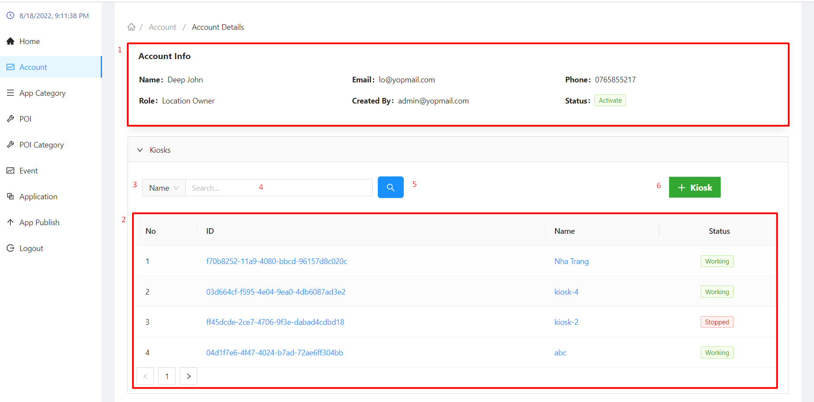

|  |  |  |  |  |  |  |  |  |  |
| --- | --- | --- | --- | --- | --- | --- | --- | --- | --- |
| No. | Field Name | Description | | Read only | | Mandatory | | Control Type | Data Type |
|  | Information of account | Detail information of account | | Yes | | Yes | | Table | String |
|  | Information of kiosk | Information about the currently selected user's kiosk | | Yes | | Yes | | Table | String |
| 3 | Search field | Select field you want to search | | No | | No | | Select | String |
| 4 | Input value to search | Enter a search value that corresponds to the search field selected in (3) | | No | | No | | Input | String |
| **No.** | **Function** | | **Description** | | **Validation** | | **Outcome** | | |
| 5 | Search information | | Search with selected information and enter items 3,4 | | Yes | | Information shown in the table below | | |
| 6 | Create kiosk button | | Create kiosk with basic information | | No | | Show modal confirm create kiosk | | |

##### Modal confirm create kiosk

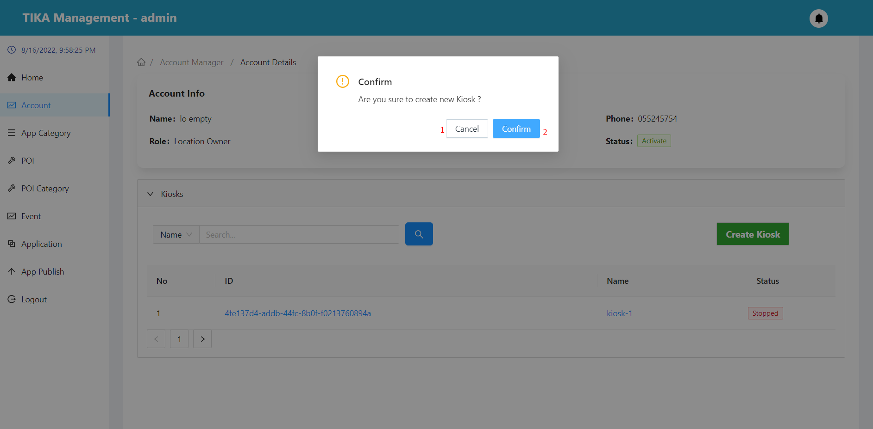

|  |  |  |  |  |
| --- | --- | --- | --- | --- |
| No. | Function | Description | Validation | Outcome |
| 1 | Cancel button | Cancel action create kiosk | No | Back to account detail page |
| 2 | Confirm button | Confirm action create kiosk | Yes | Create a new kiosk for the selected user |

##### Edit user information modal

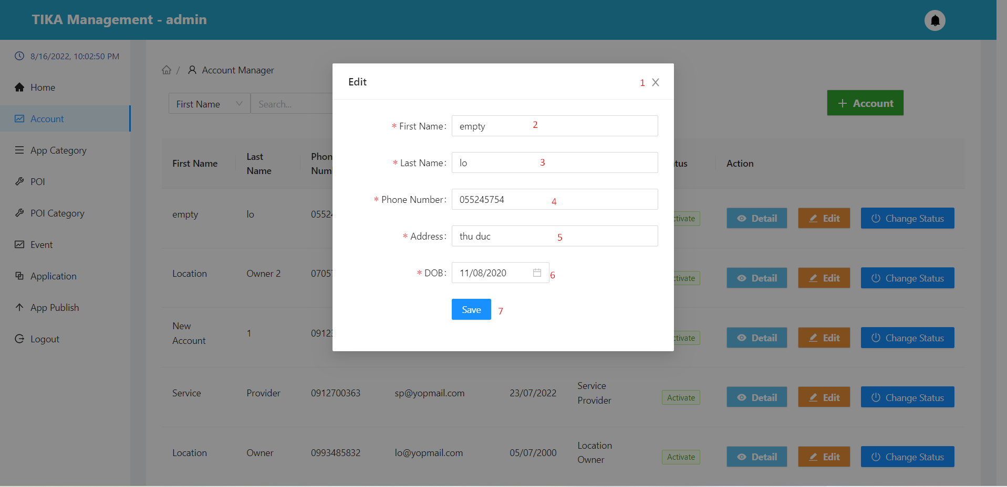

|  |  |  |  |  |  |  |  |  |
| --- | --- | --- | --- | --- | --- | --- | --- | --- |
| No. | Field Name | Description | | Read only | | Mandatory | Control Type | Data Type |
| 2 | First name | First name of user | | No | | Yes | Input | String |
| 3 | Last name | Last name of user | | No | | Yes | Input | String |
| 4 | Phone number | Phone number of user | | No | | Yes | Input | Number |
| 5 | Address | Address of user | | No | | Yes | Input | String |
| 6 | DOB | Date of birth of user | | No | | Yes | Select | String |
| **No.** | **Function** | | **Description** | | **Validation** | | **Outcome** | |
| 1 | Exit modal button | | Exit modal edit account | | No | | Back to account manager page | |
| 7 | Edit account button | | Edit an account with the information provided | | Yes | | Account information is changed | |

##### Modal confirm change status account

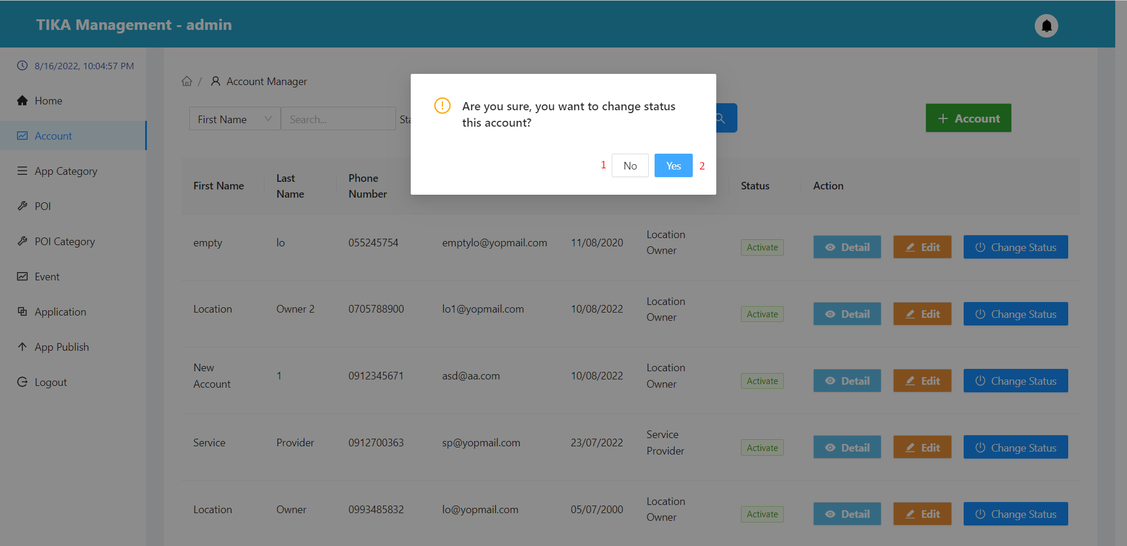

|  |  |  |  |  |
| --- | --- | --- | --- | --- |
| No. | Function | Description | Validation | Outcome |
| 1 | No button | Cancel action change status account | No | Back to account manager page |
| 2 | Yes button | Confirm action create kiosk | Yes | Change the status of the user on the same row to “Deactivate” |

##### Application category page

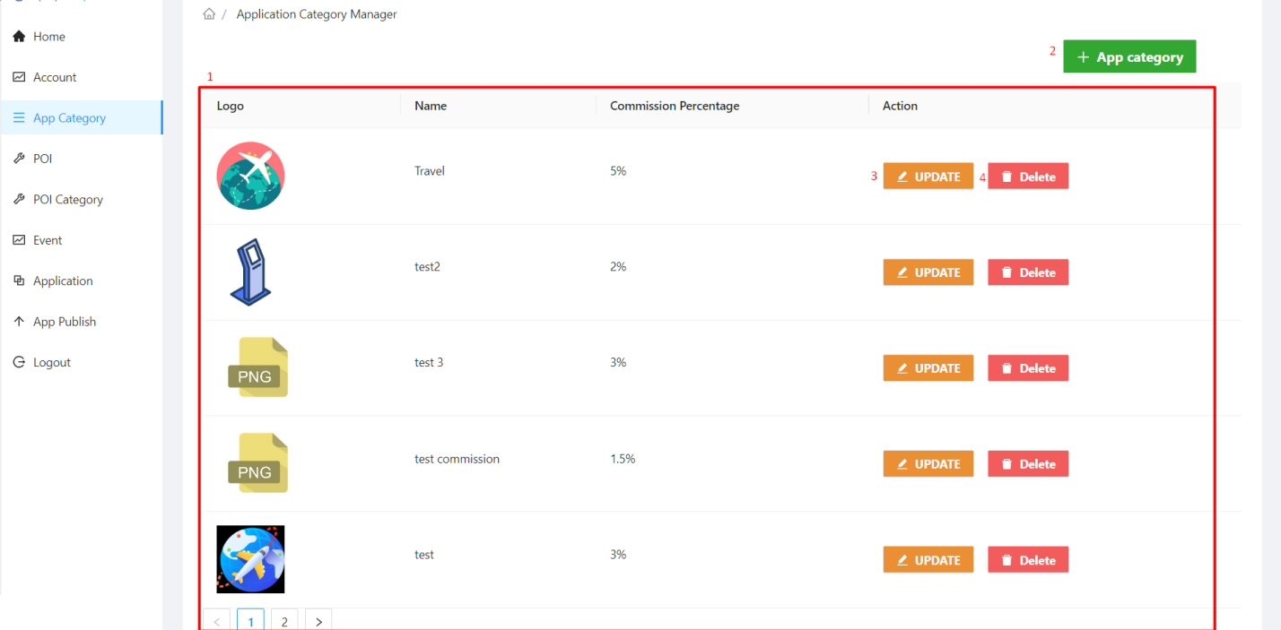

|  |  |  |  |  |  |  |  |  |  |  |
| --- | --- | --- | --- | --- | --- | --- | --- | --- | --- | --- |
| No. | Field Name | | Description | | Read only | | Mandatory | Control Type | | Data Type |
| 1 | Information of application category | | Information of application category | | Yes | | Yes | Table | | String |
| **No.** | | **Function** | | **Description** | | **Validation** | | | **Outcome** | |
| 2 | | Create application category button | | Create application category with basic information | | No | | | Show modal create application category | |
| 3 | | Update application category button | | Update application category in row | | No | | | Show modal update application category | |
| 4 | | Delete application category button | | Delete application category in row | | No | | | Show modal confirm delete application category | |

##### Create application category modal

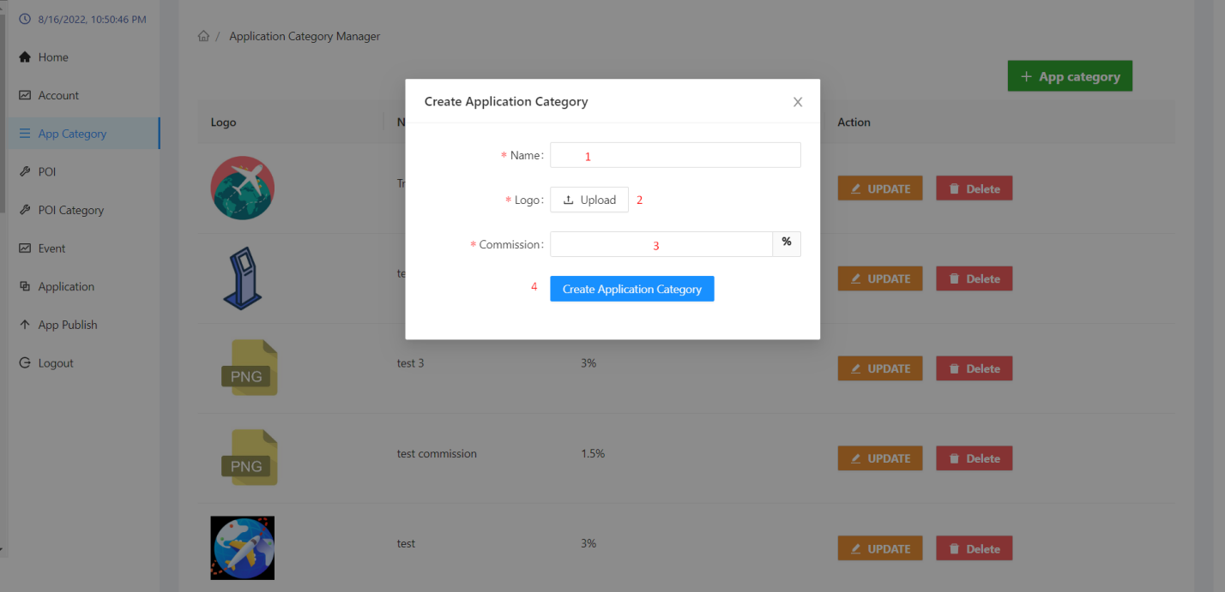

|  |  |  |  |  |  |  |  |  |  |  |
| --- | --- | --- | --- | --- | --- | --- | --- | --- | --- | --- |
| No. | Field Name | | Description | | Read only | | Mandatory | Control Type | | Data Type |
| 1 | Name | | Name of application category | | No | | Yes | Input | | String |
| 2 | Logo | | Upload logo of application category | | No | | Yes | Upload | | File |
| 3 | Commission | | Commission percent of application category | | No | | Yes | Input | | Number |
| **No.** | | **Function** | | **Description** | | **Validation** | | | **Outcome** | |
| 4 | | Create application category button | | Create new application category with the information provided | | Yes | | | New application category created | |

##### Application category update modal

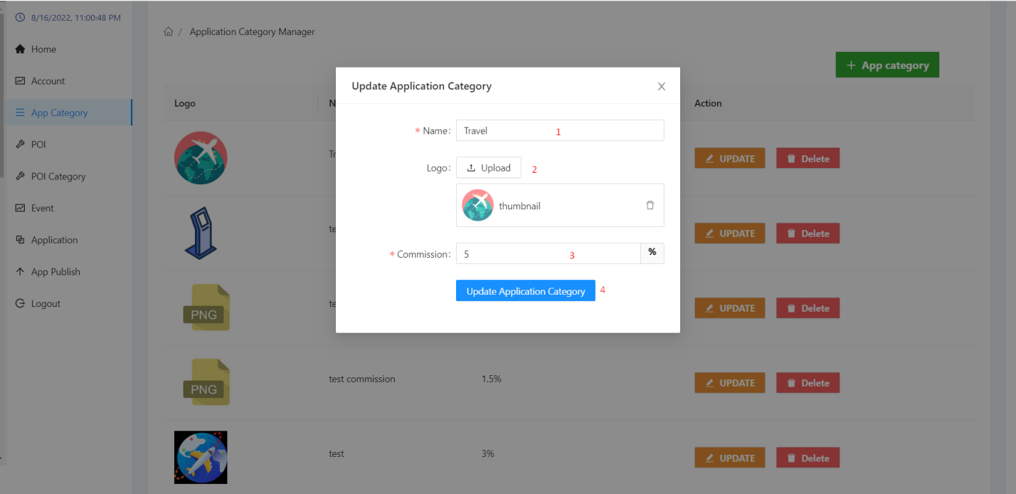

|  |  |  |  |  |  |  |  |  |  |  |
| --- | --- | --- | --- | --- | --- | --- | --- | --- | --- | --- |
| No. | Field Name | | Description | | Read only | | Mandatory | Control Type | | Data Type |
| 1 | Name | | Name of application category | | No | | Yes | Input | | String |
| 2 | Logo | | Upload logo of application category | | No | | Yes | Upload | | File |
| 3 | Commission | | Commission percent of application category | | No | | Yes | Input | | Number |
| **No.** | | **Function** | | **Description** | | **Validation** | | | **Outcome** | |
| 4 | | Update application category button | | Update new application category with the information provided | | Yes | | | Application category is change | |

##### Delete application category modal

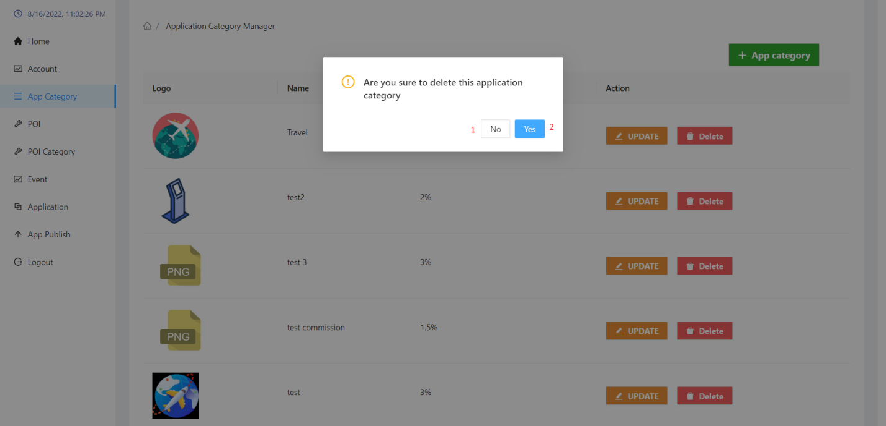

|  |  |  |  |  |
| --- | --- | --- | --- | --- |
| No. | Function | Description | Validation | Outcome |
| 1 | No button | Cancel action delete application category | No | Back to application category page |
| 2 | Yes button | Confirm action delete application category | Yes | Delete application category information from the database |

##### Poi page

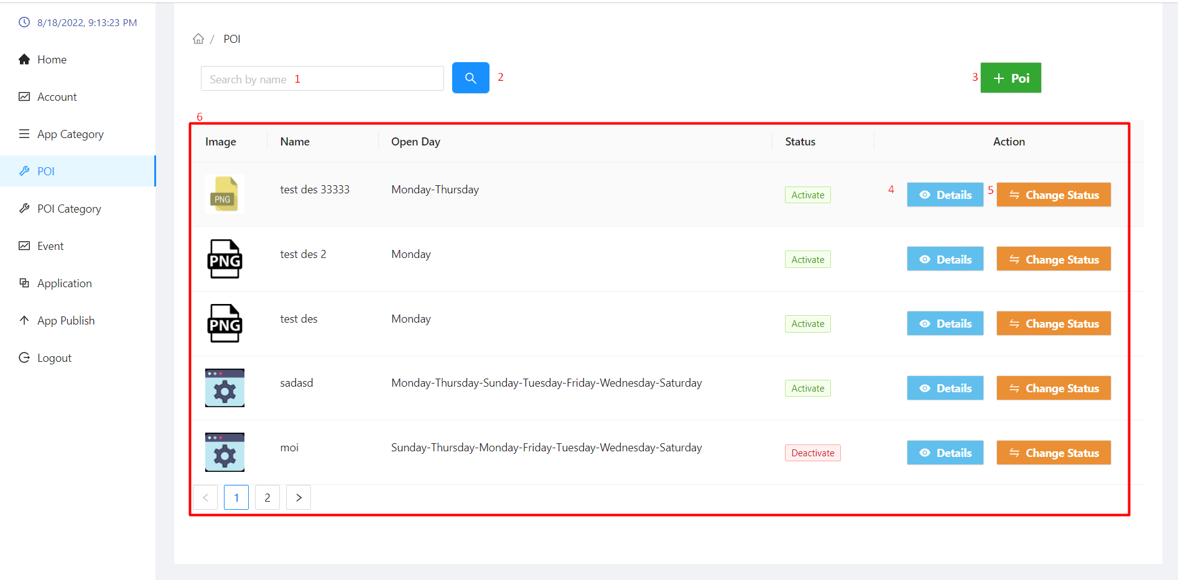

|  |  |  |  |  |  |  |  |  |  |  |
| --- | --- | --- | --- | --- | --- | --- | --- | --- | --- | --- |
| No. | Field Name | | Description | | Read only | | Mandatory | Control Type | | Data Type |
| 1 | Search name input field | | Input name you want to search | | No | | No | Input | | String |
| 6 | Information of poi | | Information of poi | | Yes | | Yes | Table | | String |
| **No.** | | **Function** | | **Description** | | **Validation** | | | **Outcome** | |
| 2 | | Search by name button | | Find information of poi based on name input field (1) and | | Yes | | | Show the results in the table below | |
| 3 | | Create button | | Create poi button | | No | | | Show modal create poi | |
| 4 | | Detail button | | Show detail of poi in the same row to view and edit | | No | | | Move to poi detail page | |
| 5 | | Change status button | | Change status button | | No | | | Show modal confirm change status poi | |

##### Create poi modal

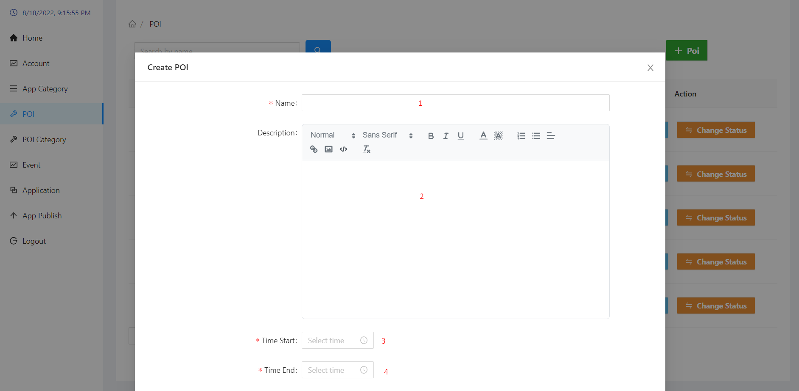

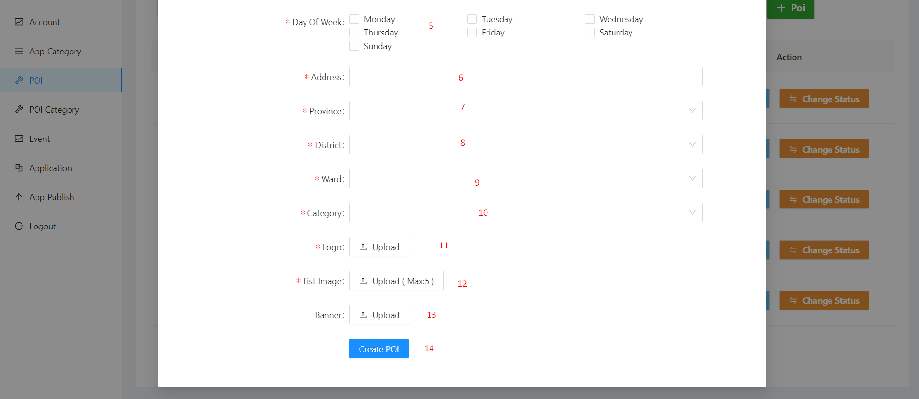

|  |  |  |  |  |  |  |  |  |  |  |
| --- | --- | --- | --- | --- | --- | --- | --- | --- | --- | --- |
| No. | Field Name | | Description | | Read only | | Mandatory | Control Type | | Data Type |
| 1 | Name | | Name of poi | | No | | Yes | Input | | String |
| 2 | Description | | Description of poi | | No | | Yes | Editor | | String |
| 3 | Time start | | Opening times of the day | | No | | Yes | DatePicker | | Datetime |
| 4 | Time end | | Closing times of the day | | No | | Yes | DatePicker | | Datetime |
| 5 | Day of week | | Opening day of the week | | No | | Yes | Checkbox | | String |
| 6 | Address | | Location of poi | | No | | Yes | Input | | String |
| 7 | Province | | Province of poi | | No | | Yes | Select | | String |
| 8 | District | | District of poi | | No | | Yes | Select | | String |
| 9 | Ward | | Ward of poi | | No | | Yes | Select | | String |
| 10 | Category | | Category of poi | | No | | Yes | Select | | String |
| 11 | Logo | | Logo of poi | | No | | Yes | Upload | | File |
| 12 | List Image | | List image of poi | | No | | Yes | Upload | | File |
| 13 | Banner | | Banner of poi | | No | | No | Upload | | File |
| **No.** | | **Function** | | **Description** | | **Validation** | | | **Outcome** | |
| 14 | | Create poi button | | Create new poi with the information provided | | Yes | | | New poi is create | |

##### Detail poi page

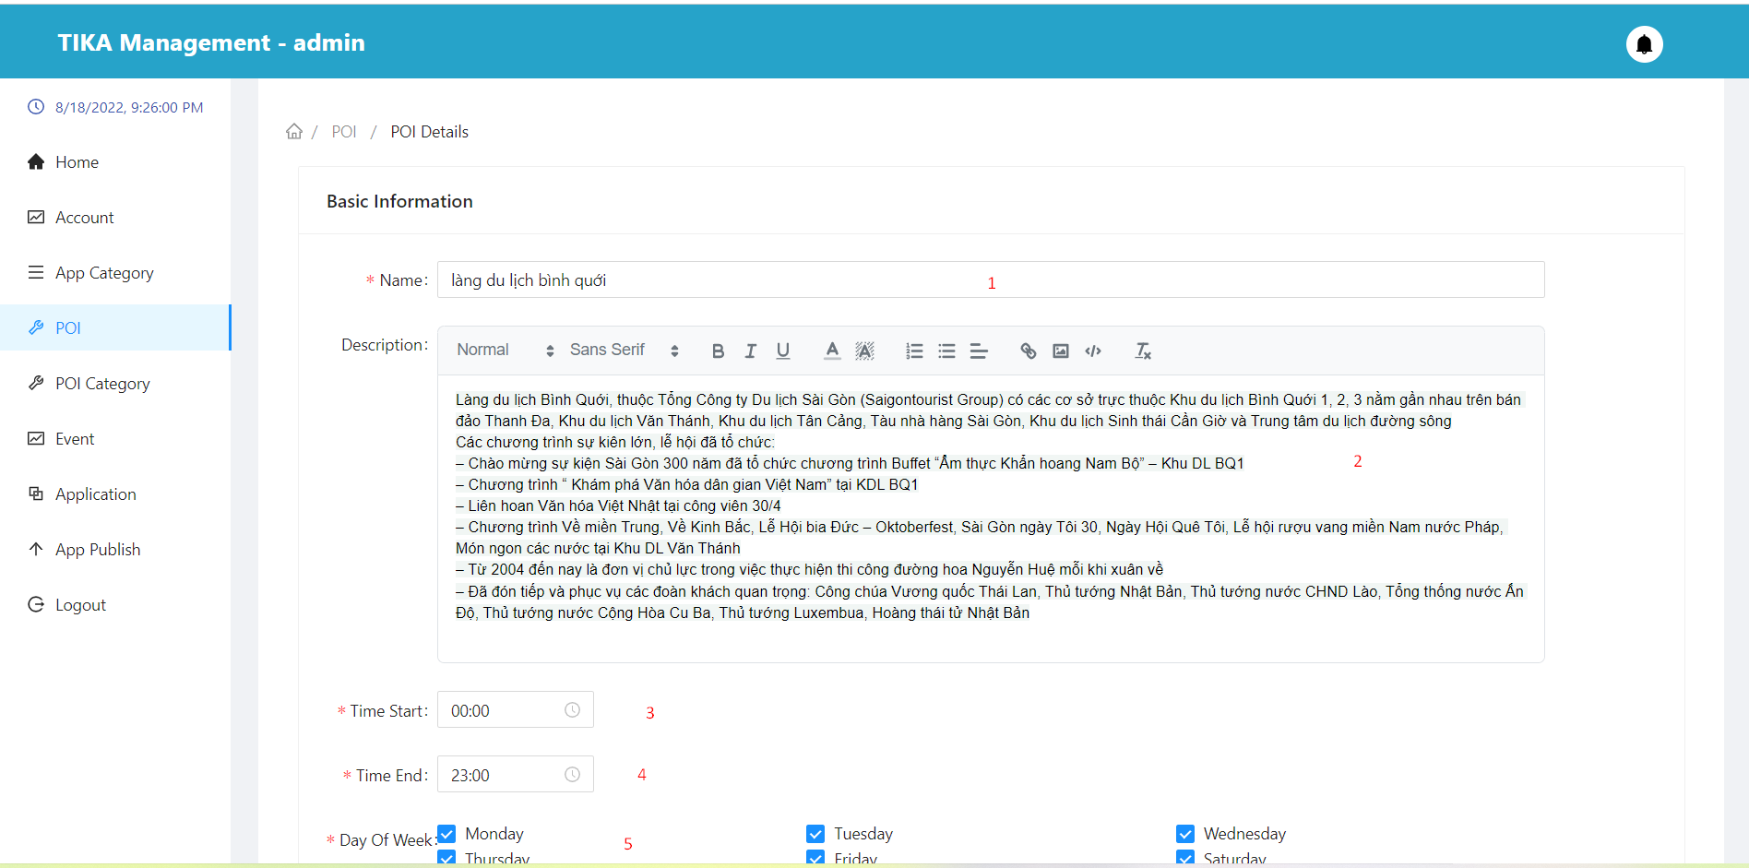

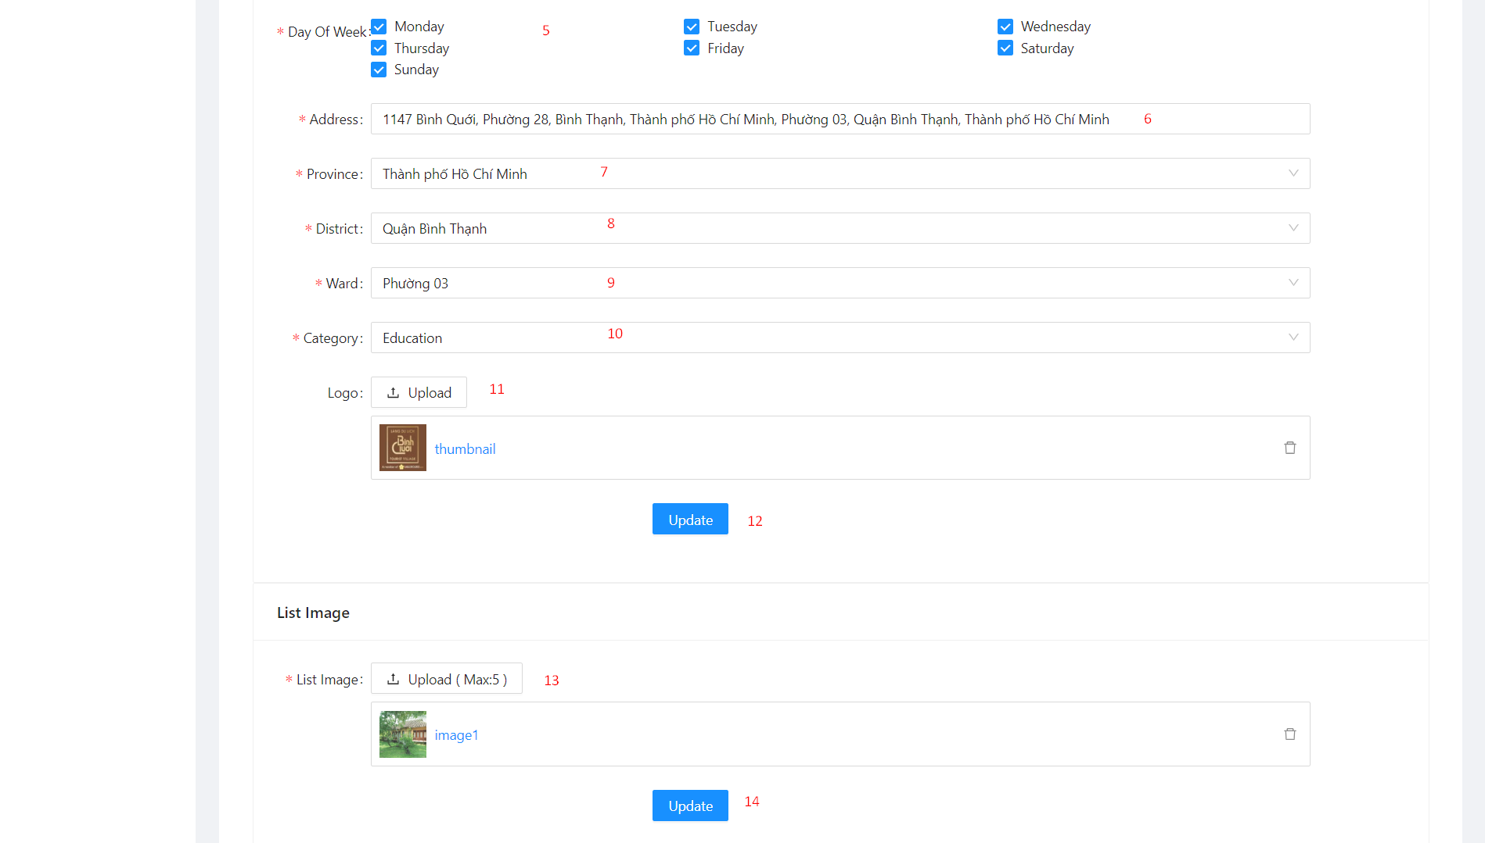

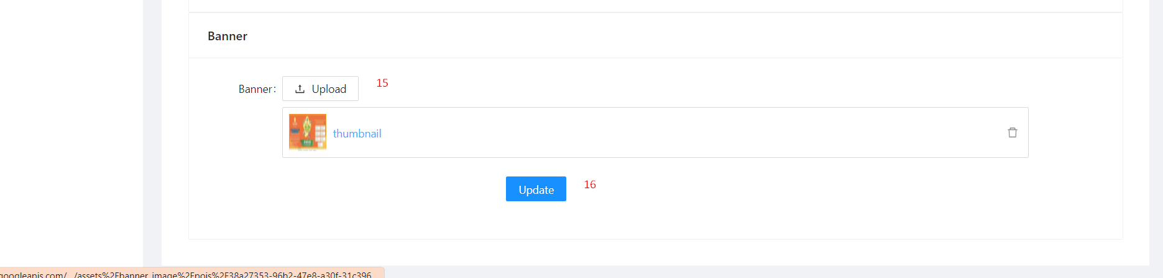

|  |  |  |  |  |  |  |  |  |  |  |
| --- | --- | --- | --- | --- | --- | --- | --- | --- | --- | --- |
| No. | Field Name | | Description | | Read only | | Mandatory | Control Type | | Data Type |
| 1 | Name | | Name of poi | | No | | Yes | Input | | String |
| 2 | Description | | Description of poi | | No | | Yes | Editor | | String |
| 3 | Time start | | Opening times of the day | | No | | Yes | DatePicker | | Datetime |
| 4 | Time end | | Closing times of the day | | No | | Yes | DatePicker | | Datetime |
| 5 | Day of week | | Opening day of the week | | No | | Yes | Checkbox | | String |
| 6 | Address | | Location of poi | | No | | Yes | Input | | String |
| 7 | Province | | Province of poi | | No | | Yes | Select | | String |
| 8 | District | | District of poi | | No | | Yes | Select | | String |
| 9 | Ward | | Ward of poi | | No | | Yes | Select | | String |
| 10 | Category | | Category of poi | | No | | Yes | Select | | String |
| 11 | Logo | | Logo of poi | | No | | Yes | Upload | | File |
| 13 | List Image | | List image of poi | | No | | Yes | Upload | | File |
| 15 | Banner | | Banner of poi | | No | | No | Upload | | File |
| **No.** | | **Function** | | **Description** | | **Validation** | | | **Outcome** | |
| 12 | | Update base information poi button | | Update poi with the information provided | | Yes | | | Poi updated | |
| 14 | | Update list image poi button | | Update list image with the list image provided | | Yes | | | Poi updated | |
| 16 | | Update banner poi button | | Update poi banner with the banner provided | | Yes | | | Poi updated | |

##### Change status poi modal

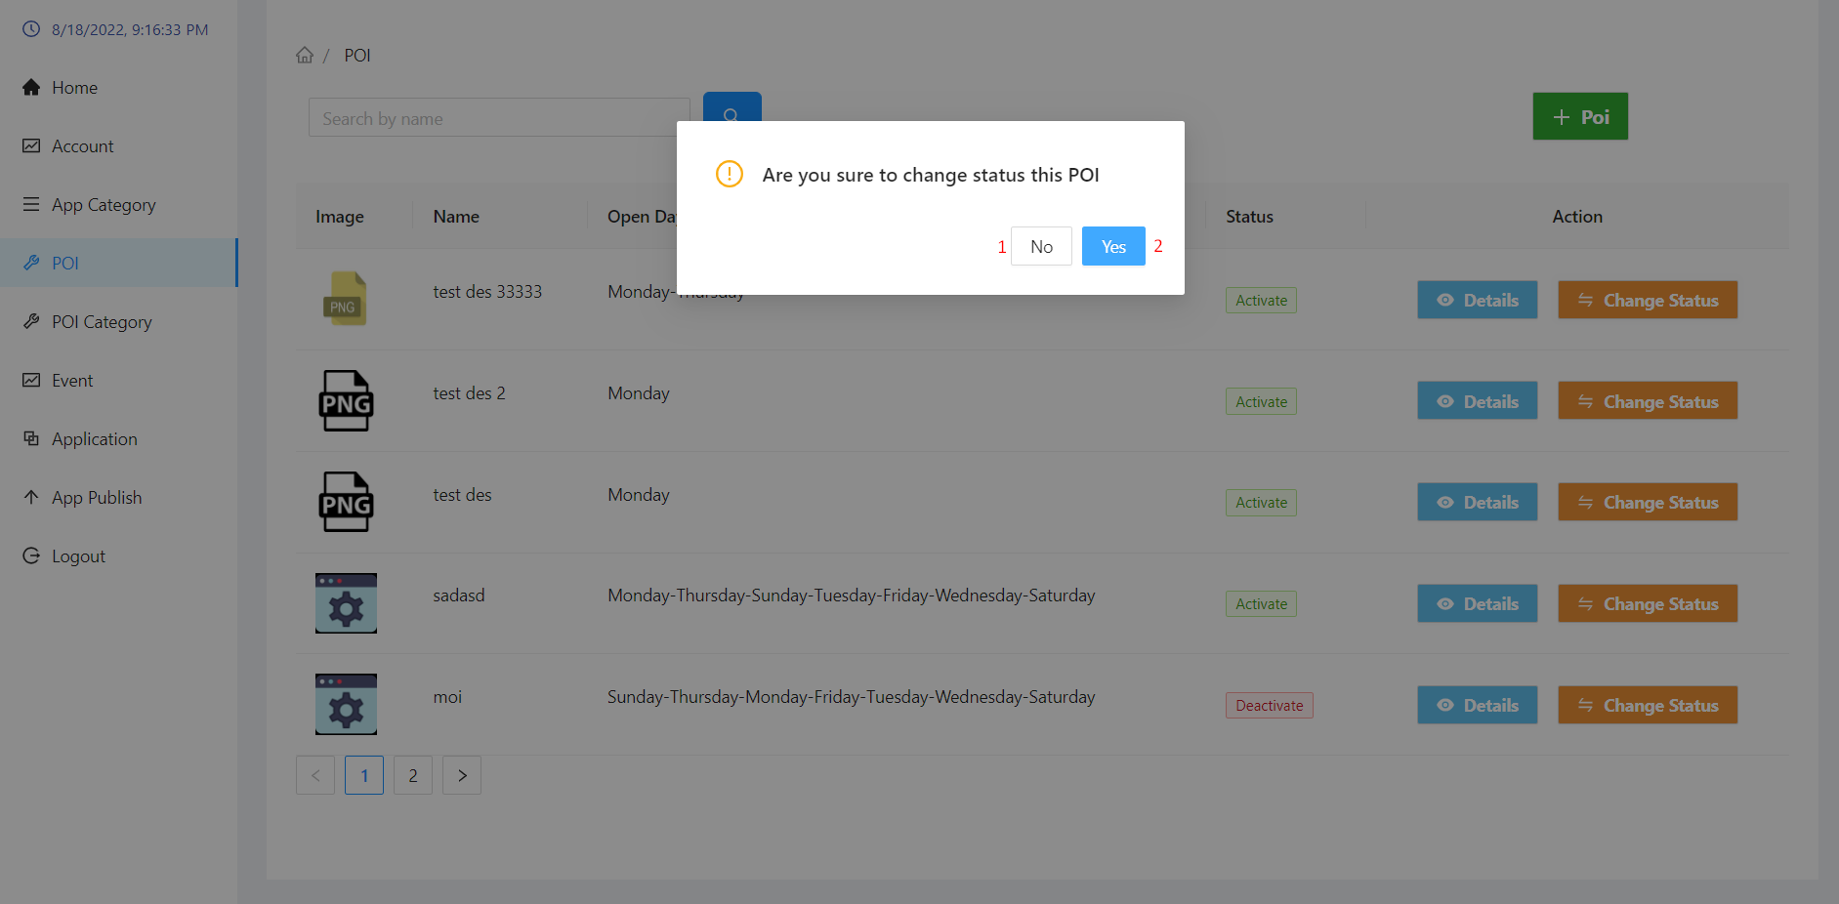

|  |  |  |  |  |
| --- | --- | --- | --- | --- |
| No. | Function | Description | Validation | Outcome |
| 1 | No button | Cancel action change status poi | No | Back to poi page |
| 2 | Yes button | Confirm action change status poi | Yes | poi's status is updated to “Deactivate” |

##### Poi category page

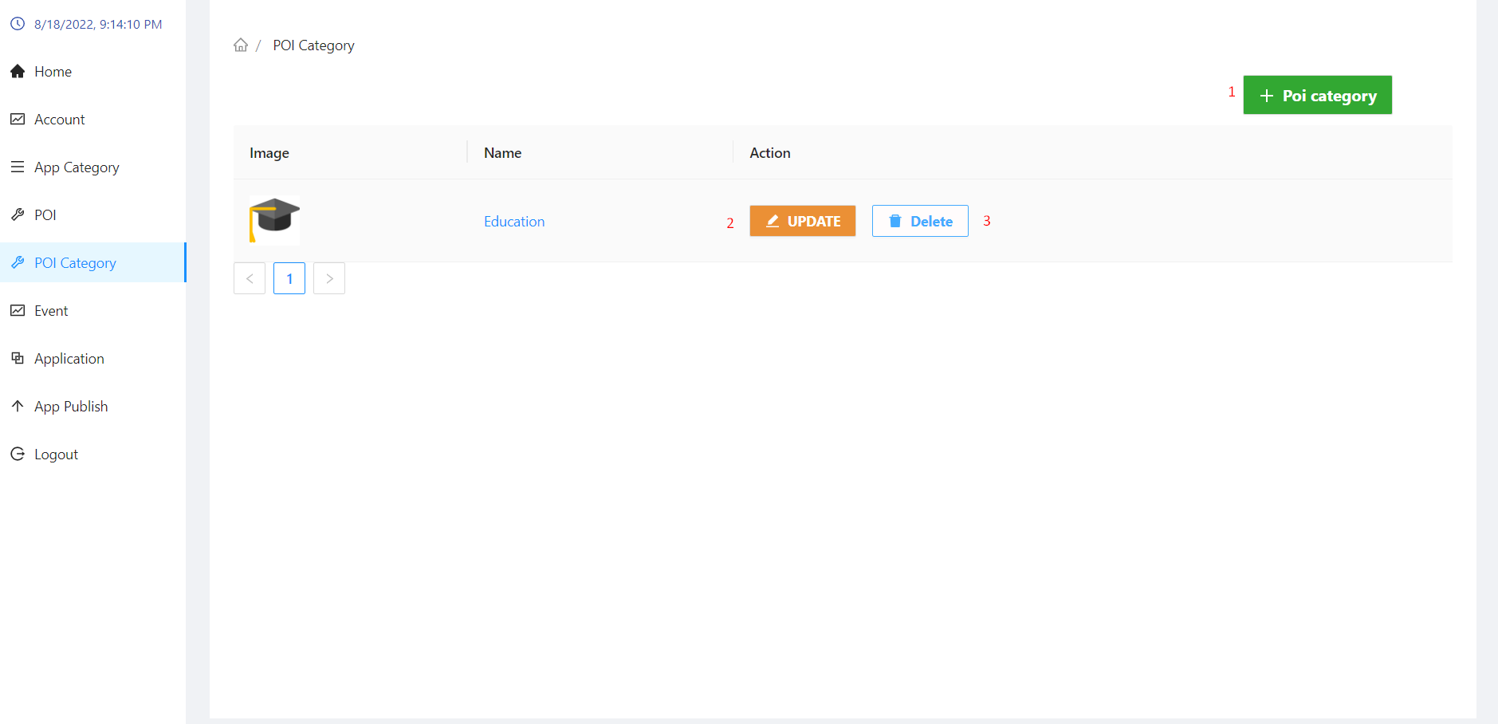

|  |  |  |  |  |
| --- | --- | --- | --- | --- |
| No. | Function | Description | Validation | Outcome |
| 1 | Create button | Create poi category button | No | Show modal create poi category |
| 2 | Update button | Update poi category button | No | Show modal update poi category |
| 3 | Delete button | Delete poi category button | No | Show modal confirm delete poi category |

##### Create poi category modal

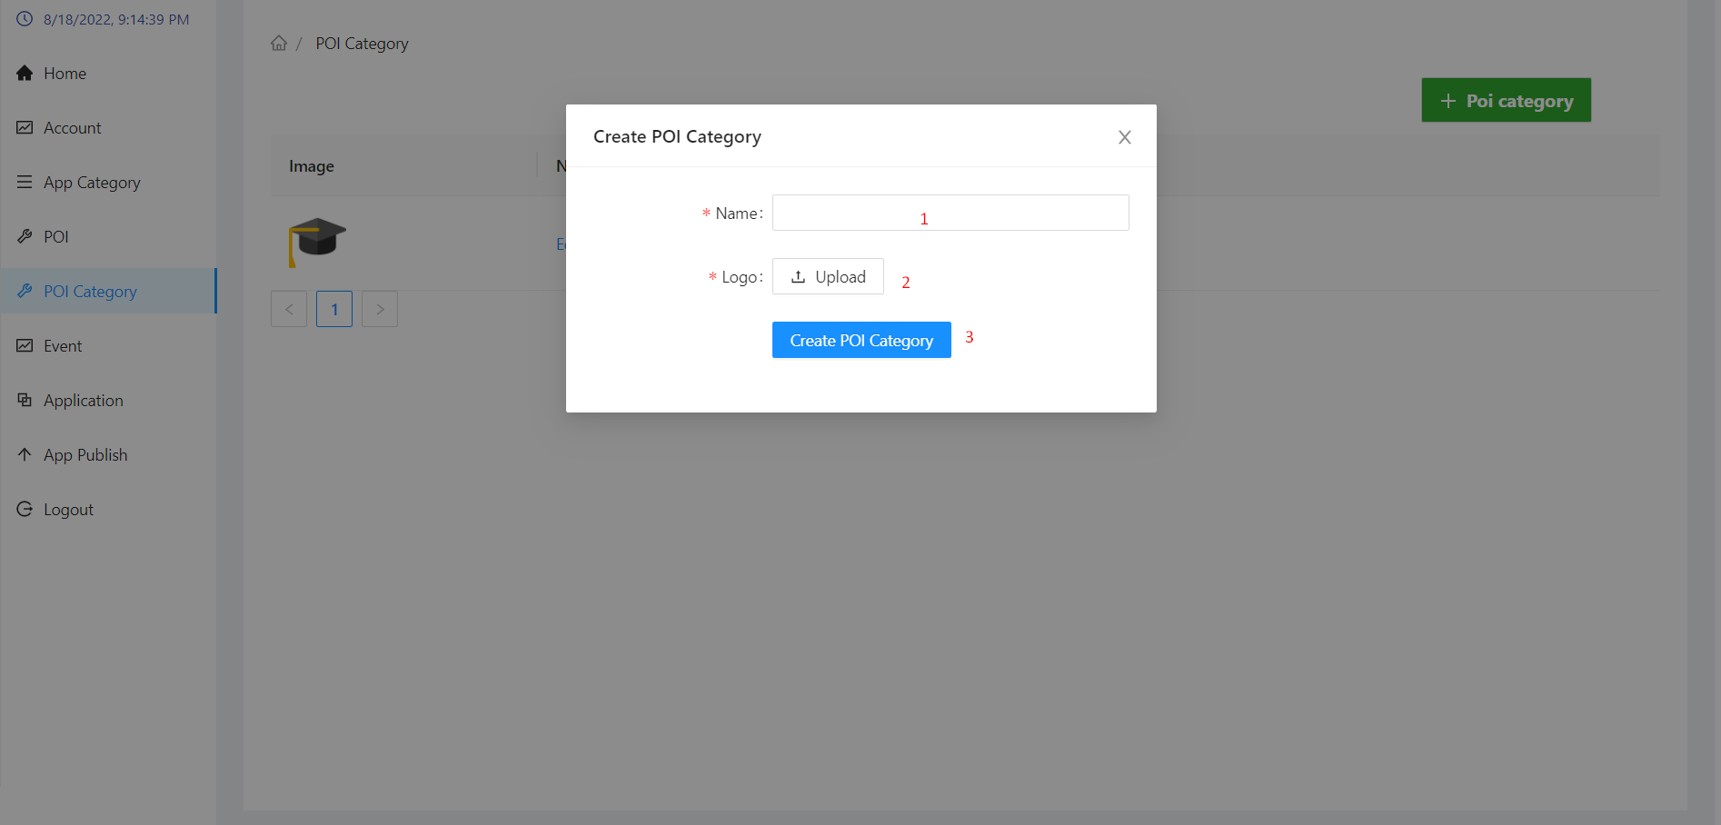

|  |  |  |  |  |  |  |  |  |  |  |
| --- | --- | --- | --- | --- | --- | --- | --- | --- | --- | --- |
| No. | Field Name | | Description | | Read only | | Mandatory | Control Type | | Data Type |
| 1 | Name | | Name of poi category | | No | | Yes | Input | | String |
| 2 | Logo | | Logo of poi category | | No | | Yes | Upload | | File |
| **No.** | | **Function** | | **Description** | | **Validation** | | | **Outcome** | |
| 3 | | Create poi category button | | Create new poi category with the information provided | | Yes | | | New poi category is create | |

##### Update poi category modal

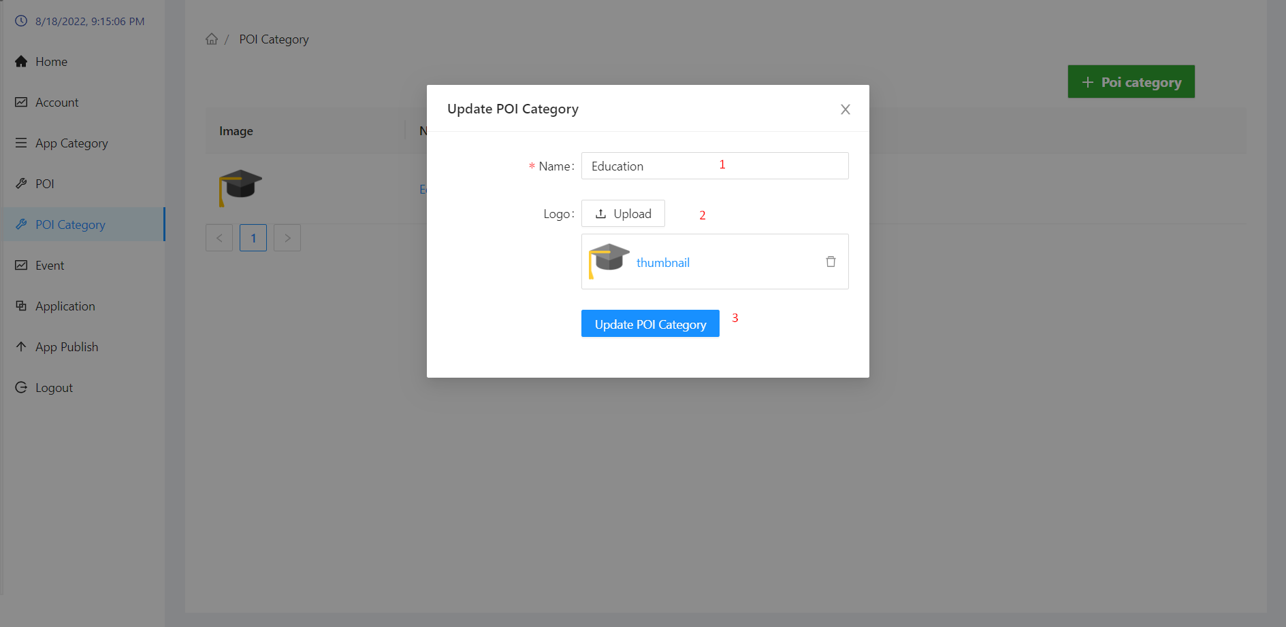

|  |  |  |  |  |  |  |  |  |  |  |
| --- | --- | --- | --- | --- | --- | --- | --- | --- | --- | --- |
| No. | Field Name | | Description | | Read only | | Mandatory | Control Type | | Data Type |
| 1 | Name | | Name of poi category | | No | | Yes | Input | | String |
| 2 | Logo | | Logo of poi category | | No | | Yes | Upload | | File |
| **No.** | | **Function** | | **Description** | | **Validation** | | | **Outcome** | |
| 3 | | Update base infortion poi category button | | Update poi category with the information provided | | Yes | | | Poi category updated | |

##### Delete poi category

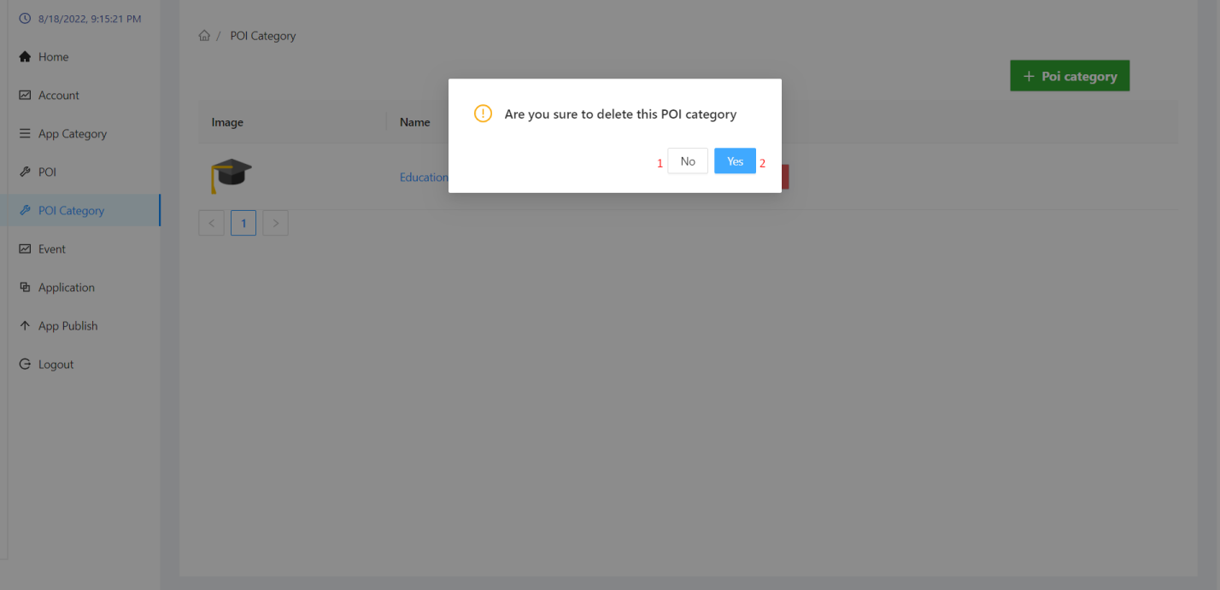

|  |  |  |  |  |
| --- | --- | --- | --- | --- |
| No. | Function | Description | Validation | Outcome |
| 1 | No button | Cancel action delete poi category | No | Back to poi category page |
| 2 | Yes button | Confirm action delete poi category | Yes | Delete poi category information from the database |

##### Event page

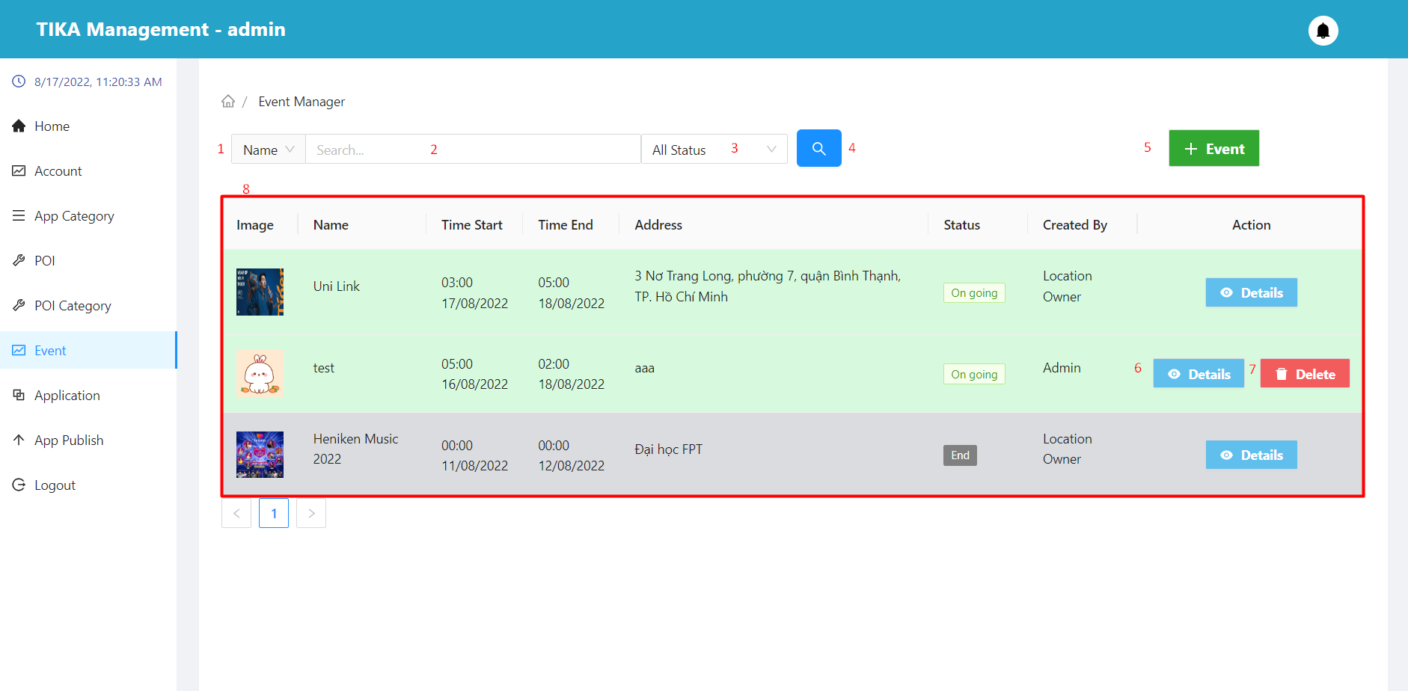

|  |  |  |  |  |  |  |  |  |
| --- | --- | --- | --- | --- | --- | --- | --- | --- |
| No. | Field Name | Description | | Read only | | Mandatory | Control Type | Data Type |
| 1 | Search field | Select field you want to search | | No | | No | Select | String |
| 2 | Input value to search | Enter a search value that corresponds to the search field selected in (1) | | No | | No | Input | String |
| 3 | Select status | Select value of status you want to search | | No | | No | Select | String |
| 8 | Information of the event | Basic information of the event | | Yes | | Yes | Table | String |
| **No.** | **Function** | | **Description** | | **Validation** | | **Outcome** | |
| 4 | Search information | | Search with selected information and enter items 1, 2, 3 | | Yes | | Information shown in the table below | |
| 5 | Create event button | | Create event with basic information | | No | | Show modal create event | |
| 6 | View detail event | | View event details in row | | No | | Move to detail event page | |
| 7 | Delete event button | | Delete event in row  You can only delete an event when it's an event created by you | | No | | Show modal confirm to delete event | |

##### Create event page

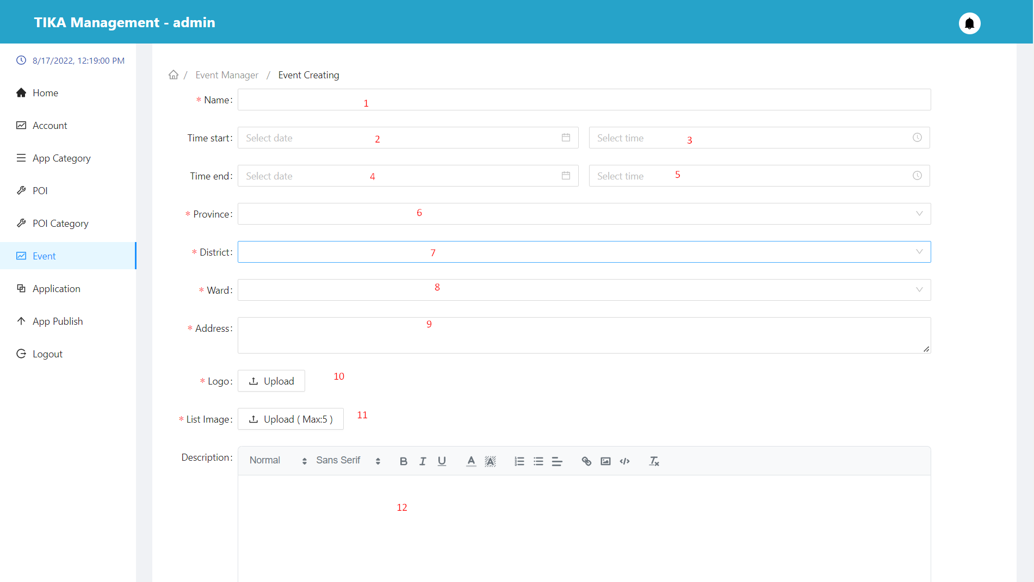

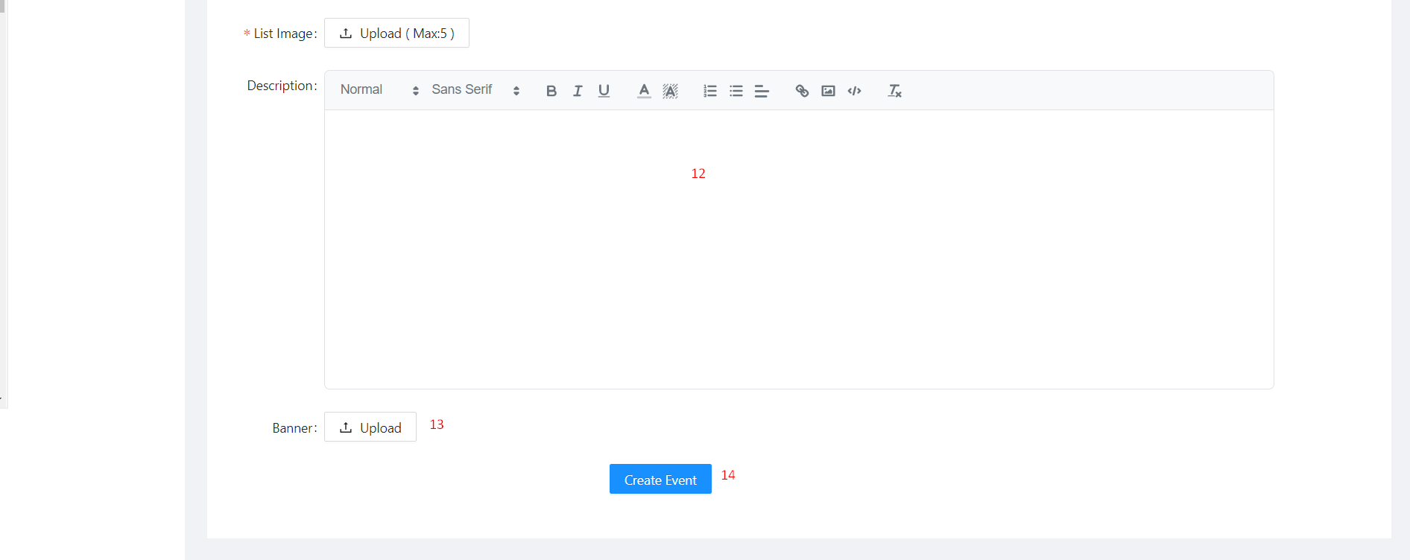

|  |  |  |  |  |  |  |  |  |  |  |
| --- | --- | --- | --- | --- | --- | --- | --- | --- | --- | --- |
| No. | Field Name | | Description | | Read only | | Mandatory | Control Type | | Data Type |
| 1 | Name | | Name of event | | No | | Yes | Input | | String |
| 2 | Date start | | Opening dates of the event | | No | | Yes | DatePicker | | Datetime |
| 3 | Time start | | Opening times of the event | | No | | Yes | DatePicker | | Datetime |
| 4 | Date end | | Closing dates of the event | | No | | Yes | DatePicker | | Datetime |
| 5 | Time end | | Closing times of the event | | No | | Yes | DatePicker | | Datetime |
| 6 | Province | | Province of event | | No | | Yes | Select | | String |
| 7 | District | | District of event | | No | | Yes | Select | | String |
| 8 | Ward | | Ward of event | | No | | Yes | Select | | String |
| 9 | Address | | Location of event | | No | | Yes | Textarea | | String |
| 10 | Logo | | Logo of event | | No | | Yes | Upload | | File |
| 11 | List Image | | List image of event | | No | | Yes | Upload | | File |
| 12 | Description | | Description of event | | No | | Yes | Editor | | String |
| 13 | Banner | | Banner of event | | No | | No | Upload | | File |
| **No.** | | **Function** | | **Description** | | **Validation** | | | **Outcome** | |
| 14 | | Create base information event button | | Create event with the information provided | | Yes | | | Event created | |

##### Detail event modal

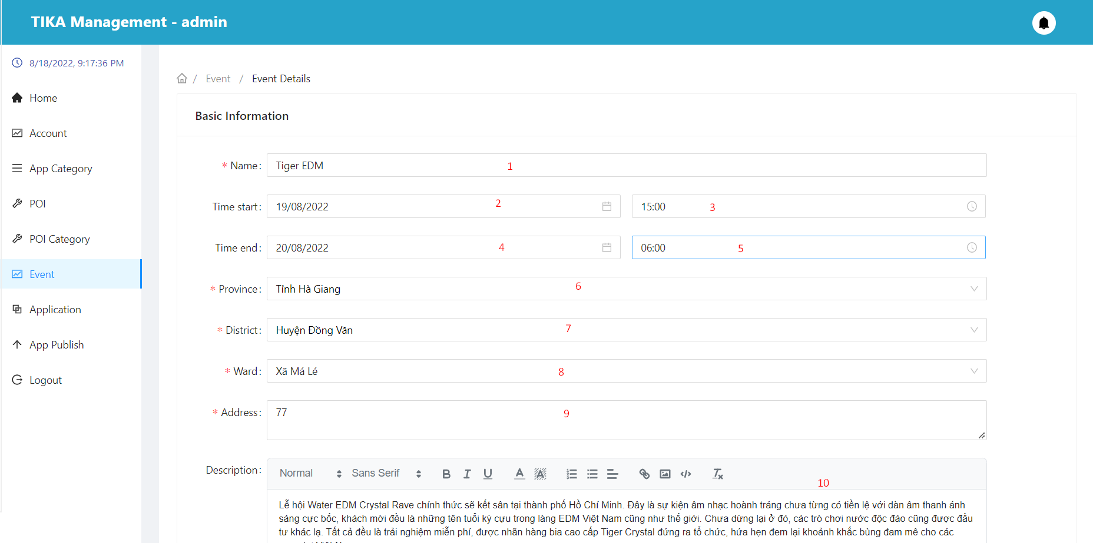

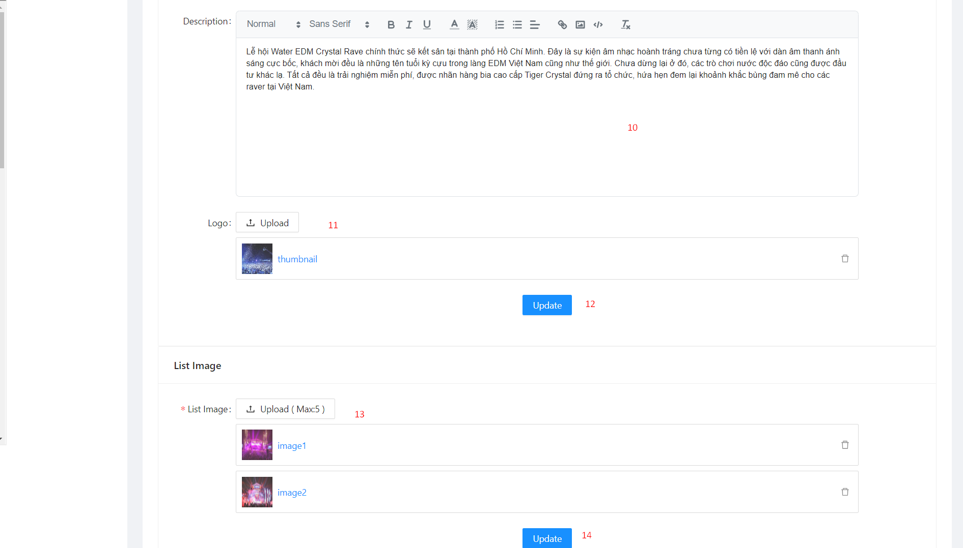

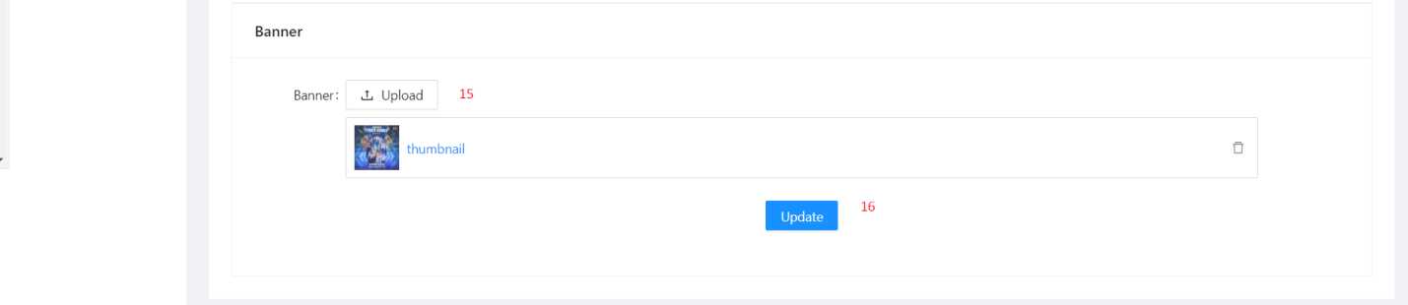

|  |  |  |  |  |  |  |  |  |  |
| --- | --- | --- | --- | --- | --- | --- | --- | --- | --- |
| No. | Field Name | Description | | Read only | | Mandatory | Control Type | | Data Type |
| 1 | Name | Name of event | | No | | Yes | Input | | String |
| 2 | Date start | Opening dates of the event | | No | | Yes | DatePicker | | Datetime |
| 3 | Time start | Opening times of the event | | No | | Yes | DatePicker | | Datetime |
| 4 | Date end | Closing dates of the event | | No | | Yes | DatePicker | | Datetime |
| 5 | Time end | Closing times of the event | | No | | Yes | DatePicker | | Datetime |
| 6 | Province | Province of event | | No | | Yes | Select | | String |
| 7 | District | District of event | | No | | Yes | Select | | String |
| 8 | Ward | Ward of event | | No | | Yes | Select | | String |
| 9 | Address | Location of event | | No | | Yes | Textarea | | String |
| 10 | Logo | Logo of event | | No | | Yes | Upload | | File |
| 11 | List Image | List image of event | | No | | Yes | Upload | | File |
| 13 | Description | Description of event | | No | | Yes | Editor | | String |
| 15 | Banner | Banner of event | | No | | No | Upload | | File |
| **No.** | **Function** | | **Description** | | **Validation** | | | **Outcome** | |
| 12 | Update base information event button | | Update event with the information provided.  You can only edit an event when it's an event created by you | | Yes | | | Event updated | |
| 14 | Updated image list button | | Updated event photo list.  You can only edit an event when it's an event created by you | | Yes | | | Event updated | |
| 16 | Updated banner button | | Updated event banner.  You can only edit an event when it's an event created by you | | Yes | | | Event updated | |

##### Delete event modal

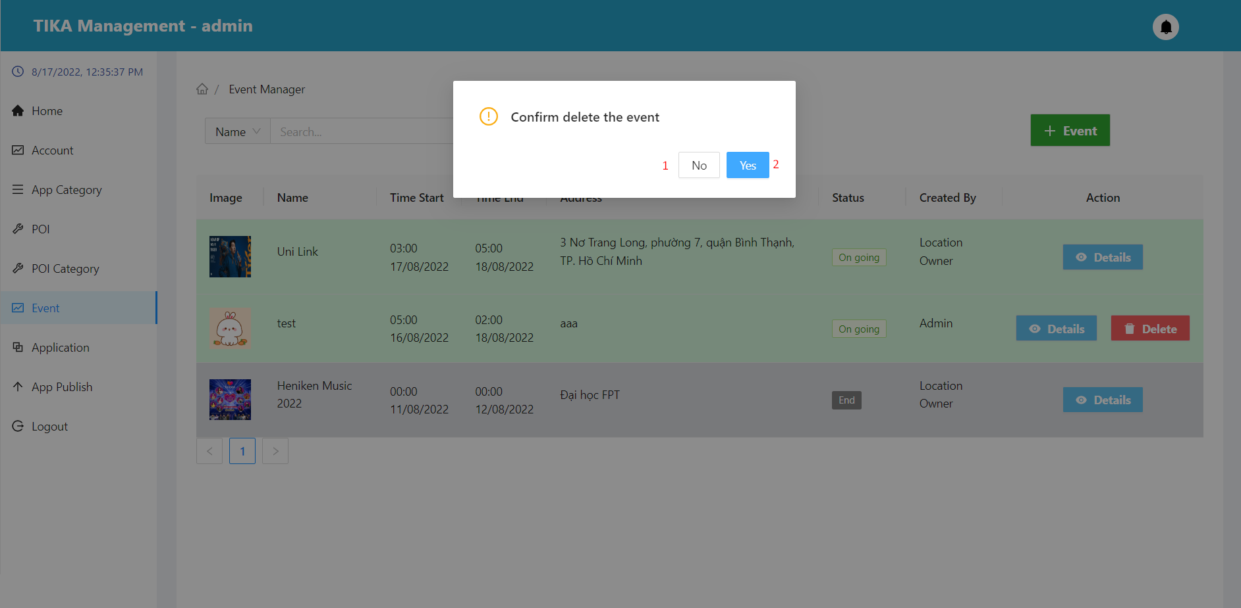

|  |  |  |  |  |
| --- | --- | --- | --- | --- |
| No. | Function | Description | Validation | Outcome |
| 1 | No button | Cancel action delete event | No | Back to event page |
| 2 | Yes button | Confirm action delete event | Yes | Event deleted from database |

##### Application page

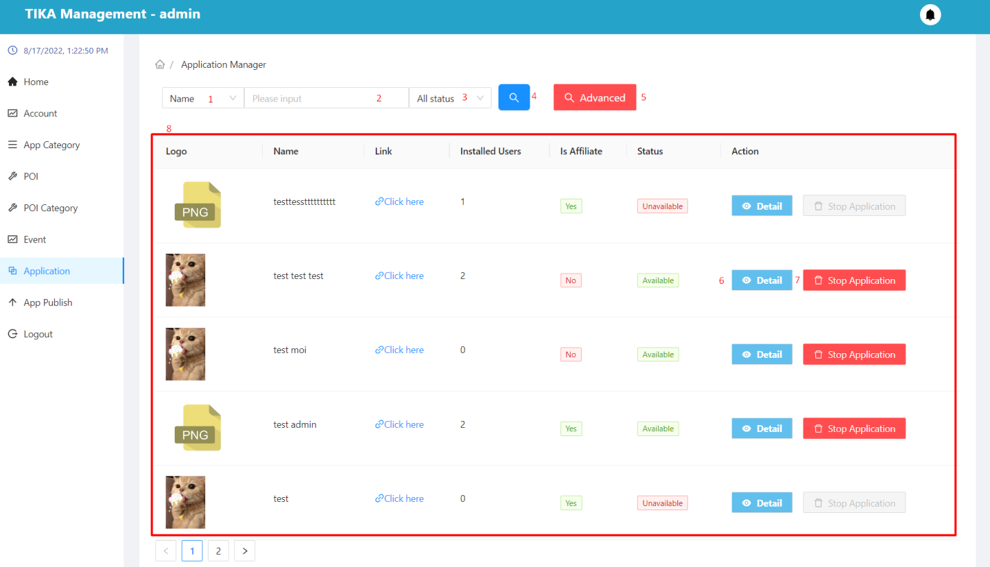

|  |  |  |  |  |  |  |  |  |
| --- | --- | --- | --- | --- | --- | --- | --- | --- |
| No. | Field Name | Description | | Read only | | Mandatory | Control Type | Data Type |
| 1 | Search field | Select field you want to search | | No | | No | Select | String |
| 2 | Input value to search | Enter a search value that corresponds to the search field selected in (1) | | No | | No | Input | String |
| 3 | Select status | Select value of status you want to search | | No | | No | Select | String |
| 8 | Information of the application | Basic information of the application | | Yes | | Yes | Table | String |
| **No.** | **Function** | | **Description** | | **Validation** | | **Outcome** | |
| 4 | Search information | | Search with selected information and enter items 1, 2, 3 | | Yes | | Information shown in the table below | |
| 5 | Advance search button | | Search with multiple data fields at the same time | | No | | Show modal advance search application | |
| 6 | View detail application | | View application details in row | | No | | Move to detail application page | |
| 7 | Stop application button | | Stop application in row  you can only stop apps with “available” status | | No | | Show modal confirm to stop application | |

##### Advance search application modal

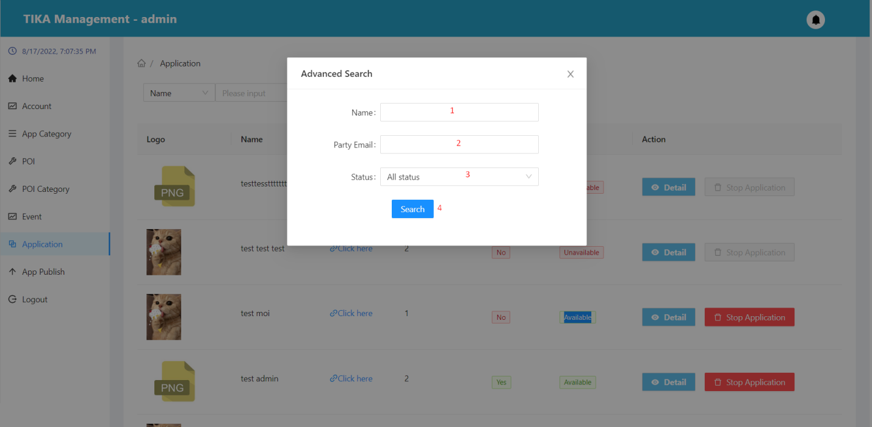

|  |  |  |  |  |  |  |  |  |
| --- | --- | --- | --- | --- | --- | --- | --- | --- |
| No. | Field Name | Description | | Read only | | Mandatory | Control Type | Data Type |
| 1 | Name | Enter the name of the app you want to search for | | No | | No | Input | String |
| 2 | Party email | Enter the party email of the app you want to search for | | No | | No | Input | String |
| 3 | Select status | Select value of status you want to search | | No | | No | Select | String |
| **No.** | **Function** | | **Description** | | **Validation** | | **Outcome** | |
| 4 | Search button | | Search with selected information and enter items 1, 2, 3 | | Yes | | Information shown in the table in application page | |

##### Application detail page

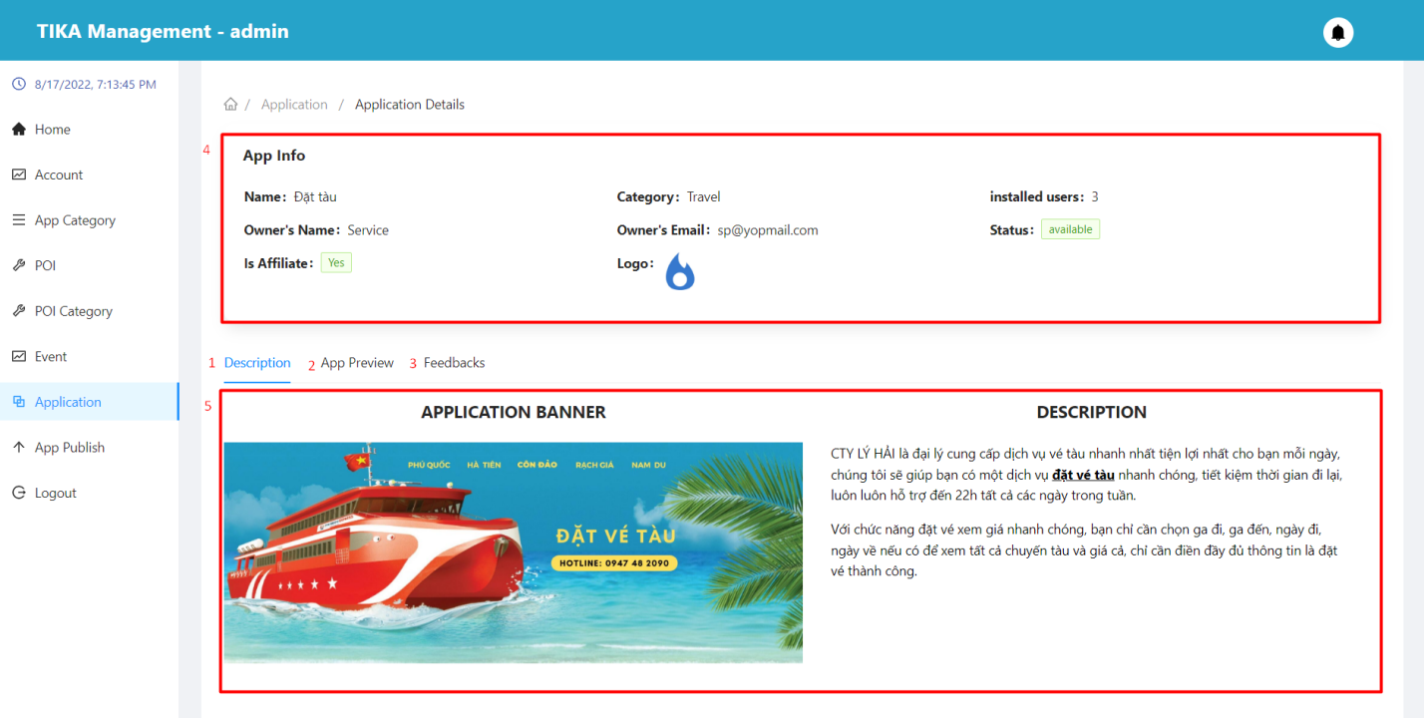

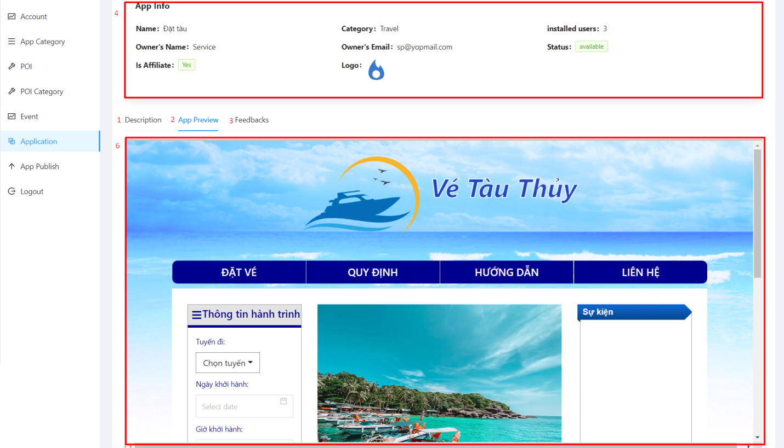

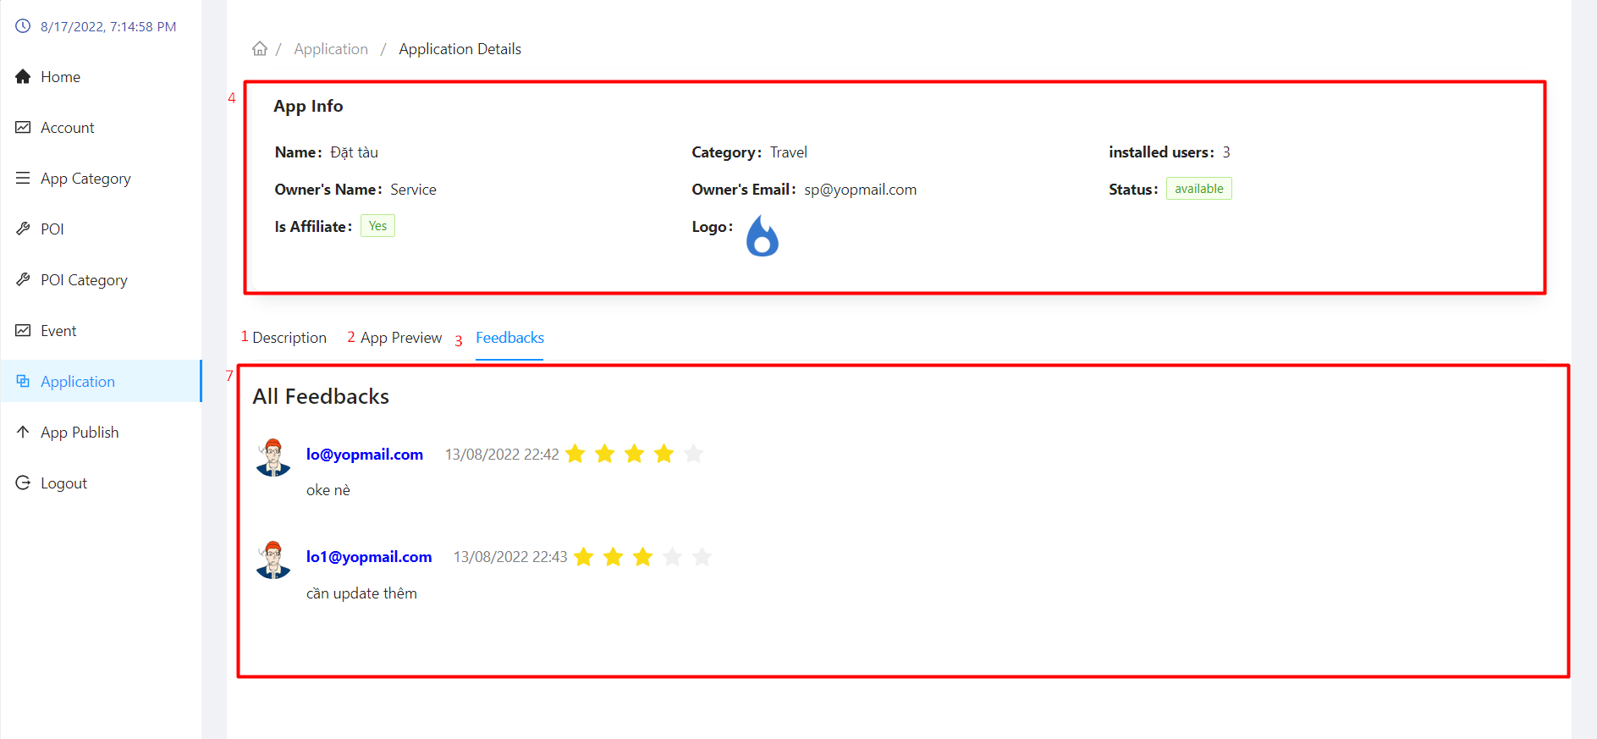

|  |  |  |  |  |  |  |  |  |
| --- | --- | --- | --- | --- | --- | --- | --- | --- |
| No. | Field Name | Description | | Read only | | Mandatory | Control Type | Data Type |
| 4 | App info | Used to view application details | | Yes | | Yes | Table | String |
| 5 | Description area | See the app's description | | Yes | | Yes | Tab | String |
| 6 | App review area | Preview the interface of the application | | Yes | | Yes | Tab | String |
| 7 | Feedback area | Used to view the feedback of users who have used the application | | Yes | | Yes | Tab | String |
| **No.** | **Function** | | **Description** | | **Validation** | | **Outcome** | |
| 1 | Description tab | | Description tab | | No | | Move to tab description | |
| 2 | App review tab | | App review tab | | No | | Move to tab app review | |
| 3 | Feedback tab | | Feedback tab | | No | | Move to tab feedback | |

##### Stop application modal

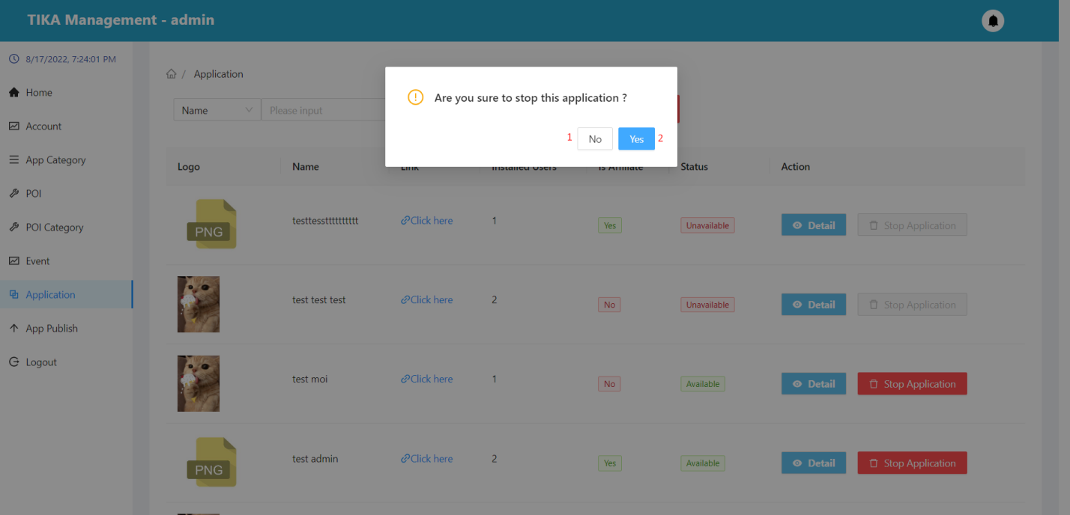

|  |  |  |  |  |
| --- | --- | --- | --- | --- |
| No. | Function | Description | Validation | Outcome |
| 1 | No button | Cancel action stop application | No | Back to application page |
| 2 | Yes button | Confirm action stop application | Yes | The app is stopped |

##### Application publish request page

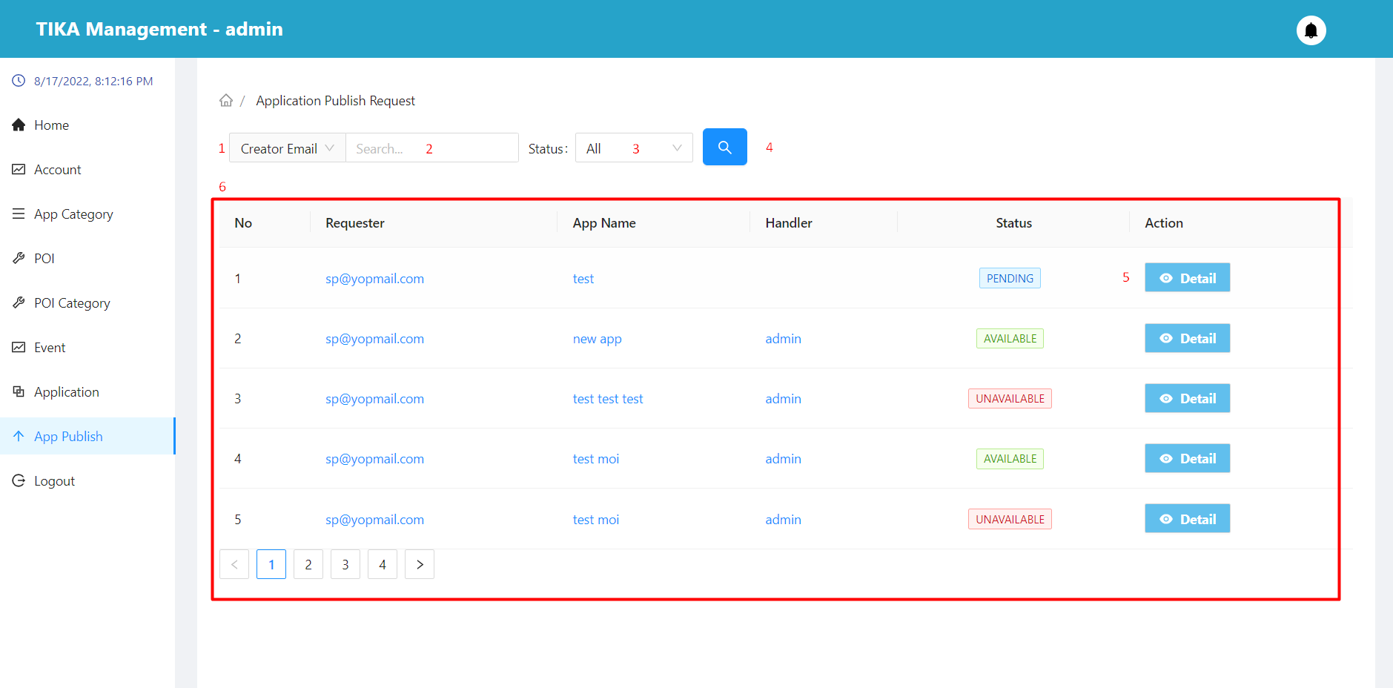

|  |  |  |  |  |  |  |  |  |
| --- | --- | --- | --- | --- | --- | --- | --- | --- |
| No. | Field Name | Description | | Read only | | Mandatory | Control Type | Data Type |
| 1 | Search field | Select field you want to search | | No | | No | Select | String |
| 2 | Input value to search | Enter a search value that corresponds to the search field selected in (1) | | No | | No | Input | String |
| 3 | Select status | Select value of status you want to search | | No | | No | Select | String |
| 6 | Basic information of the application | Basic information of applications that want to be approved | | Yes | | Yes | Table | String |
| **No.** | **Function** | | **Description** | | **Validation** | | **Outcome** | |
| 4 | Search information | | Search with selected information and enter items 1, 2, 3 | | Yes | | Information shown in the table below | |
| 5 | View detail application | | View application want to publish details in row  You cannot view application details when the status is “canceled” | | No | | Move to application detail page | |

##### Application detail in app publish page

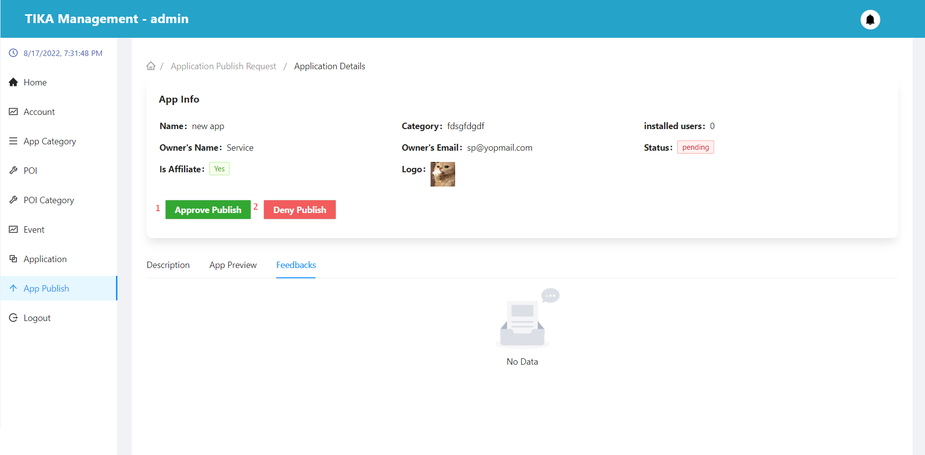

|  |  |  |  |  |
| --- | --- | --- | --- | --- |
| No. | Function | Description | Validation | Outcome |
| 1 | Approve button | Approve through application activity request | No | Display the application's acceptance confirmation dialog |
| 2 | Deny button | Reject the application's request for activity | No | Display the application's acceptance denial confirmation dialog |

##### Approve publish modal confirm

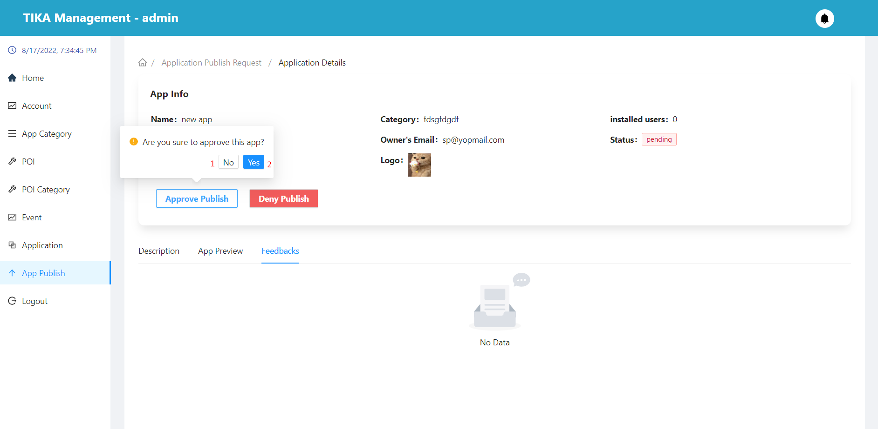

|  |  |  |  |  |
| --- | --- | --- | --- | --- |
| No. | Function | Description | Validation | Outcome |
| 1 | No button | Cancel action approve publish application | No | Back to application detail page |
| 2 | Yes button | Confirm action approve publish application | Yes | The application's status will change to “available” |

##### Deny publish modal confirm

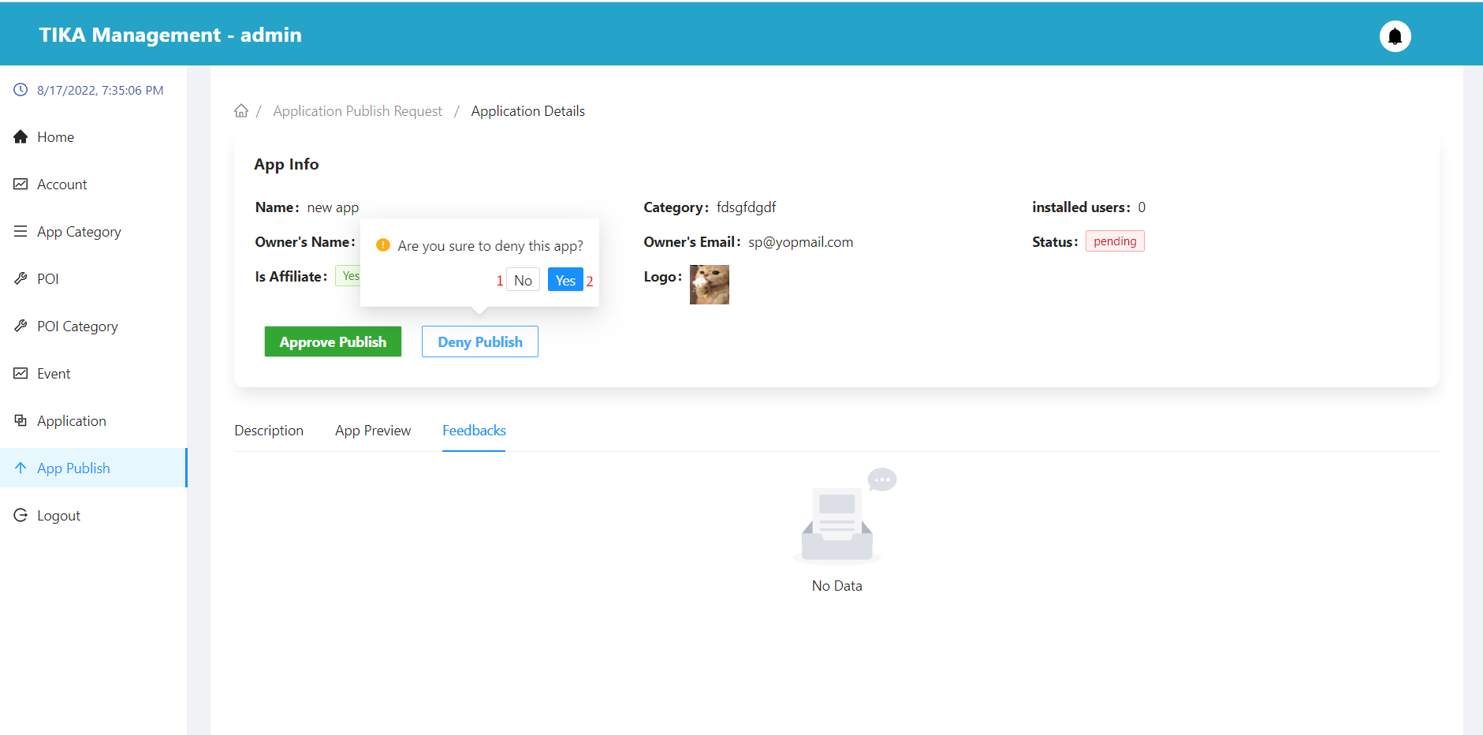

|  |  |  |  |  |
| --- | --- | --- | --- | --- |
| No. | Function | Description | Validation | Outcome |
| 1 | No button | Cancel action deny publish application | No | Back to application detail page |
| 2 | Yes button | Confirm action deny publish application | Yes | Displays a dialog box stating the reason for rejection |

##### Deny application publish request modal

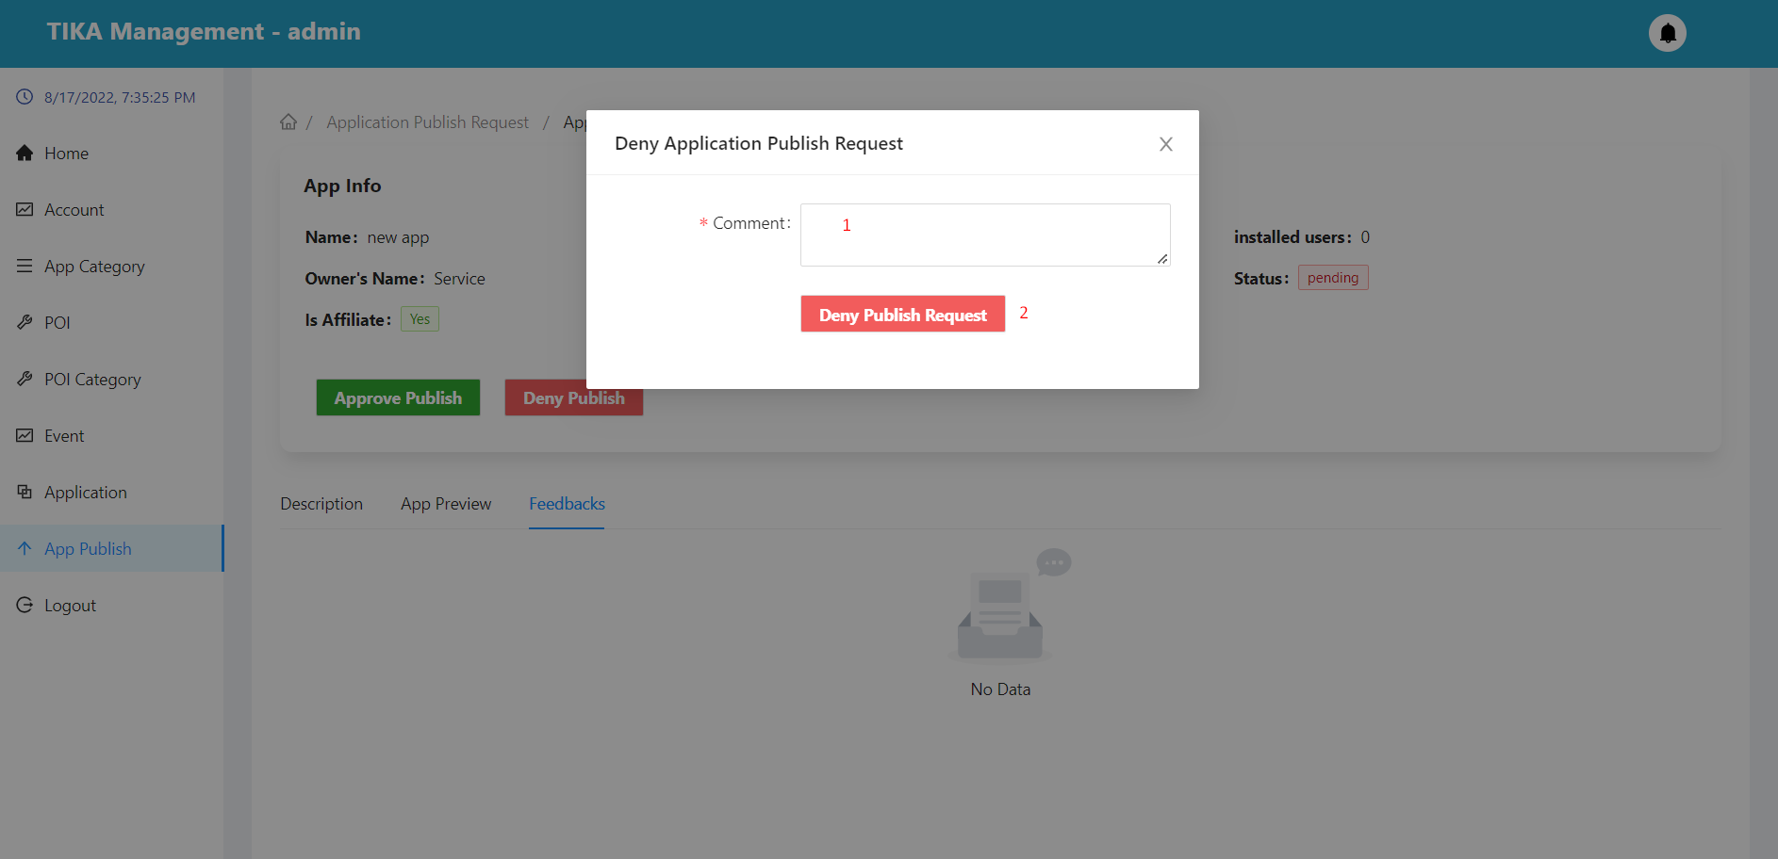

|  |  |  |  |  |  |  |  |  |
| --- | --- | --- | --- | --- | --- | --- | --- | --- |
| No. | Field Name | Description | | Read only | | Mandatory | Control Type | Data Type |
| 1 | Comment | Enter the reasons for refusing the application | | No | | Yes | Input | String |
| **No.** | **Function** | | **Description** | | **Validation** | | **Outcome** | |
| 2 | Deny publish request button | | Deny publish request button | | Yes | | The application's status will change to “unavailable” | |

Service provider Module

##### Function overview

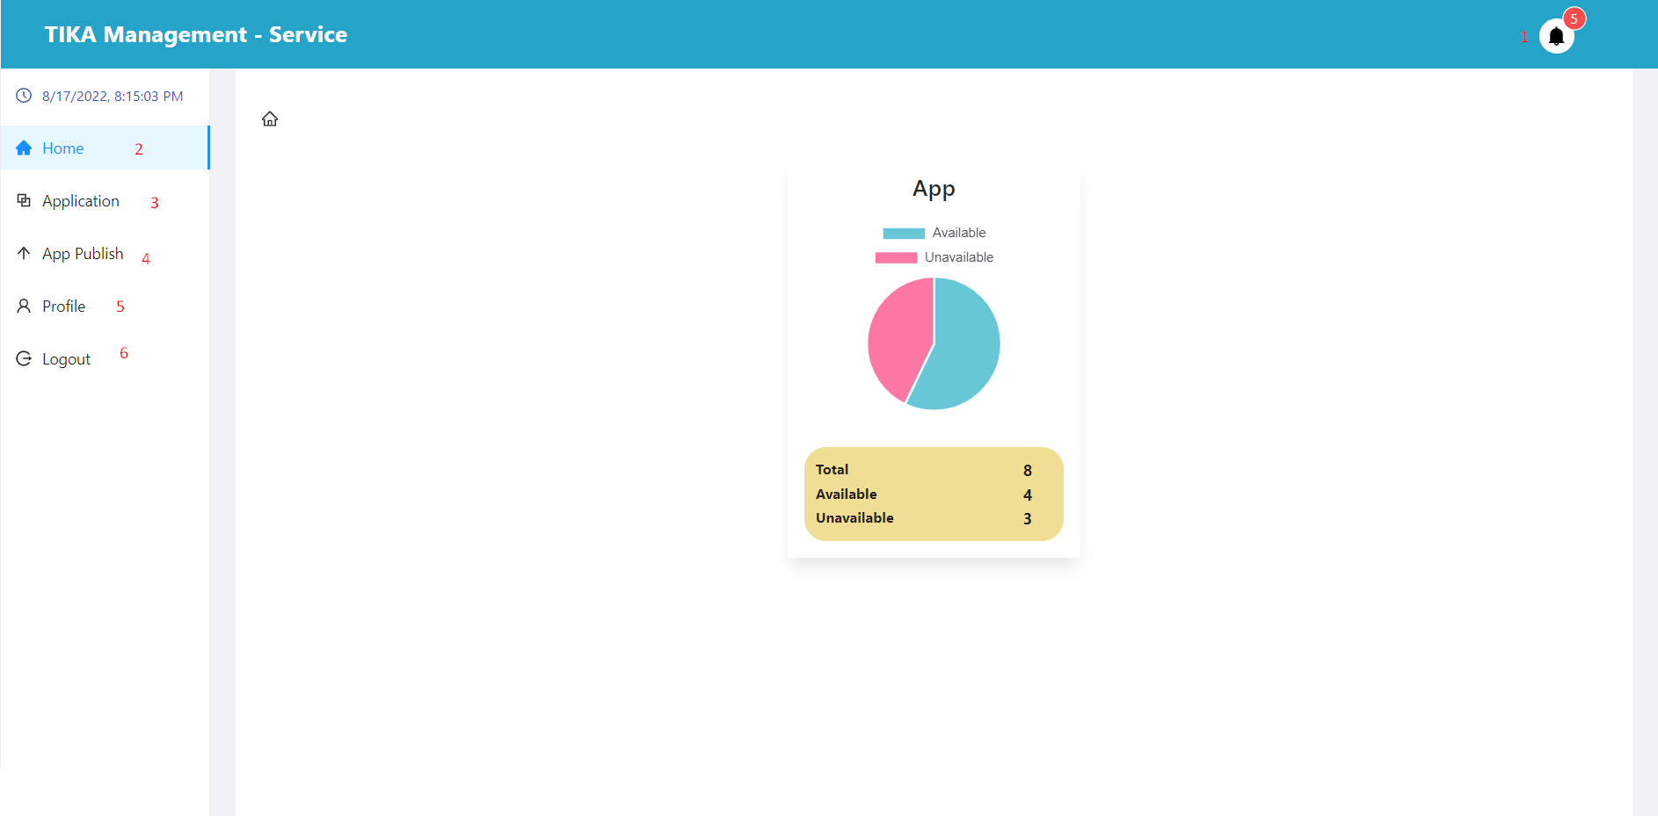

|  |  |  |  |  |
| --- | --- | --- | --- | --- |
| No. | Function | Description | Validation | Outcome |
| 1 | Notification button | Notification button | No | Display pop-ups showing user notifications |
| 2 | Home button | Home button | No | Go to home page |
| 3 | Application button | Application button | No | Go to application page |
| 4 | App publish button | App publish button | No | Go to application publish page |
| 5 | Profile button | Profile button | No | Go to profile page |
| 6 | Logout button | Logout button | No | User is unauthenticated and go to login page |

##### Home Page (View system overview statistics)

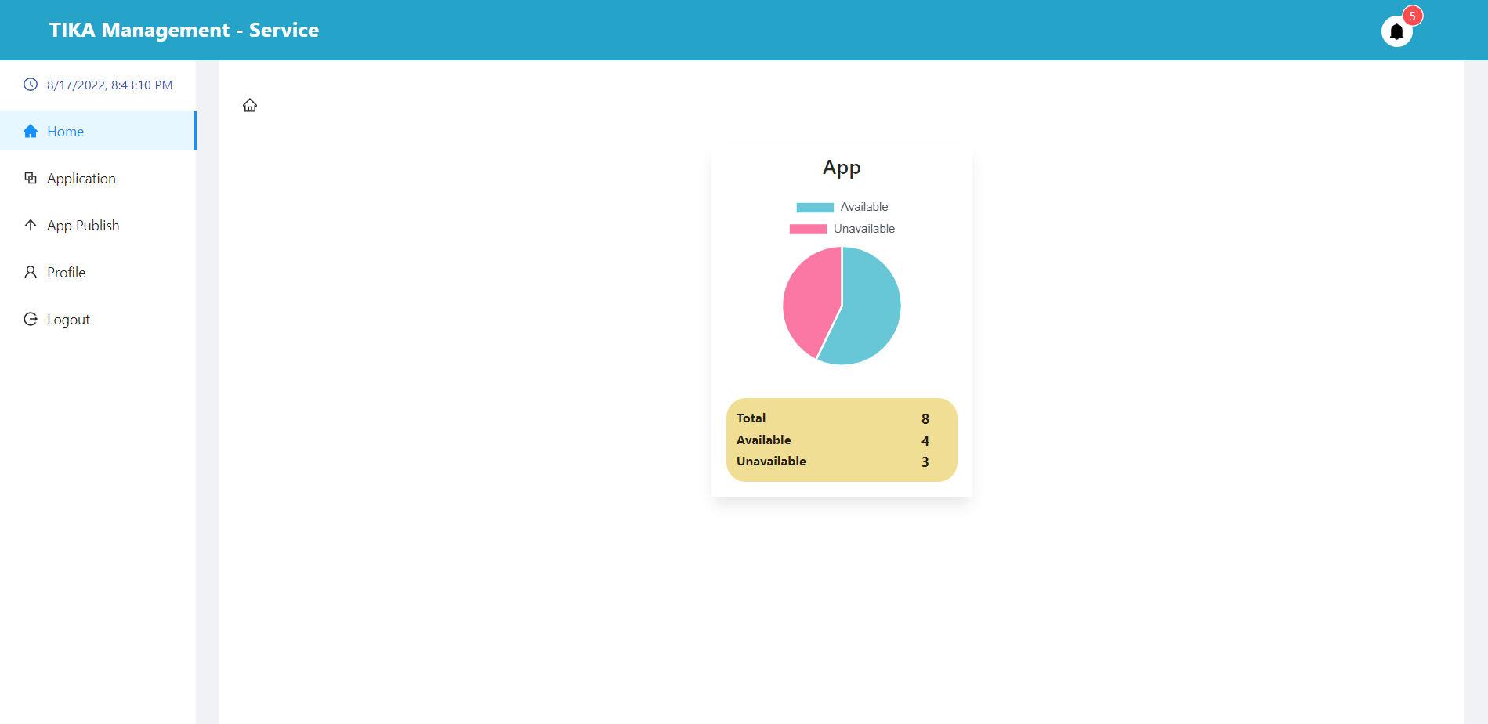

##### Application page

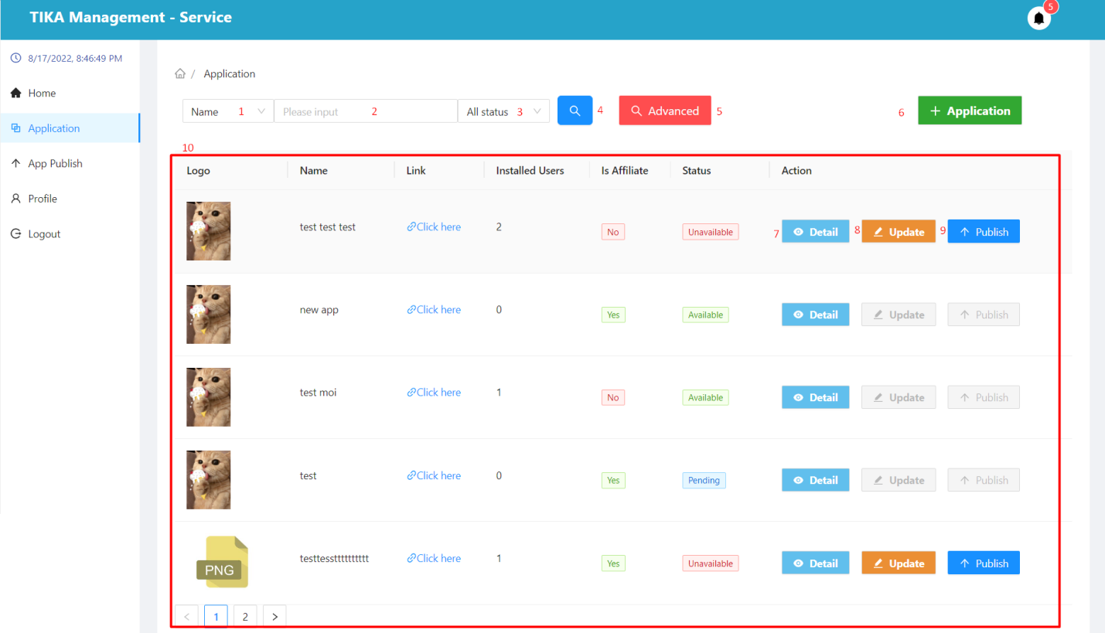

|  |  |  |  |  |  |  |  |  |
| --- | --- | --- | --- | --- | --- | --- | --- | --- |
| No. | Field Name | Description | | Read only | | Mandatory | Control Type | Data Type |
| 1 | Search field | Select field you want to search | | No | | No | Select | String |
| 2 | Input value to search | Enter a search value that corresponds to the search field selected in (1) | | No | | No | Input | String |
| 3 | Select status | Select value of status you want to search | | No | | No | Select | String |
| 10 | Information of the application | Basic information of the application | | Yes | | Yes | Table | String |
| **No.** | **Function** | | **Description** | | **Validation** | | **Outcome** | |
| 4 | Search information | | Search with selected information and enter items 1, 2, 3 | | Yes | | Information shown in the table below | |
| 5 | Advance search button | | Search with multiple data fields at the same time | | No | | Show modal advance search application | |
| 6 | Create application button | | Create a new app | | No | | Show modal create application | |
| 7 | View detail application | | View application details in row | | No | | Move to detail application page | |
| 8 | Update application button | | Update application in row  You can only update the app when it is “unavailable” | | No | | Show modal update application | |
| 9 | Publish application button | | Request publicity of the application  You can only publish the app when it is “unavailable” | | No | | Show confirmation dialog | |

##### Advance search application

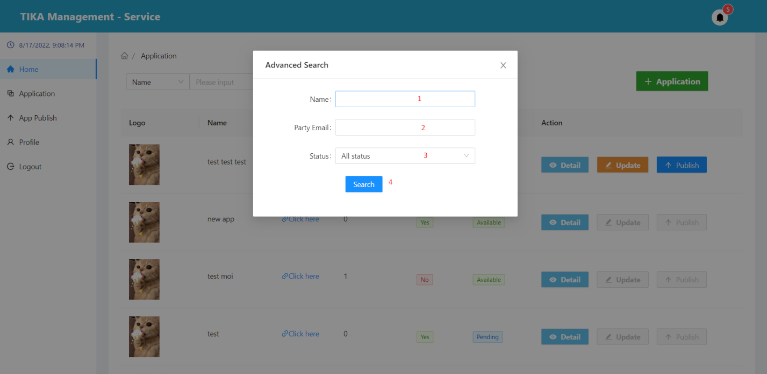

|  |  |  |  |  |  |  |  |  |
| --- | --- | --- | --- | --- | --- | --- | --- | --- |
| No. | Field Name | Description | | Read only | | Mandatory | Control Type | Data Type |
| 1 | Name | Enter the name of the app you want to search for | | No | | No | Input | String |
| 2 | Party email | Enter the party email of the app you want to search for | | No | | No | Input | String |
| 3 | Select status | Select value of status you want to search | | No | | No | Select | String |
| **No.** | **Function** | | **Description** | | **Validation** | | **Outcome** | |
| 4 | Search button | | Search with selected information and enter items 1, 2, 3 | | Yes | | Information shown in the table in application page | |

##### Create application

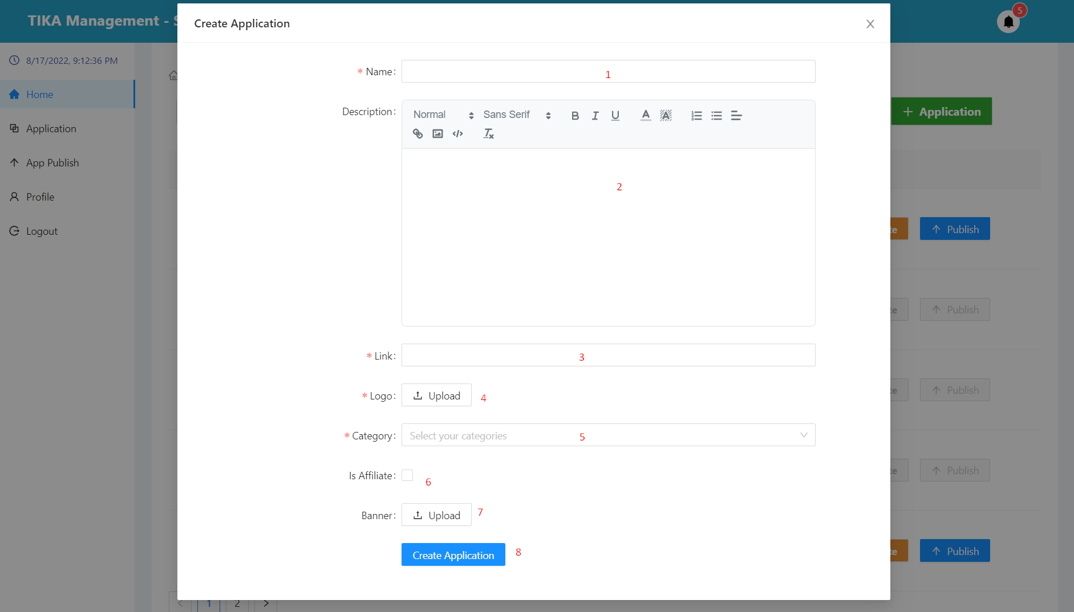

|  |  |  |  |  |  |  |  |  |  |
| --- | --- | --- | --- | --- | --- | --- | --- | --- | --- |
| No. | Field Name | Description | | Read only | | Mandatory | Control Type | | Data Type |
| 1 | Name | Name of application | | No | | Yes | Input | | String |
| 2 | Description | Description of application | | No | | Yes | Editor | | String |
| 3 | Link | Link of application | | No | | Yes | Input | | String |
| 4 | Logo | Logo of application | | No | | Yes | Upload | | File |
| 5 | Category | Category of application | | No | | Yes | Select | | File |
| 6 | Is Affiliate | Confirm if the app has affiliate marketing or not | | No | | No | Checkbox | | String |
| 7 | Banner | Banner of application | | No | | No | Upload | | File |
| **No.** | **Function** | | **Description** | | **Validation** | | | **Outcome** | |
| 8 | Create base information application button | | Create application with the information provided | | Yes | | | Application created | |

##### Application detail page

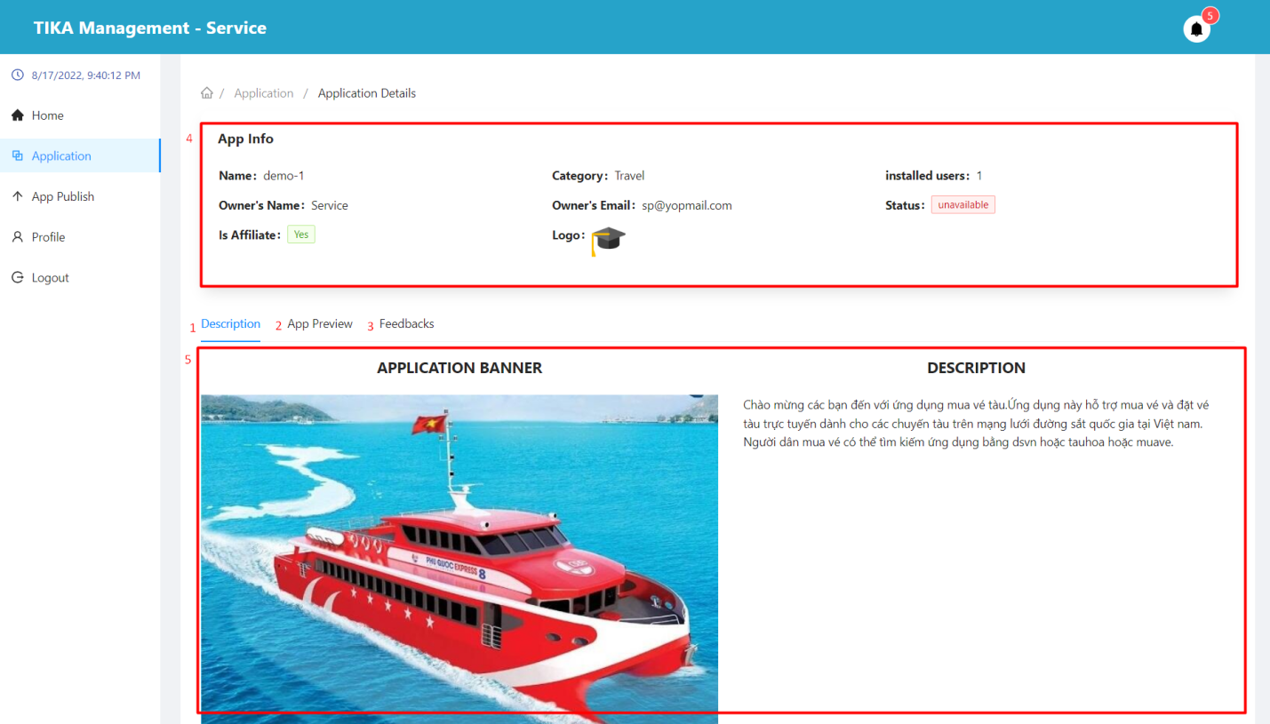

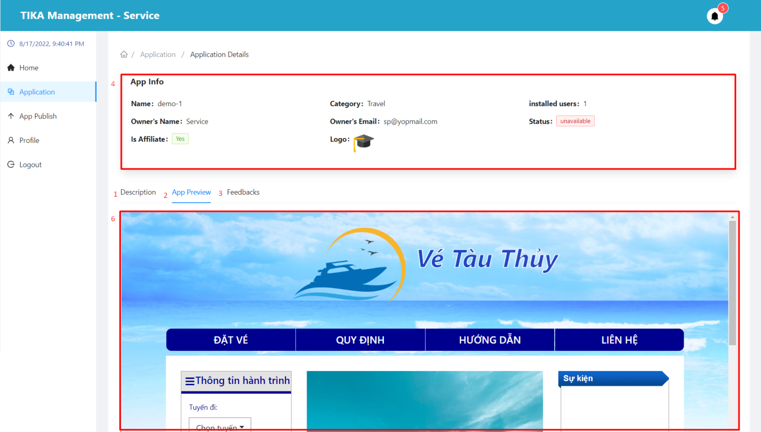

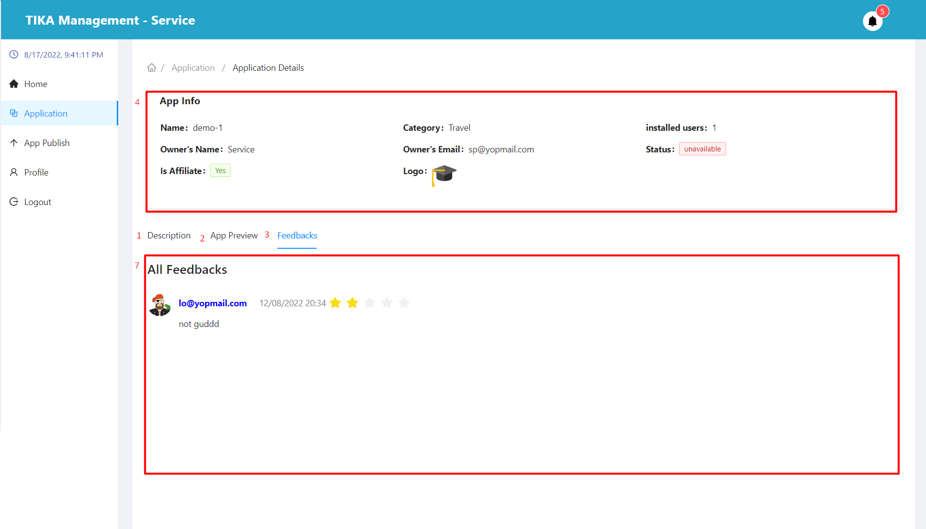

|  |  |  |  |  |  |  |  |  |
| --- | --- | --- | --- | --- | --- | --- | --- | --- |
| No. | Field Name | Description | | Read only | | Mandatory | Control Type | Data Type |
| 4 | App info | Used to view application details | | Yes | | Yes | Table | String |
| 5 | Description area | See the app's description | | Yes | | Yes | Tab | String |
| 6 | App review area | Preview the interface of the application | | Yes | | Yes | Tab | String |
| 7 | Feedback area | Used to view the feedback of users who have used the application | | Yes | | Yes | Tab | String |
| **No.** | **Function** | | **Description** | | **Validation** | | **Outcome** | |
| 1 | Description tab | | Description tab | | No | | move to tab description | |
| 2 | App review tab | | App review tab | | No | | move to tab app review | |
| 3 | Feedback tab | | Feedback tab | | No | | move to tab feedback | |

##### Update application modal

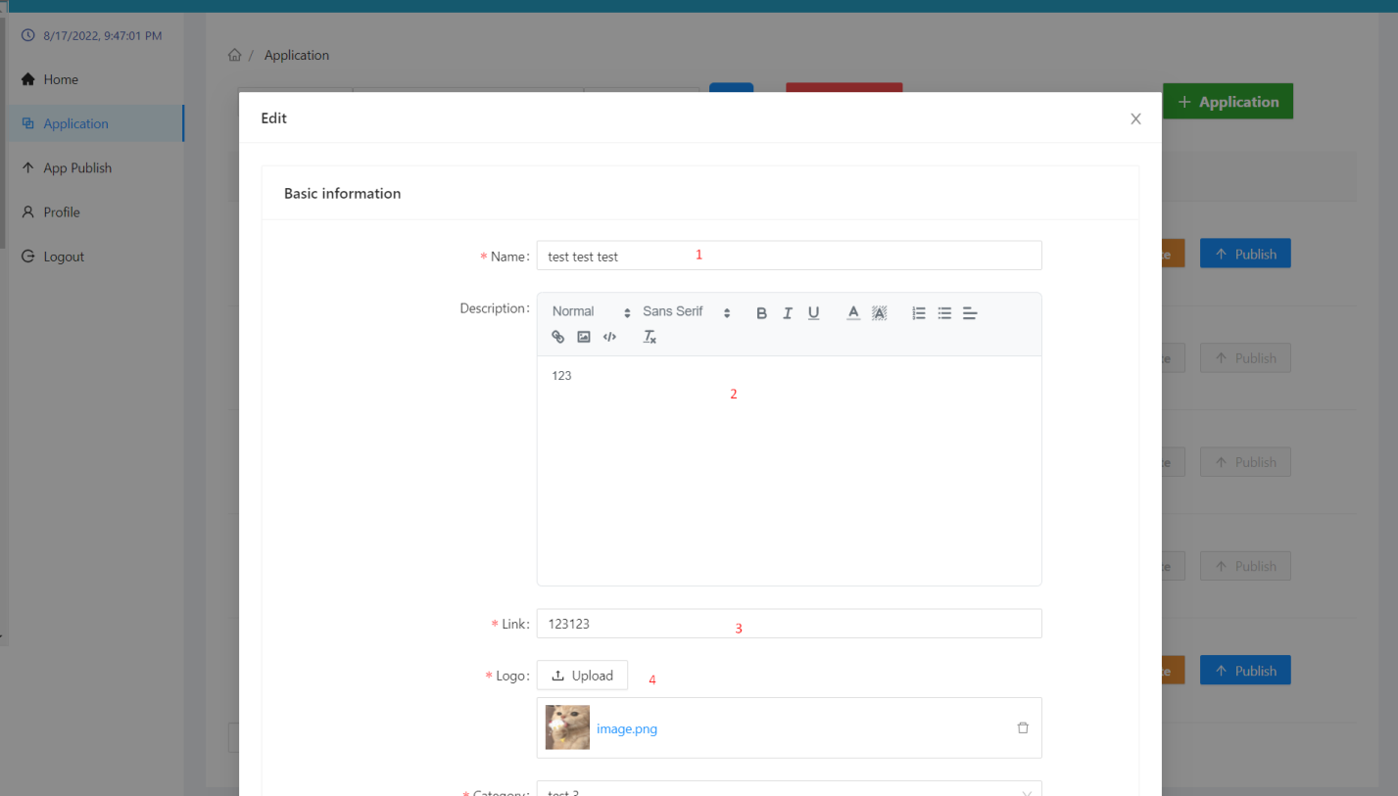

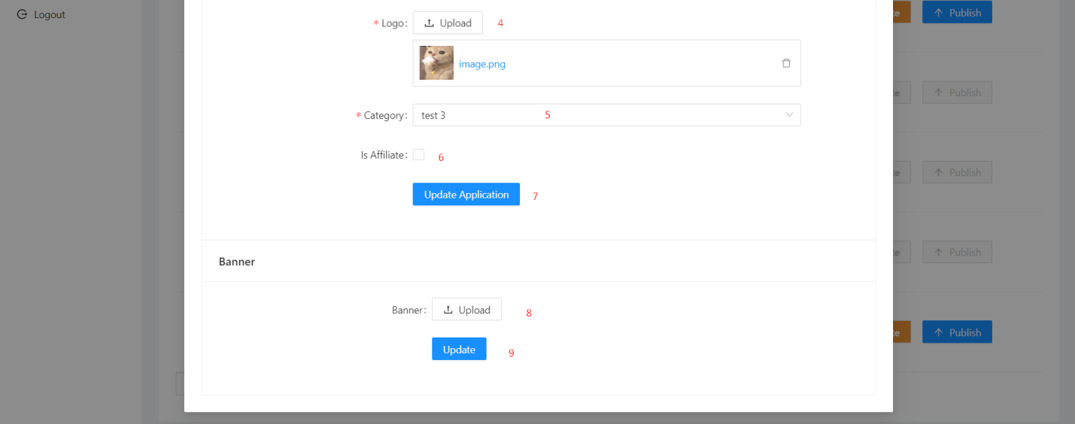

|  |  |  |  |  |  |  |  |  |  |
| --- | --- | --- | --- | --- | --- | --- | --- | --- | --- |
| No. | Field Name | Description | | Read only | | Mandatory | Control Type | | Data Type |
| 1 | Name | Name of application | | No | | Yes | Input | | String |
| 2 | Description | Description of application | | No | | Yes | Editor | | String |
| 3 | Link | Link of application | | No | | Yes | Input | | String |
| 4 | Logo | Logo of application | | No | | Yes | Upload | | File |
| 5 | Category | Category of application | | No | | Yes | Select | | File |
| 6 | Is Affiliate | Confirm if the app has affiliate marketing or not | | No | | No | Checkbox | | String |
| 8 | Banner | Banner of application | | No | | No | Upload | | File |
| **No.** | **Function** | | **Description** | | **Validation** | | | **Outcome** | |
| 7 | Update base information application button | | Update base information application button | | Yes | | | Application updated | |
| 9 | Update banner application button | | Update banner application button | | Yes | | | Application updated | |

##### Publish application modal confirm

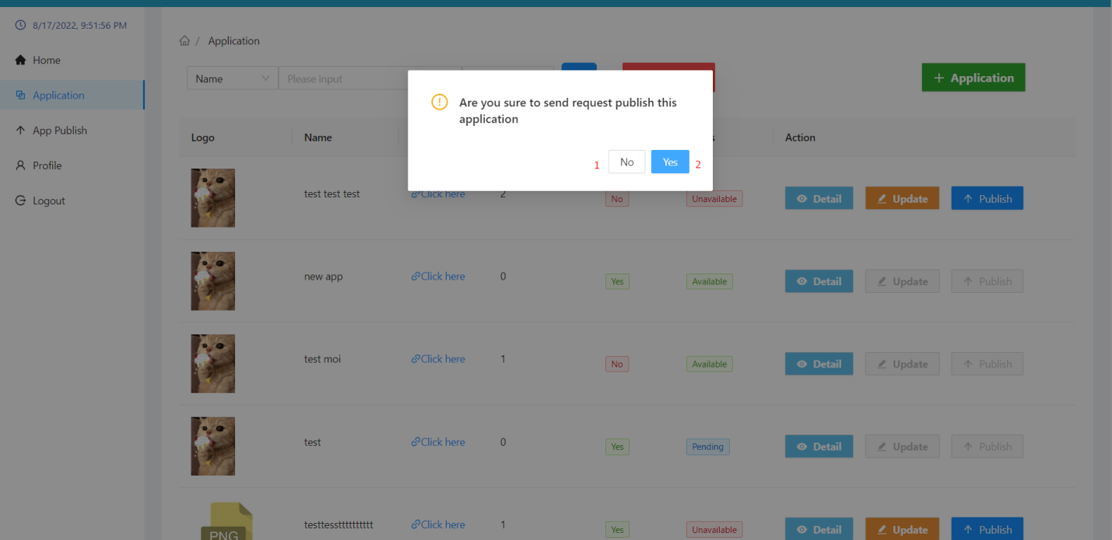

|  |  |  |  |  |
| --- | --- | --- | --- | --- |
| No. | Function | Description | Validation | Outcome |
| 1 | No button | Cancel action publish application | No | Back to application page |
| 2 | Yes button | Confirm action publish application | Yes | Change the app's state to “pending” |

##### App publish page

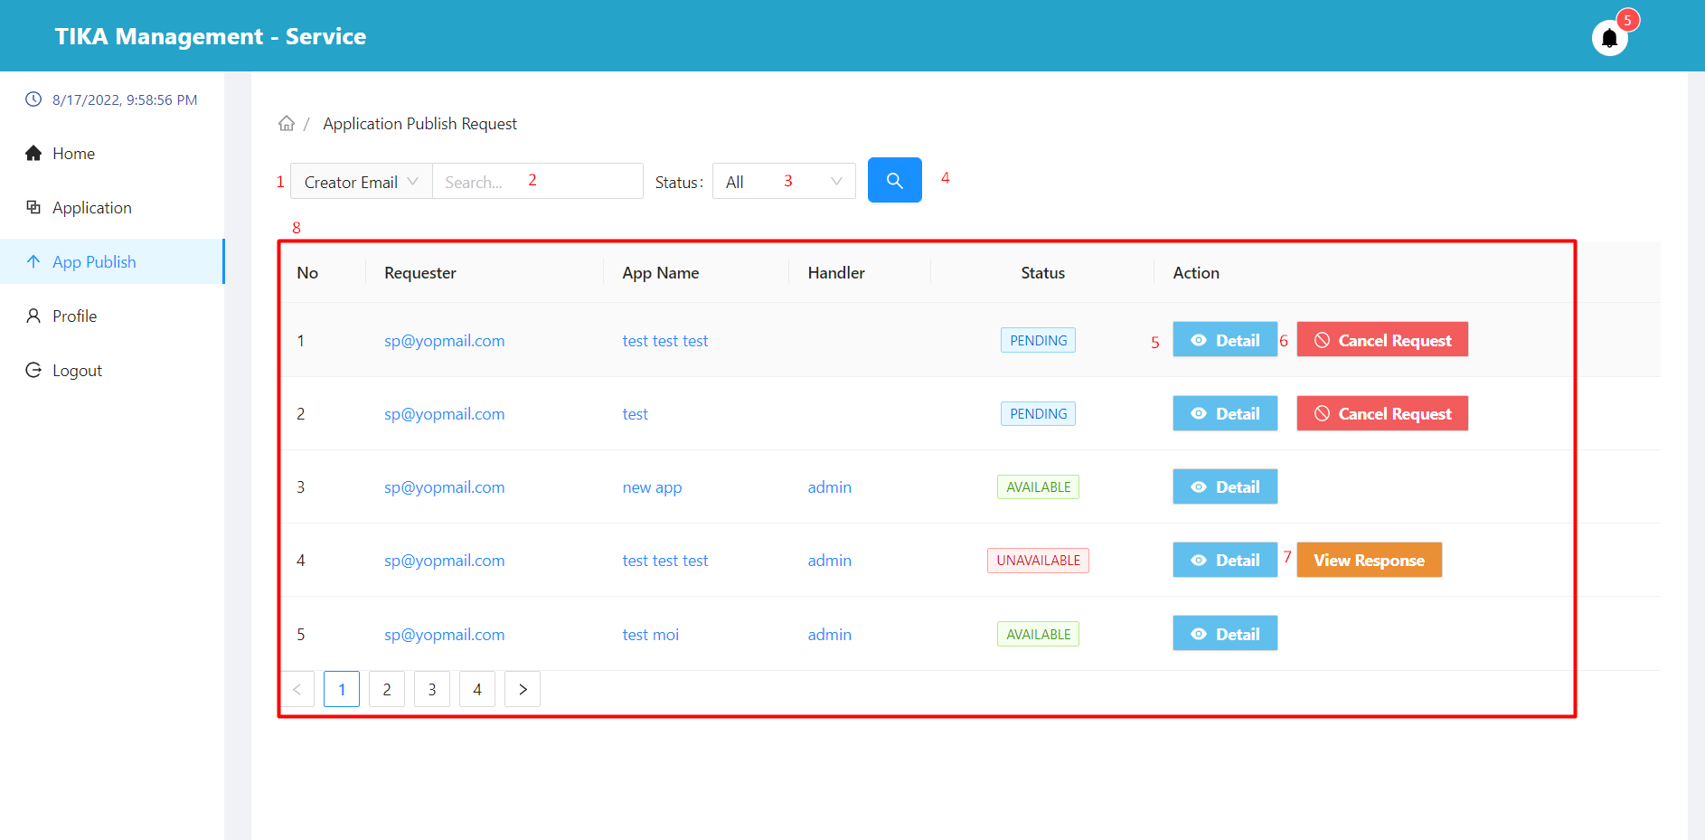

|  |  |  |  |  |  |  |  |  |
| --- | --- | --- | --- | --- | --- | --- | --- | --- |
| No. | Field Name | Description | | Read only | | Mandatory | Control Type | Data Type |
| 1 | Search field | Select field you want to search | | No | | No | Select | String |
| 2 | Input value to search | Enter a search value that corresponds to the search field selected in (1) | | No | | No | Input | String |
| 3 | Select status | Select value of status you want to search | | No | | No | Select | String |
| 8 | Basic information of the application | Basic information of applications that want to be approved | | Yes | | Yes | Table | String |
| **No.** | **Function** | | **Description** | | **Validation** | | **Outcome** | |
| 4 | Search information | | Search with selected information and enter items 1, 2, 3 | | Yes | | Information shown in the table below | |
| 5 | View detail application | | View application details in row | | No | | Move to application detail page | |
| 6 | Cancel request button | | Cancel the application for publicity | | No | | Show confirmation dialog | |
| 7 | View response button | | See why the app is publicly disapproved  This button is displayed only when the application state is “UNAVAILABLE” | | No | | Show modal result of public application | |

##### Application detail page

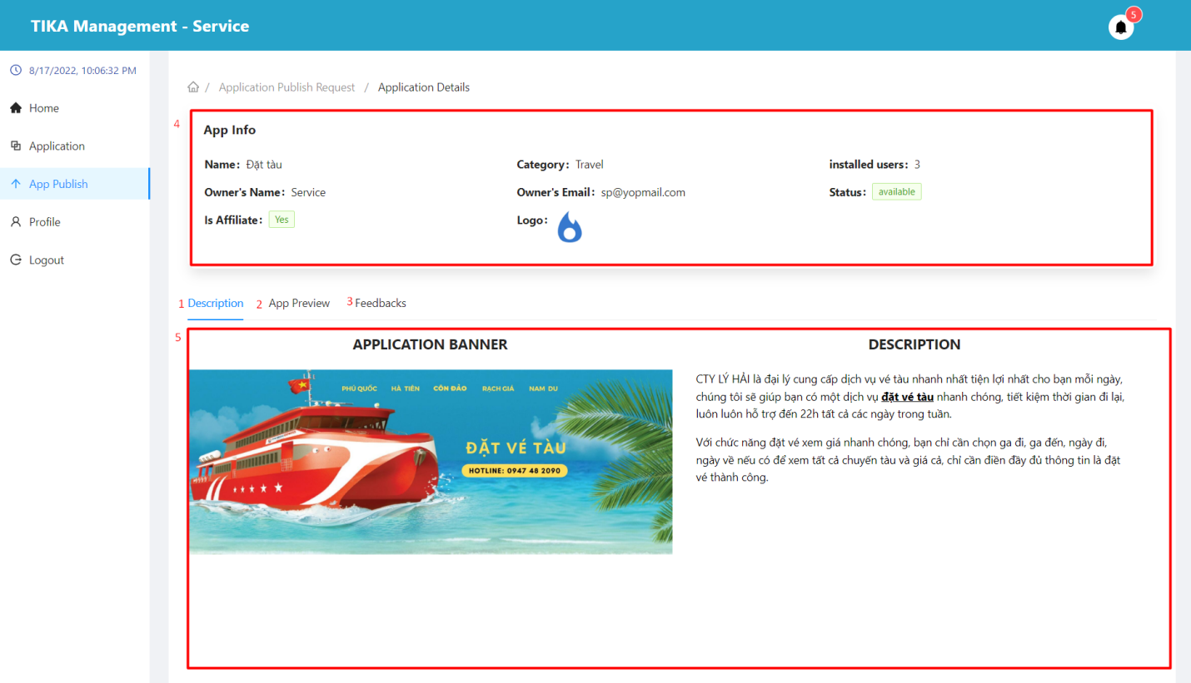

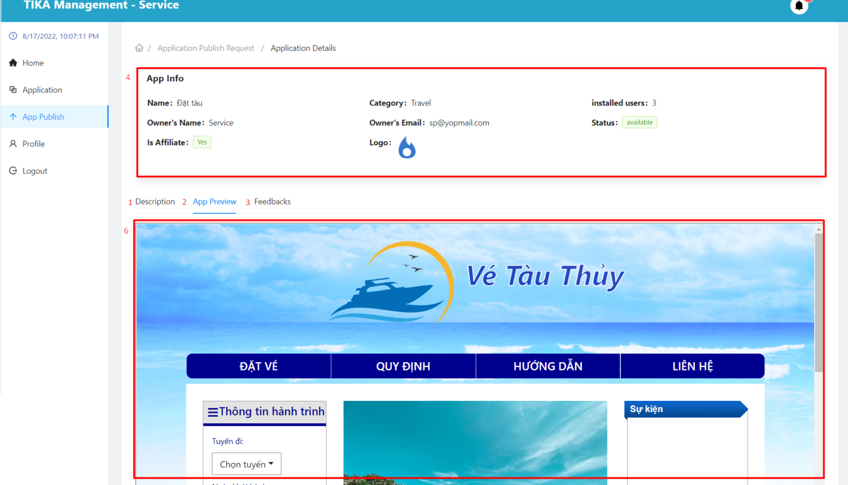

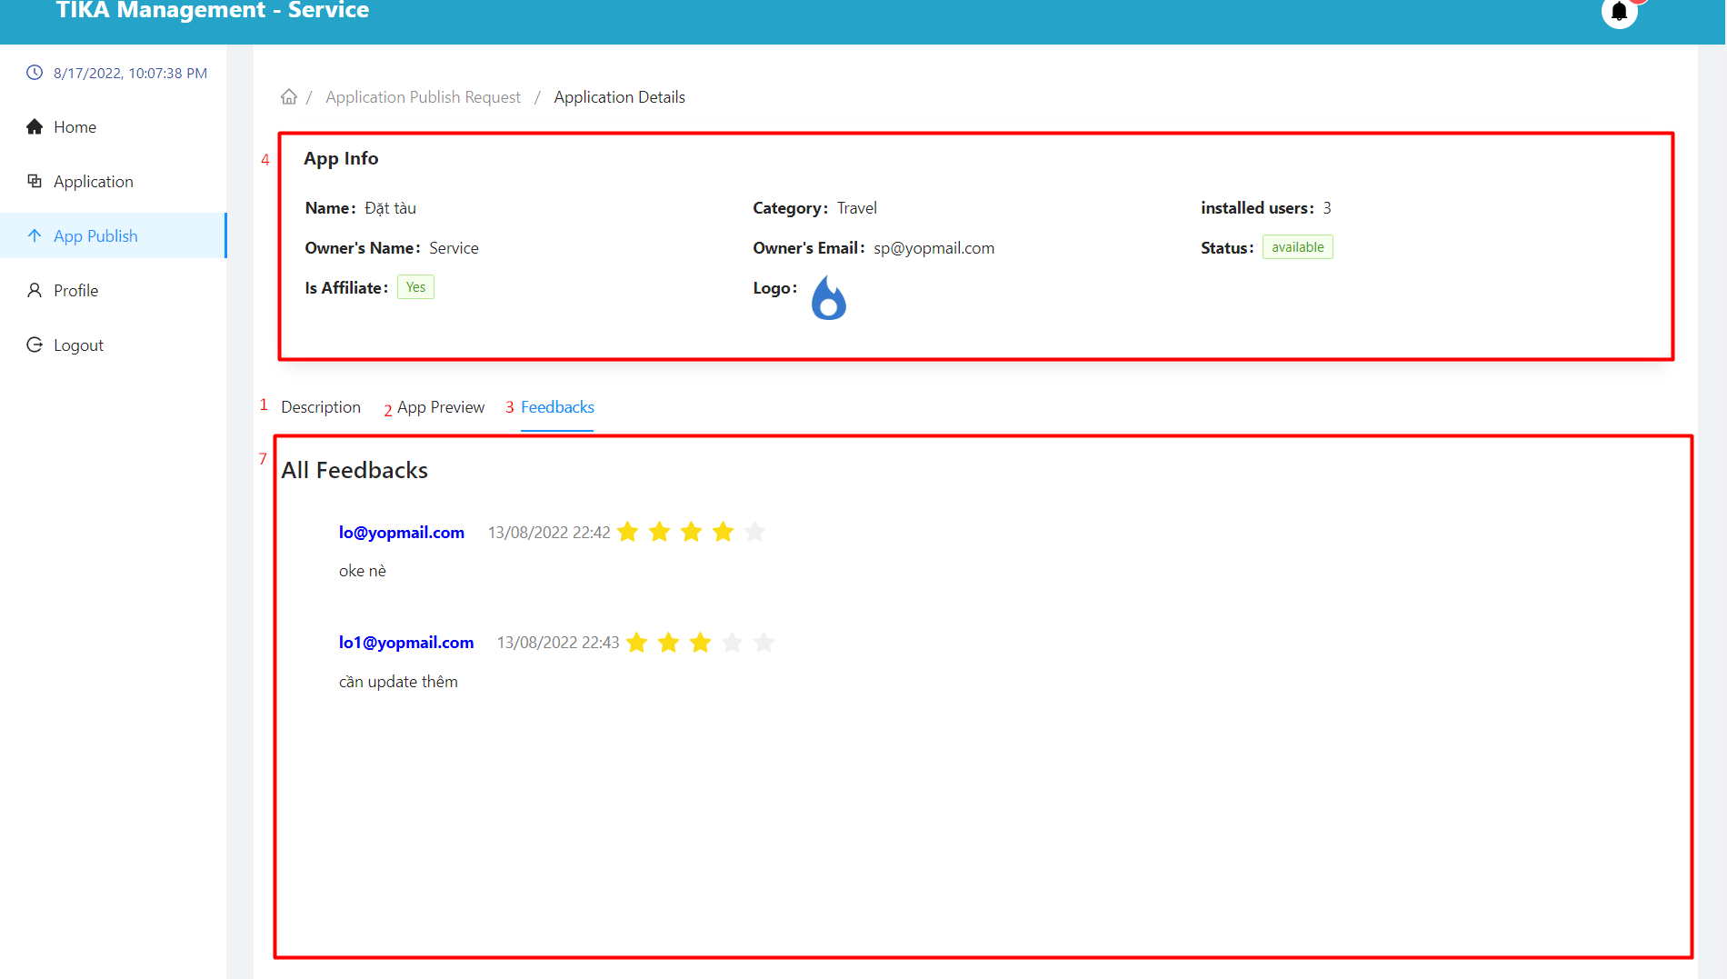

|  |  |  |  |  |  |  |  |  |
| --- | --- | --- | --- | --- | --- | --- | --- | --- |
| No. | Field Name | Description | | Read only | | Mandatory | Control Type | Data Type |
| 4 | App info | Used to view application details | | Yes | | Yes | Table | String |
| 5 | Description area | See the app's description | | Yes | | Yes | Tab | String |
| 6 | App review area | Preview the interface of the application | | Yes | | Yes | Tab | String |
| 7 | Feedback area | Used to view the feedback of users who have used the application | | Yes | | Yes | Tab | String |
| **No.** | **Function** | | **Description** | | **Validation** | | **Outcome** | |
| 1 | Description tab | | Description tab | | No | | move to tab description | |
| 2 | App review tab | | App review tab | | No | | move to tab app review | |
| 3 | Feedback tab | | Feedback tab | | No | | move to tab feedback | |

##### Cancel request publish application modal

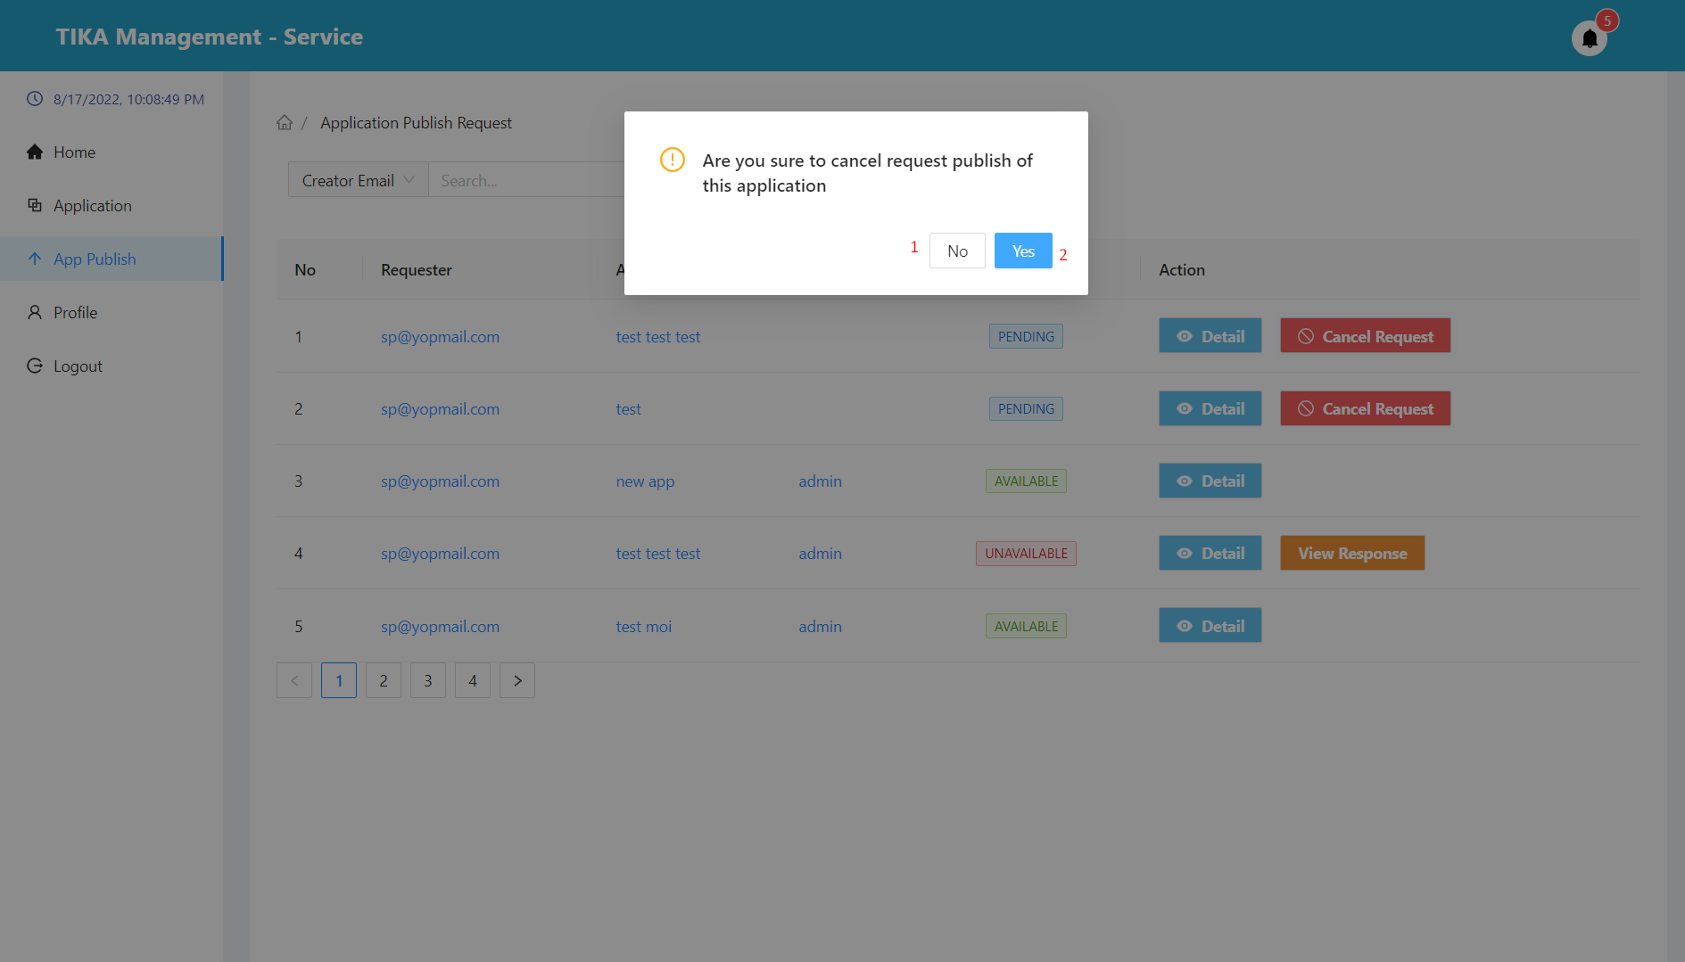

|  |  |  |  |  |
| --- | --- | --- | --- | --- |
| No. | Function | Description | Validation | Outcome |
| 1 | No button | Cancel action cancel request application | No | Back to application publish page |
| 2 | Yes button | Confirm action cancel request application | Yes | Change the status of the application to “CANCELED” |

##### View response publish application modal

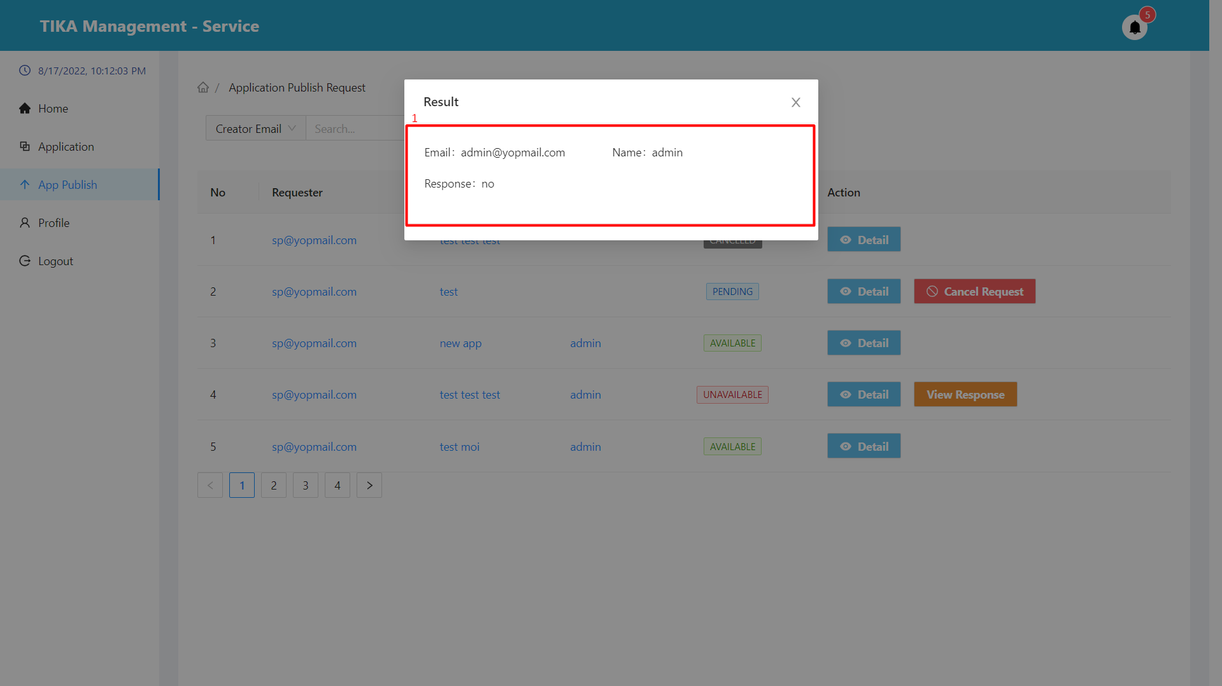

|  |  |  |  |  |  |  |
| --- | --- | --- | --- | --- | --- | --- |
| No. | Field Name | Description | Read only | Mandatory | Control Type | Data Type |
| 1 | Specific information of the result | Specific information of the result | Yes | Yes | Input | String |

##### Profile page

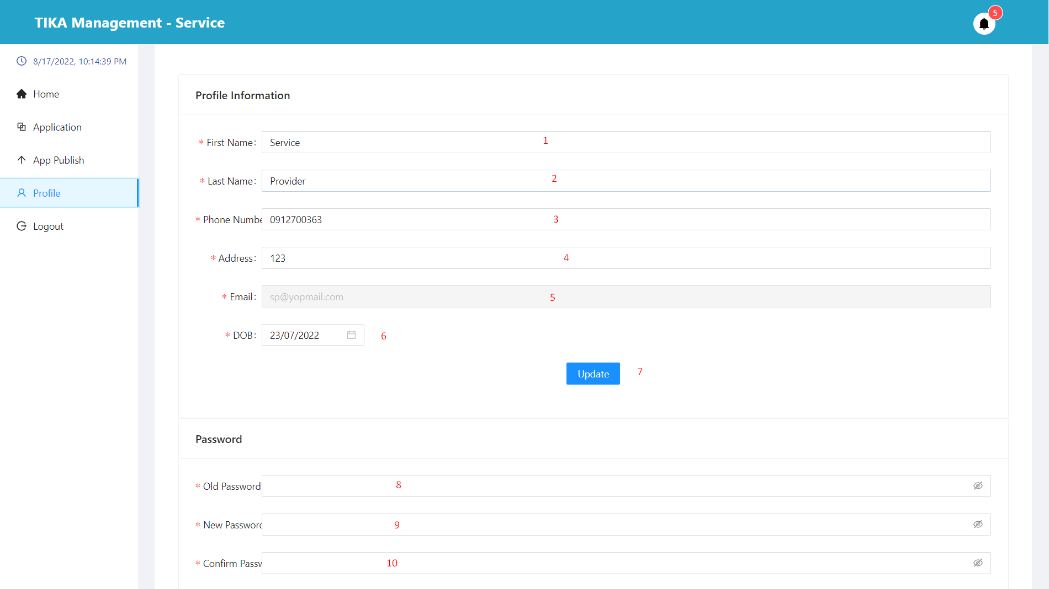

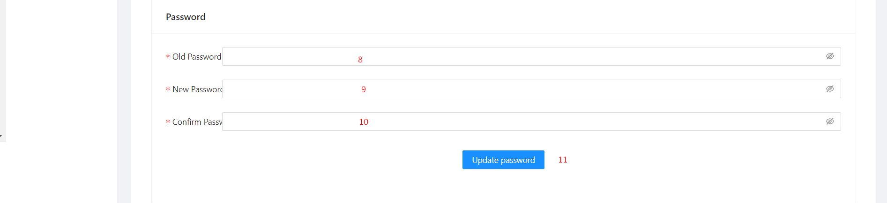

|  |  |  |  |  |  |  |  |  |
| --- | --- | --- | --- | --- | --- | --- | --- | --- |
| No. | Field Name | Description | | Read only | | Mandatory | Control Type | Data Type |
| 1 | First name | First name of user | | No | | Yes | Input | String |
| 2 | Last name | Last name of user | | No | | Yes | Input | String |
| 3 | Phone number | Phone number of user | | No | | Yes | Input | Number |
| 4 | Address | Address of user | | No | | Yes | Input | String |
| 5 | Email | Email of user | | Yes | | Yes | Input | String |
| 6 | DOB | Date of birth of user | | No | | Yes | Select | String |
| 8 | Old password | Your original password | | No | | Yes | Input | String |
| 9 | New password | The new password you want to change to | | No | | Yes | Input | String |
| 10 | Confirm password | Confirm new password | | No | | Yes | Input | String |
| **No.** | **Function** | | **Description** | | **Validation** | | **Outcome** | |
| 7 | Update button | | Change the basic information of the user | | Yes | | User information has been changed | |
| 11 | Update password button | | Change user's password | | Yes | | User's password has been changed | |

Location owner module

##### Function overview

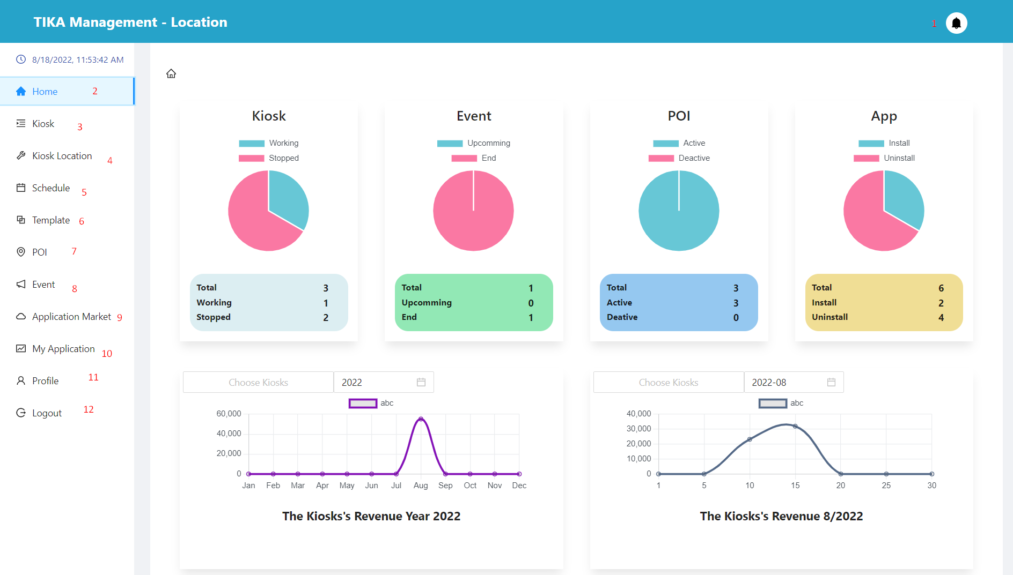

|  |  |  |  |  |
| --- | --- | --- | --- | --- |
| No. | Function | Description | Validation | Outcome |
| 1 | Notification button | Notification button | No | Display pop-ups showing user notifications |
| 2 | Home button | Home button | No | Go to home page |
| 3 | Kiosk button | Kiosk button | No | Go to kiosk page |
| 4 | Kiosk location button | Kiosk location button | No | Go to kiosk location page |
| 5 | Schedule button | Schedule button | No | Go to schedule page |
| 6 | Template button | Template button | No | Go to template page |
| 7 | Poi button | Poi button | No | Go to poi page |
| 8 | Event button | Event button | No | Go to event page |
| 9 | Application market button | Application market button | No | Go to application market page |
| 10 | My application button | My application button | No | Go to my application page |
| 11 | Profile button | Profile button | No | Go to profile page |
| 12 | Logout button | Logout button | No | User is unauthenticated and go to login page |

##### Home Page (View system overview statistics)

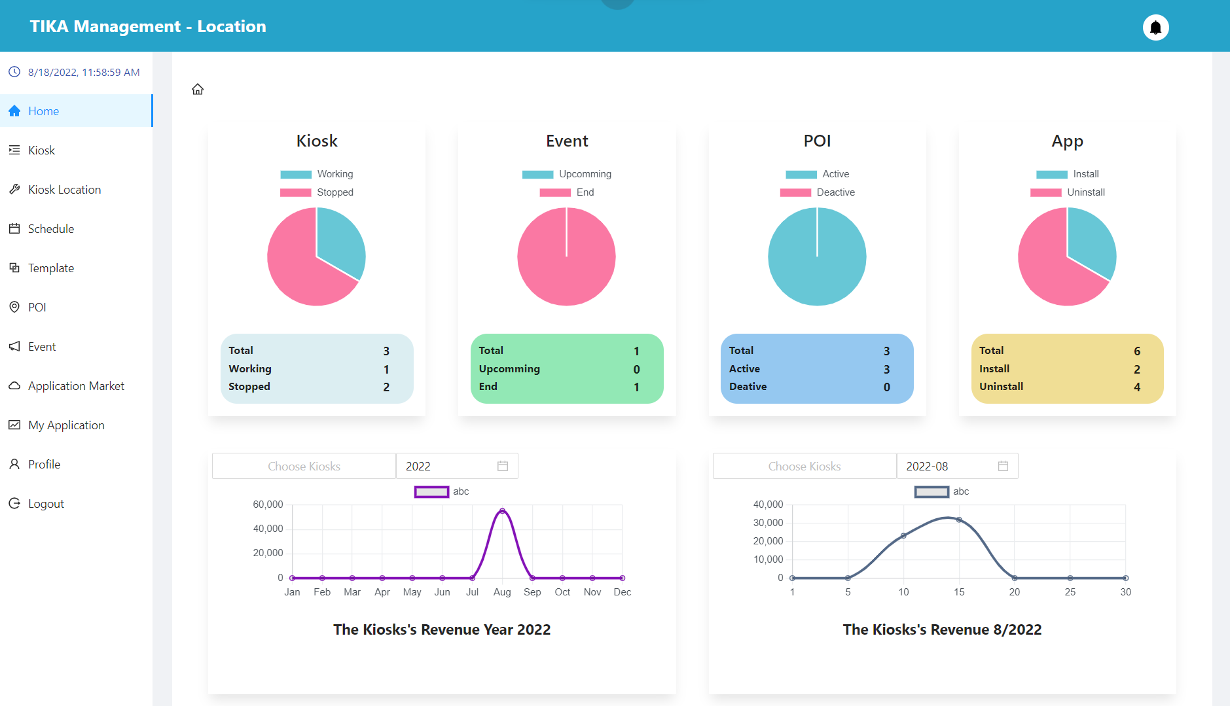

##### Kiosk page

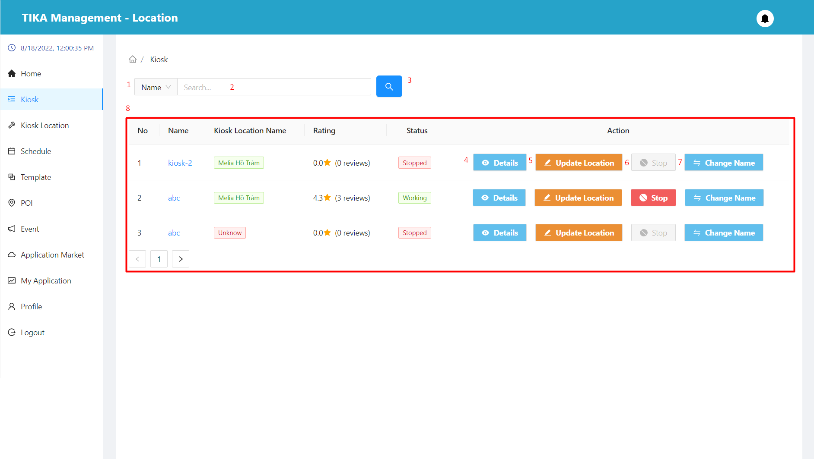

|  |  |  |  |  |  |  |  |  |
| --- | --- | --- | --- | --- | --- | --- | --- | --- |
| No. | Field Name | Description | | Read only | | Mandatory | Control Type | Data Type |
| 1 | Search field | Select field you want to search | | No | | No | Select | String |
| 2 | Input value to search | Enter a search value that corresponds to the search field selected in (1) | | No | | No | Input | String |
| 8 | Information of the kiosk | Basic information of the kiosk | | Yes | | Yes | Table | String |
| **No.** | **Function** | | **Description** | | **Validation** | | **Outcome** | |
| 3 | Search information | | Search with selected information and enter items 1, 2 | | Yes | | Information shown in the table below | |
| 4 | View detail kiosk | | View kiosk details in row | | No | | Move to detail kiosk page | |
| 5 | Update kiosk location button | | Update kiosk location in row | | No | | Show modal update kiosk location | |
| 6 | Stop kiosk button | | Deactivate the active kiosk.  You can only stop the kiosk with “working” status | | No | | Show confirmation dialog | |
| 7 | Change name button | | Update name for kiosk | | No | | Show modal update kiosk name | |

##### Kiosk detail page

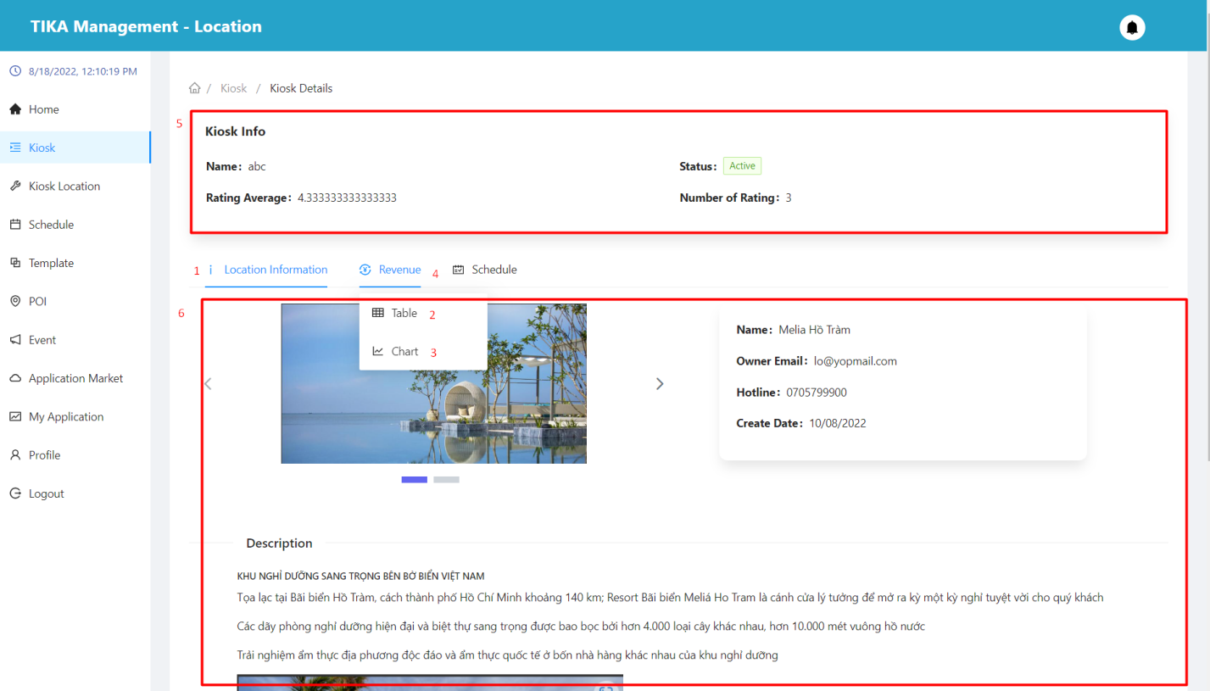

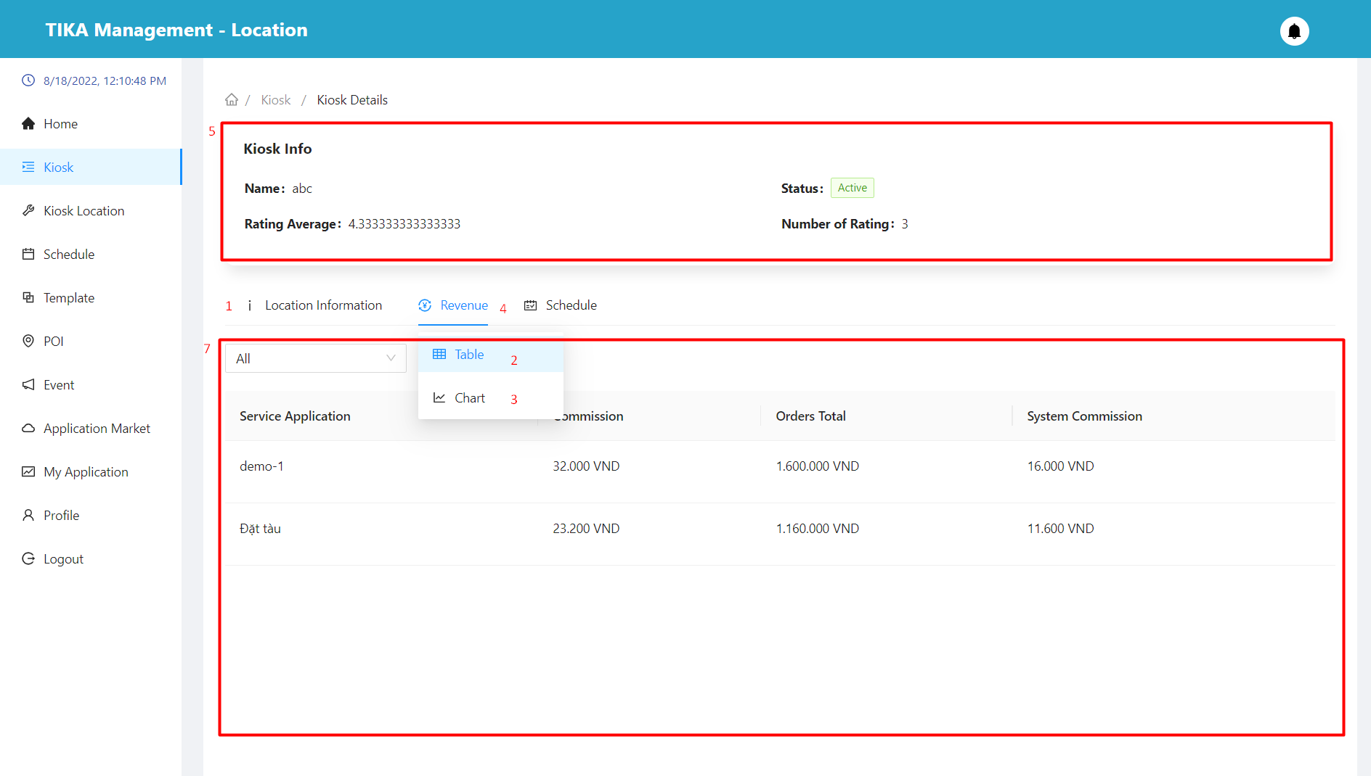

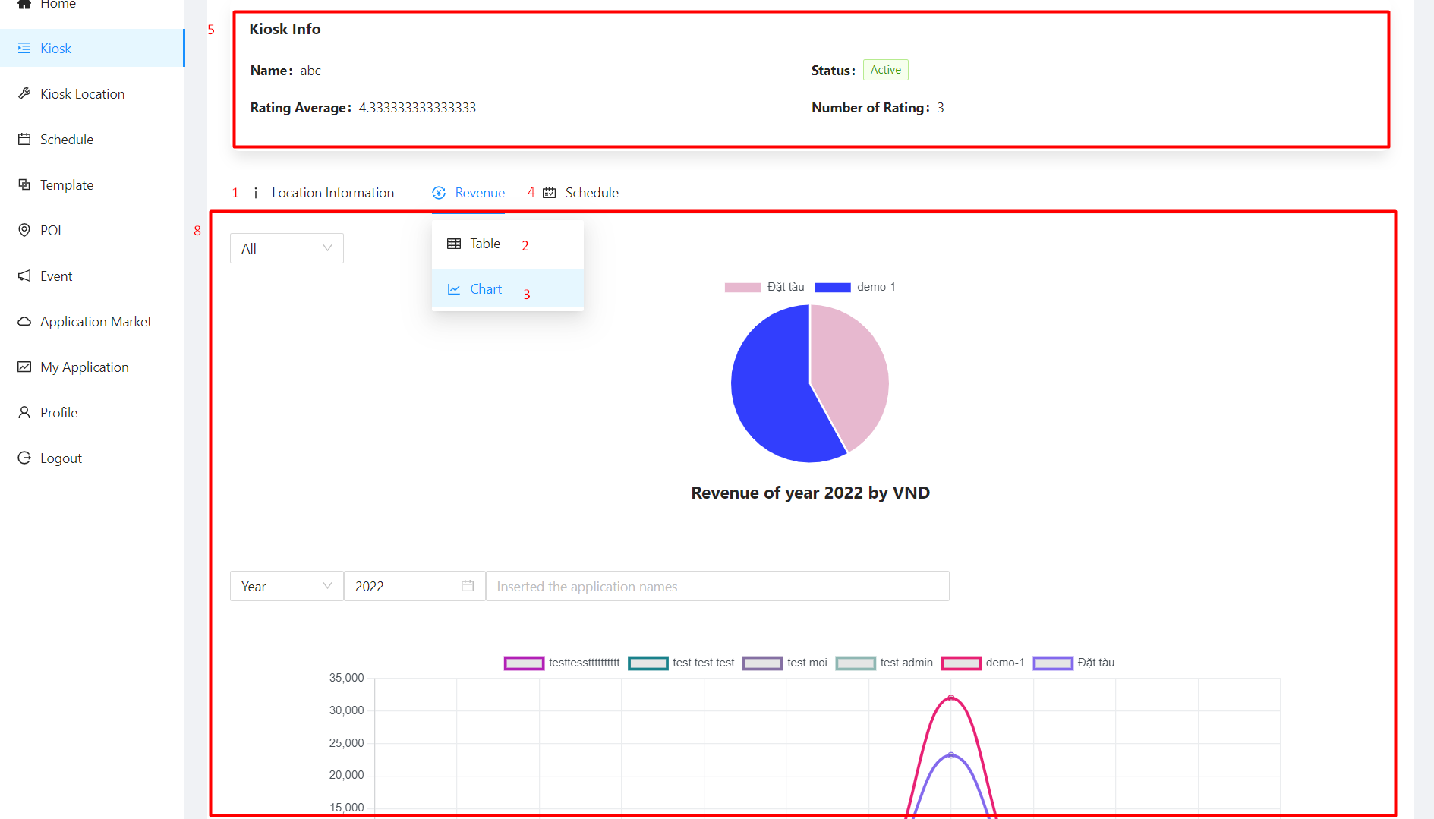

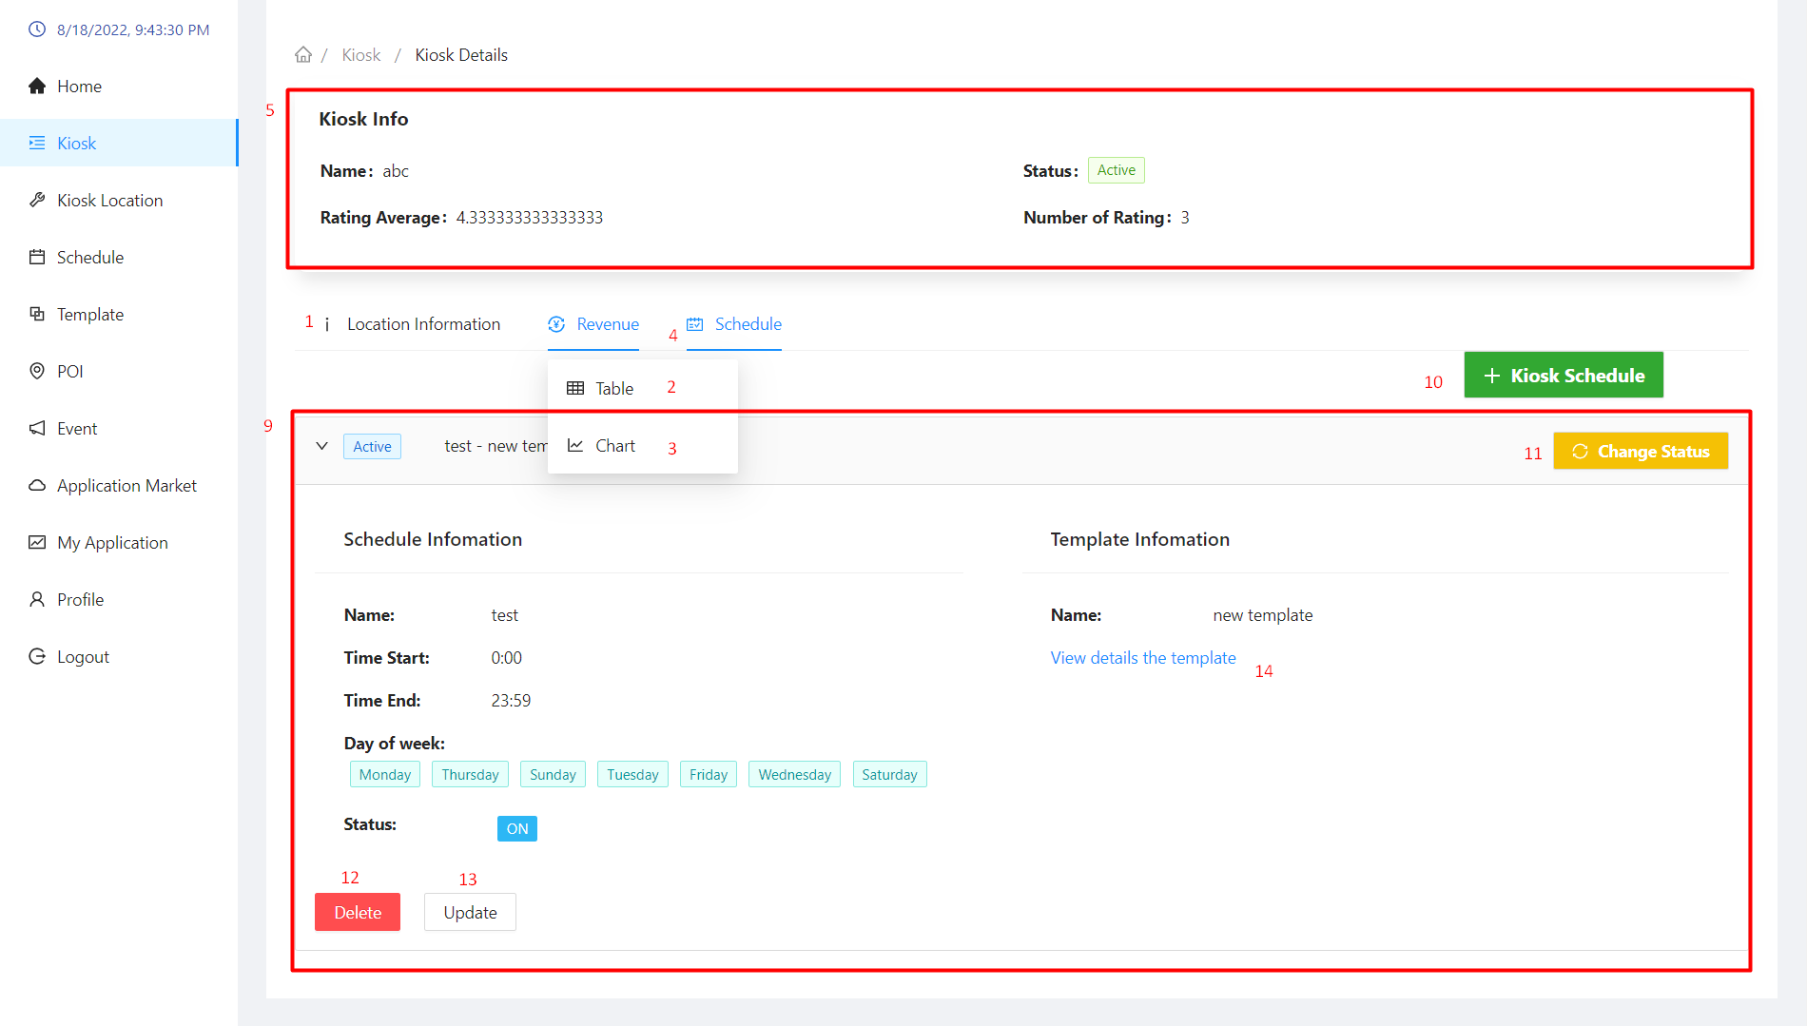

|  |  |  |  |  |  |  |  |  |
| --- | --- | --- | --- | --- | --- | --- | --- | --- |
| No. | Field Name | Description | | Read only | | Mandatory | Control Type | Data Type |
| 5 | Kiosk info | Used to view kiosk details | | Yes | | Yes | Table | String |
| 6 | Location information area | See the kiosk location information | | Yes | | Yes | Tab | String |
| 7 | Revenue table area | View revenue statistics by table | | Yes | | Yes | Tab | String |
| 8 | Revenue chart area | View revenue statistics by chart | | Yes | | Yes | Tab | String |
| 9 | Schedule area | View the schedules set up for the kiosk | | Yes | | Yes | Tab | String |
| **No.** | **Function** | | **Description** | | **Validation** | | **Outcome** | |
| 1 | Location information tab | | Location information tab | | No | | Move to tab location information | |
| 2 | Revenue table tab | | Revenue table tab | | No | | Move to tab revenue table | |
| 3 | Revenue chart tab | | Revenue chart tab | | No | | Move to tab revenue chart | |
| 4 | Schedule tab | | Schedule tab | | No | | Move to tab schedule | |
| 10 | New kiosk schedule button | | Create a new schedule for the kiosk | | No | | Show modal to create kiosk | |
| 11 | Change status button | | Change schedule activity status | | No | | Show confirmation dialog | |
| 12 | Delete button | | Delete schedule | | No | | Show confirmation dialog | |
| 13 | Update button | | Update schedule | | No | | Show modal to update kiosk | |
| 14 | View detail the template | | View detail the template | | No | | open a new browser and show you the details of the template | |

##### Create kiosk schedule modal

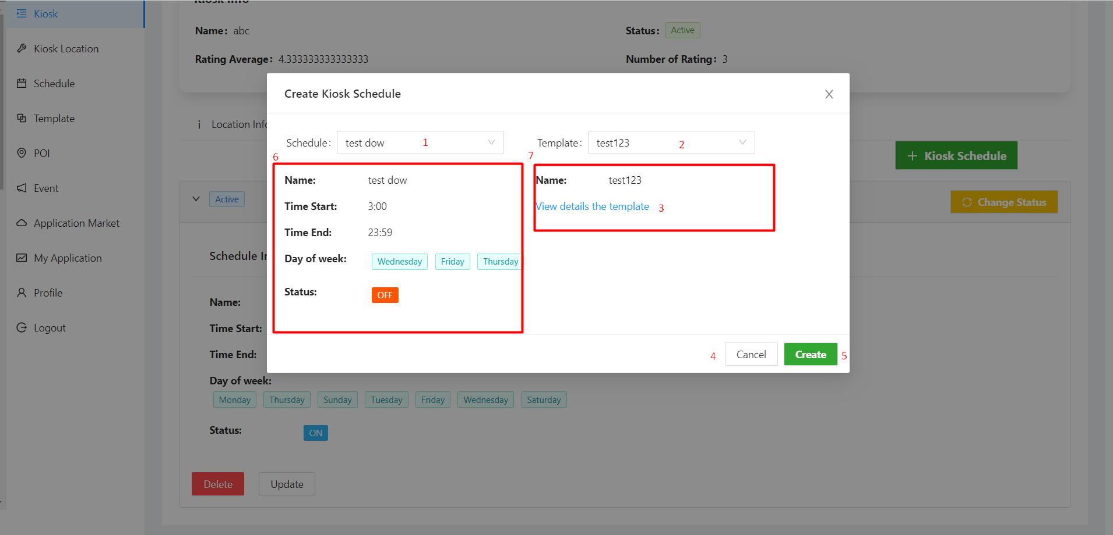

|  |  |  |  |  |  |  |  |  |
| --- | --- | --- | --- | --- | --- | --- | --- | --- |
| No. | Field Name | Description | | Read only | | Mandatory | Control Type | Data Type |
| 1 | Select schedule | Choose the right schedule for the kiosk | | No | | Yes | Select | String |
| 2 | Select template | Choose the right template for the kiosk | | No | | Yes | Select | String |
| 6 | Information of the schedule | Information of the schedule | | Yes | | Yes | Input | String |
| 7 | Information of the template | Information of the template | | Yes | | Yes | Input | String |
| **No.** | **Function** | | **Description** | | **Validation** | | **Outcome** | |
| 3 | View details the template | | View details the template | | No | | Open a new browser tab and go to the template's detail page | |
| 4 | Cancel button | | Cancel the creation of a new schedule | | No | | Back to schedule tab | |
| 5 | Create button | | Create a new schedule | | Yes | | Create a new schedule successfully if the new schedule does not coincide with the old schedule | |

##### Change status schedule modal

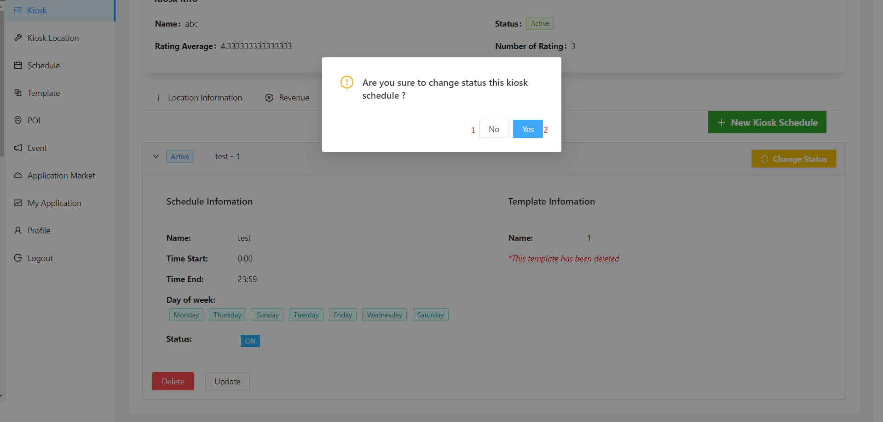

|  |  |  |  |  |
| --- | --- | --- | --- | --- |
| No. | Function | Description | Validation | Outcome |
| 1 | No button | Cancel action change status schedule | No | Back to schedule tab |
| 2 | Yes button | Confirm action change status schedule | Yes | The status of the schedule is changed to activate/deactivate |

##### Delete kiosk schedule modal

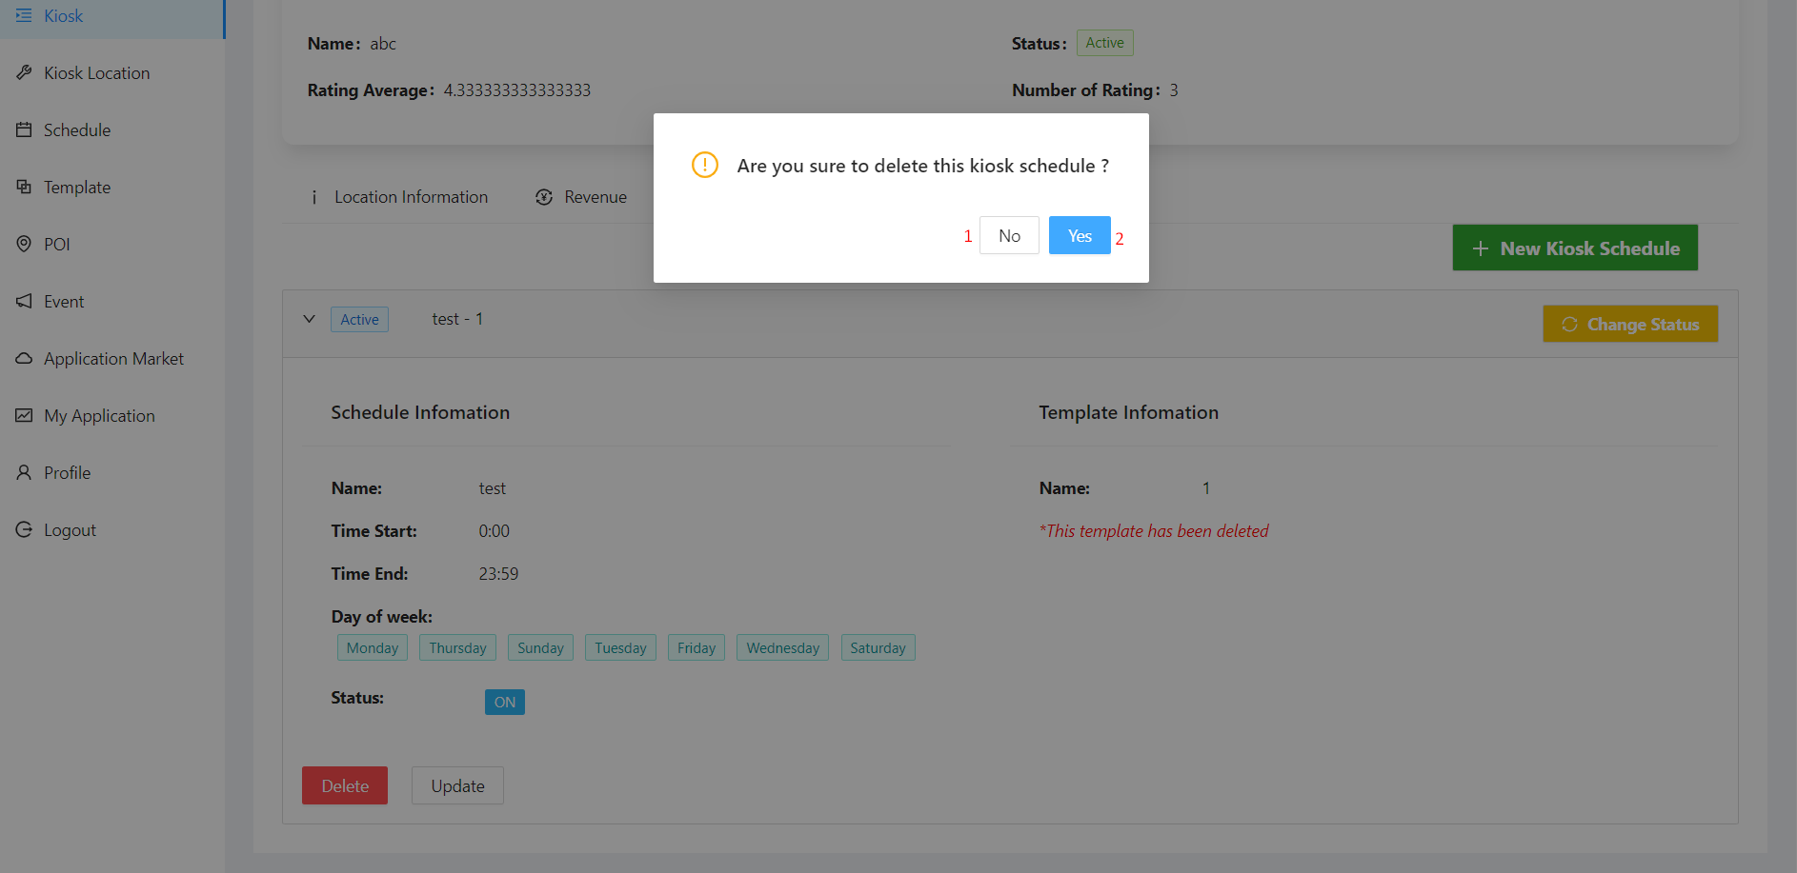

|  |  |  |  |  |
| --- | --- | --- | --- | --- |
| No. | Function | Description | Validation | Outcome |
| 1 | No button | Cancel action delete kiosk schedule | No | Back to schedule tab |
| 2 | Yes button | Confirm action delete kiosk schedule | Yes | The schedule is deleted |

##### Update schedule modal

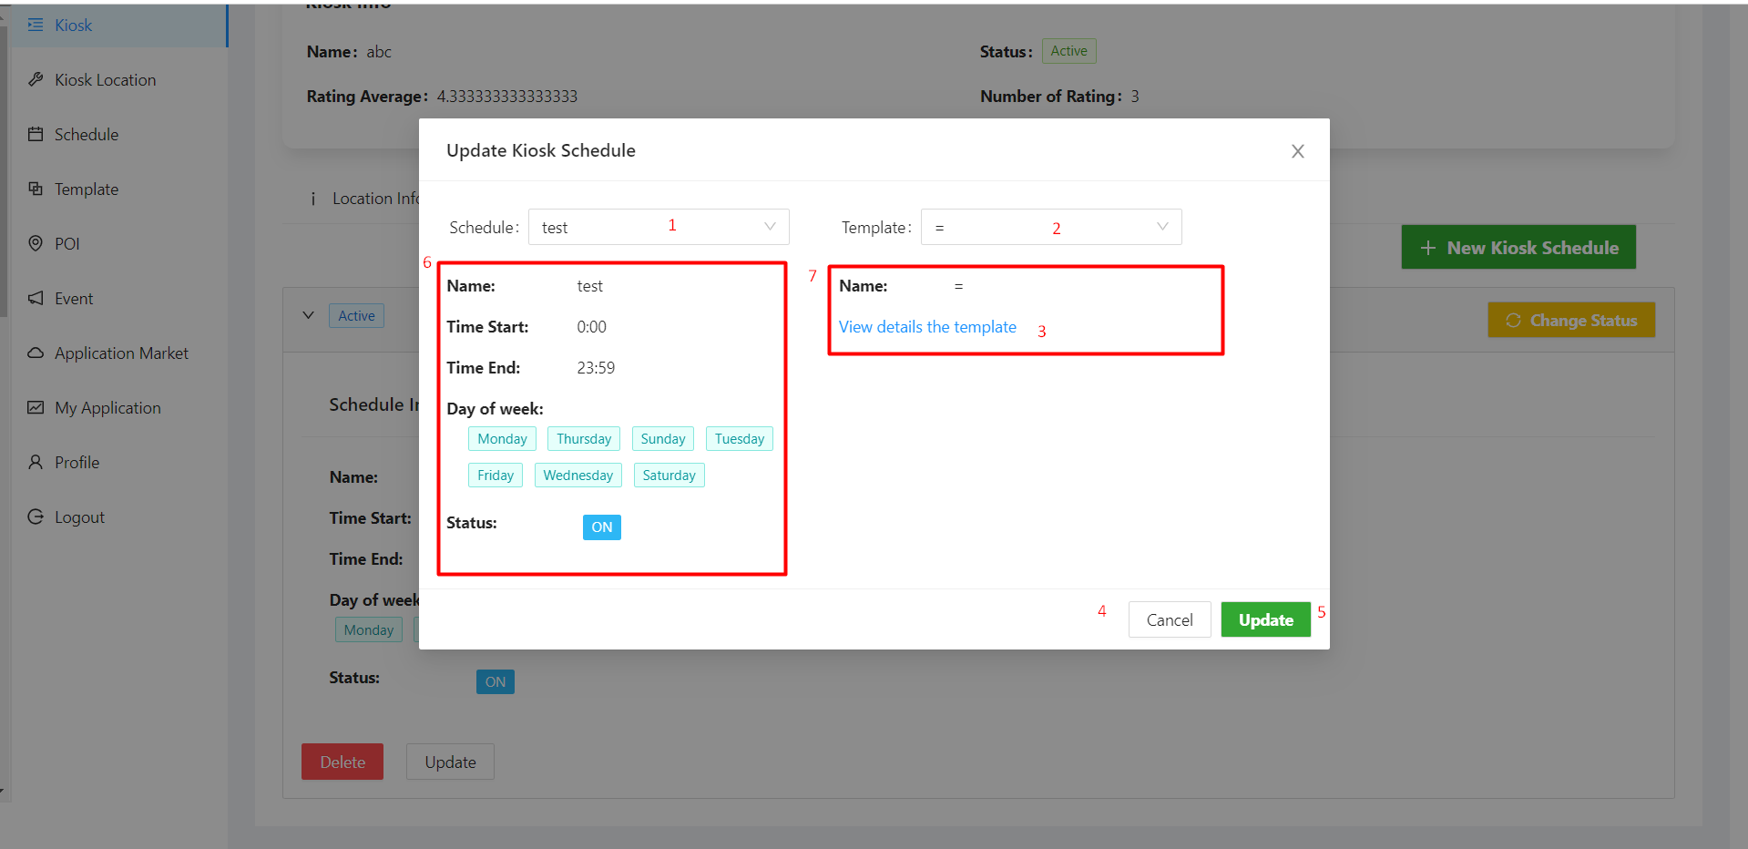

|  |  |  |  |  |  |  |  |  |
| --- | --- | --- | --- | --- | --- | --- | --- | --- |
| No. | Field Name | Description | | Read only | | Mandatory | Control Type | Data Type |
| 1 | Select schedule | select the new schedule you want to update to the current schedule | | No | | Yes | Select | String |
| 2 | Select template | select the new template you want to update to the current template | | No | | Yes | Select | String |
| 6 | Information of the schedule | Information of the schedule | | Yes | | Yes | Input | String |
| 7 | Information of the template | Information of the template | | Yes | | Yes | Input | String |
| **No.** | **Function** | | **Description** | | **Validation** | | **Outcome** | |
| 3 | View details the template | | View details the template | | No | | Open a new browser tab and go to the template's detail page | |
| 4 | Cancel button | | Canceling schedule update | | No | | Back to schedule tab | |
| 5 | Update button | | Update schedule | | Yes | | Updated schedule | |

##### Update location for kiosk modal

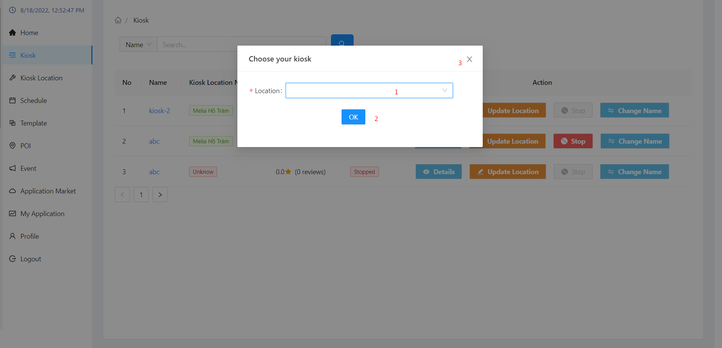

|  |  |  |  |  |  |  |  |  |
| --- | --- | --- | --- | --- | --- | --- | --- | --- |
| No. | Field Name | Description | | Read only | | Mandatory | Control Type | Data Type |
| 1 | Select location | select the new location you want to update to the current location | | No | | Yes | Select | String |
| **No.** | **Function** | | **Description** | | **Validation** | | **Outcome** | |
| 2 | Ok button | | Update location for kiosk | | Yes | | Location has been updated | |
| 3 | Exit button | | Canceling location update | | No | | Back to kiosk page | |

##### Stop kiosk modal

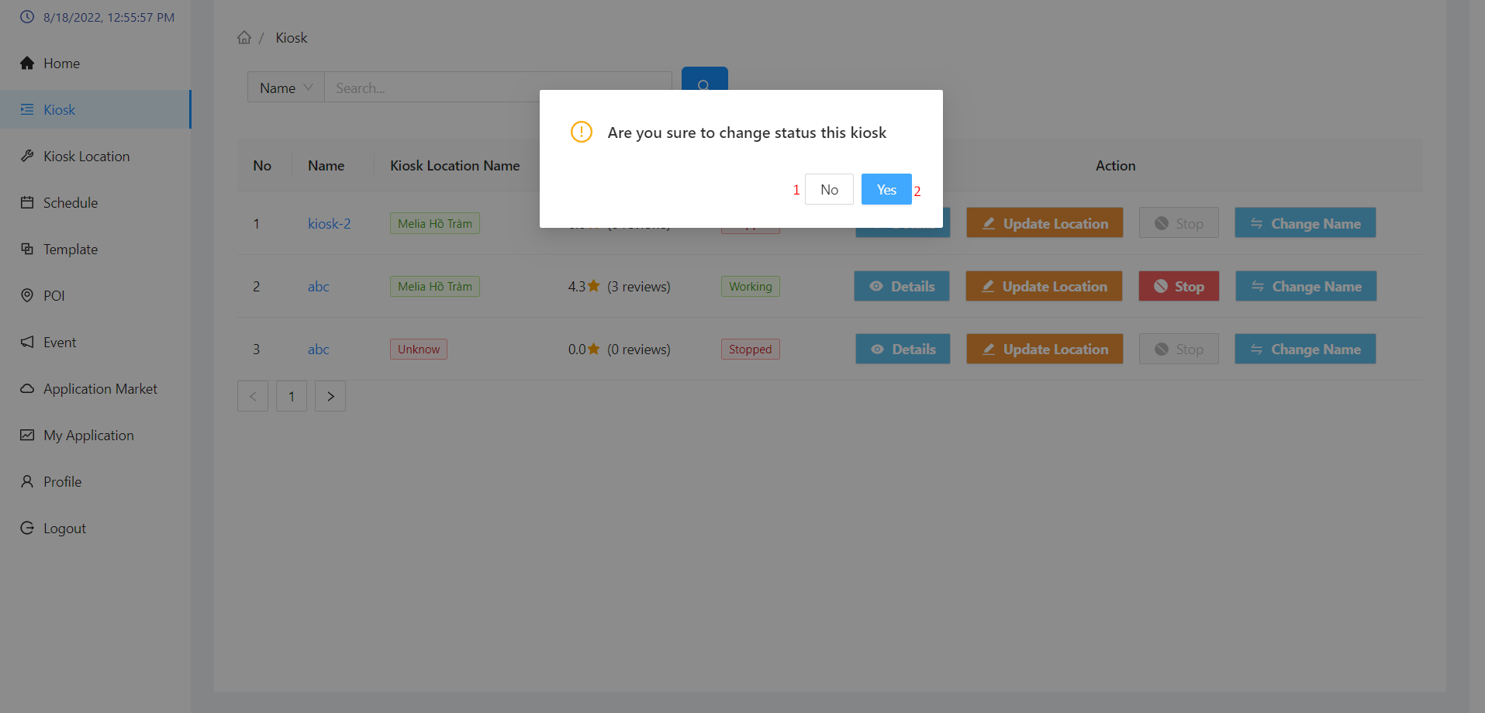

|  |  |  |  |  |
| --- | --- | --- | --- | --- |
| No. | Function | Description | Validation | Outcome |
| 1 | No button | Cancel action stop kiosk | No | Back to kiosk page |
| 2 | Yes button | Confirm action stop kiosk | Yes | The status of the kiosk changes to “Stopped”.  You can only update the kiosk in the “Working” state |

##### Change name kiosk modal

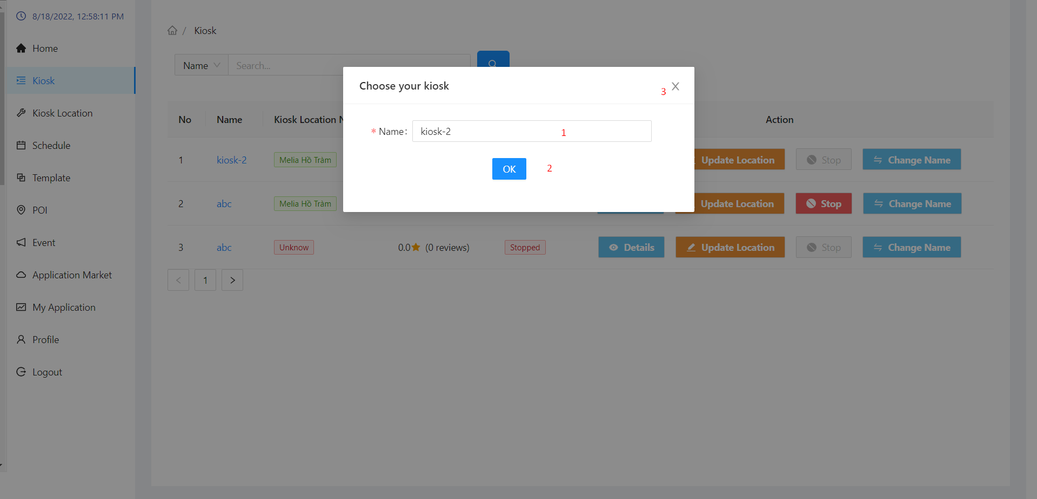

|  |  |  |  |  |  |  |  |  |
| --- | --- | --- | --- | --- | --- | --- | --- | --- |
| No. | Field Name | Description | | Read only | | Mandatory | Control Type | Data Type |
| 1 | Name | Enter new name to update kiosk's name | | No | | Yes | Input | String |
| **No.** | **Function** | | **Description** | | **Validation** | | **Outcome** | |
| 2 | Ok button | | Update name for kiosk | | Yes | | Name has been updated | |
| 3 | Exit button | | Canceling name update | | No | | Back to kiosk page | |

##### Kiosk location page

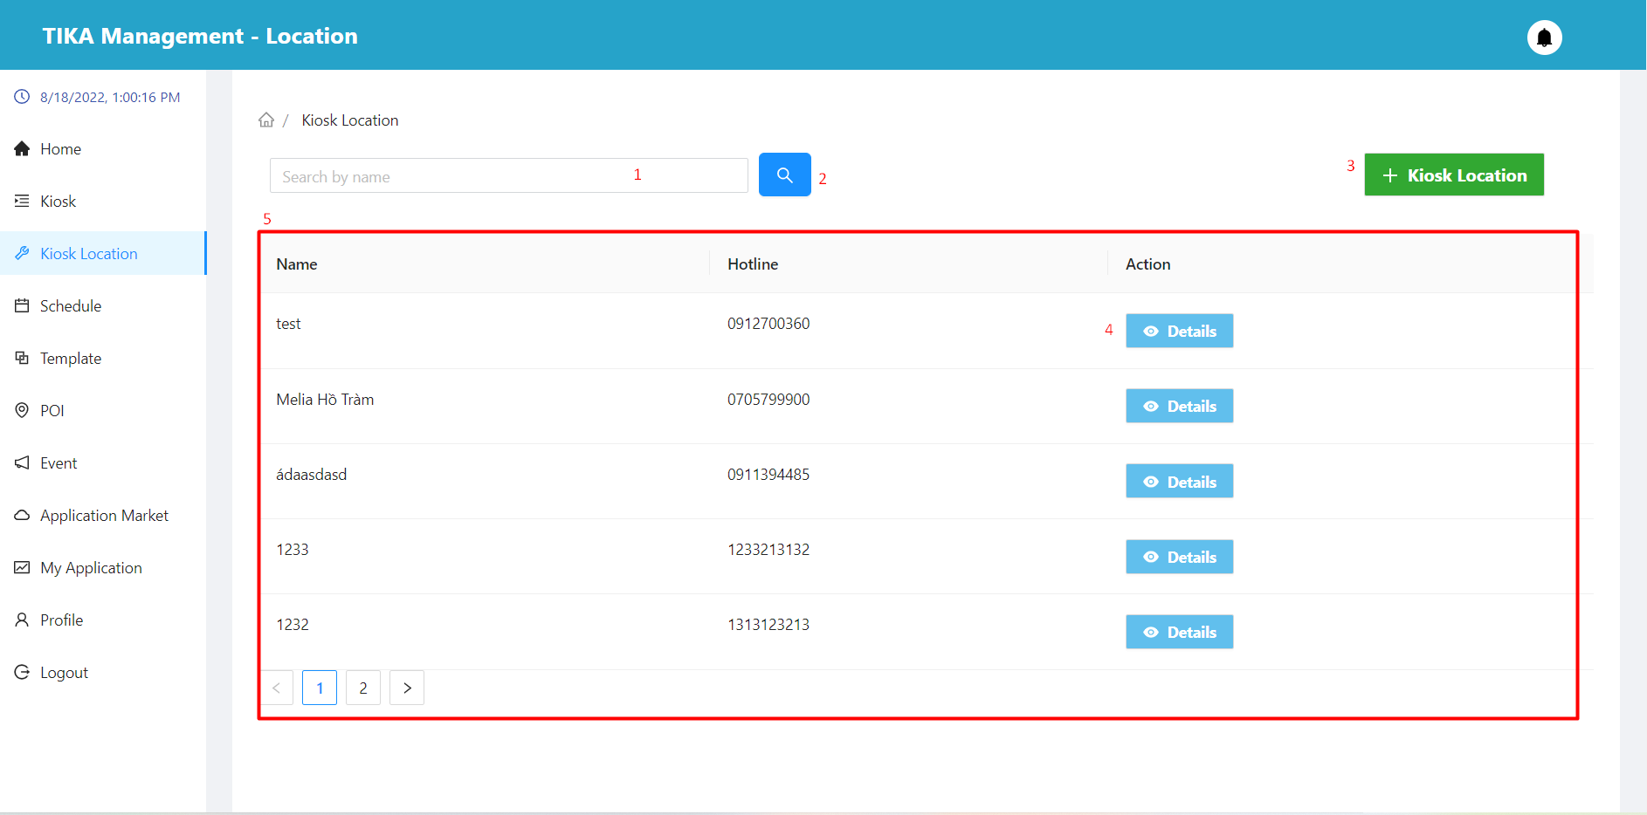

|  |  |  |  |  |  |  |  |  |
| --- | --- | --- | --- | --- | --- | --- | --- | --- |
| No. | Field Name | Description | | Read only | | Mandatory | Control Type | Data Type |
| 1 | Input value to search | Enter a value to search by name | | No | | No | Input | String |
| 5 | Information of the kiosk location | Basic information of the kiosk location | | Yes | | Yes | Table | String |
| **No.** | **Function** | | **Description** | | **Validation** | | **Outcome** | |
| 2 | Search information | | Search for information according to the data entered in (1) | | Yes | | Information shown in the table below | |
| 3 | Create kiosk location button | | Create a new kiosk location | | No | | Displays a modal to create a new kiosk location | |
| 4 | View detail kiosk location | | View kiosk location details in row | | No | | Move to detail kiosk location page | |

##### Create location modal

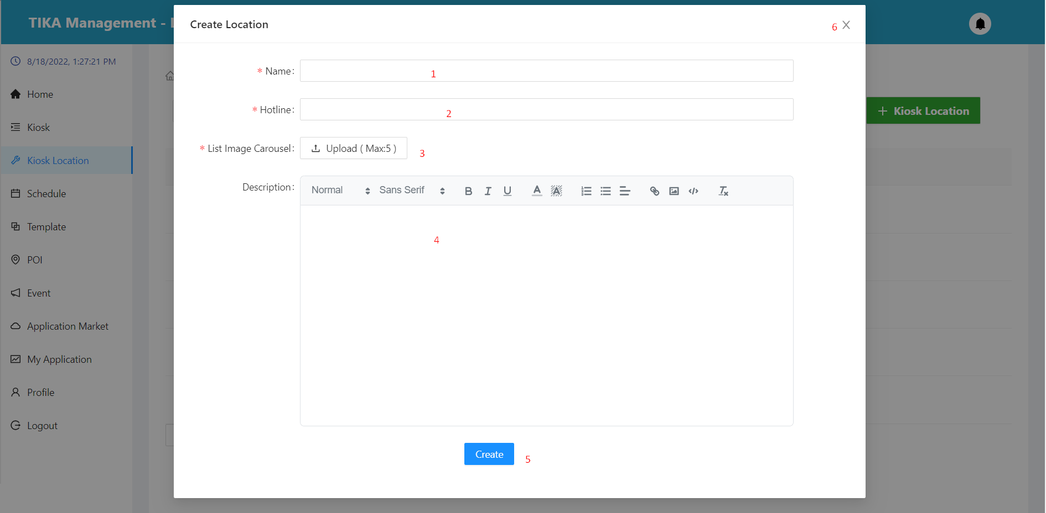

|  |  |  |  |  |  |  |  |  |  |  |
| --- | --- | --- | --- | --- | --- | --- | --- | --- | --- | --- |
| No. | Field Name | | Description | | Read only | | Mandatory | Control Type | | Data Type |
| 1 | Name | | Name of location | | No | | Yes | Input | | String |
| 2 | Hotline | | Hotline of location | | No | | Yes | Input | | Number |
| 3 | List Image | | List image of location | | No | | Yes | Upload | | File |
| 4 | Description | | Description of location | | No | | Yes | Editor | | String |
| **No.** | | **Function** | | **Description** | | **Validation** | | | **Outcome** | |
| 5 | | Create base information location button | | Create location with the information provided | | Yes | | | Location created | |
| 6 | | Exit button | | Exit modal | | No | | | Back to location page | |

##### Detail kiosk location page

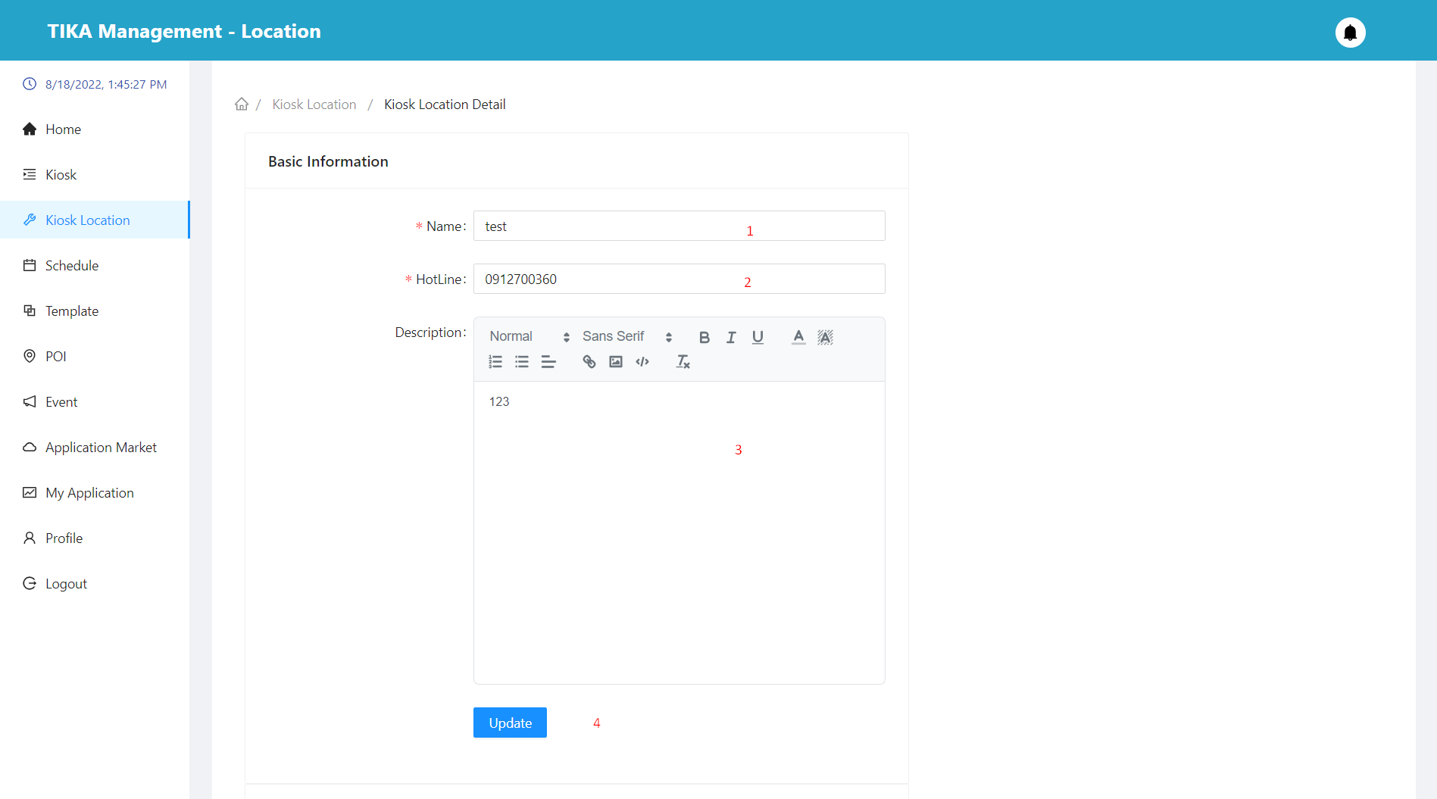

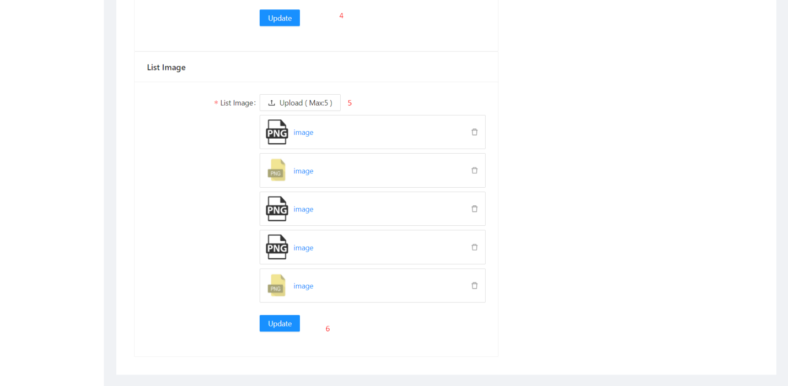

|  |  |  |  |  |  |  |  |  |  |
| --- | --- | --- | --- | --- | --- | --- | --- | --- | --- |
| No. | Field Name | Description | | Read only | | Mandatory | Control Type | | Data Type |
| 1 | Name | Name of location | | No | | Yes | Input | | String |
| 2 | Hotline | Hotline of location | | No | | Yes | Input | | Number |
| 3 | Description | Description of location | | No | | Yes | Editor | | String |
| 5 | List Image | List image of location | | No | | Yes | Upload | | File |
| **No.** | **Function** | | **Description** | | **Validation** | | | **Outcome** | |
| 4 | Update button | | Update the basic information of the place | | Yes | | | Location updated | |
| 6 | Update button | | Updated image list of the location | | Yes | | | Location updated | |

##### Schedule page

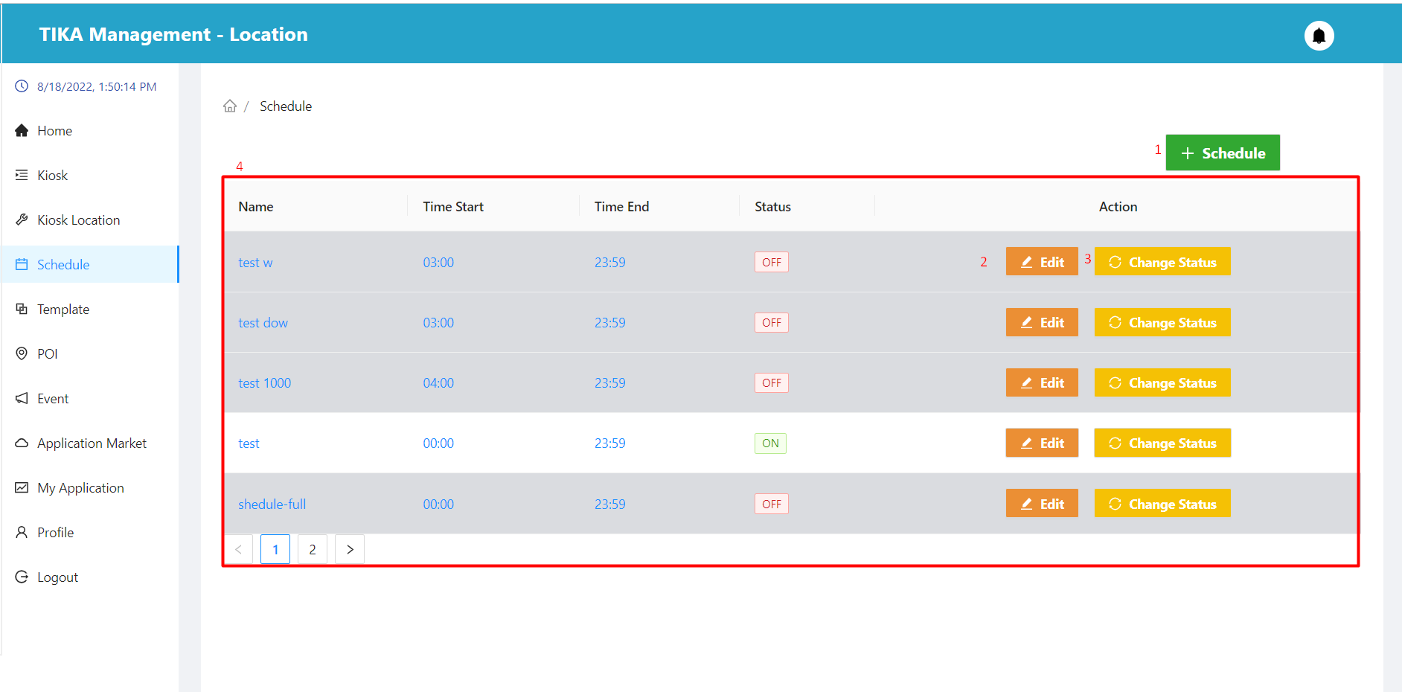

|  |  |  |  |  |  |  |  |  |
| --- | --- | --- | --- | --- | --- | --- | --- | --- |
| No. | Field Name | Description | | Read only | | Mandatory | Control Type | Data Type |
| 4 | Information of the schedule | Basic information of the schedule | | Yes | | Yes | Table | String |
| **No.** | **Function** | | **Description** | | **Validation** | | **Outcome** | |
| 1 | Create schedule button | | Create a new schedule | | No | | Displays a modal to create a new schedule | |
| 2 | Edit schedule button | | Schedule update | | No | | Displays a modal to update the schedule | |
| 3 | Change status button | | Change status button | | No | | Show confirmation dialog | |

##### Create schedule modal

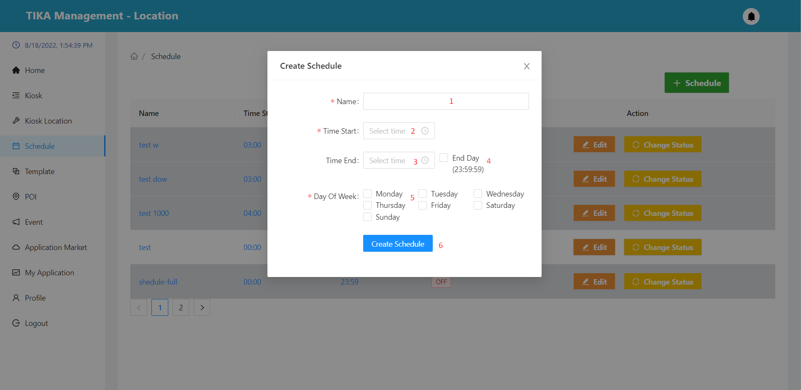

|  |  |  |  |  |  |  |  |  |  |  |
| --- | --- | --- | --- | --- | --- | --- | --- | --- | --- | --- |
| No. | Field Name | | Description | | Read only | | Mandatory | Control Type | | Data Type |
| 1 | Name | | Name of schedule | | No | | Yes | Input | | String |
| 2 | Time start | | Schedule activity start time | | No | | Yes | DatePicker | | Datetime |
| 3 | Time end | | Schedule activity end time | | No | | Yes | DatePicker | | Datetime |
| 4 | End day | | Change the end time of the schedule to 23:59:59 | | No | | No | Checkbox | | String |
| 5 | Day of week | | Schedule activity day of the week | | No | | Yes | Checkbox | | String |
| **No.** | | **Function** | | **Description** | | **Validation** | | | **Outcome** | |
| 6 | | Create base information schedule button | | Create schedule with the information provided | | Yes | | | Schedule created | |

##### Edit schedule modal

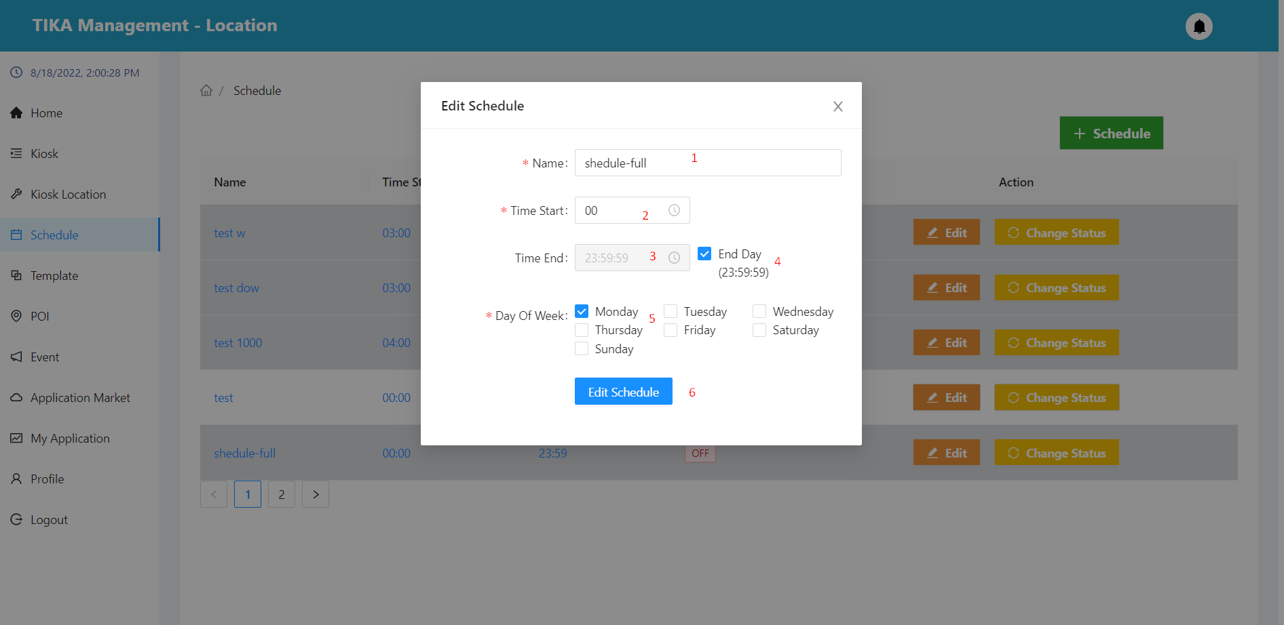

|  |  |  |  |  |  |  |  |  |  |  |
| --- | --- | --- | --- | --- | --- | --- | --- | --- | --- | --- |
| No. | Field Name | | Description | | Read only | | Mandatory | Control Type | | Data Type |
| 1 | Name | | Name of schedule | | No | | Yes | Input | | String |
| 2 | Time start | | Schedule activity start time | | No | | Yes | DatePicker | | Datetime |
| 3 | Time end | | Schedule activity end time | | No | | Yes | DatePicker | | Datetime |
| 4 | End day | | Change the end time of the schedule to 23:59:59 | | No | | No | Checkbox | | String |
| 5 | Day of week | | Schedule activity day of the week | | No | | Yes | Checkbox | | String |
| **No.** | | **Function** | | **Description** | | **Validation** | | | **Outcome** | |
| 6 | | Update schedule button | | Update the information of the schedule | | Yes | | | Schedule updated | |

##### Change status schedule

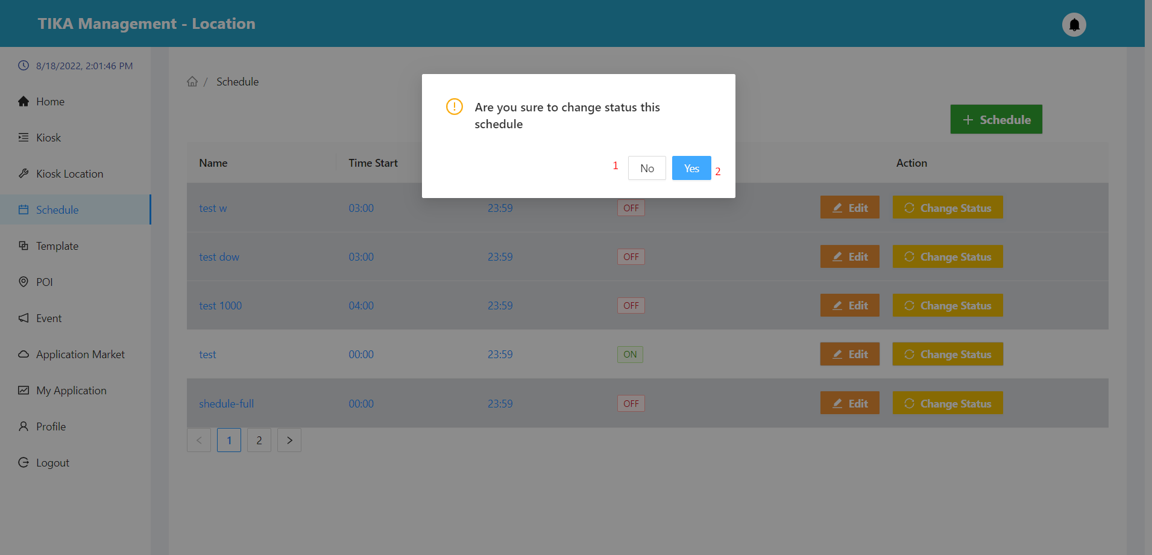

|  |  |  |  |  |
| --- | --- | --- | --- | --- |
| No. | Function | Description | Validation | Outcome |
| 1 | No button | Cancel action change status schedule | No | Back to schedule page |
| 2 | Yes button | Confirm action change status schedule | Yes | The status of the schedule changes to ON/OFF. |

##### Template page

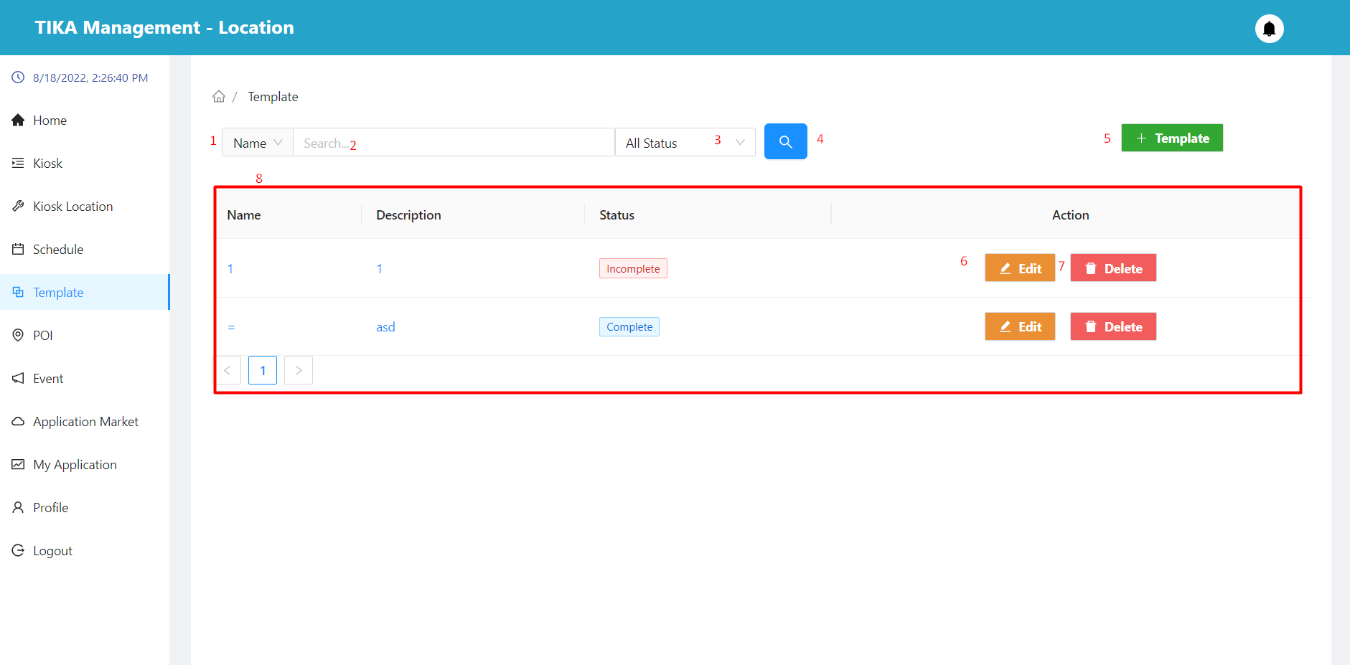

|  |  |  |  |  |  |  |  |  |
| --- | --- | --- | --- | --- | --- | --- | --- | --- |
| No. | Field Name | Description | | Read only | | Mandatory | Control Type | Data Type |
| 1 | Search field | Select field you want to search | | No | | No | Select | String |
| 2 | Input value to search | Enter a search value that corresponds to the search field selected in (1) | | No | | No | Input | String |
| 3 | Select status | Select value of status you want to search | | No | | No | Select | String |
| 8 | Basic information of the application | Basic information of template | | Yes | | Yes | Table | String |
| **No.** | **Function** | | **Description** | | **Validation** | | **Outcome** | |
| 4 | Search information | | Search with selected information and enter items 1, 2, 3 | | Yes | | Information shown in the table below | |
| 5 | Create template button | | Create template button | | No | | Show modal create template | |
| 6 | Edit template button | | Edit template button | | No | | Show modal edit template | |
| 7 | Delete template button | | Delete template button | | No | | Show confirmation dialog | |

##### Create template modal

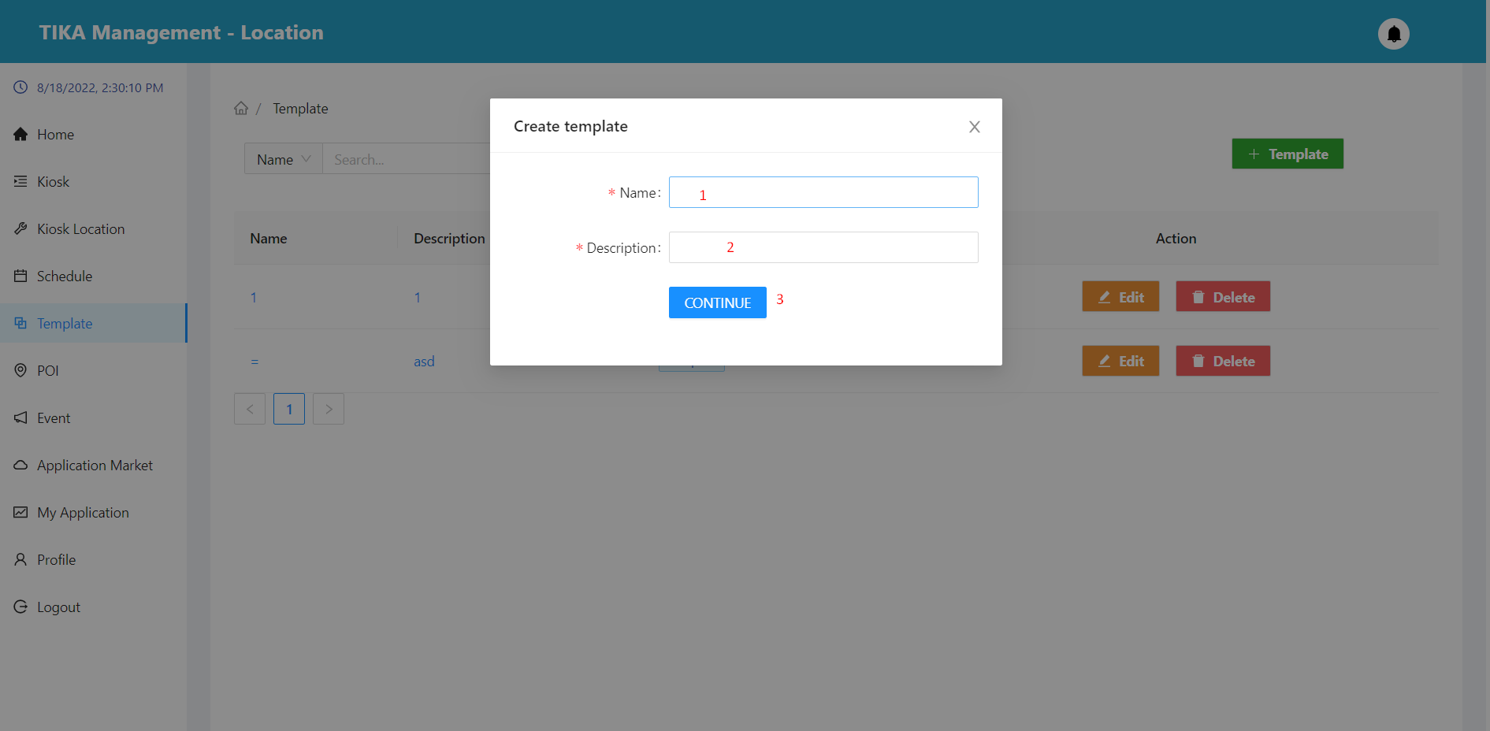

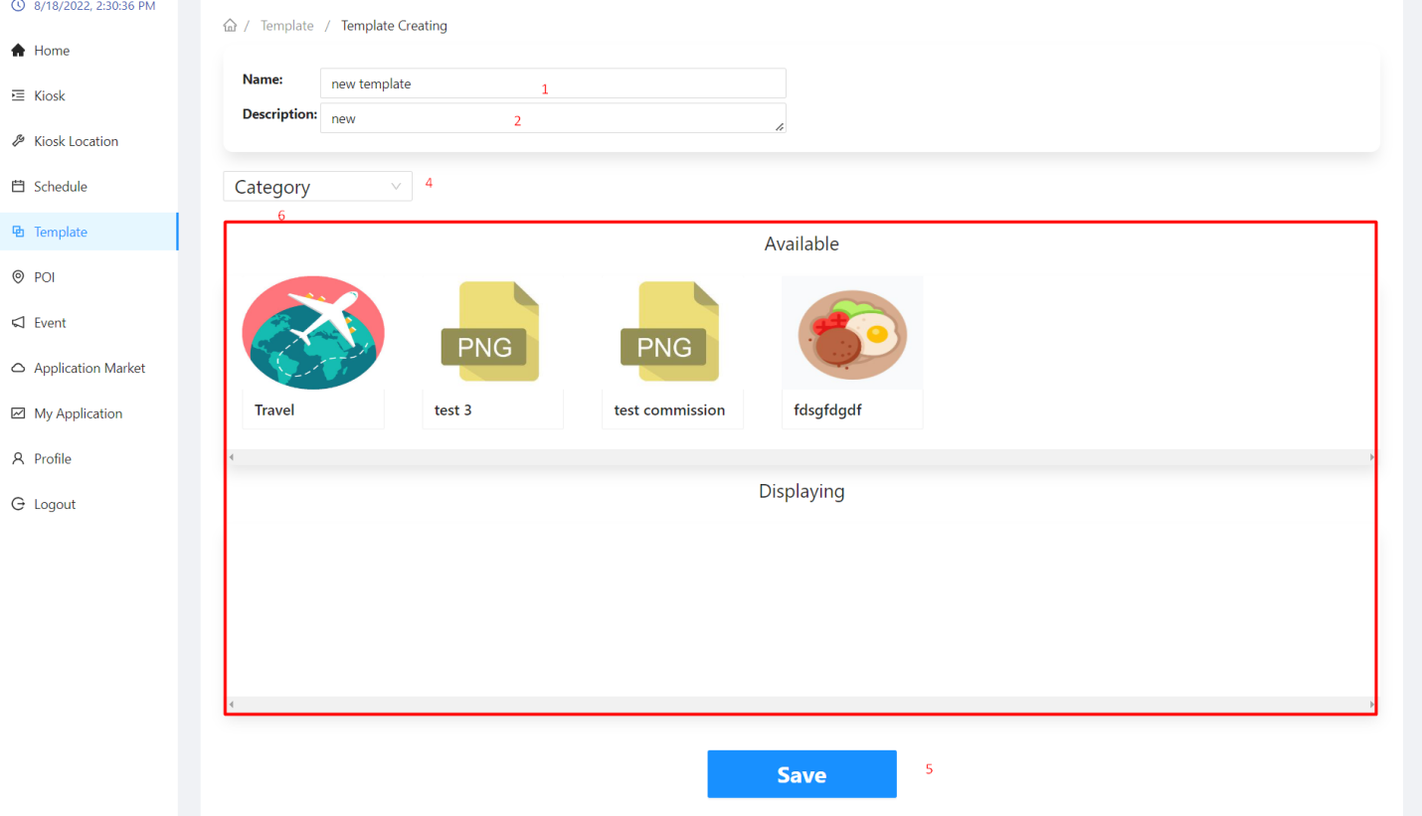

|  |  |  |  |  |  |  |  |  |
| --- | --- | --- | --- | --- | --- | --- | --- | --- |
| No. | Field Name | Description | | Read only | | Mandatory | Control Type | Data Type |
| 1 | Name | Name of the template | | No | | Yes | Input | String |
| 2 | Description | Description of the template | | No | | Yes | Input | String |
| 4 | Select type | Select type to setup | | No | | Yes | Select | String |
| **No.** | **Function** | | **Description** | | **Validation** | | **Outcome** | |
| 3 | Continue button | | Continue button | | Yes | | Go to template creating page | |
| 5 | Save button | | Save selected settings | | Yes | | A finished template | |
| 6 | Interface setting area | | Interface setting area by dragging and dropping to the desired position | | No | | Desired interface | |

##### Edit template

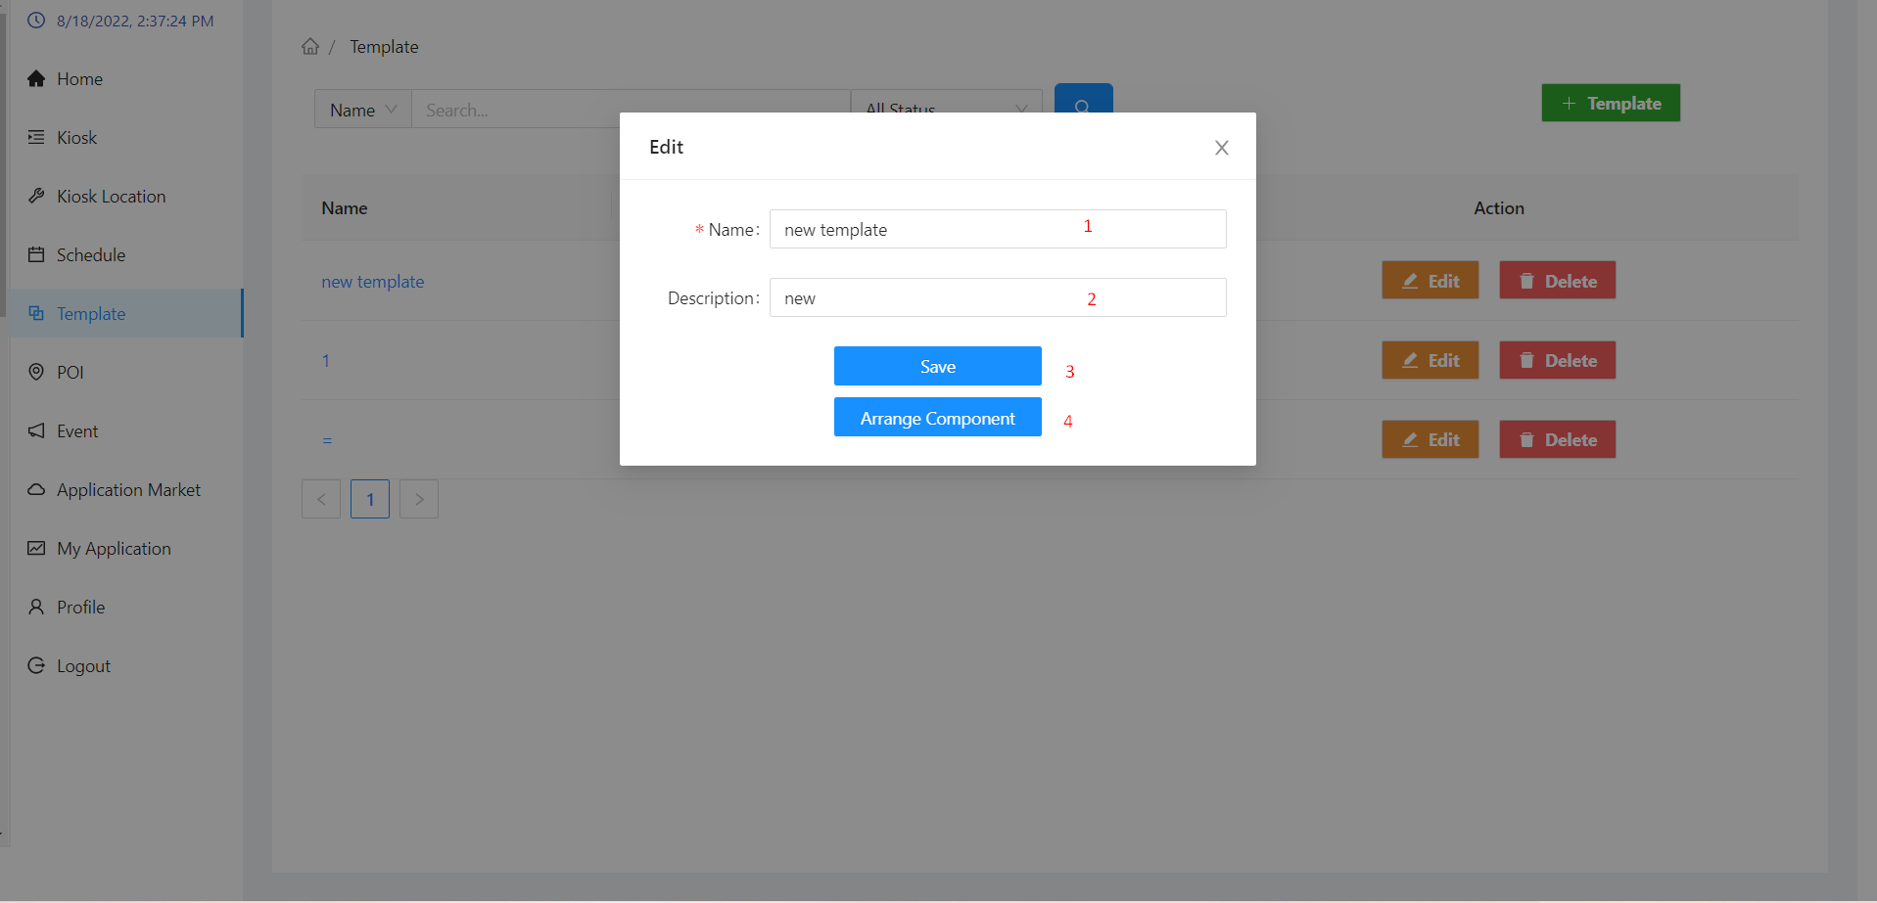

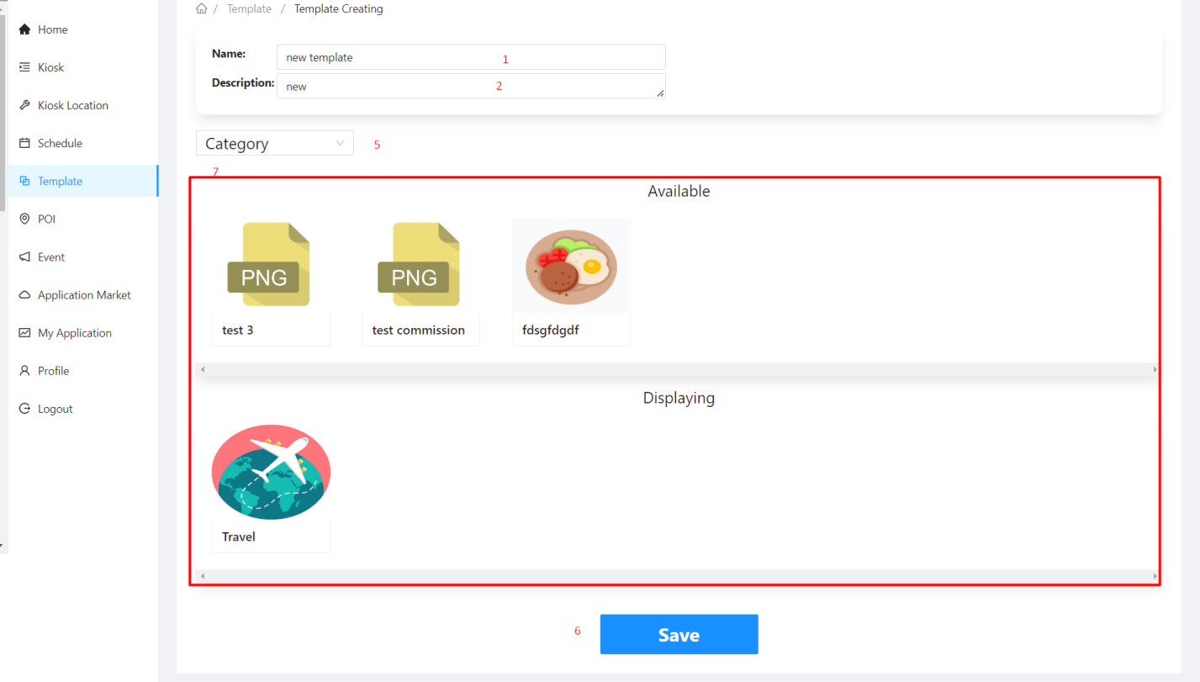

|  |  |  |  |  |  |  |  |  |
| --- | --- | --- | --- | --- | --- | --- | --- | --- |
| No. | Field Name | Description | | Read only | | Mandatory | Control Type | Data Type |
| 1 | Name | Name of the template | | No | | Yes | Input | String |
| 2 | Description | Description of the template | | No | | Yes | Input | String |
| 5 | Select type | Select type to setup | | No | | Yes | Select | String |
| **No.** | **Function** | | **Description** | | **Validation** | | **Outcome** | |
| 3 | Save button | | Save button | | Yes | | Save name and description changes | |
| 4 | Arrange button | | Arrange button | | No | | Go to template creating page | |
| 6 | Save button | | Save selected settings | | Yes | | Template updated | |
| 7 | Interface setting area | | Interface setting area by dragging and dropping to the desired position | | No | | Desired interface | |

##### Delete template

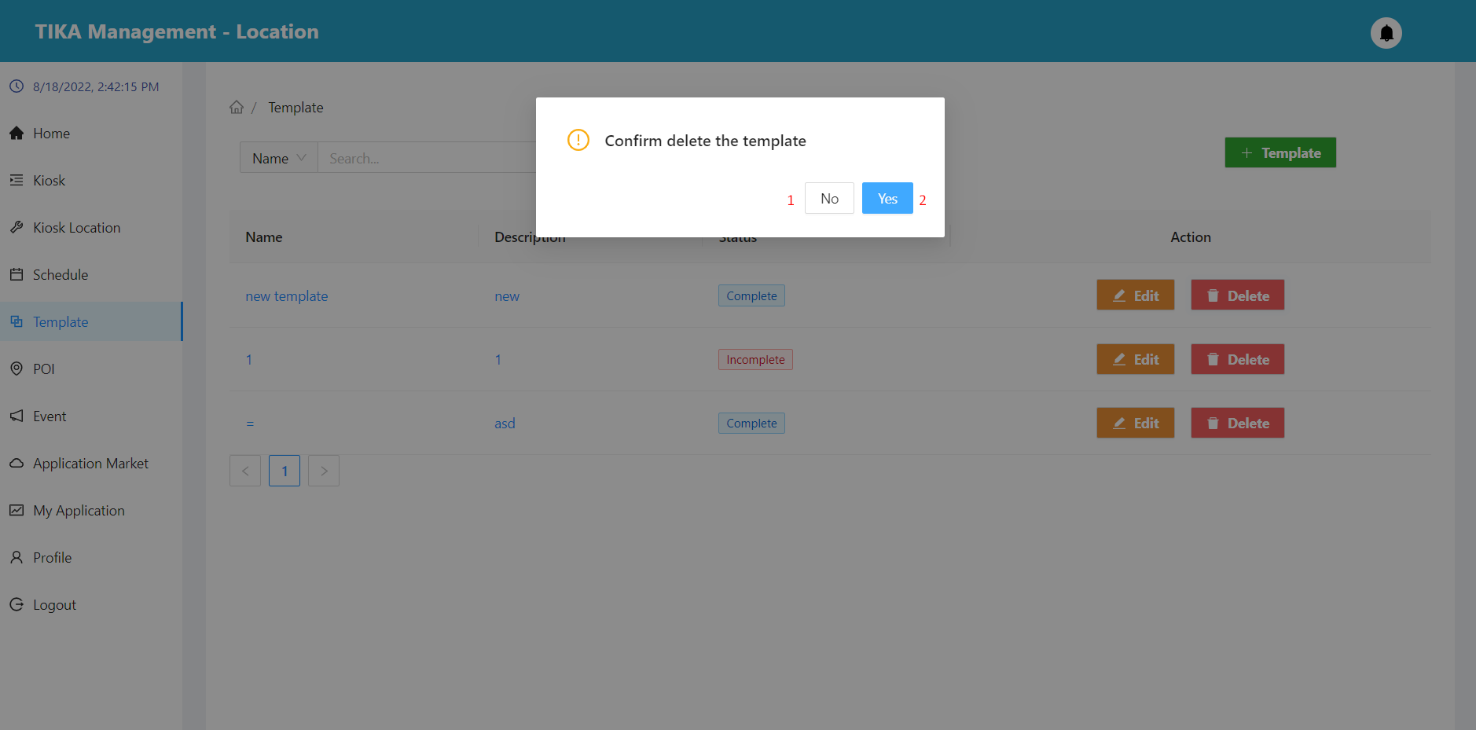

|  |  |  |  |  |
| --- | --- | --- | --- | --- |
| No. | Function | Description | Validation | Outcome |
| 1 | No button | Cancel action delete template | No | Back to template page |
| 2 | Yes button | Confirm action delete template | Yes | Template removed from the database |

##### Poi page

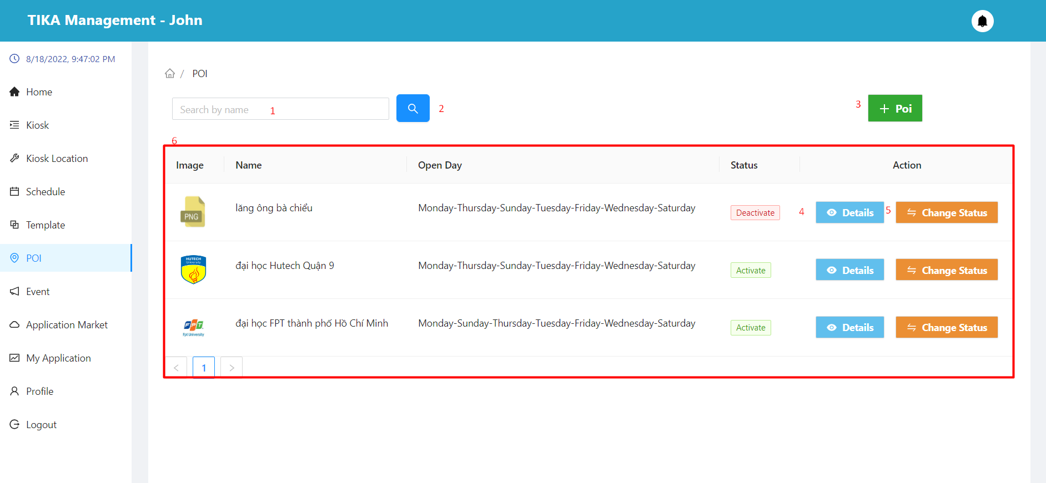

|  |  |  |  |  |  |  |  |  |
| --- | --- | --- | --- | --- | --- | --- | --- | --- |
| No. | Field Name | Description | | Read only | | Mandatory | Control Type | Data Type |
| 2 | Input name | Enter the name of the poi you want to search for | | No | | No | Input | String |
| 6 | Information of the poi | Basic information of the poi | | Yes | | Yes | Table | String |
| **No.** | **Function** | | **Description** | | **Validation** | | **Outcome** | |
| 2 | Search information | | Search with the name entered in (2) | | Yes | | Information shown in the table below | |
| 3 | Create poi button | | Create a new poi | | No | | Displays a modal to create a new poi | |
| 4 | View detail kiosk | | View kiosk details in row | | No | | Move to detail poi page | |
| 5 | Change status button | | Change status of poi | | No | | Show confirmation dialog | |

##### Create poi modal

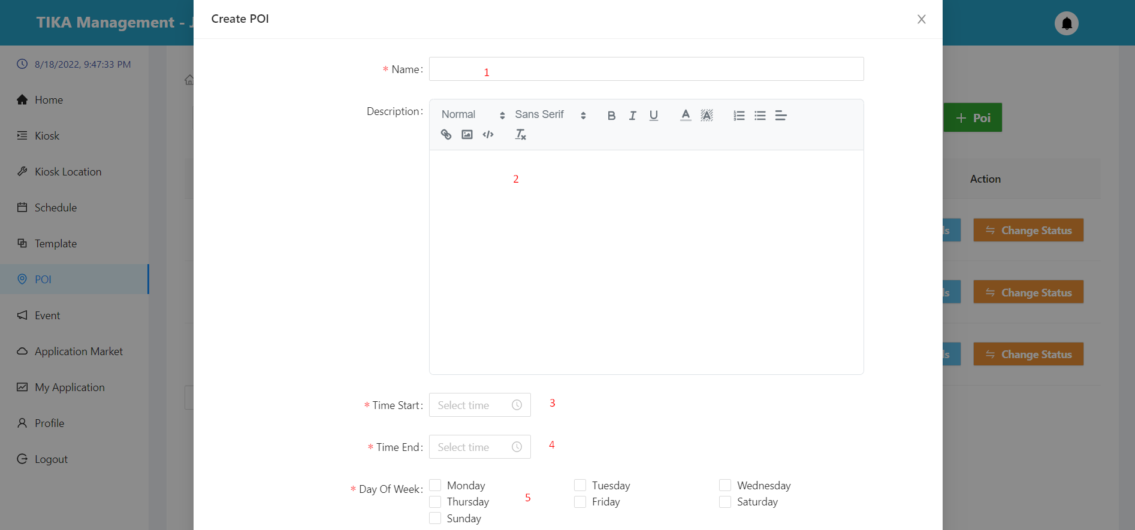

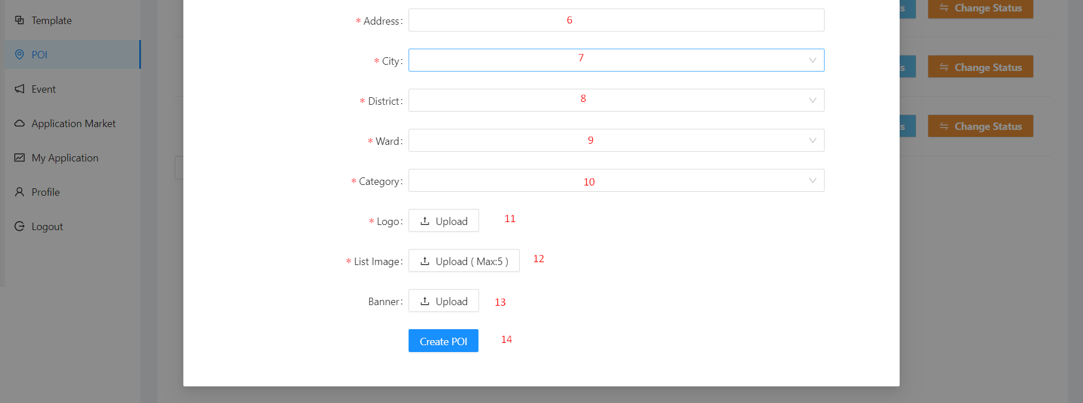

|  |  |  |  |  |  |  |  |  |  |  |
| --- | --- | --- | --- | --- | --- | --- | --- | --- | --- | --- |
| No. | Field Name | | Description | | Read only | | Mandatory | Control Type | | Data Type |
| 1 | Name | | Name of event | | No | | Yes | Input | | String |
| 2 | Description | | Description of event | | No | | Yes | Editor | | String |
| 3 | Time start | | Opening time of the day | | No | | Yes | DatePicker | | Datetime |
| 4 | Time end | | Closing time of the day | | No | | Yes | DatePicker | | Datetime |
| 5 | Day of week | | Location opening day of the week | | No | | Yes | Checkbox | | String |
| 6 | Address | | Location of poi | | No | | Yes | Input | | String |
| 7 | Province | | Province of poi | | No | | Yes | Select | | String |
| 8 | District | | District of poi | | No | | Yes | Select | | String |
| 9 | Ward | | Ward of poi | | No | | Yes | Select | | String |
| 10 | Category | | Category of poi | | No | | Yes | Select | | String |
| 11 | Logo | | Logo of poi | | No | | Yes | Upload | | File |
| 12 | List Image | | List image of poi | | No | | Yes | Upload | | File |
| 13 | Banner | | Banner of poi | | No | | No | Upload | | File |
| **No.** | | **Function** | | **Description** | | **Validation** | | | **Outcome** | |
| 14 | | Create base information poi button | | Create poi with the information provided | | Yes | | | Poi created | |

##### Detail poi page

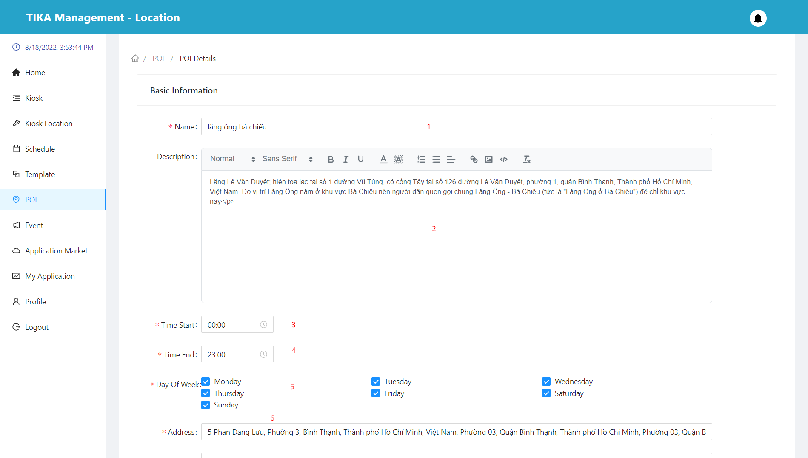

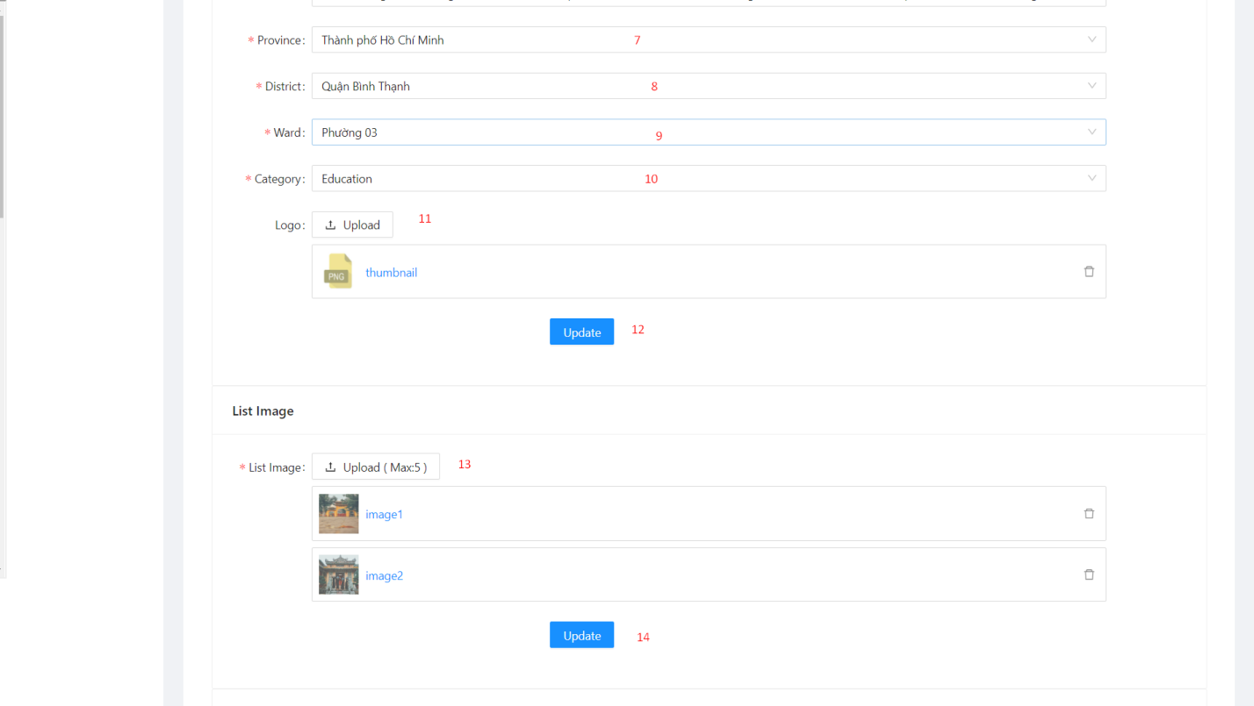

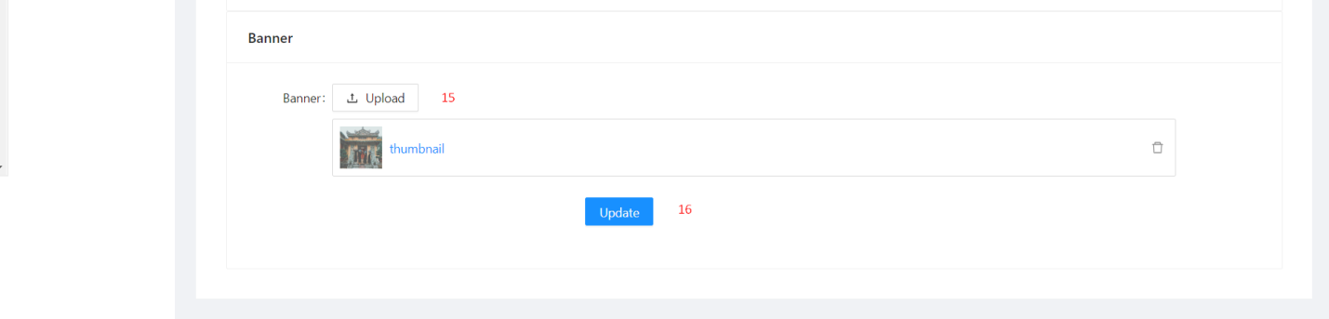

|  |  |  |  |  |  |  |  |  |  |  |
| --- | --- | --- | --- | --- | --- | --- | --- | --- | --- | --- |
| No. | Field Name | | Description | | Read only | | Mandatory | Control Type | | Data Type |
| 1 | Name | | Name of event | | No | | Yes | Input | | String |
| 2 | Description | | Description of event | | No | | Yes | Editor | | String |
| 3 | Time start | | Opening time of the day | | No | | Yes | DatePicker | | Datetime |
| 4 | Time end | | Closing time of the day | | No | | Yes | DatePicker | | Datetime |
| 5 | Day of week | | Location opening day of the week | | No | | Yes | Checkbox | | String |
| 6 | Address | | Location of poi | | No | | Yes | Input | | String |
| 7 | Province | | Province of poi | | No | | Yes | Select | | String |
| 8 | District | | District of poi | | No | | Yes | Select | | String |
| 9 | Ward | | Ward of poi | | No | | Yes | Select | | String |
| 10 | Category | | Category of poi | | No | | Yes | Select | | String |
| 11 | Logo | | Logo of poi | | No | | Yes | Upload | | File |
| 13 | List Image | | List image of poi | | No | | Yes | Upload | | File |
| 15 | Banner | | Banner of poi | | No | | No | Upload | | File |
| **No.** | | **Function** | | **Description** | | **Validation** | | | **Outcome** | |
| 12 | | Update base information poi button | | Update poi with the information provided | | Yes | | | Poi updated | |
| 14 | | Updated poi's image list | | Updated poi's image list | | Yes | | | Poi updated | |
| 16 | | Updated poi's banner | | Updated poi's banner | | Yes | | | Poi updated | |

##### Change status poi modal

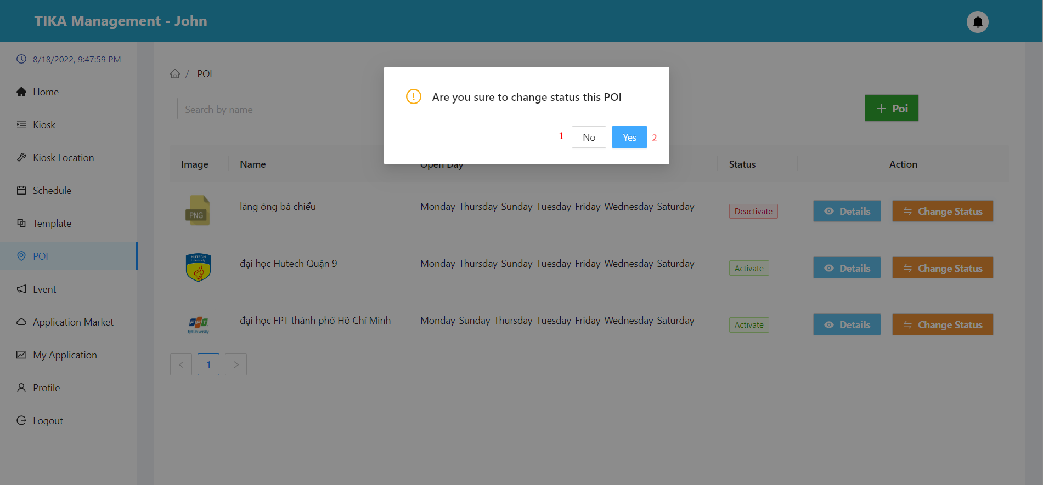

|  |  |  |  |  |
| --- | --- | --- | --- | --- |
| No. | Function | Description | Validation | Outcome |
| 1 | No button | Cancel action change status poi | No | Back to poi page |
| 2 | Yes button | Confirm action change status poi | Yes | The status of the poi changes to Activate/Deactivate. |

##### Event page

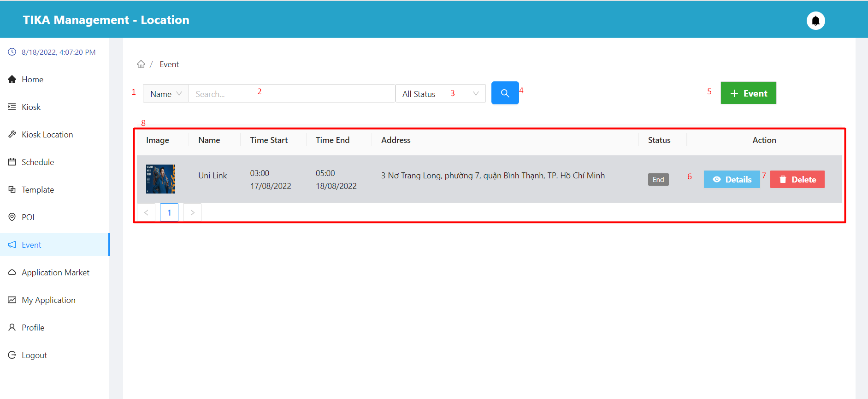

|  |  |  |  |  |  |  |  |  |
| --- | --- | --- | --- | --- | --- | --- | --- | --- |
| No. | Field Name | Description | | Read only | | Mandatory | Control Type | Data Type |
| 1 | Search field | Select field you want to search | | No | | No | Select | String |
| 2 | Input value to search | Enter a search value that corresponds to the search field selected in (1) | | No | | No | Input | String |
| 3 | Select status | Select value of status you want to search | | No | | No | Select | String |
| 8 | Information of the event | Basic information of the event | | Yes | | Yes | Table | String |
| **No.** | **Function** | | **Description** | | **Validation** | | **Outcome** | |
| 4 | Search information | | Search with selected information and enter items 1, 2, 3 | | Yes | | Information shown in the table below | |
| 5 | Create event button | | Create event with basic information | | No | | Show modal create event | |
| 6 | View detail event | | View event details in row | | No | | Move to detail event page | |
| 7 | Delete event button | | Delete event in row | | No | | Show modal confirm to delete event | |

##### Create event page

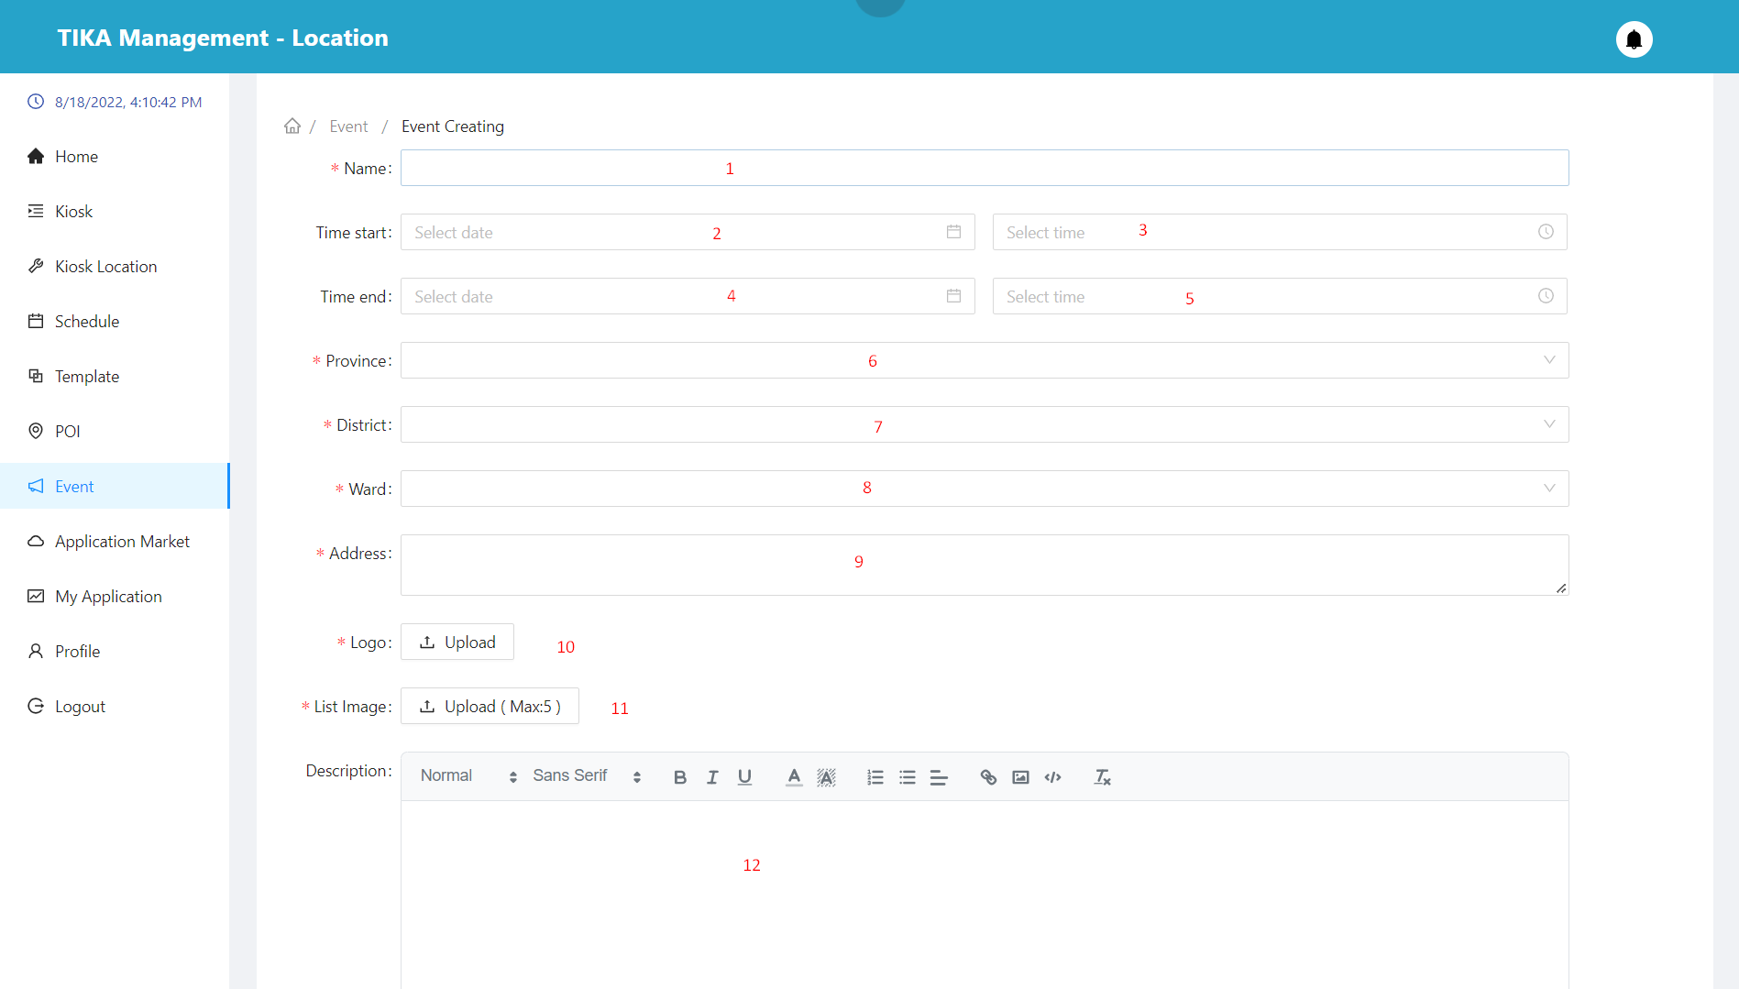

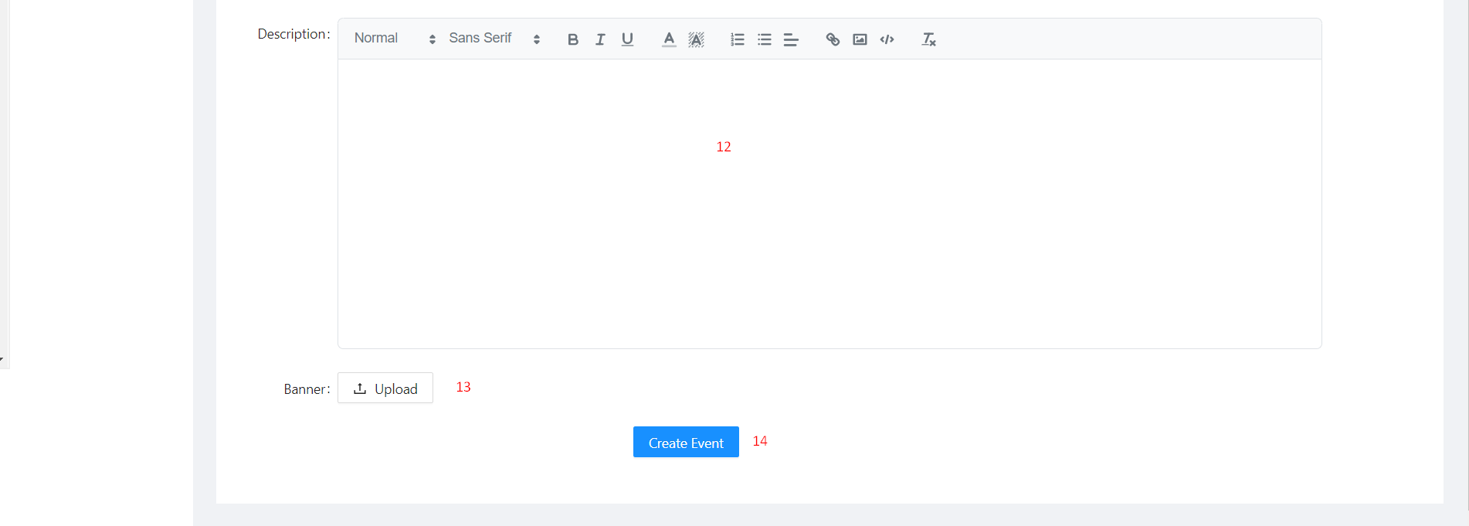

|  |  |  |  |  |  |  |  |  |  |  |
| --- | --- | --- | --- | --- | --- | --- | --- | --- | --- | --- |
| No. | Field Name | | Description | | Read only | | Mandatory | Control Type | | Data Type |
| 1 | Name | | Name of event | | No | | Yes | Input | | String |
| 2 | Date start | | Opening dates of the event | | No | | Yes | DatePicker | | Datetime |
| 3 | Time start | | Opening times of the event | | No | | Yes | DatePicker | | Datetime |
| 4 | Date end | | Closing dates of the event | | No | | Yes | DatePicker | | Datetime |
| 5 | Time end | | Closing times of the event | | No | | Yes | DatePicker | | Datetime |
| 6 | Province | | Province of event | | No | | Yes | Select | | String |
| 7 | District | | District of event | | No | | Yes | Select | | String |
| 8 | Ward | | Ward of event | | No | | Yes | Select | | String |
| 9 | Address | | Location of event | | No | | Yes | Textarea | | String |
| 10 | Logo | | Logo of event | | No | | Yes | Upload | | File |
| 11 | List Image | | List image of event | | No | | Yes | Upload | | File |
| 12 | Description | | Description of event | | No | | Yes | Editor | | String |
| 13 | Banner | | Banner of event | | No | | No | Upload | | File |
| **No.** | | **Function** | | **Description** | | **Validation** | | | **Outcome** | |
| 14 | | Create base information event button | | Create event with the information provided | | Yes | | | Event created | |

##### Detail event page

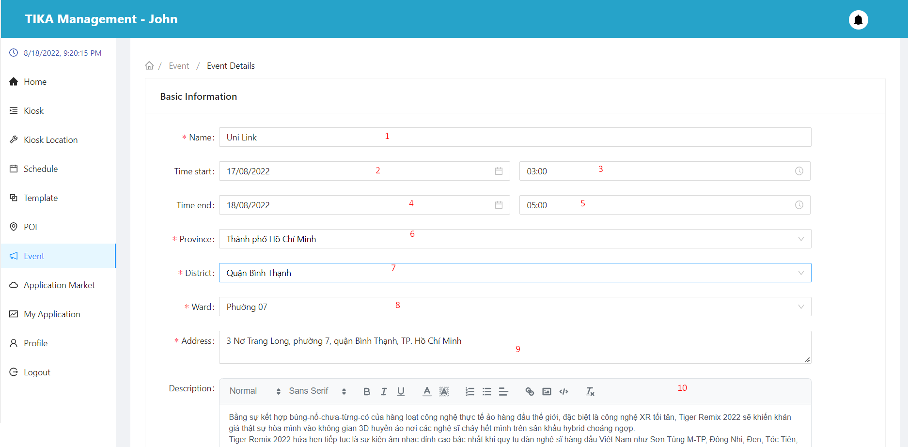

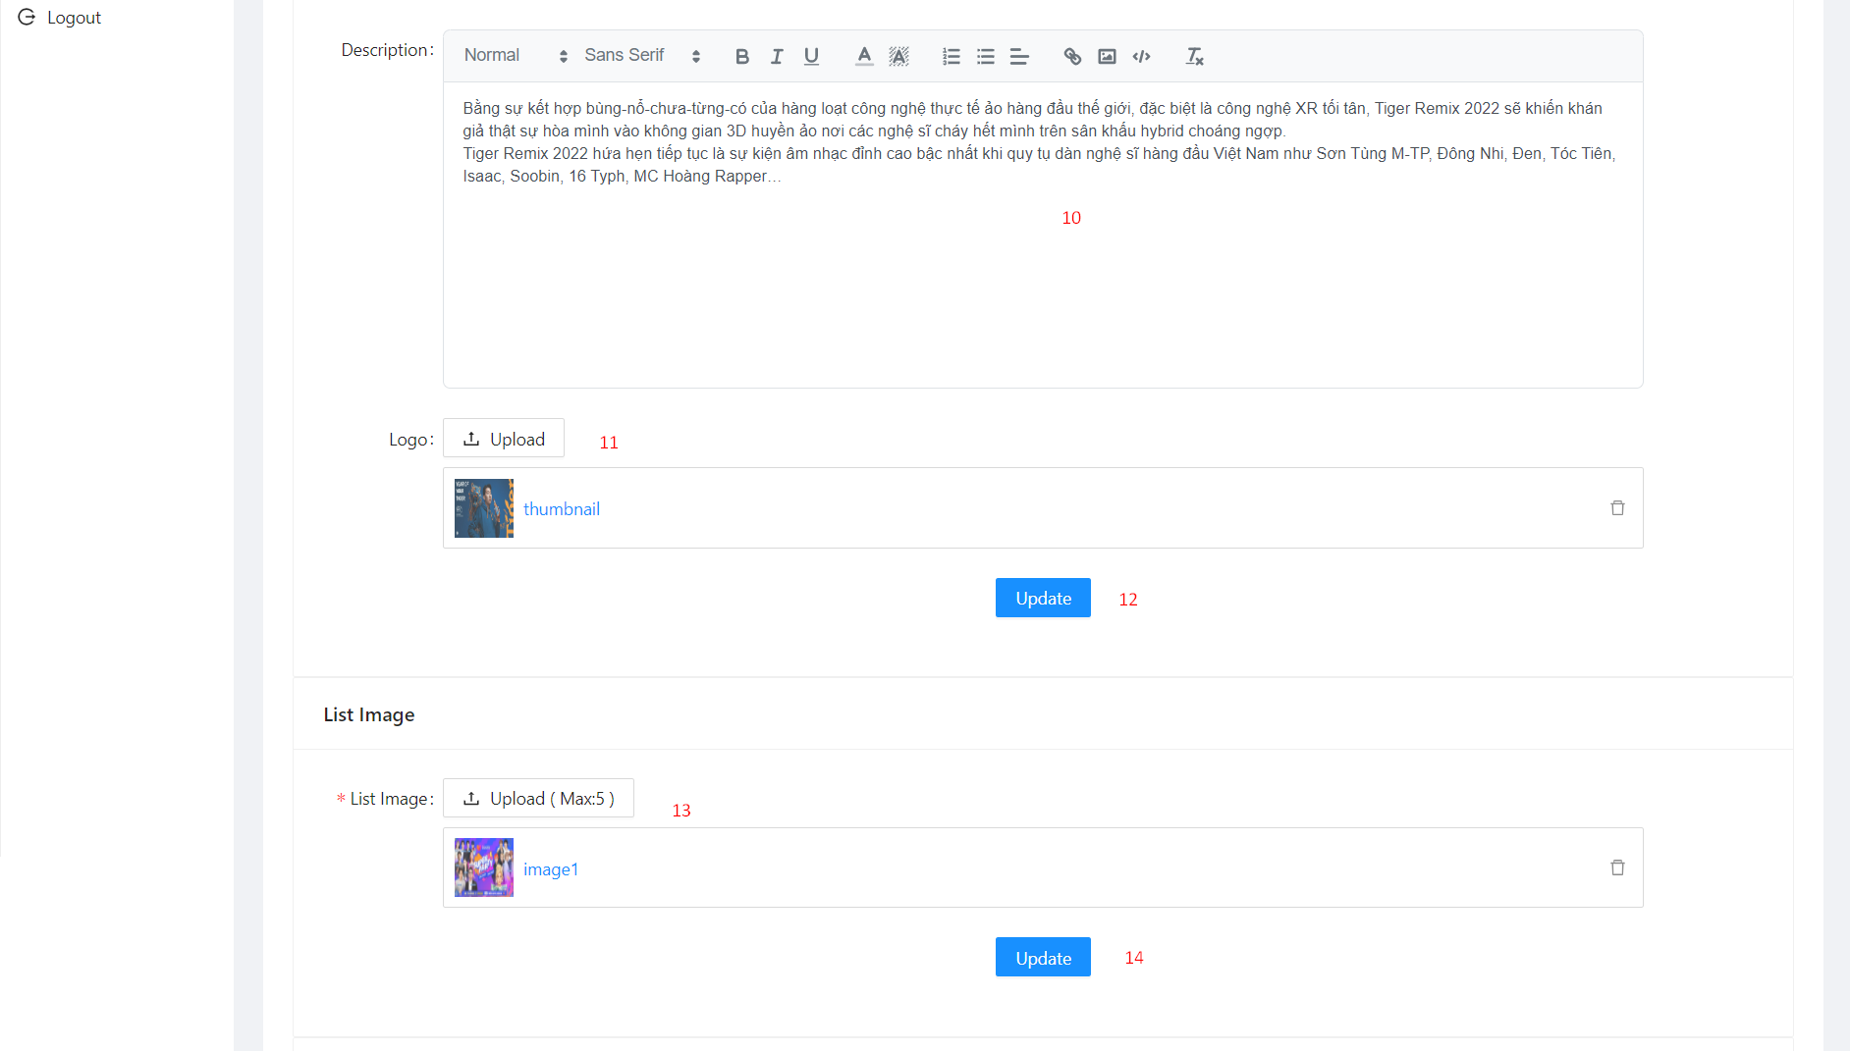

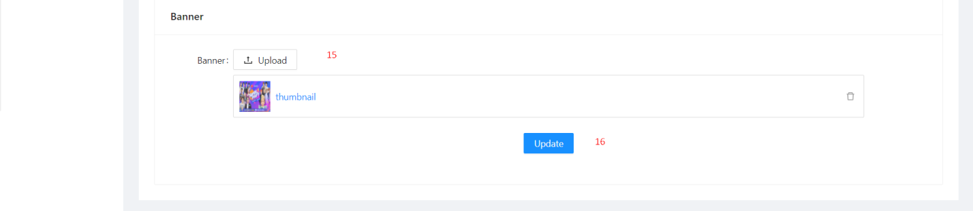

|  |  |  |  |  |  |  |  |  |  |
| --- | --- | --- | --- | --- | --- | --- | --- | --- | --- |
| No. | Field Name | Description | | Read only | | Mandatory | Control Type | | Data Type |
| 1 | Name | Name of event | | No | | Yes | Input | | String |
| 2 | Date start | Opening dates of the event | | No | | Yes | DatePicker | | Datetime |
| 3 | Time start | Opening times of the event | | No | | Yes | DatePicker | | Datetime |
| 4 | Date end | Closing dates of the event | | No | | Yes | DatePicker | | Datetime |
| 5 | Time end | Closing times of the event | | No | | Yes | DatePicker | | Datetime |
| 6 | Province | Province of event | | No | | Yes | Select | | String |
| 7 | District | District of event | | No | | Yes | Select | | String |
| 8 | Ward | Ward of event | | No | | Yes | Select | | String |
| 9 | Address | Location of event | | No | | Yes | Textarea | | String |
| 10 | Logo | Logo of event | | No | | Yes | Upload | | File |
| 11 | List Image | List image of event | | No | | Yes | Upload | | File |
| 13 | Description | Description of event | | No | | Yes | Editor | | String |
| 15 | Banner | Banner of event | | No | | No | Upload | | File |
| **No.** | **Function** | | **Description** | | **Validation** | | | **Outcome** | |
| 12 | Update base information event button | | Update event with the information provided. | | Yes | | | Event updated | |
| 14 | Updated image list button | | Updated event photo list. | | Yes | | | Event updated | |
| 16 | Updated banner button | | Updated event banner. | | Yes | | | Event updated | |

##### Delete event modal

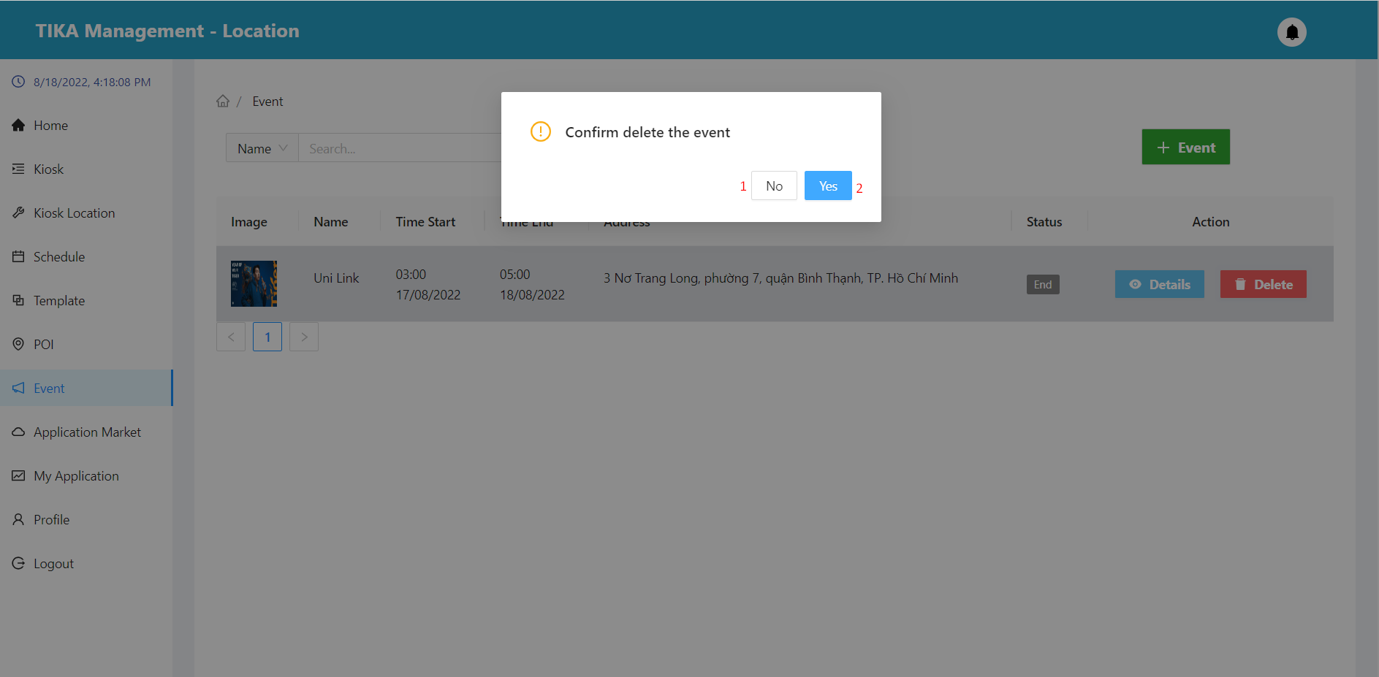

|  |  |  |  |  |
| --- | --- | --- | --- | --- |
| No. | Function | Description | Validation | Outcome |
| 1 | No button | Cancel action delete event | No | Back to event page |
| 2 | Yes button | Confirm action delete event | Yes | Event deleted from database |

##### Application market page

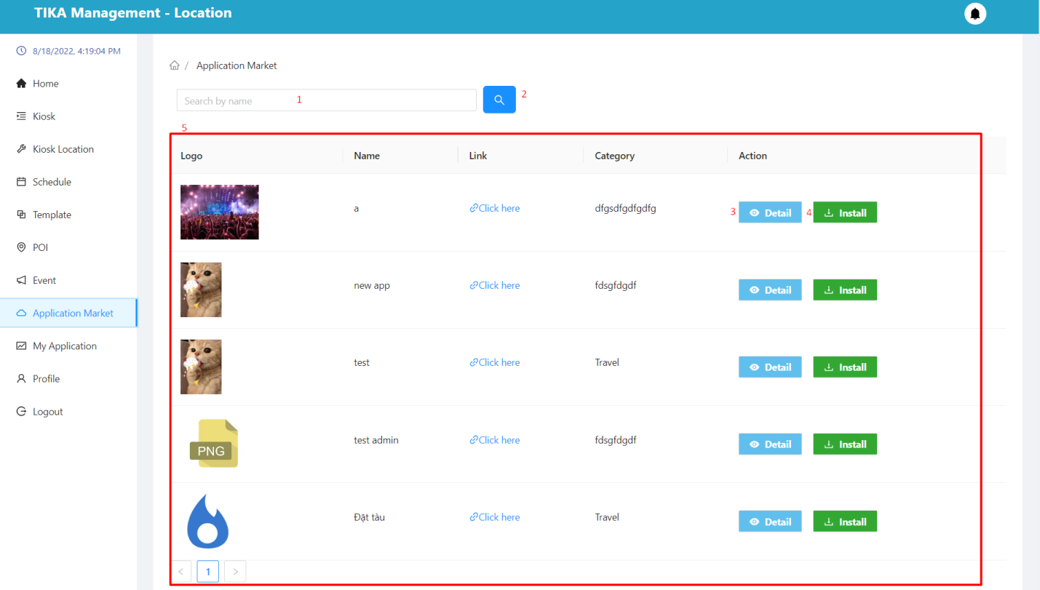

|  |  |  |  |  |  |  |  |  |
| --- | --- | --- | --- | --- | --- | --- | --- | --- |
| No. | Field Name | Description | | Read only | | Mandatory | Control Type | Data Type |
| 1 | Input value to search | Enter the name of the application you want to search for | | No | | No | Input | String |
| 5 | Information of the application | Basic information of the application | | Yes | | Yes | Table | String |
| **No.** | **Function** | | **Description** | | **Validation** | | **Outcome** | |
| 2 | Search information | | Search for names according to the data entered in (1) | | Yes | | Information shown in the table below | |
| 3 | View detail application | | View application details in row | | No | | Move to detail application page | |
| 4 | Install button | | Install apps | | No | | Display the installation confirmation dialog | |

##### Detail application page from application market

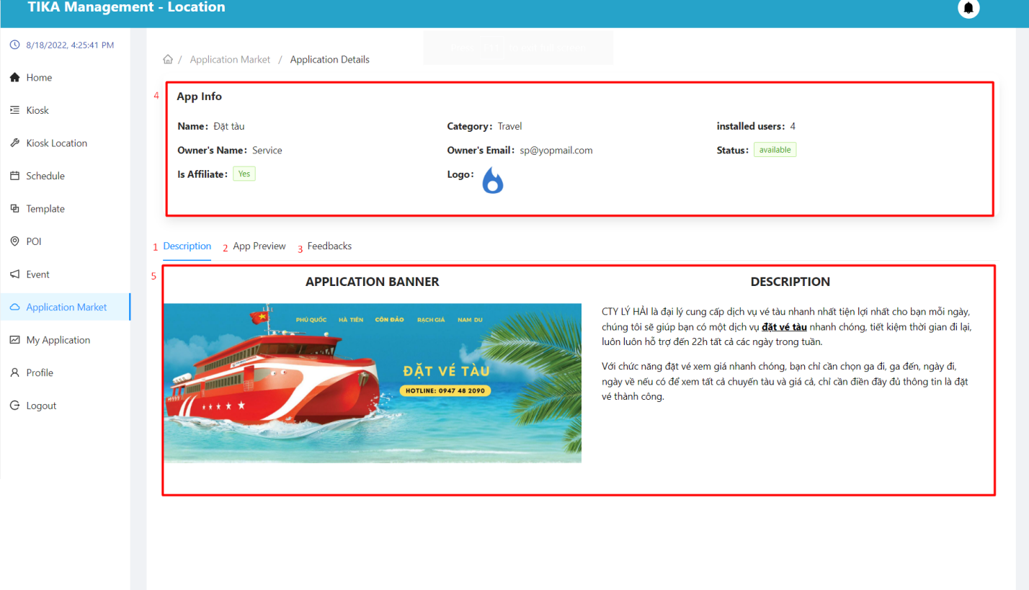

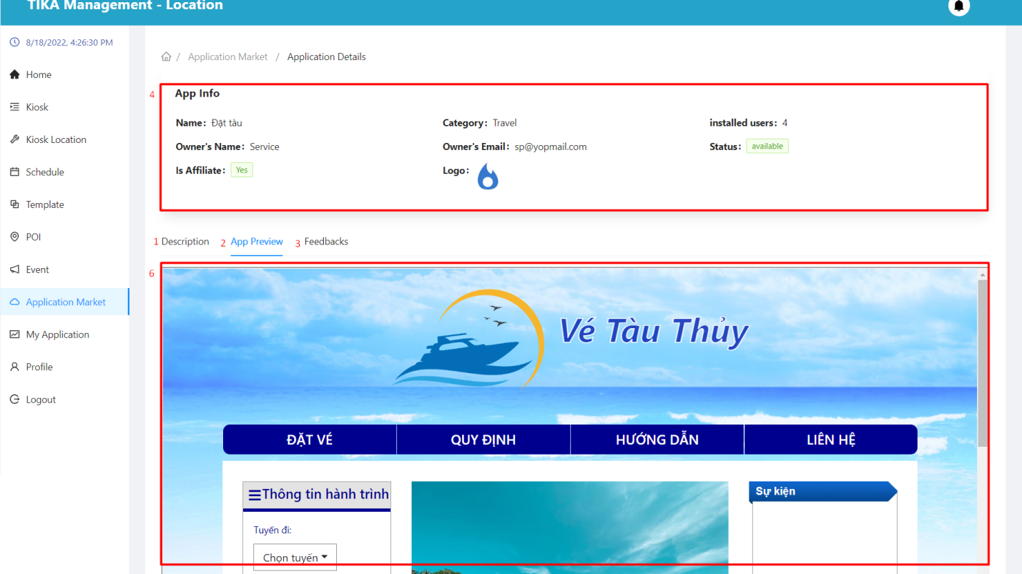

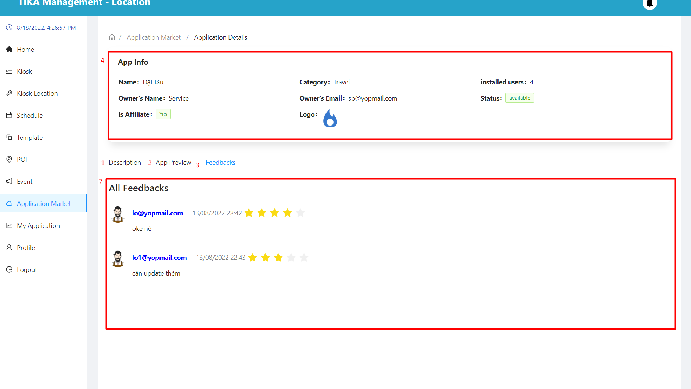

|  |  |  |  |  |  |  |  |  |
| --- | --- | --- | --- | --- | --- | --- | --- | --- |
| No. | Field Name | Description | | Read only | | Mandatory | Control Type | Data Type |
| 4 | App info | Used to view application details | | Yes | | Yes | Table | String |
| 5 | Description area | See the app's description | | Yes | | Yes | Tab | String |
| 6 | App review area | Preview the interface of the application | | Yes | | Yes | Tab | String |
| 7 | Feedback area | Used to view the feedback of users who have used the application | | Yes | | Yes | Tab | String |
| **No.** | **Function** | | **Description** | | **Validation** | | **Outcome** | |
| 1 | Description tab | | Description tab | | No | | Move to tab description | |
| 2 | App review tab | | App review tab | | No | | Move to tab app review | |
| 3 | Feedback tab | | Feedback tab | | No | | Move to tab feedback | |

##### Install application modal

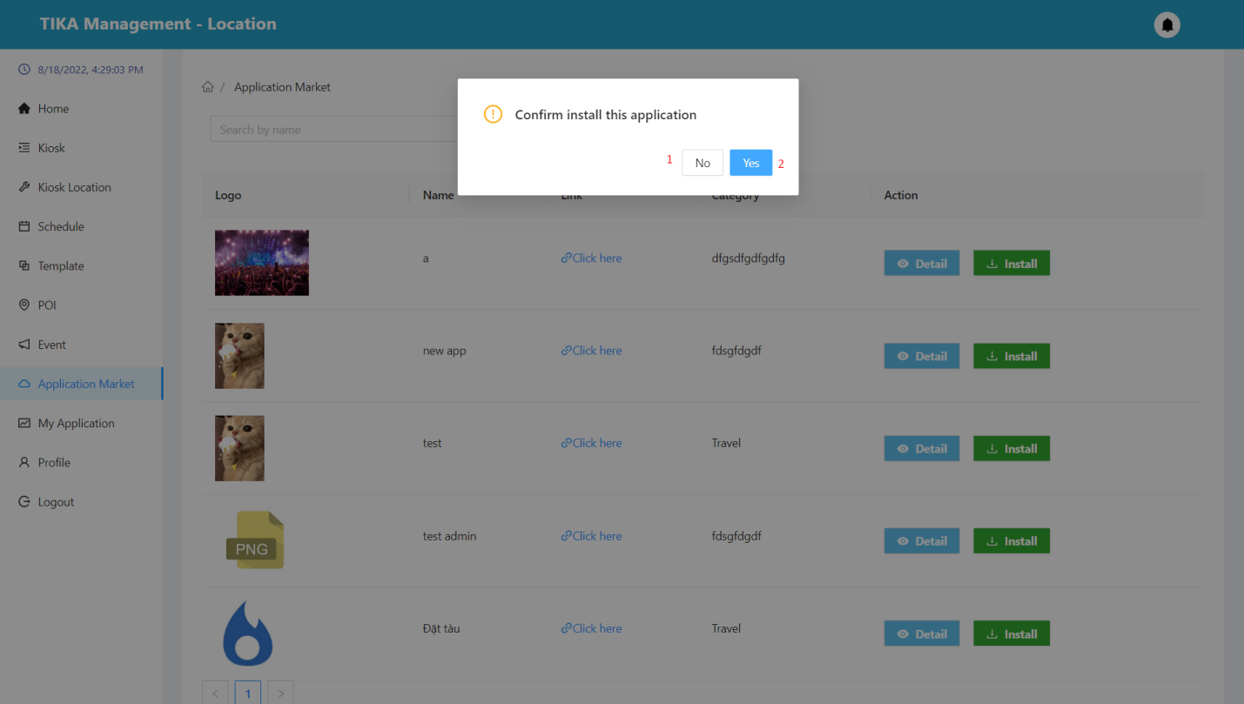

|  |  |  |  |  |
| --- | --- | --- | --- | --- |
| No. | Function | Description | Validation | Outcome |
| 1 | No button | Cancel action install application | No | Back to application market page |
| 2 | Yes button | Confirm action install application | Yes | The app's data will be saved to “my application” |

##### My application page

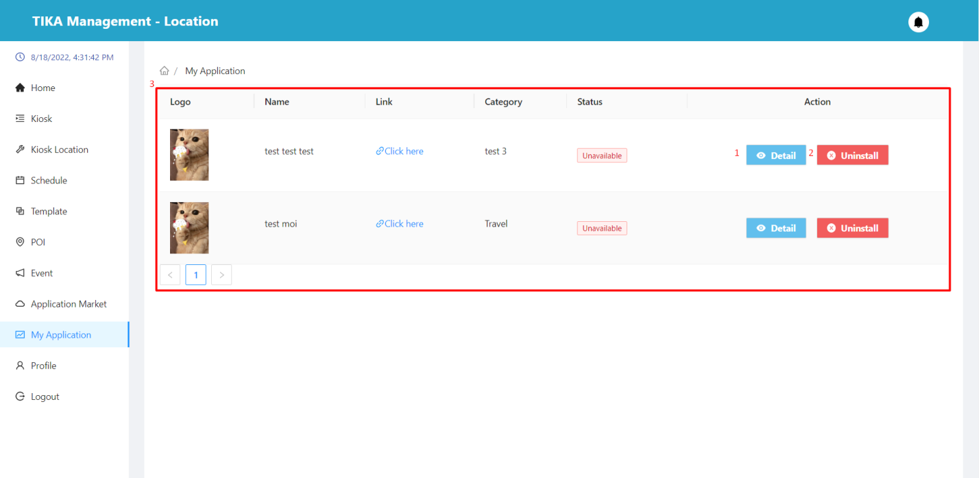

|  |  |  |  |  |  |  |  |  |
| --- | --- | --- | --- | --- | --- | --- | --- | --- |
| No. | Field Name | Description | | Read only | | Mandatory | Control Type | Data Type |
| 3 | Information of the application | Basic information of the application | | Yes | | Yes | Table | String |
| **No.** | **Function** | | **Description** | | **Validation** | | **Outcome** | |
| 3 | View detail application | | View application details in row | | No | | Move to detail application page | |
| 4 | Uninstall button | | Uninstall apps | | No | | Show uninstall confirmation dialog | |

##### Detail application page from my application

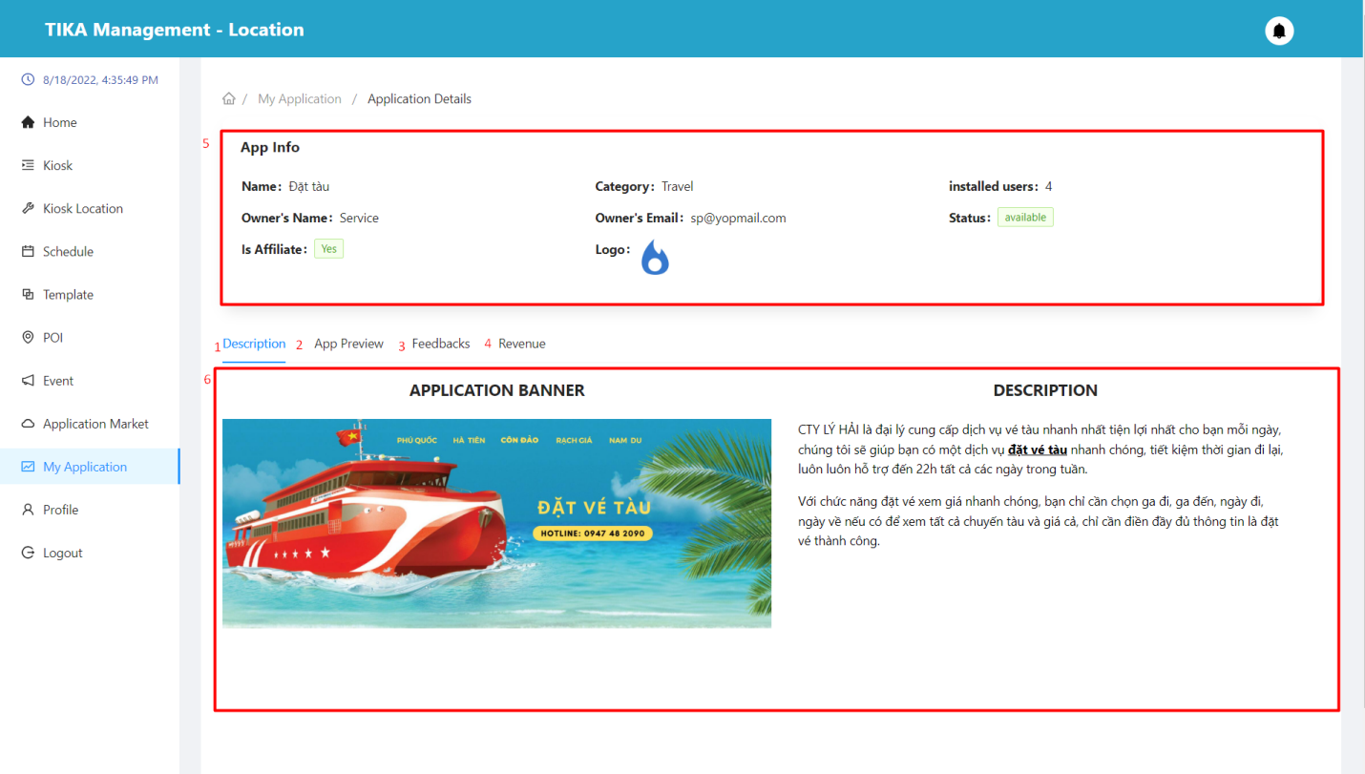

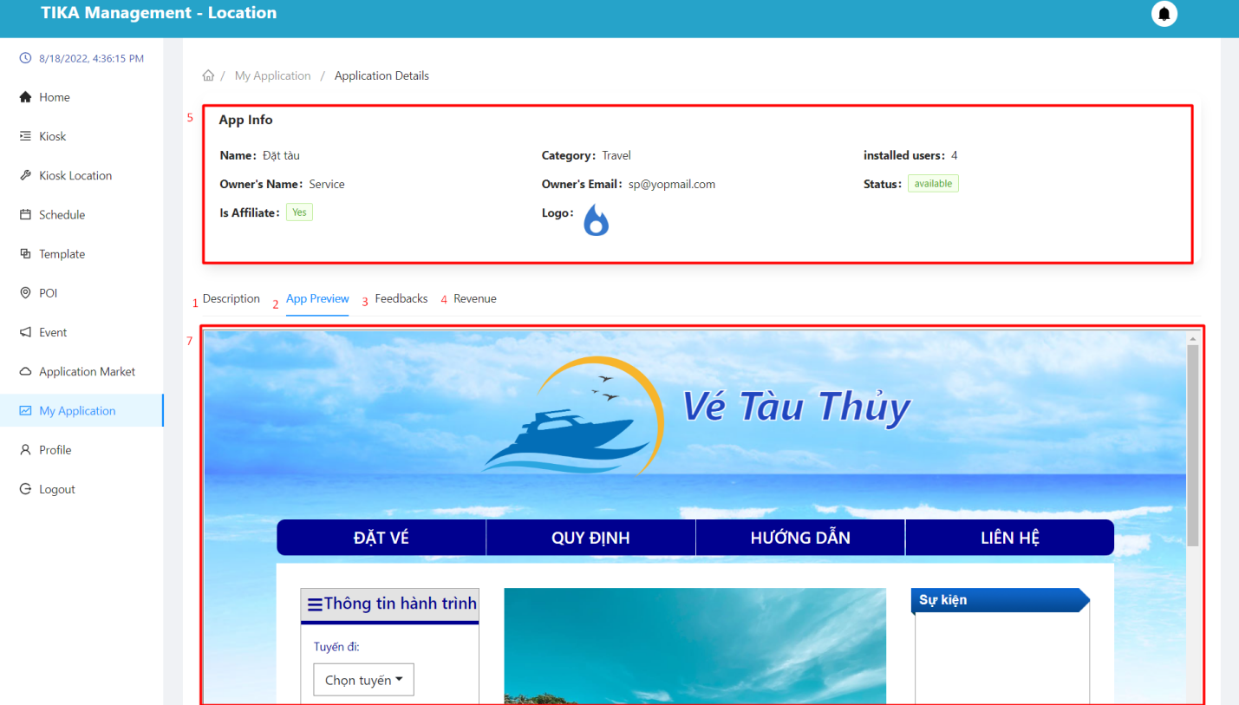

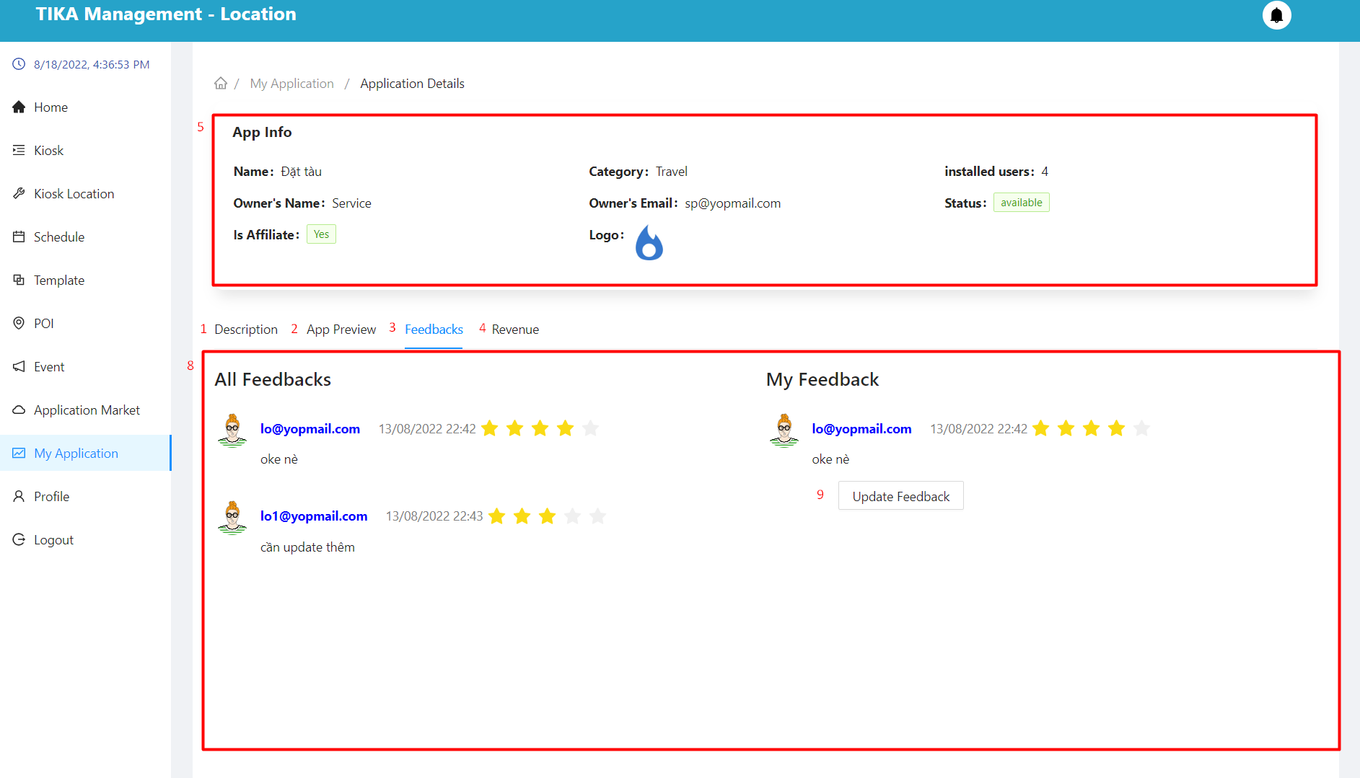

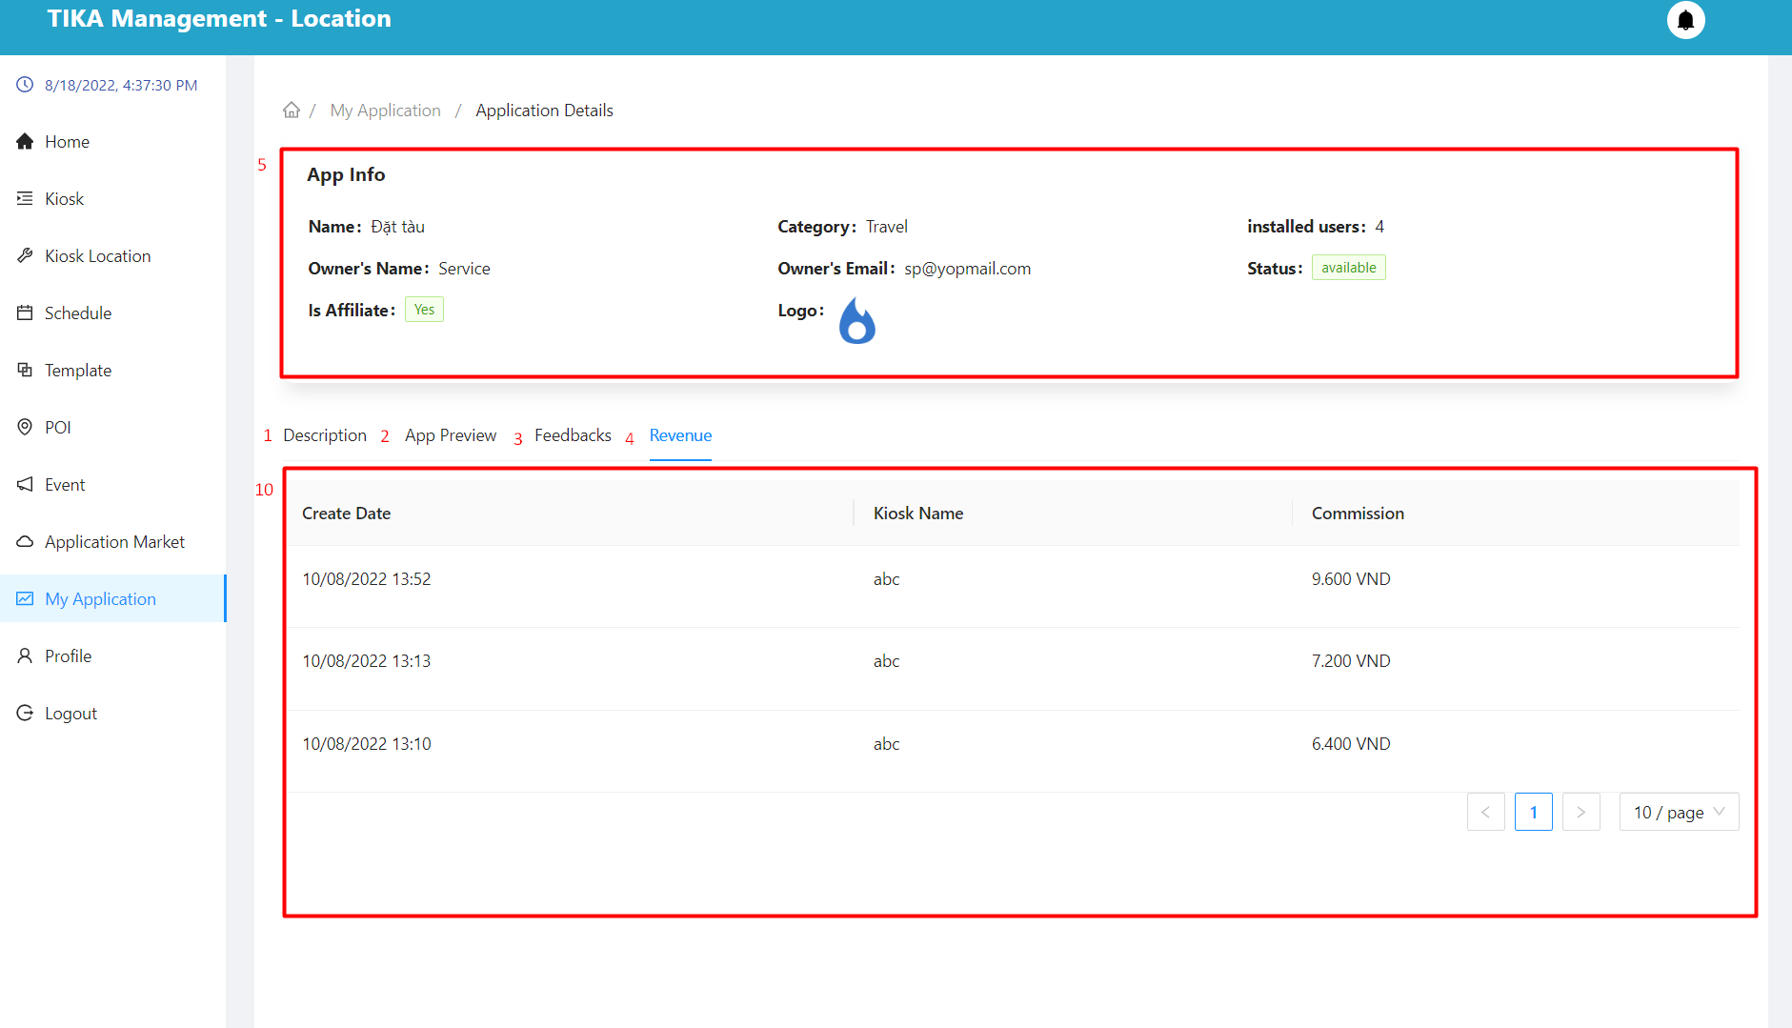

|  |  |  |  |  |  |  |  |  |
| --- | --- | --- | --- | --- | --- | --- | --- | --- |
| No. | Field Name | Description | | Read only | | Mandatory | Control Type | Data Type |
| 5 | App info | Used to view application details | | Yes | | Yes | Table | String |
| 6 | Description area | See the app's description | | Yes | | Yes | Tab | String |
| 7 | App review area | Preview the interface of the application | | Yes | | Yes | Tab | String |
| 8 | Feedback area | Used to view feedback from users who have used the application.User can create new feedback or edit old feedback | | Yes | | Yes | Tab | String |
| 10 | Revenue area | Users can view the app's revenue statistics by each kiosk | | Yes | | Yes | Tab | String |
| **No.** | **Function** | | **Description** | | **Validation** | | **Outcome** | |
| 1 | Description tab | | Description tab | | No | | Move to tab description | |
| 2 | App review tab | | App review tab | | No | | Move to tab app review | |
| 3 | Feedback tab | | Feedback tab | | No | | Move to tab feedback | |
| 4 | Revenue tab | | Revenue tab | | No | | Move to tab revenue | |
| 9 | Feedback now/Update feedback | | Feedback for installed apps | | No | | The dialog box used to respond to comments appears | |

##### Feedback now/Update feedback

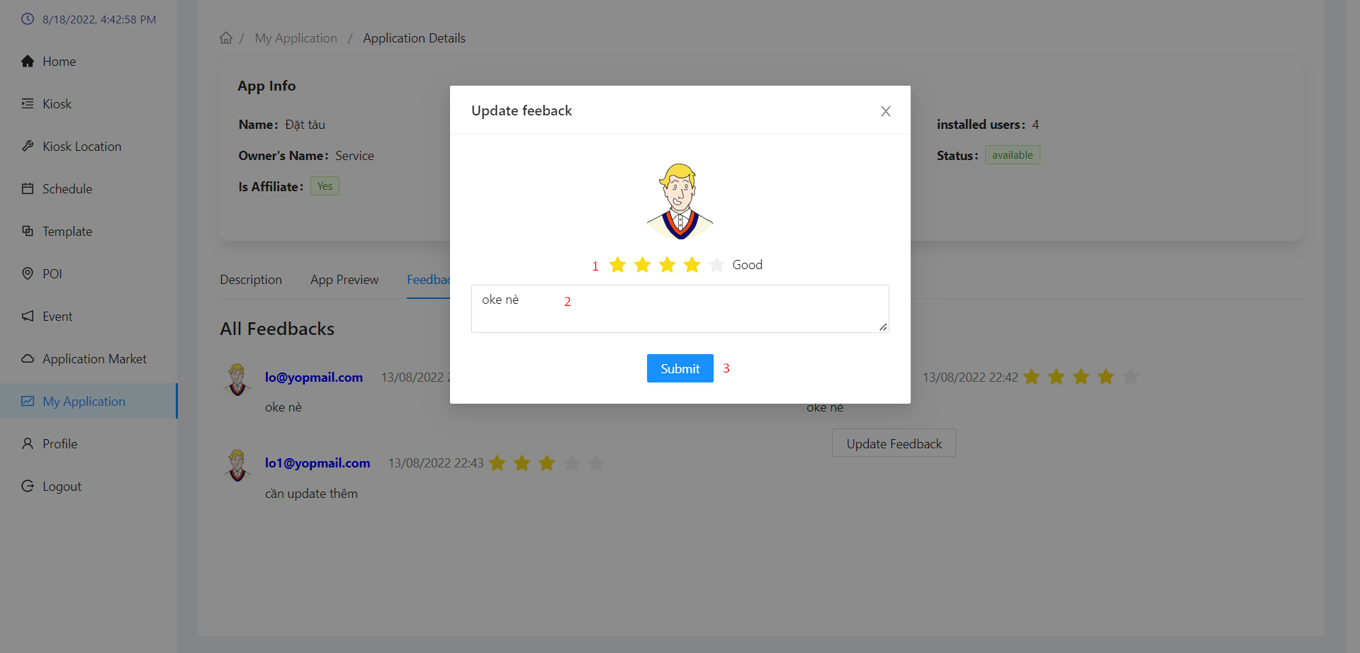

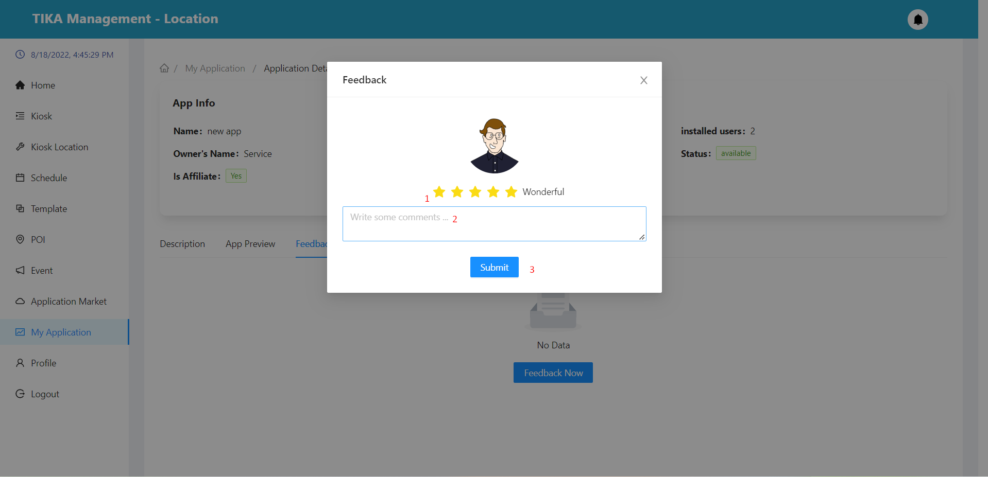

|  |  |  |  |  |  |  |  |  |
| --- | --- | --- | --- | --- | --- | --- | --- | --- |
| No. | Field Name | Description | | Read only | | Mandatory | Control Type | Data Type |
| 1 | Rating | App Experience Rating | | No | | Yes | Rating | Number |
| 2 | Comment | Give your experience about the application | | No | | No | Textarea | String |
| **No.** | **Function** | | **Description** | | **Validation** | | **Outcome** | |
| 3 | Submit button | | Send feedback | | Yes | | New feedback created/Feedback updated | |

##### Uninstall application modal

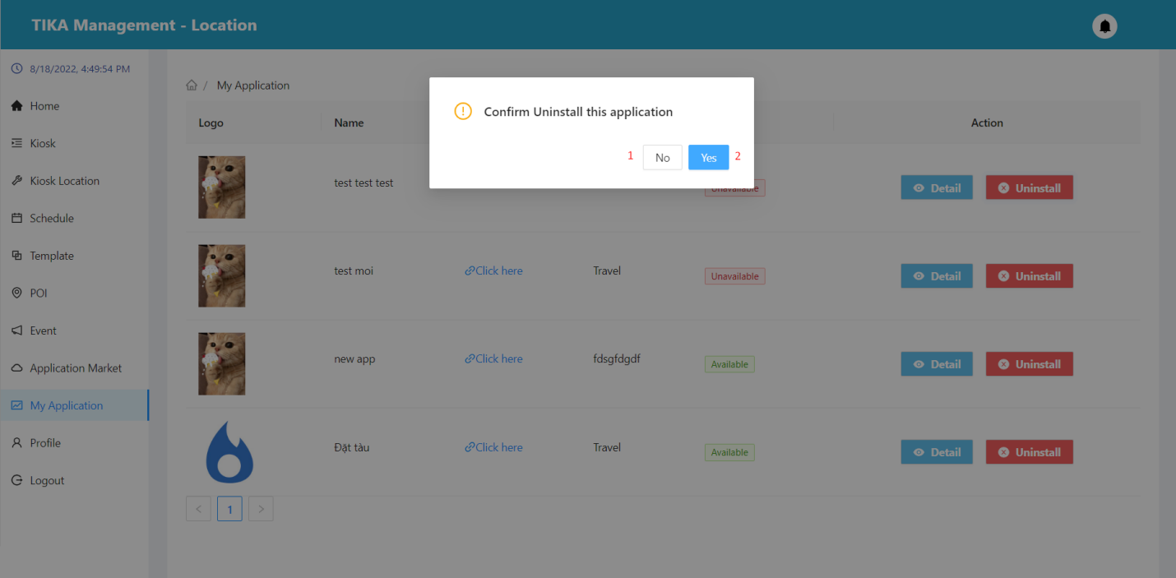

|  |  |  |  |  |
| --- | --- | --- | --- | --- |
| No. | Function | Description | Validation | Outcome |
| 1 | No button | Cancel action uninstall application | No | Back to my application page |
| 2 | Yes button | Confirm action uninstall application | Yes | the app's data will be deleted from “my application” |

##### Profile page

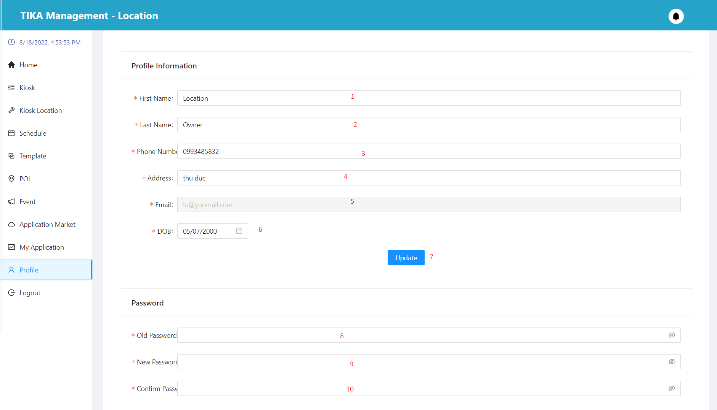

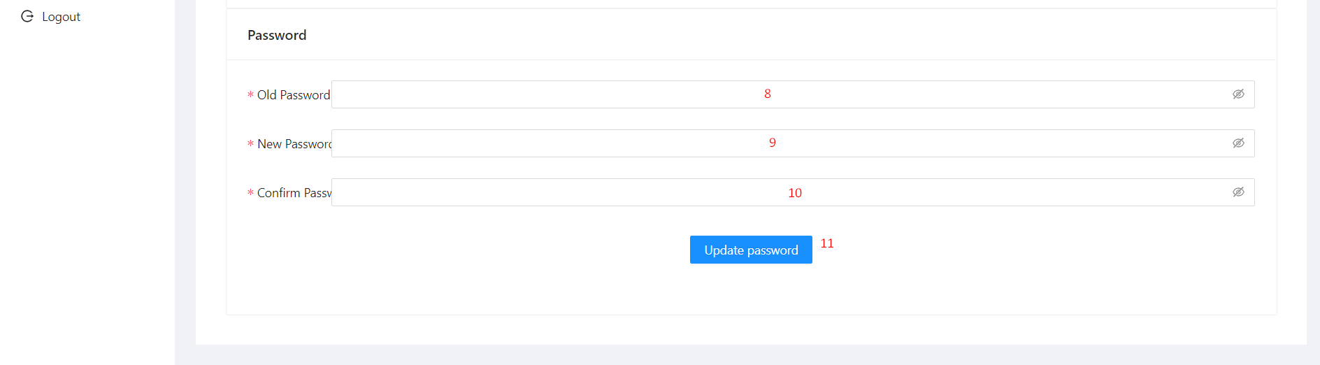

|  |  |  |  |  |  |  |  |  |
| --- | --- | --- | --- | --- | --- | --- | --- | --- |
| No. | Field Name | Description | | Read only | | Mandatory | Control Type | Data Type |
| 1 | First name | First name of user | | No | | Yes | Input | String |
| 2 | Last name | Last name of user | | No | | Yes | Input | String |
| 3 | Phone number | Phone number of user | | No | | Yes | Input | Number |
| 4 | Address | Address of user | | No | | Yes | Input | String |
| 5 | Email | Email of user | | Yes | | Yes | Input | String |
| 6 | DOB | Date of birth of user | | No | | Yes | Select | String |
| 8 | Old password | Your original password | | No | | Yes | Input | String |
| 9 | New password | The new password you want to change to | | No | | Yes | Input | String |
| 10 | Confirm password | Confirm new password | | No | | Yes | Input | String |
| **No.** | **Function** | | **Description** | | **Validation** | | **Outcome** | |
| 7 | Update button | | Change the basic information of the user | | Yes | | User information has been changed | |
| 11 | Update password button | | Change user's password | | Yes | | User's password has been changed | |

Kiosk interface

##### Function overview

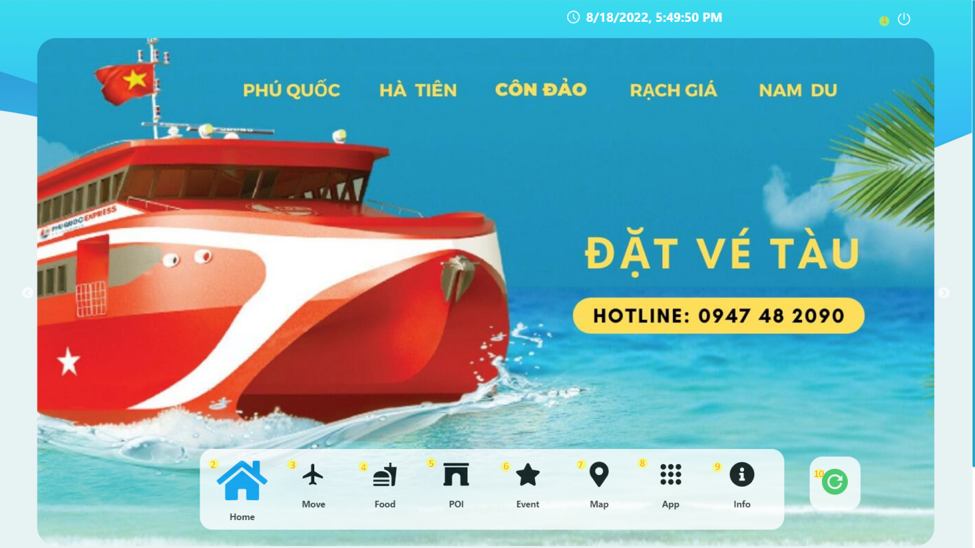

|  |  |  |  |  |
| --- | --- | --- | --- | --- |
| No. | Function | Description | Validation | Outcome |
| 1 | Update button | Change the basic information of the user | No | User information has been changed |
| 2 | Home button | Home button | No | Go to home page |
| 3 | Move button | Move button | No | Go to move page |
| 4 | Food button | Food button | No | Go to food page |
| 5 | Poi button | Poi button | No | Go to poi page |
| 6 | Event button | Event button | No | Go to event page |
| 7 | Map button | Map button | No | Go to map page |
| 8 | App button | App button | No | Go to app page |
| 9 | Info button | Info button | No | Go to info page |
| 10 | Refresh button | Refresh button | No | Refresh the website |

##### Home page

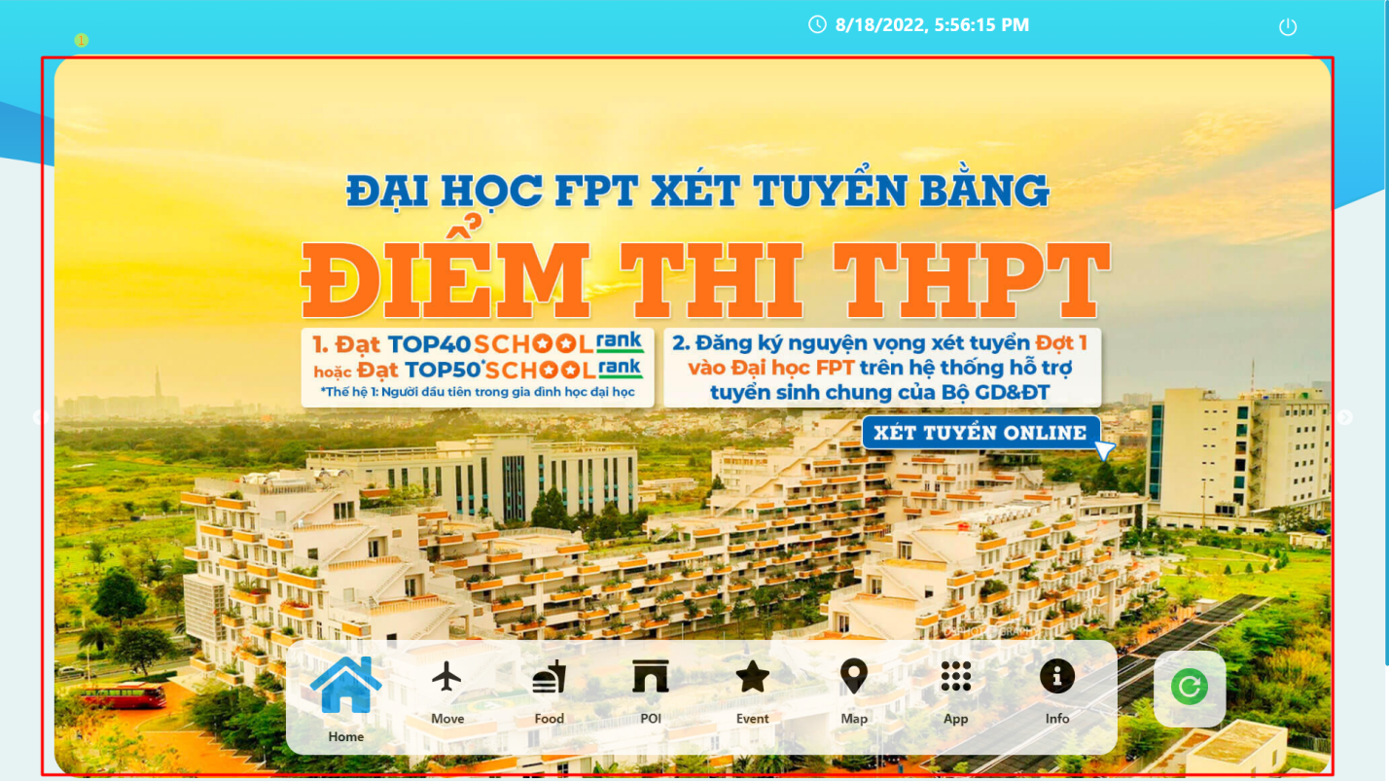

|  |  |  |  |  |  |  |
| --- | --- | --- | --- | --- | --- | --- |
| No. | Field Name | Description | Read only | Mandatory | Control Type | Data Type |
| 1 | Banner area | display banners of applications, interesting places around, etc.. | Yes | Yes | Input | String |

##### Poi page

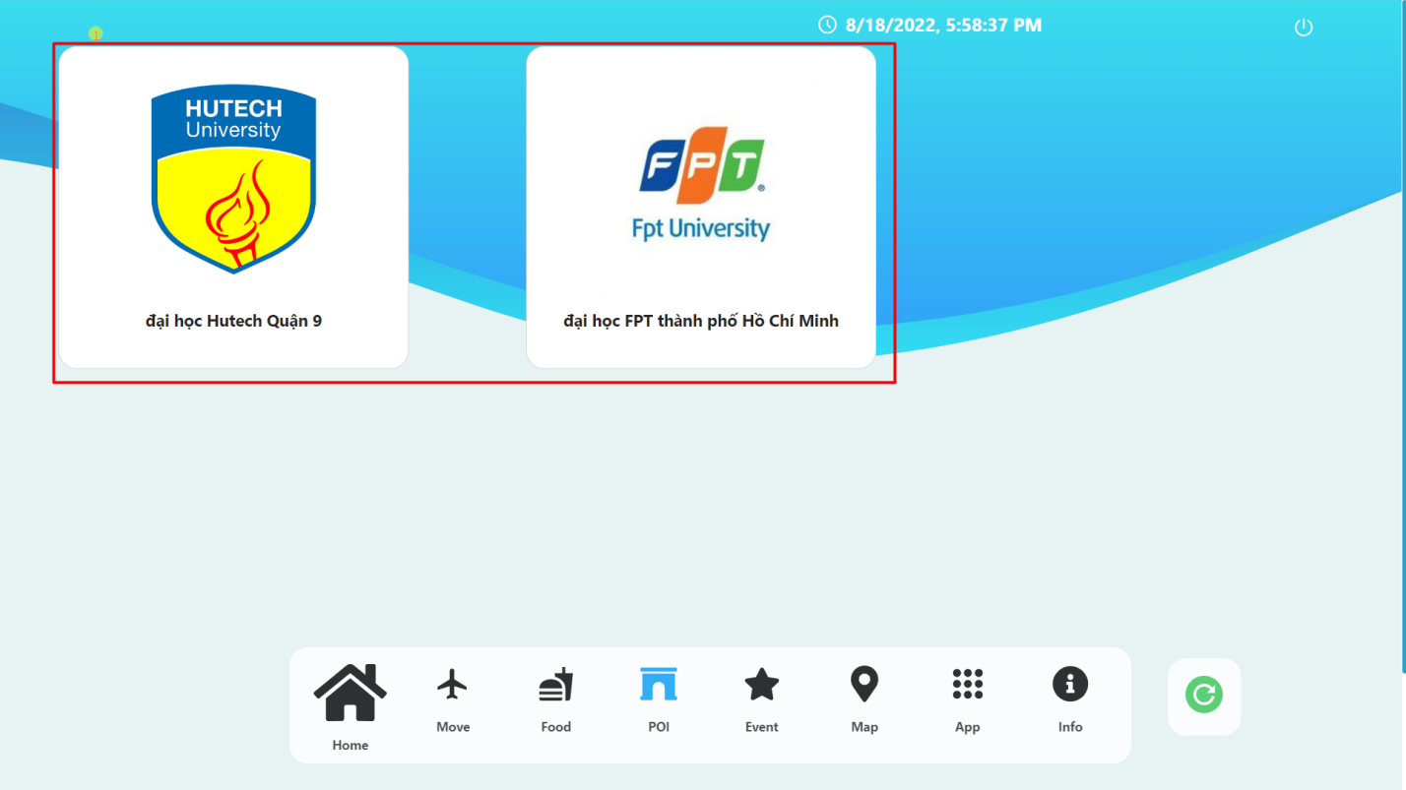

|  |  |  |  |  |
| --- | --- | --- | --- | --- |
| No. | Function | Description | Validation | Outcome |
| 1 | Poi button | List of poi around | No | Move to details of poi |

##### Poi detail page

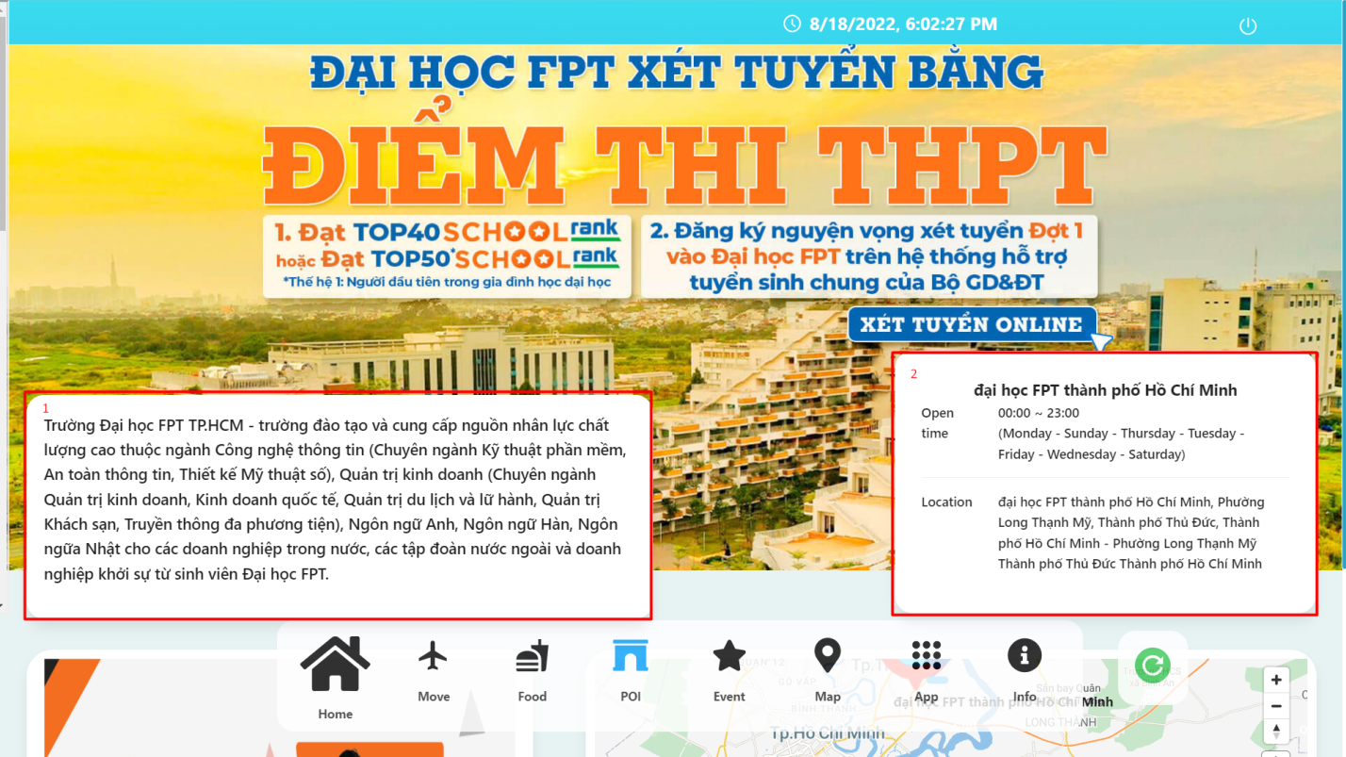

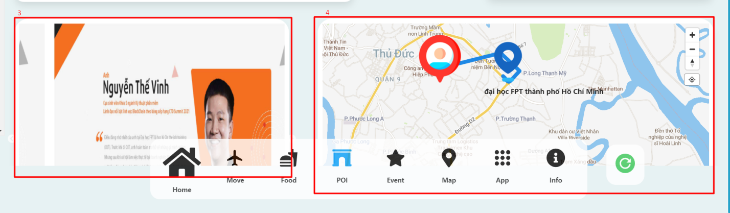

|  |  |  |  |  |  |  |
| --- | --- | --- | --- | --- | --- | --- |
| No. | Field Name | Description | Read only | Mandatory | Control Type | Data Type |
| 1 | Description | Descriptions of places | Yes | Yes | Input | String |
| 2 | Base information | Other basic information | Yes | Yes | Input | String |
| 3 | List of pictures of the place | List of pictures of the place | Yes | Yes | Input | String |
| 4 | Map | Directions from current location to selected location | No | Yes | Input | String |

##### Event page

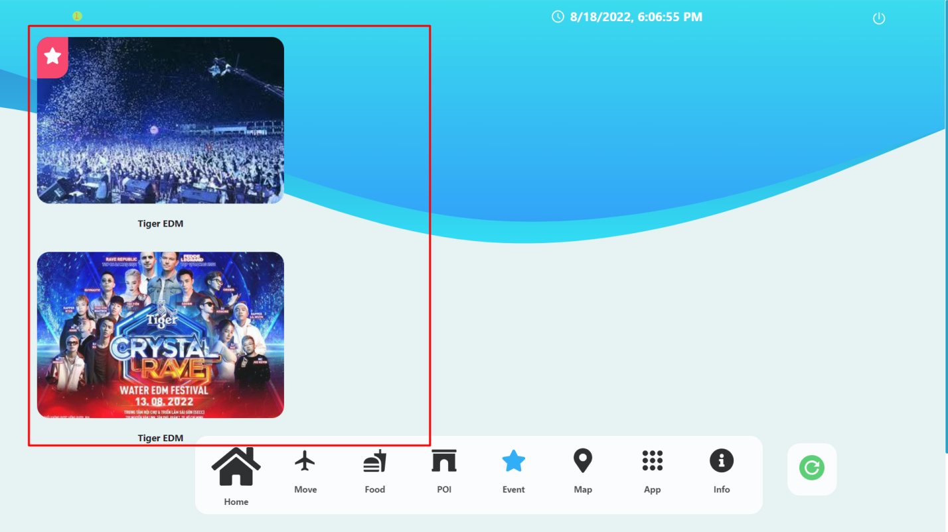

|  |  |  |  |  |
| --- | --- | --- | --- | --- |
| No. | Function | Description | Validation | Outcome |
| 1 | Event button | List of event around | No | Move to details of event |

##### Event detail page

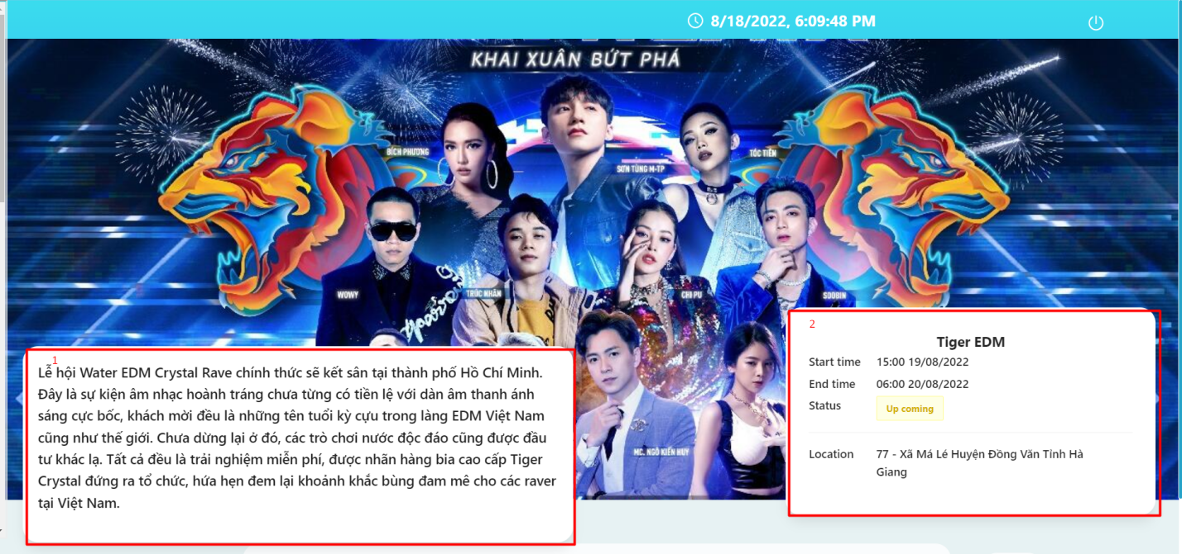

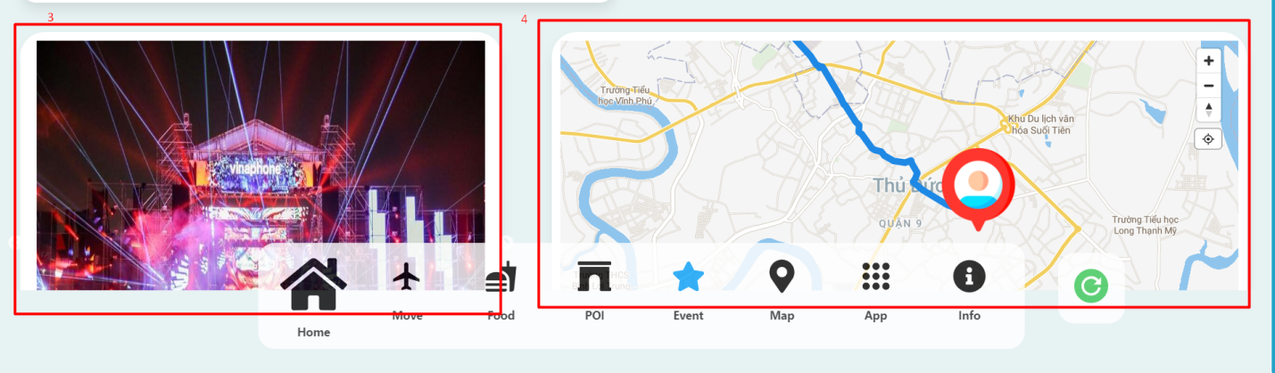

|  |  |  |  |  |  |  |
| --- | --- | --- | --- | --- | --- | --- |
| No. | Field Name | Description | Read only | Mandatory | Control Type | Data Type |
| 1 | Description | Descriptions of event | Yes | Yes | Input | String |
| 2 | Base information | Other basic information | Yes | Yes | Input | String |
| 3 | List of pictures of the place | List of pictures of the event | Yes | Yes | Input | String |
| 4 | Map | Directions from current location to selected location | No | Yes | Input | String |

##### Map page

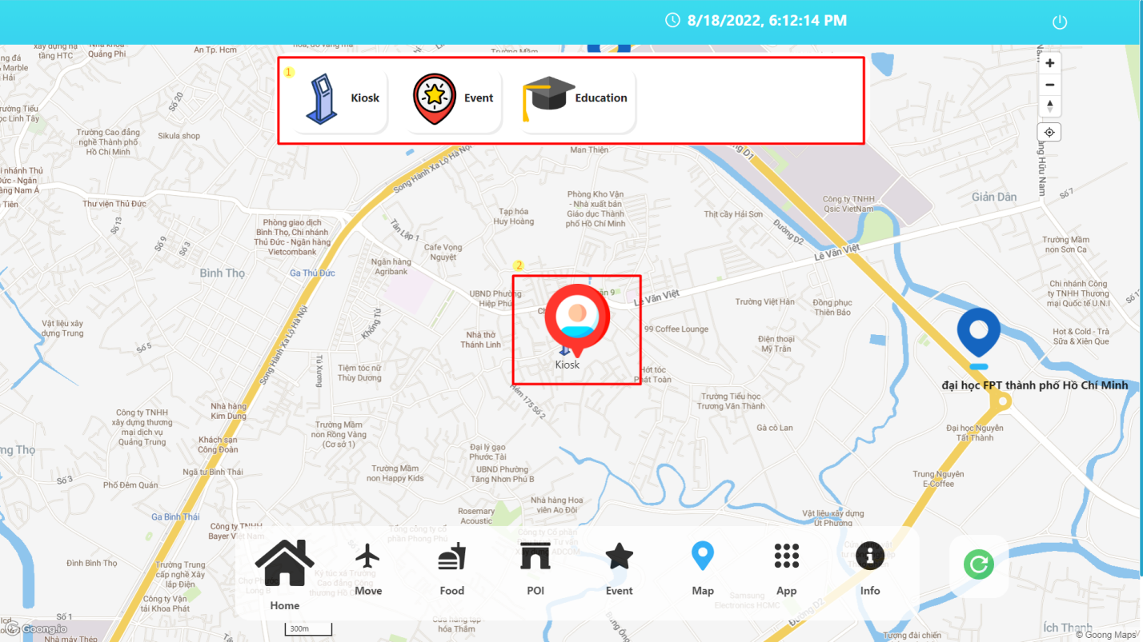

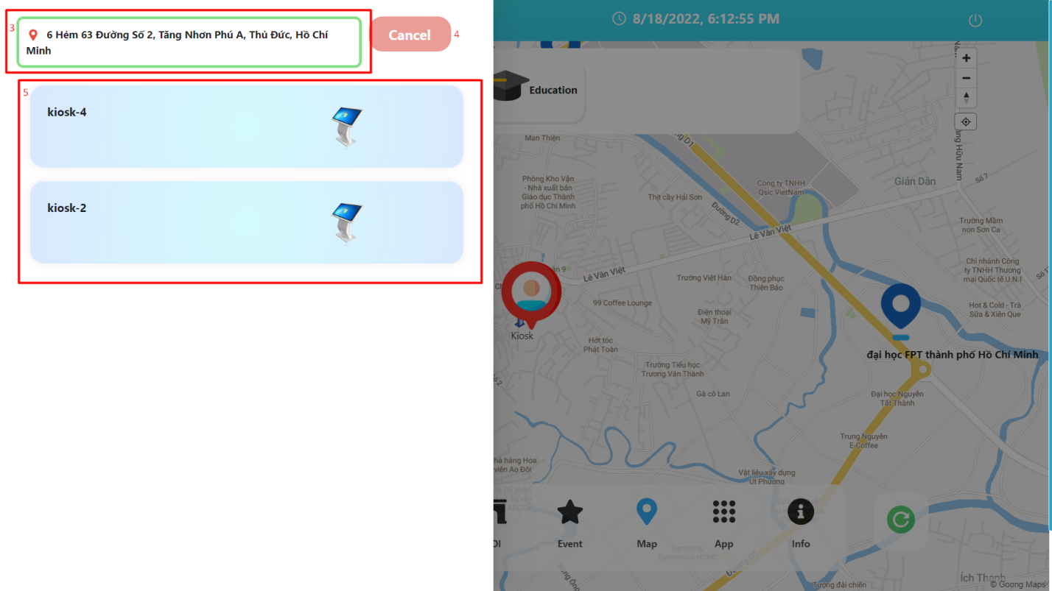

|  |  |  |  |  |  |  |  |  |
| --- | --- | --- | --- | --- | --- | --- | --- | --- |
| No. | Field Name | Description | | Read only | | Mandatory | Control Type | Data Type |
| 2 | Pin | Your location on the map | | Yes | | Yes | Input | String |
| 3 | Current address | Current address | | Yes | | Yes | Input | Number |
| 5 | The list of items | The list of items near the kiosk is filtered based on the category you choose | | Yes | | Yes | Input | String |
| **No.** | **Function** | | **Description** | | **Validation** | | **Outcome** | |
| 1 | Category | | Click to search for nearby places by category | | No | | Show list of points filtered by category | |
| 4 | Cancel button | | Cancel button | | Yes | | Return to the map interface | |

##### App page

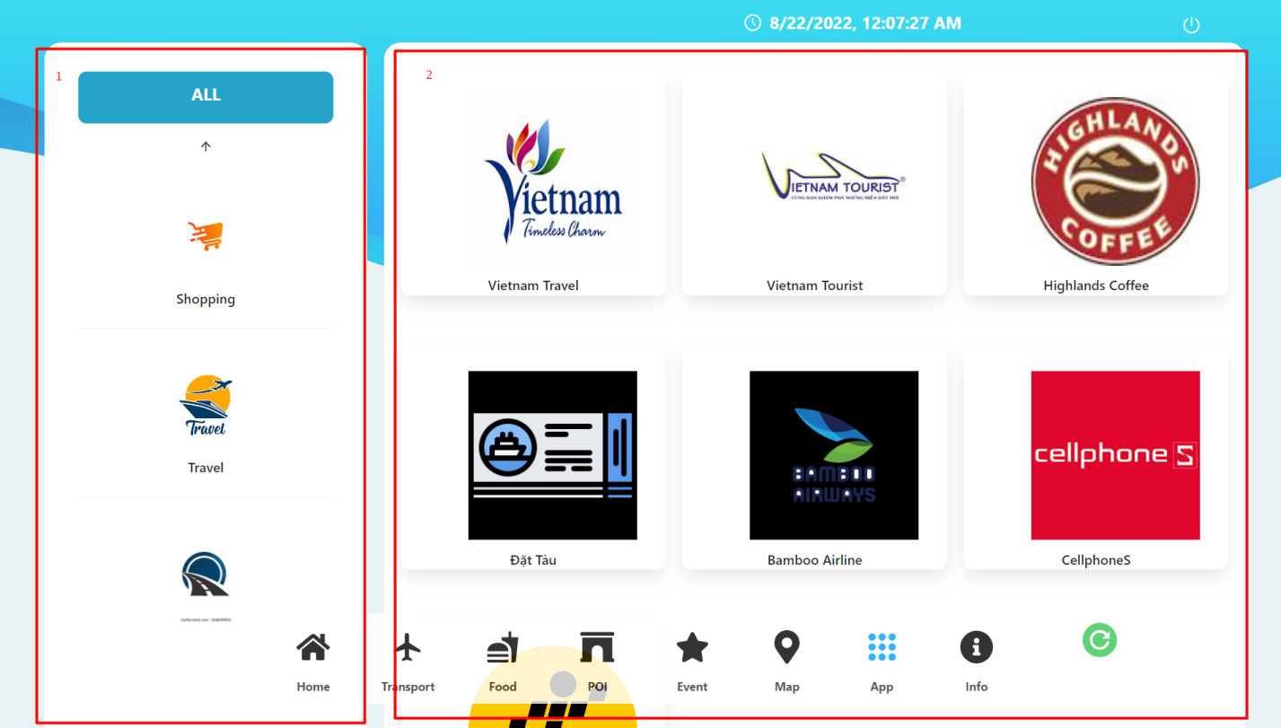

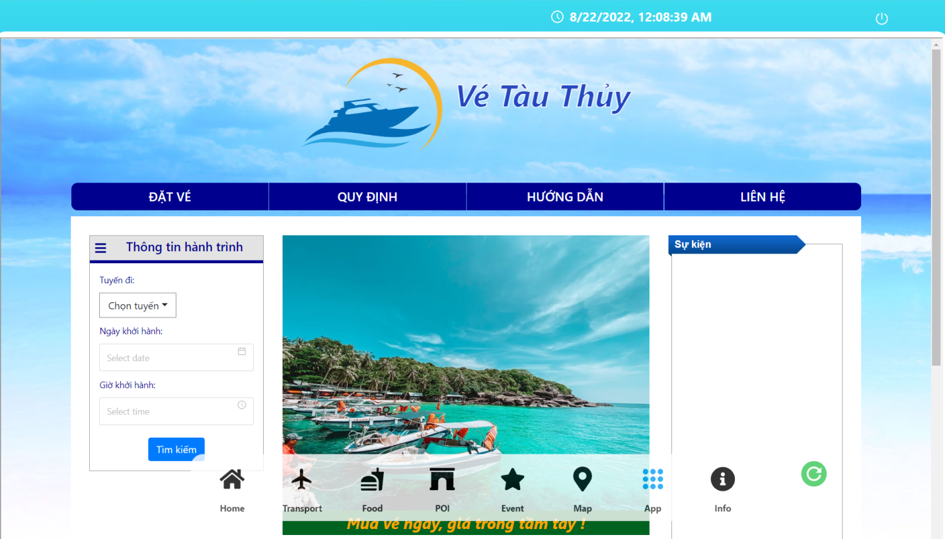

|  |  |  |  |  |  |  |
| --- | --- | --- | --- | --- | --- | --- |
| No. | Field Name | Description | Read only | Mandatory | Control Type | Data Type |
| 1 | App category list | List of app categories to choose from | Yes | Yes | Input | String |
| 2 | App list | The list of applications displayed based on the selected categories | Yes | Yes | Input | String |
| 3 | Screen displayed when clicking on an application | Screen displayed when clicking on an application | Yes | Yes | Iframe | web |

##### Info page

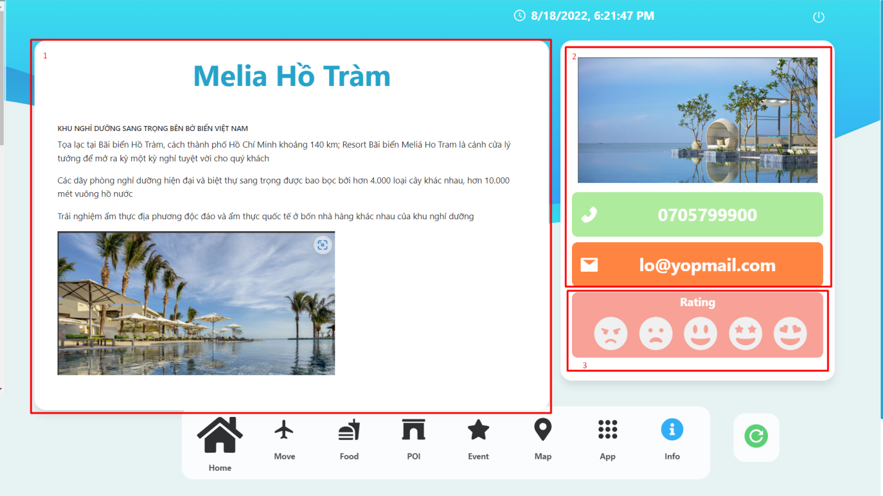

|  |  |  |  |  |  |  |  |  |
| --- | --- | --- | --- | --- | --- | --- | --- | --- |
| No. | Field Name | Description | | Read only | | Mandatory | Control Type | Data Type |
| 1 | Description | Article about the place | | Yes | | Yes | Input | String |
| 2 | Basic information | Basic information | | Yes | | Yes | Input | Number |
| **No.** | **Function** | | **Description** | | **Validation** | | **Outcome** | |
| 3 | Rating | | Choose the level based on your level of experience with the kiosk | | No | | Show confirmation dialog | |

##### Rating modal

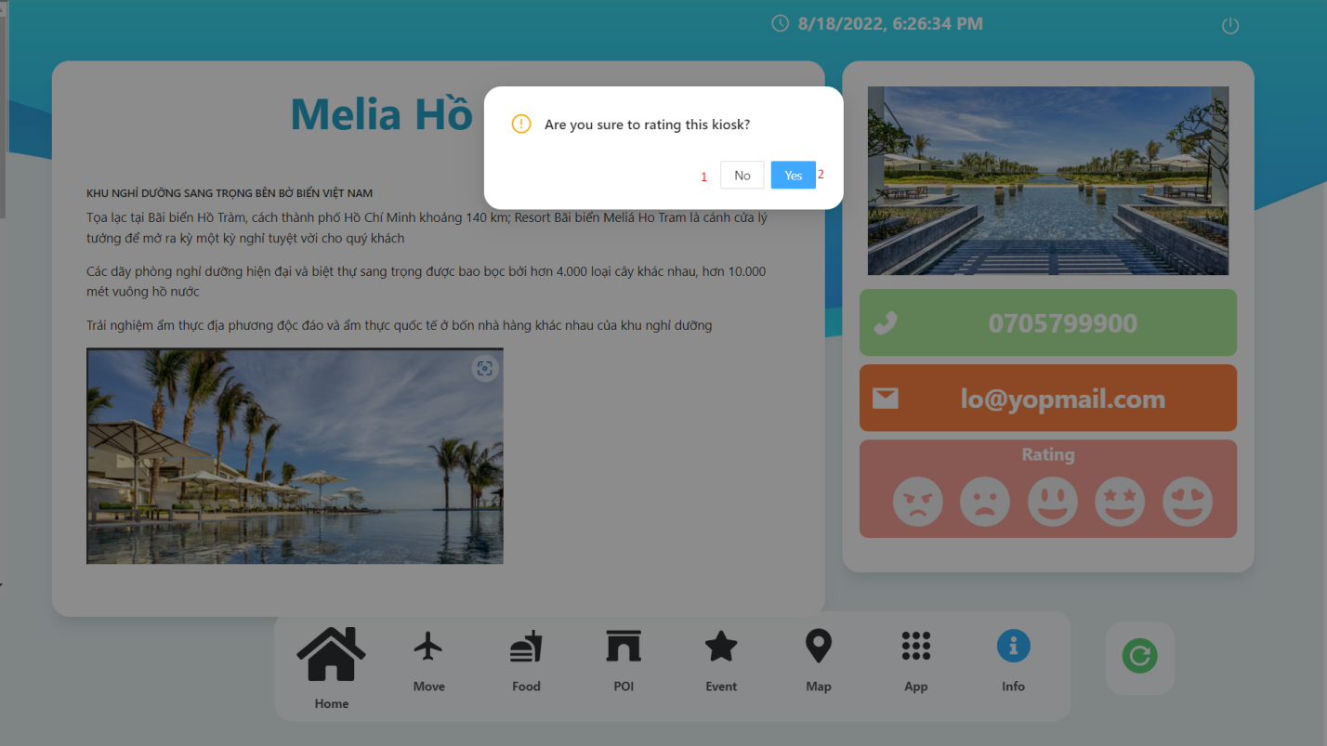

|  |  |  |  |  |
| --- | --- | --- | --- | --- |
| No. | Function | Description | Validation | Outcome |
| 1 | No button | Cancel action rating | No | Back to info page |
| 2 | Yes button | Confirm action rating | No | Success Rating |